**Summary**

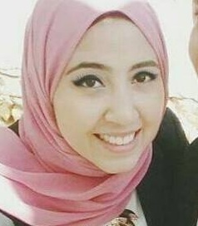

SALLY NADER AHMED

Web Developer

sallynaderahmed@gmail.com

01144083438

Education

College :

B.SC of Computers and Information- shrouk academy – 2016

Grades :

First year : very good

Second year : very good

Third year : good

School :

Manara Girls Language School

Languages

Arabic native speaker

English fluent

### P Personal Skills

H I'm very accurate person , adaptable to any changes , alert person who don't sleep until I finish my task ,I'm cooperative person who help my own team and I'm optimistic person who see the light spot in the darkness.

I'm ambitious girl who have passion of web development ,I want to professional web developer , so I a applied to your reputable company to gain experience.

**Technical Skills**

Programming/Web :

PHP , laravel, java SE , HTML , CSS

Development tool :

PhpDesigner 8

Operating system :

Windows

Server technologies :

Apache

Database/DBMS : SQL MYSQL, Microsoft SQL Server.

**Graduation Project**

**Title : Virtual class room.**

**My Role : Coding with PHP.**

**Activities**

### ACM - Microsoft club - google community - AIESEC