How to install new VM using current exist img

1. Img files.

DMF-GFS.img DMF.img ne-bmcbdcAccess.xml ne-ingestion.xml ne-om.xml

1. Copy file

Create a fole to store img files, for example: /var/tong

Copy DMF-GFS.img DMF.img ne-bmcbdcAccess.xml ne-ingestion.xml ne-om.xml

to /var/tong

1. On the host machine, open a terminal, then define your virtual net-work
   1. check exist bridge

# brctl show

Example output:

bridge name     bridge id               STP enabled     interfaces

virbr1          8000.5254000fed99       yes             virbr1-nic

                                                        vnet1

virbr2          8000.5254000fed99       yes             virbr2-nic

                                                        vnet0

virbr1&virbr2 had been used, so next step we can use virbr3,virbr4,virbr5. Otherwise we can use start from virb1.

* 1. create a new bridge first:

if we use br0 for example, under /etc/sysconfig/network-scripts

[root@localhost network-scripts]# vi ifcfg-br0

DEVICE="br0"

BOOTPROTO="static"

ONBOOT="yes"

TYPE="Bridge"

IPADDR=192.168.3.129

GATEWAY=192.168.3.1

NETMASK=255.255.255.0

Then make an ethernet interface to bind with this br.

[root@localhost network-scripts]# vi ifcfg-eth0

DEVICE="eth0"

BOOTPROTO="static"

HWADDR="00:0C:29:A6:57:79"

IPV6INIT="yes"

NM_CONTROLLED="yes"

ONBOOT="yes"

BRIDGE="br0"

TYPE="Ethernet"

UUID="5d769f41-9ec4-4877-9185-637670d83889"

* 1. restart and verify your host network

[root@localhost network-scripts]# service network restart

[root@localhost network-scripts]# ifconfig

br0 Link encap:Ethernet HWaddr 00:0C:29:A6:57:79

inet addr:192.168.3.129 Bcast:192.168.3.255 Mask:255.255.255.0

inet6 addr: fe80::20c:29ff:fea6:5779/64 Scope:Link

UP BROADCAST RUNNING MULTICAST MTU:1500 Metric:1

RX packets:199 errors:0 dropped:0 overruns:0 frame:0

TX packets:135 errors:0 dropped:0 overruns:0 carrier:0

collisions:0 txqueuelen:0

RX bytes:17182 (16.7 KiB) TX bytes:18161 (17.7 KiB)

eth0 Link encap:Ethernet HWaddr 00:0C:29:A6:57:79

inet6 addr: fe80::20c:29ff:fea6:5779/64 Scope:Link

UP BROADCAST RUNNING MULTICAST MTU:1500 Metric:1

RX packets:253 errors:0 dropped:0 overruns:0 frame:0

TX packets:248 errors:0 dropped:0 overruns:0 carrier:0

collisions:0 txqueuelen:1000

RX bytes:26676 (26.0 KiB) TX bytes:29902 (29.2 KiB)

lo Link encap:Local Loopback

inet addr:127.0.0.1 Mask:255.0.0.0

inet6 addr: ::1/128 Scope:Host

UP LOOPBACK RUNNING MTU:16436 Metric:1

RX packets:2524 errors:0 dropped:0 overruns:0 frame:0

TX packets:2524 errors:0 dropped:0 overruns:0 carrier:0

collisions:0 txqueuelen:0

RX bytes:1903338 (1.8 MiB) TX bytes:1903338 (1.8 MiB)

* 1. edit the host-bridge network file

<network>

<name> ne-om </name>

<uuid>9e7fa3ab-ec29-9642-a429-40217e4f8f1e</uuid>

<forward mode='bridge'/>

<bridge name='br0' />

</network>

* 1. check network

#virsh net-list --all

* 1. define network bridge

#virsh net-define ne-om.xml

#virsh net-define ne-ingestion.xml

#virsh net-define ne-bmcbdcAccess.xml

* 1. check network, the define network should be inactive.

#virsh net-list --all

Name State Autostart Persistent

--------------------------------------------------

ne-bmcbdcAccess inactive no yes

ne-ingestion inactive no yes

ne-oam inactive no yes

* 1. Active network:

#virsh net-start ne-om

#virsh net-start ne-ingestion

#virsh net-start ne-bmcbdcAccess

#virsh net-list --all

Name State Autostart Persistent

--------------------------------------------------

default active yes yes

ne-bmcbdcAccess active no yes

ne-ingestion active no yes

ne-om active no yes

* 1. Check ifconfig, it should has below bridge,

Your virtual network interface should be working:

virbr3 Link encap:Ethernet HWaddr 52:54:00:0F:ED:80

inet addr:192.168.11.1 Bcast:192.168.11.255 Mask:255.255.255.0

UP BROADCAST RUNNING MULTICAST MTU:1500 Metric:1

RX packets:0 errors:0 dropped:0 overruns:0 frame:0

TX packets:0 errors:0 dropped:0 overruns:0 carrier:0

collisions:0 txqueuelen:0

RX bytes:0 (0.0 b) TX bytes:0 (0.0 b)

virbr4 Link encap:Ethernet HWaddr 52:54:00:0F:ED:81

inet addr:192.168.12.1 Bcast:192.168.12.255 Mask:255.255.255.0

UP BROADCAST RUNNING MULTICAST MTU:1500 Metric:1

RX packets:0 errors:0 dropped:0 overruns:0 frame:0

TX packets:0 errors:0 dropped:0 overruns:0 carrier:0

collisions:0 txqueuelen:0

RX bytes:0 (0.0 b) TX bytes:0 (0.0 b)

virbr5 Link encap:Ethernet HWaddr 52:54:00:0F:ED:82

inet addr:192.168.13.1 Bcast:192.168.13.255 Mask:255.255.255.0

UP BROADCAST RUNNING MULTICAST MTU:1500 Metric:1

RX packets:0 errors:0 dropped:0 overruns:0 frame:0

TX packets:0 errors:0 dropped:0 overruns:0 carrier:0

collisions:0 txqueuelen:0

RX bytes:0 (0.0 b) TX bytes:0 (0.0 b)

1. copy vm domain file

copy DMF.xml to /etc/libvirt/qemu

1. Edit DMF.xml
   1. VNC port

<graphics type='vnc' port='5911' autoport='no'/>

Port should different with other domain under /etc/libvirt/qemu

* 1. Network

<interface type='network'>

<mac address='52:54:00:5b:fc:be'/>

<source network='ne-om'/>

<address type='pci' domain='0x0000' bus='0x00' slot='0x04' function='0x0'/>

</interface>

<interface type='network'>

<mac address='52:54:00:5b:fc:bf'/>

<source network='ne-ingestion'/>

<address type='pci' domain='0x0000' bus='0x00' slot='0x07' function='0x0'/>

</interface>

<interface type='network'>

<mac address='52:54:00:5b:fc:bd'/>

<source network='ne-bmcbdcAccess'/>

<address type='pci' domain='0x0000' bus='0x00' slot='0x08' function='0x0'/>

</interface>

Each device should have different slot.

1. check how many vm and status

#virsh list --all

If no result shows, means there is no instance.

1. add the new vm to vm manager

#cd /etc/libvirt/qemu

#virsh define DMF.xml

1. Check if DMF vm is correctly defined.

#virsh list --all

Id Name State

----------------------------------------------------

- DMF shut off

1. start the DMF vm

#virsh start DMF

1. check DMF status again, the State should be running

#virsh list --all

Id Name State

----------------------------------------------------

1 DMF running

1. open VM

There are several method to open VM

* 1. using host console

If host machine OS had installed desktop

using iLo console, access the host desktop.

In the toolbar, click Application->System tools ->virtual machine manager

Or you can open a terminal and type “virt-manager”.

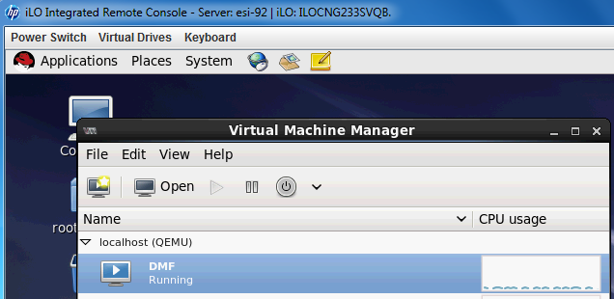

Select DMF, click **Open** button

* 1. Xshell4 and Xmanager

1. Install Xshell4 and Xmanager
2. In Xshell4 Tunneling

Open “X11 Forwarding”, and choose “Xmanager”

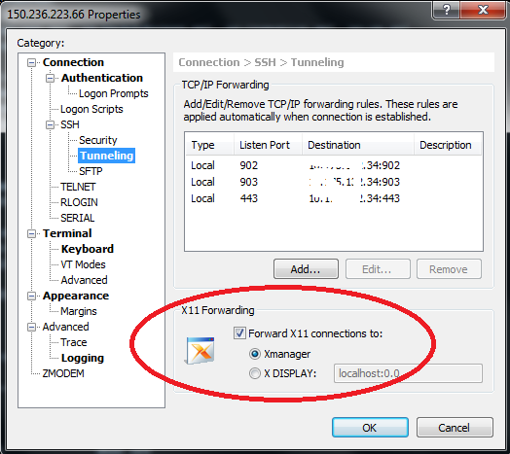

1. Open Xmanager
2. Open vm using virt-viewer

# virt-viewer {vm name}

For example:

# virt-viewer DMF

1. log in to DMF vm

User name and password is: root/embms1234

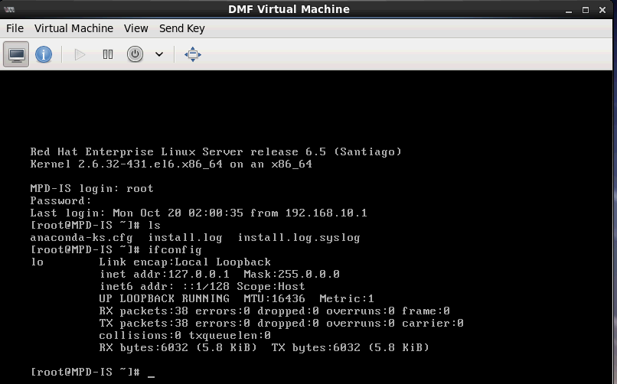

1. config network

#ifconfig eth0 up

#ifconfig eth1 up

#ifconfig eth2 up

**Note**: If there is no /etc/sysconfig/network-scripts/ifcfg-eth0, you can cope a template from /var/tmp/ifcfg-eth0, then change macaddress

#vi /etc/sysconfig/network-scripts/ifcfg-eth0

DEVICE="eth0"

BOOTPROTO="static"

HWADDR="00:0C:29:A6:57:79"

IPV6INIT="yes"

NM_CONTROLLED="yes"

ONBOOT="yes"

TYPE="Ethernet"

IPADDR=192.168.3.130 🡪make it to the same net segment with its br

GATEWAY=192.168.3.1

NETMASK=255.255.255.0

Same to /etc/sysconfig/network-scripts/ ifcfg-eth1 & /etc/sysconfig/network-scripts/ ifcfg-eth2

Configure the current IP address

#service network restart