How to install redhat 6.5 OS with KVM tools

1. Mount rhel-server-6.5-x86_64-dvd.iso:

1. In the iLO Integrated Remote Console, click **Virtual Drives** > **Image File CD/DVD-ROM**

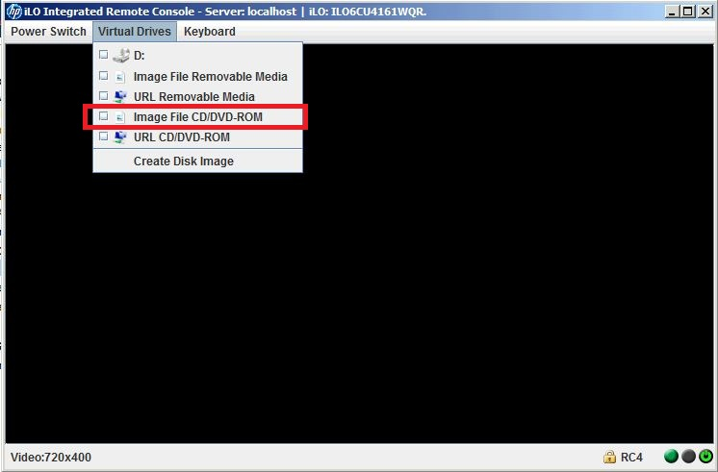

1. Select rhel-server-6.5-x86_64-dvd.iso from your local path.

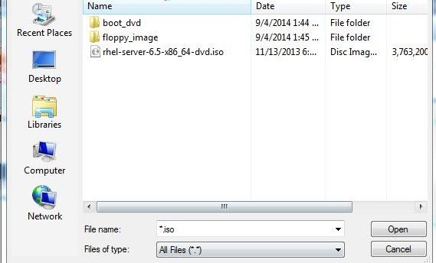

2. Reset the machine

Click **Power Switch** > **Reset**.

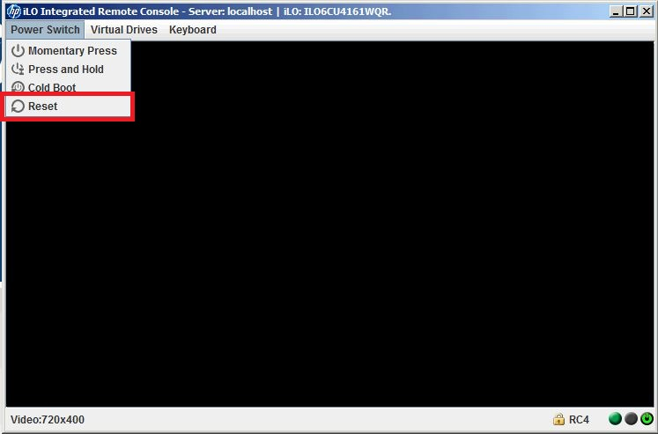

1. Wait until the install screen appears

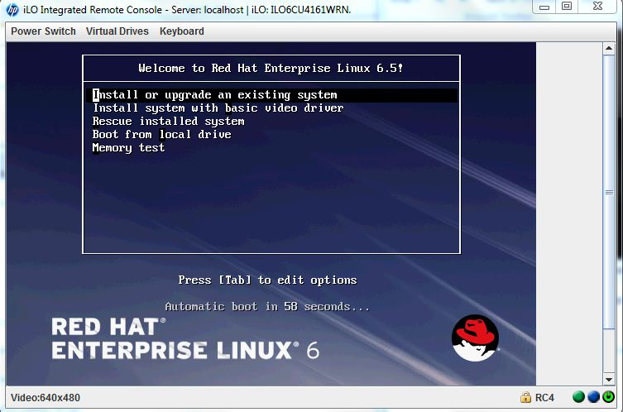

1. Press **Enter**. The installation starts automatically.

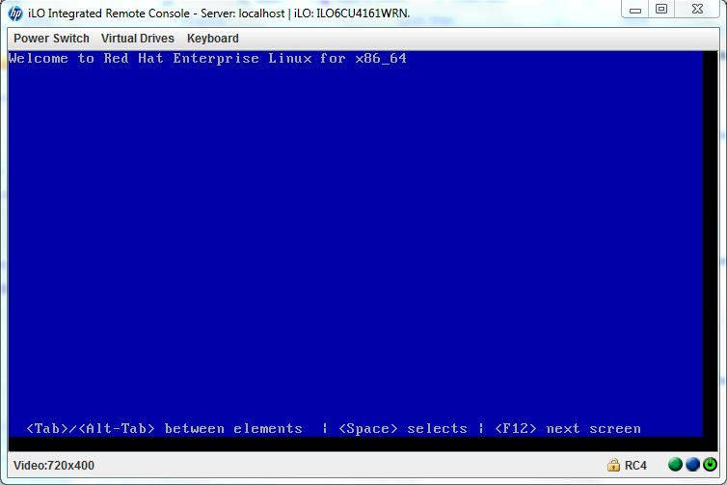

3. install the OS.

keep press **next** to until to below step:

Select “Virtualization Host”, and click “Customize Now”

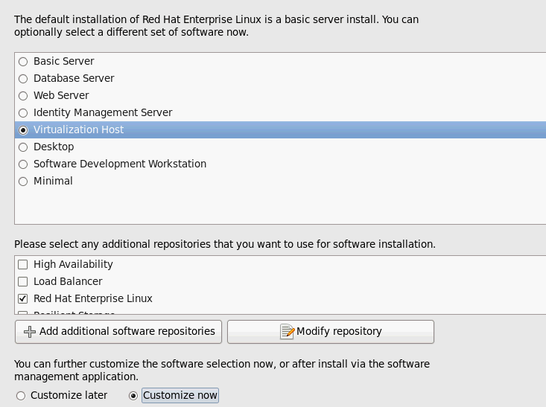

Press **Next**, select “Virtualization”, check on “Virtualization Tools”

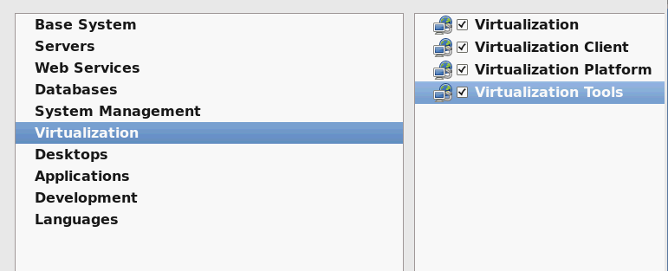

It’s better to select all “Desktops”

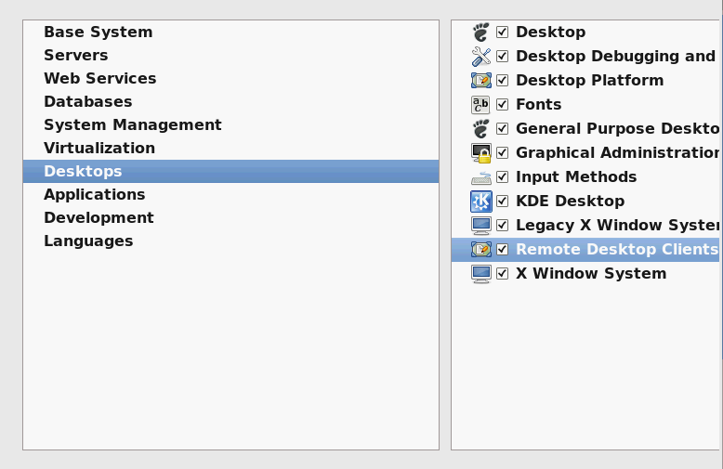

Keep press **next** until OS install finished.