Boston 311 Intake-to-Plan: Analysis Report
Nov 8, 2026 · @Team3 (Heewon Myeong, Jongmin Lee, Tatenda Mwashaireni)

Summary
We built an Intake-to-Plan pipeline that plans 2025 field crews for four Boston 311 departments and warns when incoming resident messages point to a crew shortage next month. The 2025 plan costs about $16.85M and closes 99.8% of forecast requests on time; in a simulated August parking surge, the pipeline flags Transportation as 19 crews short for September.
The pipeline has three parts, each owned by one team member:
- Data and forecast (Tatenda): 2025 monthly demand per department from real 2023–2024 311 data.
- Staffing model (Jongmin): a month-by-month crew plan that follows the brief's hiring, release and seasonal-crew rules.
- Intake assistant (Heewon): an LLM that reads a resident's plain-language message and returns the request type, department and queue.
Departments in scope: Public Works (PWDx), Transportation (BTDT), Parks & Recreation (PARK) and Inspectional Services (ISD).

Architecture and GenAI techniques
Two inputs feed one check: real 311 data builds the forecast and the fixed 2025 plan, and resident messages, classified by the LLM, show whether demand is running above that forecast.
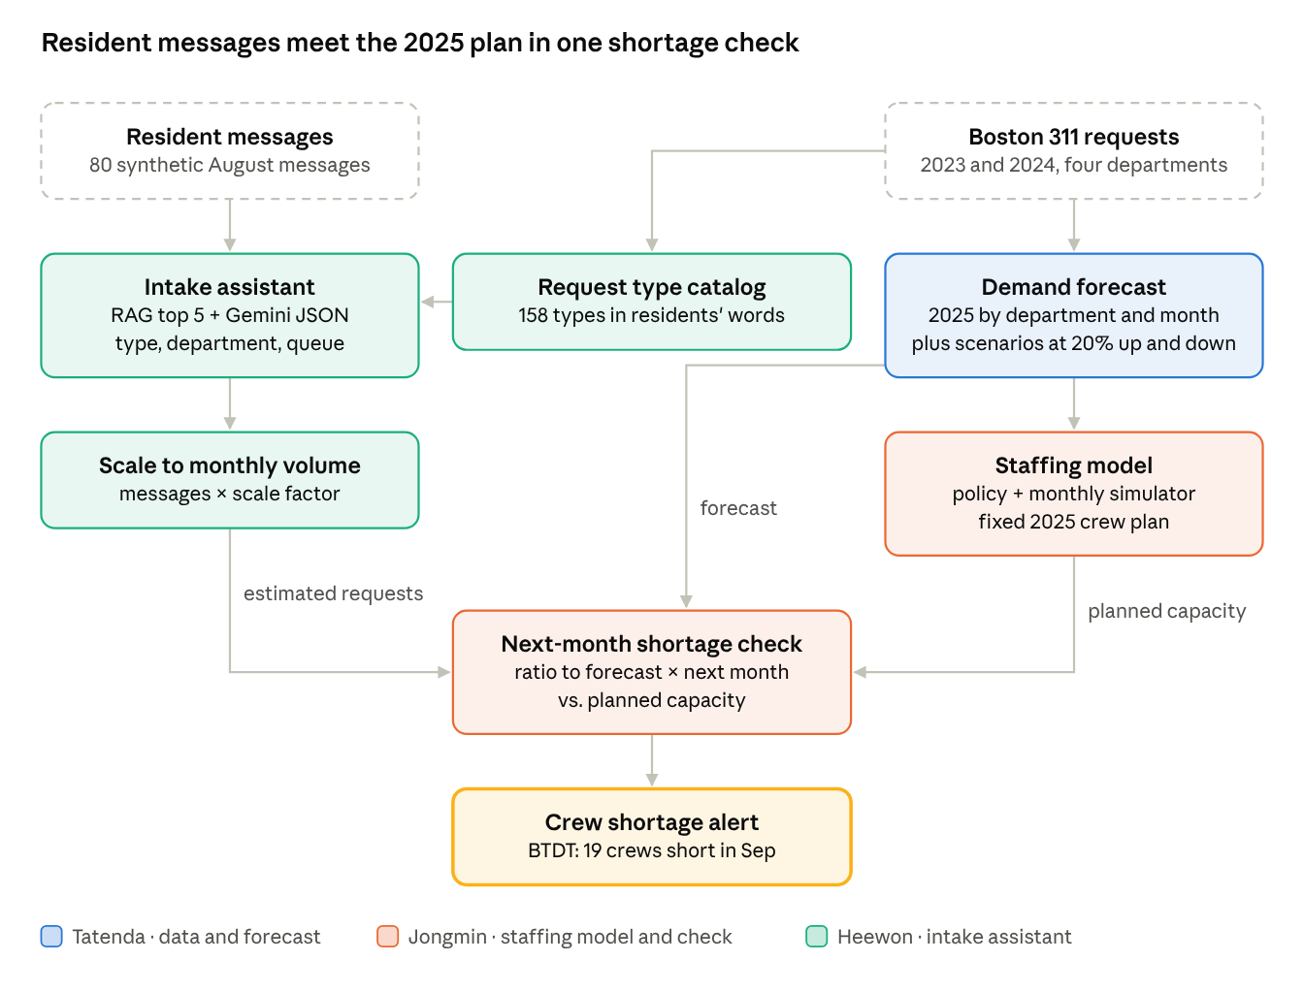
Intake-to-Plan architecture · two inputs, one shortage check
Technique | Where it is used | What it does
RAG | Intake assistant, retrieval step | Embedding search returns the 5 closest of 158 catalog types
Structured output | Intake assistant, choice step | Gemini returns type, department and a follow-up question as a JSON schema
Prompt engineering | Intake prompt | Department descriptions and rules for "Other" and "Unknown" messages
API calls | Gemini API | Classifies each message and writes the synthetic August stream

Data and demand forecast
We forecast 274,137 requests for the four departments in 2025, slightly below the 276,417 observed in 2024. Demand peaks in August (27,921) and is lowest in February (18,688).
Data decisions. We used the City of Boston 311 files for 2023 and 2024, counted demand by opening date (open_dt) because the model plans for newly arriving work, and kept only the four departments in scope. Our 2024 totals matched the brief's benchmark figures, and no records were dropped for invalid dates, missing departments or duplicate IDs.
Forecast method. With only two years of history, we chose a simple, explainable seasonal model over a complex one.
- Annual total: 2024 total × a damped growth factor, √(2024 ÷ 2023), capped between 0.85 and 1.15.
- Monthly shape: 65% of the 2024 monthly pattern + 35% of the 2023 pattern.
The weights and the cap are our assumptions, chosen so one unusual year does not carry straight into 2025. As a reference, predicting 2024 from the same month in 2023 gave errors of 8–16% by department, which is the uncertainty our ±20% sensitivity test is meant to cover.
Department | 2023 actual | 2024 actual | 2025 forecast
Public Works (PWDx) | 171,268 | 157,610 | 151,195
Transportation (BTDT) | 75,314 | 81,447 | 84,698
Parks & Recreation (PARK) | 17,541 | 18,736 | 19,364
Inspectional Services (ISD) | 18,123 | 18,624 | 18,880
Total | 282,246 | 276,417 | 274,137

Intake assistant
The intake assistant picks the right department for 96–100% of test messages and the exact request type for about 94%. It fills a gap in the data: 311 records have no resident-written descriptions, so nothing else can turn a message like "there's a big hole on Centre St near the T stop" into a request type.
Catalog. From 2024 data we built a catalog of 158 request types. Each type maps to the department that handled most of its requests (145 of 158 types have at least 80% in one department), and each got a short description in residents' words, since internal names like "CE Collection" are hard to match.
Classification, in two steps:
- Retrieve (RAG): an embedding search (sentence-transformers, all-MiniLM-L6-v2) finds the 5 closest catalog types.
- Choose (structured output): Gemini (temperature 0) picks one and returns a JSON schema. The prompt says to return "Other" with a department when nothing fits, so no message drops out of the counts, and "Unknown" with a follow-up question when the message is too vague.
The queue comes from the catalog, not the LLM, because many queues depend on the district rather than the message.
Evaluation. Two human-reviewed test sets cover six message kinds: clear cases, several acceptable types, cross-department confusion, types outside the catalog, policy feedback and vague messages. v1 was used to fix errors; v2 was written afterward to check that the fixes generalize.
Test set | Messages | Type accuracy | Department accuracy | Retrieval hit rate (top 5)
v1 (tuning) | 49 | 93.9% | 95.9% | 95.2%
v2 (held out) | 38 | 94.7% | 100% | 97.0%
Synthetic stream. Because there are no real resident messages, Gemini wrote 80 messages representing all of August, with the type mix of real August 2024. A second stream doubles Parking Enforcement messages to simulate a surge. These streams feed the shortage check below.

Staffing model and the 2025 plan
The 2025 plan costs $16.85M and keeps the on-time rate at 99.8% on the forecast. Public Works grows from 50 to 72 crews for its August peak, then releases most of them in October; Parks covers its summer peak with up to 14 seasonal crews.
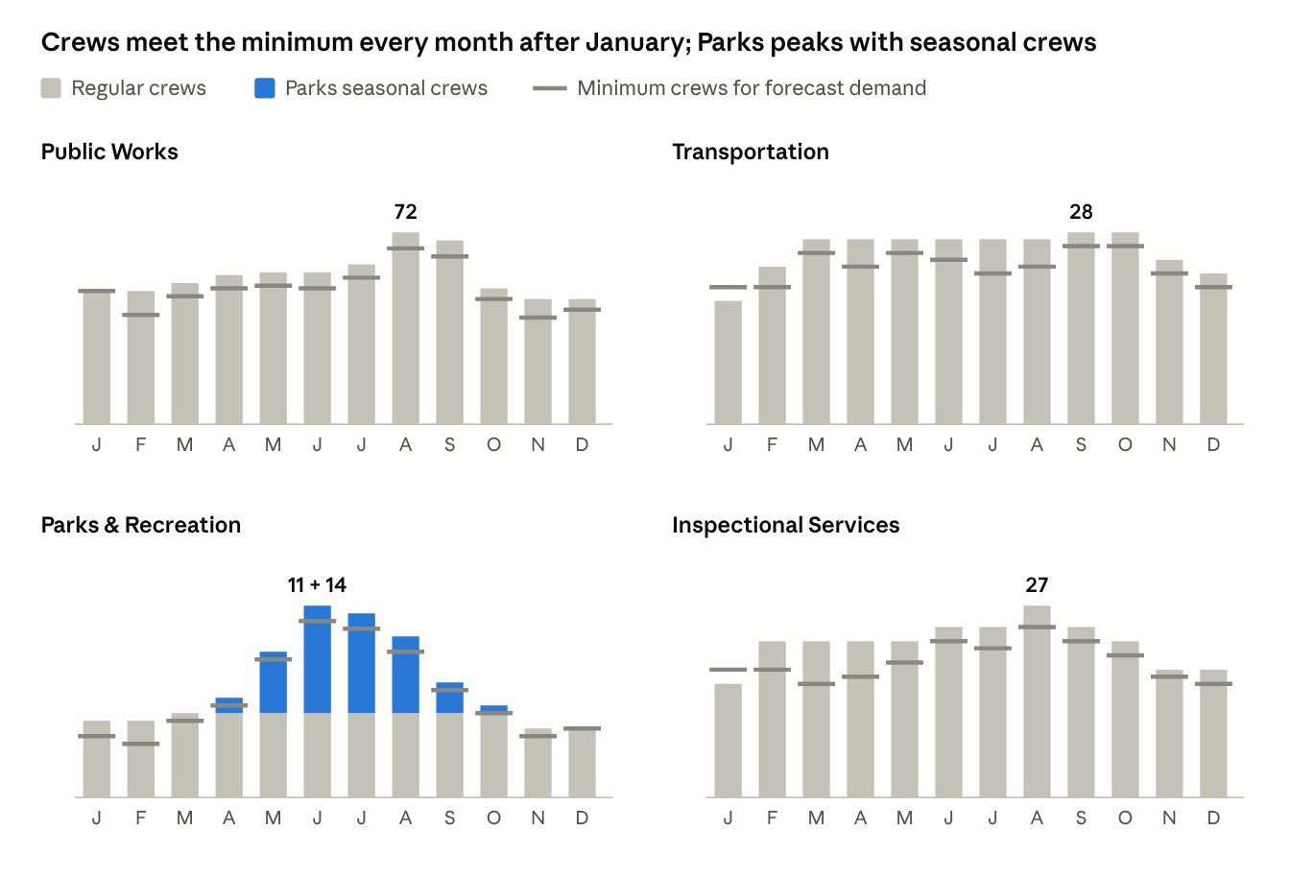
The minimum is forecast demand divided by one crew's monthly capacity, with no buffer or backlog. Only January falls below it, because January crews are fixed at the brief's starting level.
Cost structure. Each month's cost is crew pay (including crews in their paid training month) + seasonal crews + release fees + overdue costs. A request still open at month-end costs $20, and +$100 if still open a month later. Idle crews are reported but not added again, because their pay is already in crew cost.
Policy rules and why.
Decision | Rule | Why
Crews needed | (forecast × 1.10 + backlog) ÷ monthly capacity per crew, rounded up | Unfinished work carries over, and the 10% buffer covers forecast error
Releasing after a peak | Keep a crew if it is needed again within 4 months | A release costs 3 months of pay, plus 1 training month to rehire
Parks peak (Apr–Oct) | Extra crews are seasonal only | A new regular crew for a k-month peak costs $40,000 + $10,000·k; a seasonal crew costs $13,000·k. Break-even is ~13 months; the season is 7
A simulator checks every plan month by month: crews close the oldest requests first, new crews start after one paid training month, and releases need one month's notice. January is fixed at the brief's starting crews.
Department | Annual cost | On-time rate
Public Works | $8.30M | 100%
Inspectional Services | $3.49M | 99.4%
Transportation | $3.06M | 99.6%
Parks & Recreation | $2.01M | 100%
Total | $16.85M | 99.8%
The few overdue requests are all in January, when crews cannot yet be added.

Intake-to-plan shortage check
When August parking messages double, the check flags Transportation as 19 crews short for September (166% utilization); the normal stream raises no alerts.
At the end of a month, the check works in three steps:
- Scale up: classified messages per department × a scale factor = estimated real requests. The scale is set so the normal stream reproduces the forecast exactly, so the normal stream is a control case.
- Compare: ratio = estimated requests ÷ forecast for that month. In the surge, Transportation's estimate rises from 7,090 to 12,998, a ratio of 1.83.
- Check next month: next month's forecast × the ratio, against next month's planned capacity. For Transportation, 7,990 × 1.83 = 14,648 requests against 8,820 of capacity (28 crews), so 19 crews short.
Department | Aug ratio | Sep load | Sep capacity | Crews short
Transportation | 1.83 | 14,648 | 8,820 | 19
Public Works | 1.00 | 15,662 | 17,388 | 0
Parks & Recreation | 1.00 | 1,658 | 1,890 | 0
Inspectional Services | 1.00 | 1,804 | 2,016 | 0
The alert is an early warning: a crew hired at the end of August trains in September and starts in October. Parks is the exception, since seasonal crews start right away.

Sensitivity analysis
The plan absorbs 20% lower demand at almost no extra cost, but 20% higher demand pushes cost to $19.67M and the on-time rate down to 57%. In each test the plan stays fixed at what the policy chose for the base forecast, and only actual demand changes.
Scenario | Annual cost | On-time rate
Demand −20% | $16.85M | 100%
Base forecast | $16.85M | 99.8%
Demand +20% | $19.67M | 57%
Higher demand hurts unevenly. At +20%, on-time rates fall to 52% in Public Works, 61% in Transportation, 66% in Parks and 81% in Inspectional Services. Public Works suffers most because its August–September peak already runs close to capacity, so the extra requests pile up as backlog.
The buffer is insurance. Without the 10% buffer, the plan would cost $1.34M less on the forecast ($15.51M), but +20% demand would cut on-time to 33% instead of 57%. We kept 10% because it is close to the 8–16% error of a same-month-last-year forecast.
Event spike. The parking surge in the previous section acts as our spike test: one department, one month, a near-doubling.

What we learned along the way
Our biggest lesson was that the first, obvious answer was often wrong, and checking it with real numbers is what moved the project forward.
- Yearly totals hide delays. Transportation's yearly capacity is only 16% short of demand, yet in 2024 it closed just 50% of requests on time. Working through it month by month showed why: unfinished requests go first in line next month, so new requests are late too. That is why we built a month-by-month simulator instead of a yearly formula.
- We counted a cost twice. Our first cost formula added idle crew cost on top of crew pay. Plugging in a simple example (50 crews, 10 of them idle) showed the idle crews were already paid for. Idle crews became a diagnostic, not a cost.
- The simplest staffing rule churned crews. Releasing crews the moment demand dropped led to 29 hires and 36 releases in Public Works alone. Working out that a release costs as much as 3 idle months gave us the 4-month keep rule.
- New messages are evidence, not extra demand. At first we planned to add incoming messages on top of the forecast. We realized they are part of the demand the forecast already expects, so they tell us whether the forecast is running high or low. That turned the pipeline into a ratio check.
- An LLM can look worse than it is. The intake assistant's first run scored 44.9% on type accuracy, but most "errors" were names that differed only in spacing or capitals. Fixing the comparison, then fixing real confusions in the descriptions, raised it to about 94%.
- Simple, explainable methods were the right call. With two years of data, a transparent seasonal forecast and a rule-based policy were easier to test, explain and trust than a complex model.

Limitations and other considerations
- Half of demand never reaches the intake assistant. About 53% of 2024 requests were logged by city employees, not residents (62% in Transportation). The surge test doubled all parking requests; if only resident complaints doubled, Transportation would gain about 1,800 requests a month, not 5,900. A real system would combine intake estimates with employee requests counted directly.
- More crews can create more requests. Employee-logged volume partly depends on how many crews are in the field, so a rise may reflect crew activity rather than need.
- Overdue costs are conservative. Every request's target is set to the end of its opening month, while many real targets are longer (some Parks targets are 365 days).
- The shortage check is simple. It assumes a month's ratio to forecast continues into the next month, and does not add the surge month's backlog. Synthetic messages are few (80) and LLM-written, and one message stands for about 300–400 real requests.
- The plan ends in December. Year-end releases do not account for demand in early 2026.
- Queues ignore location. The assistant uses each type's most common queue; district-based queues would need the neighborhood from the message.
Code, setup steps and the architecture diagram are in the GitHub README.

