**Software Requirements Specifications**

**UNDER THE SUPERVISION OF**

**Dr. Tarek Elghazaly**

|  |  |
| --- | --- |
| **Name** | **ID** |
| **Salma Ayman** | **19104941** |
| **Alaa Mamdouh** | **19106209** |
| **Khalil Ahmed** | **19100923** |
| **Ziad Tamer** | **19104259** |
| **Omar Alshafaey** | **19100227** |

**1. Introduction**  3

**1.1. Purpose** 3

**1.2. Scope** 3

**1.3.Technologies used** 3

**1.4. Intended audience** 3

**1.5. References** 4

**1.6. Overview** 4

**2. Overall Description** 4

**2.1. Product Perspective** 4

**2.2. User Characteristics** 5

**2.3. Operating Environment** 5

**2.3. Constraints** 6

**2.4.Assumptions and Dependencies** 6

**3. Interfaces**  6

**3.1. System Interface** 6

**3.2. Software Interface** 9

**3.3. Hardware Interface** 9

**4. Functional Requirements** 10

4.1 User Class 1 - The User 10

**4.2. User Class 2 - The Admin** 14

**5. Non-Functional requirements** 14

**6. Diagrams**  17

# **1. Introduction**

## **1.1. Purpose**

The aim of this document is to provide a comprehensive overview of People's app system. It will describe the stem's function and features, as well as the system's interfaces, what the system will do, the constraints under which it must work, and how the system will respond to external stimuli

## **1.2. Scope**

People’s app is an app that provides easy way to make the government papers by installing everything about that citizen from his/her date of birth until date of death on a large database. The government are going to have this database to check the citizens papers without even ask them about it, and the citizens are going to have website, mobile application, and computer application to just make their requests, and even without going to the government building unless they want to do just two things taking photos to process their service application or receive their services. And of course, we are going to provide online payment to make it easier to anyone.

## **1.3. Technologies used**

* HTML, CSS, andJavascript for the Front-end
* Node.js on the backend
* Express.js for server and creating RESTful API
* SQL for database
* Java and Android Studio for mobile version
* Python for desktop version

## **1.4. Intended audience**

This document is useful to: -

**Customer**: To follow up with the project team if there are requirements change.

**Developer**: To have ease of implementation.

**Software Tester**: To be able to develop the correct test cases for the system and test it to improve the system's quality.

**Software architect:** To be able to design and improve the system's architecture.

**Project Manager:** To be able to develop a good plan to work on the project and construct the team.

## **1.5. References**

## **1.6. Overview**

The rest of the SRS explains the detailed specifications of the people’s Application. Chapter II of the SRS presents the general factors that affect the people’s Application and its requirements, such as project constraints and user characteristics. Chapter III outlines the details of interfaces, and then the rest of the chapters' present the functional and nonfunctional requirements, Diagrams, and other related requirements of " People's app" Application.

“*People’s app from the people to the people*”

# **2. Overall Description**

## **2.1. Product Perspective**

* People’s app is a simple and intuitive app that will make it easier for people to use government services without needing to physically go to government buildings.
* The system will have two types of users: The user and the admin. Each has different functions and purpose.
* The system will use a centralized database which contains citizen data which will eliminate the need to go to different government institutions.

## **2.2. User Characteristics**

There are two types of users who will interact with the system: the users and the admins

* The user is any citizen which needs to make use of a government service, such as applying for a national ID card.
* The admin will create user data and approve/decline user applications based on the user data.

## **2.3. Operating Environment**

* The system will run on any desktop running Windows or Linux, and will be compatible with mobile phones running Android or iOS.

## **2.3. Constraints**

* The only constraint for the app is an internet connection is required, an internet connection is required for the user to be able to submit data.

## **2.4.Assumptions and Dependencies**

* It is assumed that a user will have a device compatible with the application such as a desktop or modern mobile phone
* It is assumed that the user will have a reliable internet connection.

# **3. Interfaces**

## **3.1. System Interface**

The first screen the user will see is the log-in page (Figure 2). The user will be able to log-in using their credentials.

After logging in, user will be able to see the services available to them. (Figure 3)

The user will be able to click on any one of the available services and view the required data, and will be able to submit them.

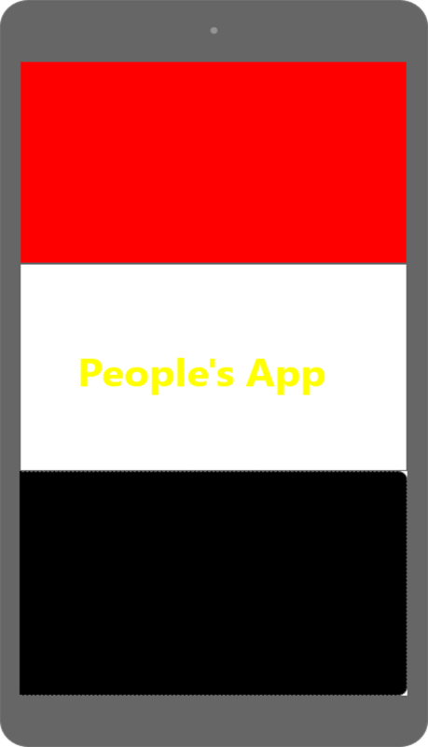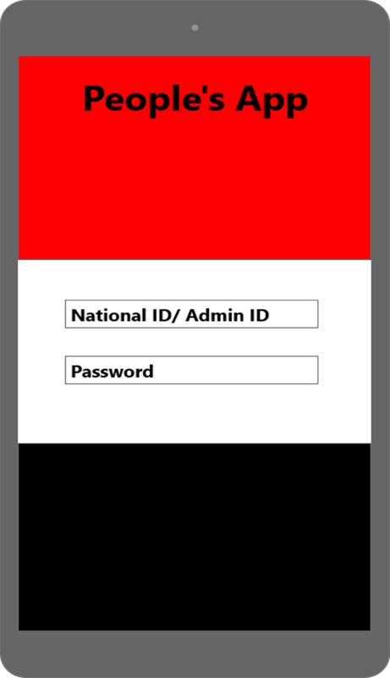

Figure 1 – Loading Screen Figure 2 – Log -in page

After Logging in, the user will be able to see the available services (Figure 3). After selecting a service, the user will see a sub-menu of the available options (Figure 4)

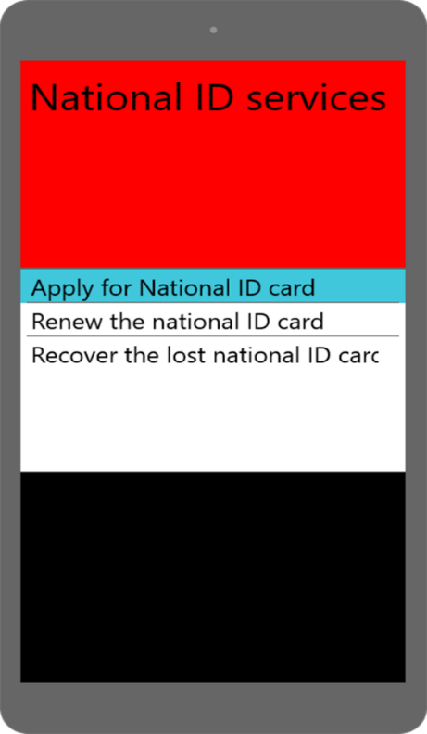

Figure 3 – Available Services Figure 4 – Service sub-menu

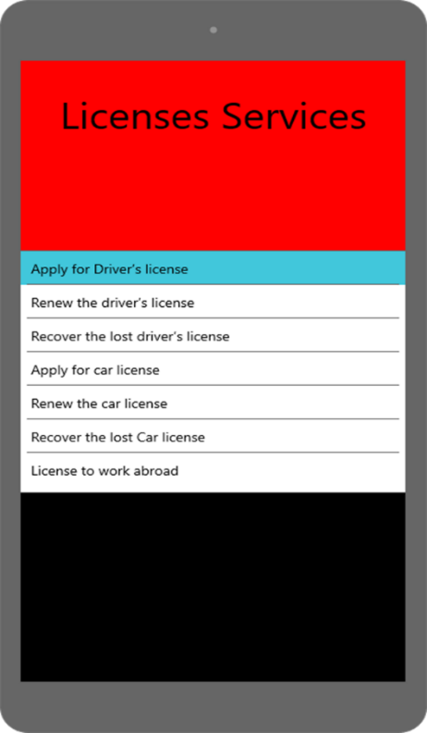

Figure 5 Figure 6

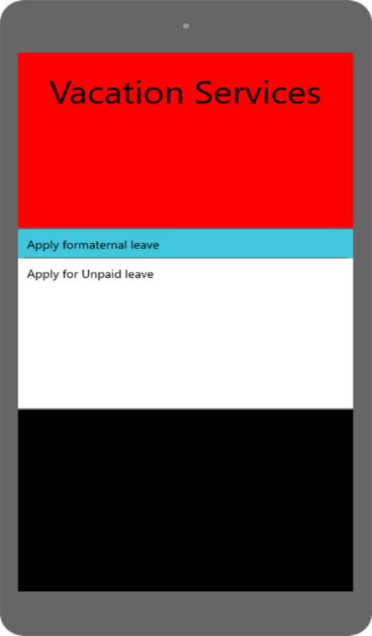

Figure 7 Figure 8

The admin can create/modify users and accept/decline user applications (Figure 9, 10)

Figure 9 Figure 10

## **3.2. Software Interface**

People’s app is a cross-platform desktop application developed with Python and mySQL, external Python libraries will be used for User Interface and application will interact with a mySQL database, an HTTPS server will be used to handle requests from and to the application.

## **3.3. Hardware Interface**

People’s app is a desktop app that requires an internet connection for the user to be able to submit and access data, a camera is also required to be able to submit any needed photographs.

# **4. Functional Requirements**

## 4.1 User Class 1 - The User

**4.1.1 Functional requirements**

**Title:** User Login.

**Desc:** System shall allow users to be able to enter their account by entering their personal details (National ID ,Password)

**4.1.2 Functional requirements**

**Title:** Apply for National ID card

**Desc:** System shall allow to apply to national ID card if they are above 16

**4.1.3 Functional requirements**

**Title:** Renew the national ID card

**Desc:** system shall allow the user to renew their national ID card

**4.1.4 Functional requirements**

**Title:** Recover the lost national ID card

**Desc:** System shall allow the user to recover their lost ID card

**4.1.5 Functional requirements**

**Title**: Apply for Driver’s license

**Desc:** System shall allow to apply to driving license card if they are above 18

**4.1.6 Functional requirements**

**Title:** Renew the driver’s license

**Desc:** System shall allow the user to renew the driver’s license

**4.1.7Functional requirements**

**Title:** Recover the lost driver’s license

**Desc:** System shall allow the user to recover the lost driver’s license

**4.1.8 Functional requirements**

**Title:** Apply for car license

**Desc:** System shall allow the user to apply for car license

**4.1.9 Functional requirements**

**Title:** Renew the car license

**Desc:** System shall allow the user to renew the car license

**4.1.10 Functional requirements**

**Title:** Recover the lost Car license

**Desc:** System shall allow the user to recover the lost car license

**4.1.11 Functional requirements**

**Title:** Apply for Covid-19 vaccine

**Desc:** System shall allow user to apply for covid vaccine

**4.1.12 Functional requirements**

**Title:** Apply for Travel permission

**Desc:** System shall allow the male user to travel if they are in education and above 18

**4.1.13 Functional requirements**

**Title:** License to work abroad

**Desc:** System shall allow the user to apply for work abroad

**4.1.14 Functional requirements**

**Title:** Apply for maternal leave

**Desc:** System shall allow female user to take a 6 year vacation after giving birth till the baby become 18 (Birth Certificate)

**4.1.15 Functional requirements**

**Title:** Apply for Unpaid leave

**Desc:** System shall allow the user to apply for unpaid vacation

**4.1.16 Functional requirements**

**Title:** Apply for pension

**Desc:** System shall allow user to apply for pension if user is eligible for retirement

**4.1.17 Functional requirements**

**Title:** Apply for catering card ((تموين

**Desc:** System shall allow user to apply for catering card if user is a household caretaker and eligible

**4.1.18 Functional requirements**

**Title:** Pay income tax and insurance

**Desc:** System shall allow user to pay their income taxes and insurance fees via online payment

**4.1.19 Functional requirements**

**Title:** Death Certificate

**Desc:** System shall send user’s death certificate to their relatives after user’s death

**4.1.20 Functional requirements**

**Title:** Apply for public universities

**Desc:** System shall allow user to apply for public universities if they have graduated from high school

**4.1.21 Functional requirements**

**Title:** View medical history

**Desc:** System will allow user to view their medical history based on hospital records

**4.1.22 Functional requirements**

**Title:** View insurance plan

**Desc:** System will allow user to view their insurance plan and view hospitals which cover their insurance plan

## **4.2. User Class 2 - The Admin**

**4.2.1 Functional requirements**

**Title:** Login as admin

**Desc:** Admins shall be able to log in as an admin by using their admin credentials

**4.2.2 Functional requirements**

**Title:** Create user

**Desc:** Admin can create user after user’s birth by entering user’s data (Full name, Parents’ names, national ID, date of birth, location of birth, etc.)

**4.2.3 Functional requirements**

**Title:** Modify user

**Desc:** Admin can modify user’s data

**4.2.4 Functional requirements**

**Title:** Approve or decline user applications

**Desc:** Admin can approve or decline a user’s application based on the user data.

# **5. Non-Functional requirements**

There are requirements for the system’s performance, reliability, security, and user experience. They are as follows:

**5.1 Reliability**

* System should not fail unless there is a case of country wide power outage, as system should rely on backup servers in case of main server failure.

**5.2 Recoverability**

* System should not take more than 30 mins to run on backup servers in case of main server failure.

**5.3 Performance**

* System response time should not be over 2 seconds

**5.4 Availability**

* System should be running 24 hours a day, 7 days a week

**5.5 Usability**

* System should be intuitive and easy to use, user should not take more than 30 mins to be able to use system.
* System admin should receive 6 hours training time in order to be able to manage system adequately.

**5.6 Maintainability**

* System architecture is based on OOP which will make it easier to add or modify functionality in the future

**5.7 Security**

Since the system manages sensitive user data, security measures need to be in place in order to protect user data from being stolen or modified.

* Passwords will be encrypted by SHA-3method
* SQL Injection prevention methods will be in place, such as input validation.
* Secure Database privileges: Developers and admins can only read and write from the database, they cannot delete or modify table structure.
* Server will use HTTPS protocol for higher security.

# **6. Diagrams**

Use case diagram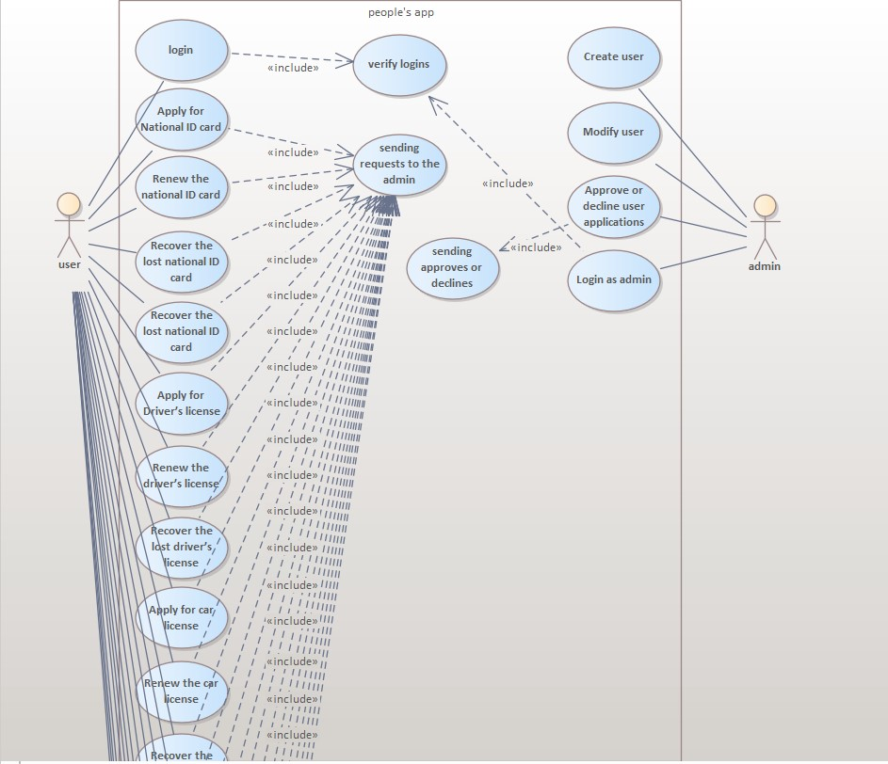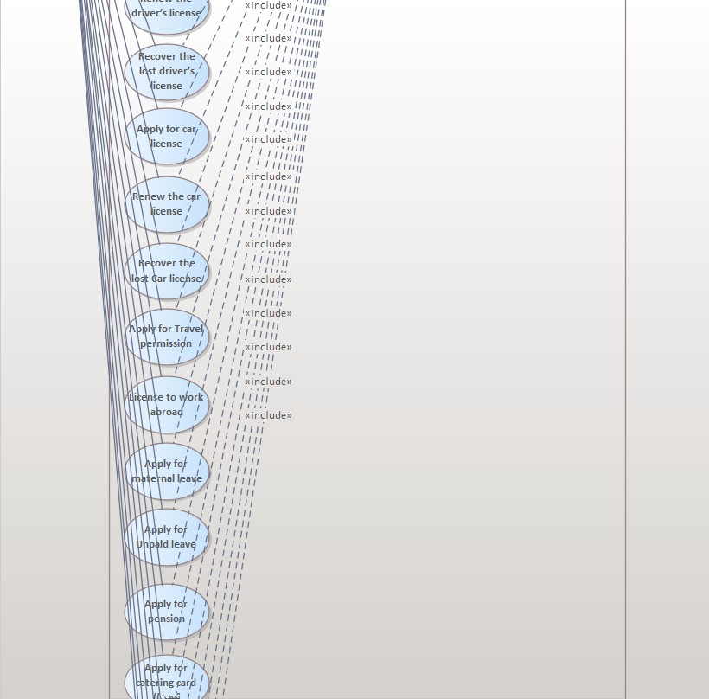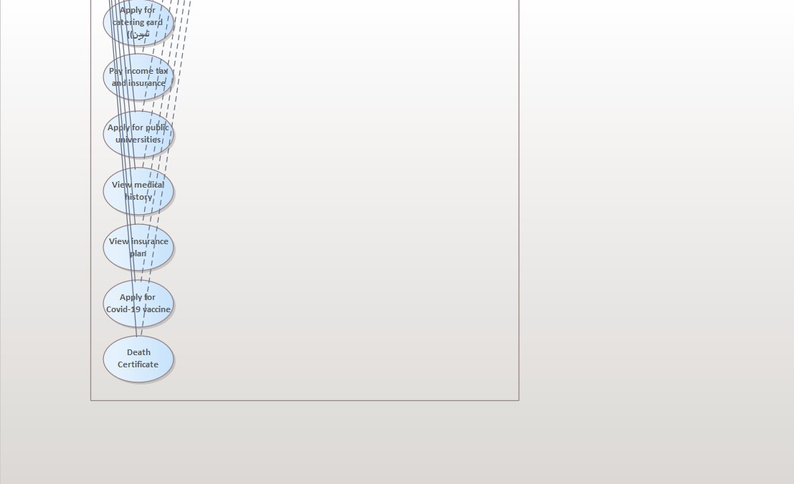

**Use case scenarios**

Use case 1

|  |  |
| --- | --- |
| Usecase name | Sign-in |
| Actors | User/Admin |
| Main success scenario | 1. System prompts user for username and password 2. User enters required information 3. User clicks on sign-in 4. System checks the username and password entered 5. System signs the user in |
| Exceptions | 3a User clicks on sign in without completing the required fields |
| Actions | 3.1 System displays error message “The marked fields are required”  3.2 User fills in the missing information |
| Pre-condition | User has downloaded the application  User has an active internet connection |
| Post-condition | User is successfully signed in |

Use case 2

|  |  |
| --- | --- |
| Usecase name | Create User |
| Actors | Admin |
| Main success scenario | 1. System prompts admin for user’s data (Full name, Parents’ names, national ID, date of birth, location of birth, etc.) 2. Admin enters required information 3. Admin clicks on create user 4. System checks that user doesn’t already exist and data is valid 5. System creates the user |
| Exceptions | 1a Admin clicks on create user without completing all the required fields  4a Admin enters a user that already exists |
| Actions | 1.1 System displays error message “The marked fields are required”  1.2 admin fills in the missing information  4.1 System displays error message “User already exists” |
| Pre-condition | User does not already exist |
| Post-condition | User is successfully created |

Use case 3

|  |  |
| --- | --- |
| Usecase name | Modify User |
| Actors | Admin |
| Main success scenario | 1. System displays user’s info 2. Admin modifies any of the info 3. Admin clicks on save changes 4. System checks that input is valid and no fields are empty 5. System updates the user |
| Exceptions | 1a Admin clicks on save changes while one field or more is empty |
| Actions | 1.1 System displays error message “The marked fields are required”  1.2 admin fills in the missing information |
| Pre-condition | No user data is missing |
| Post-condition | User is successfully modified |

Use case 4

|  |  |
| --- | --- |
| Usecase name | Approve or decline user applications |
| Actors | Admin |
| Main success scenario | 1. System displays pending user applications 2. Admin selects application to review 3. Admin clicks on approve or decline 4. System sends the approved application to the ministry and notifies the user |
| Exceptions | 3a Admin’s internet connection is faulty |
| Actions | 3.1 System displays error “Unable to communicate with server, please check internet connection.” |
| Pre-condition | Application has been submitted by user |
| Post-condition | Application is successfully approved and is sent to the appropriate ministry |

Use case 5

|  |  |
| --- | --- |
| Usecase name | Apply for ID card |
| Actors | User |
| Main success scenario | 1. System prompts user for required information 2. User enters required information 3. User clicks on apply 4. System checks that user is above 16 years old, all data has been filled, and user does not already have an ID card 5. System sends the application to be reviewed by admin |
| Exceptions | 3a User clicks on apply without completing all the required fields  4a User is not 16 or older  4b User already has an ID card |
| Actions | 3.1 System displays error message “The marked fields are required”  3.2 user fills in the missing information  4.1 System displays error message “User must be 16 or older” or “User already has an ID card” |
| Pre-condition | User is 16 or older and has not already applied for ID |
| Post-condition | Application is successfully sent to be reviewed by admin |

Use case 6

|  |  |
| --- | --- |
| Usecase name | Apply for Driver’s License |
| Actors | User |
| Main success scenario | 1. System prompts user for required information 2. User enters required information 3. User clicks on apply 4. System checks that user is above 18 years old, all data has been filled, and user does not already have driver’s license 5. System sends the application to be reviewed by admin |
| Exceptions | 3a User clicks on apply without completing all the required fields  4a User is not 18 or older |
| Actions | 3.1 System displays error message “The marked fields are required”  3.2 user fills in the missing information  4.1 System displays error message “User must be 18 or older” or “User already has a license” |
| Pre-condition | User is 18 or older and has not already applied for a driver’s license |
| Post-condition | Application is successfully sent to be reviewed by admin |

Use case 7

|  |  |
| --- | --- |
| Usecase name | Apply for Car License |
| Actors | User |
| Main success scenario | 1. System prompts user for required information 2. User enters required information 3. User clicks on apply 4. System checks that user is above 18 years old, all data has been filled, and user does not already have Car License 5. System sends the application to be reviewed by admin |
| Exceptions | 3a User clicks on apply without completing all the required fields  4a User is not 18 or older |
| Actions | 3.1 System displays error message “The marked fields are required”  3.2 user fills in the missing information  4.1 System displays error message “User must be 18 or older” or “User already has a Car License ” |
| Pre-condition | User is 18 or older and has not already applied for a Car License |
| Post-condition | Application is successfully sent to be reviewed by admin |

Use case 8

|  |  |
| --- | --- |
| Usecase name | Apply for Covid Vaccine |
| Actors | User |
| Main success scenario | 1. System prompts user for required information 2. User enters required information 3. User clicks on apply 4. System checks that all data has been filled, and user has not already applied 5. System sends the application to be reviewed by admin |
| Exceptions | 3a User clicks on apply without completing all the required fields  4a User has already applied |
| Actions | 3.1 System displays error message “The marked fields are required”  3.2 user fills in the missing information  4.1 System displays error message “User has already applied ” |
| Pre-condition | User has not already applied for the vaccine |
| Post-condition | Application is successfully sent to be reviewed by admin |

Use case 9

|  |  |
| --- | --- |
| Usecase name | View medical history |
| Actors | User |
| Main success scenario | 1. User clicks on “View medical history” 2. System displays user’s hospital records |
| Exceptions | 2a User has no medical records |
| Actions | 2.1 System displays message “No medical history found” |
| Pre-condition | User is logged in |
| Post-condition | User’s medical history is displayed |

Use case 10

|  |  |
| --- | --- |
| Usecase name | Apply for pension |
| Actors | User |
| Main success scenario | 1. System prompts user for required information 2. User enters required information 3. User clicks on apply 4. System checks that all data has been filled, user has not already applied, and user is eligible for pension 5. System sends the application to be reviewed by admin |
| Exceptions | 3a User clicks on apply without completing all the required fields  4a User has already applied  4b User is not eligible for pension |
| Actions | 3.1 System displays error message “The marked fields are required”  3.2 user fills in the missing information  4.1 System displays error message “User has already applied ”  4.2 System displays error message “User is not eligible for pension” |
| Pre-condition | User has not already applied for the pension User is eligible |
| Post-condition | Application is successfully sent to be reviewed by admin |

**Sequence Diagram** 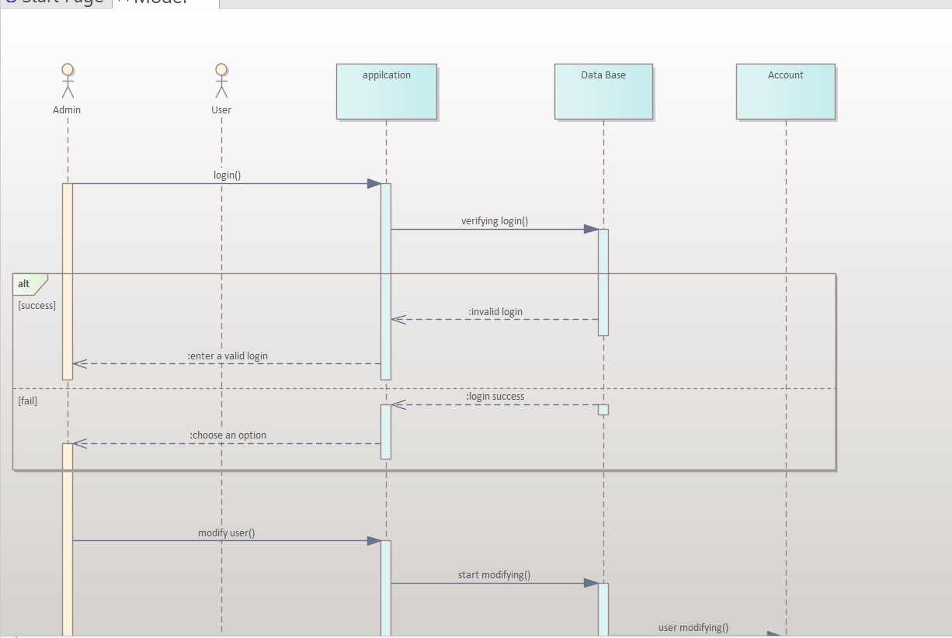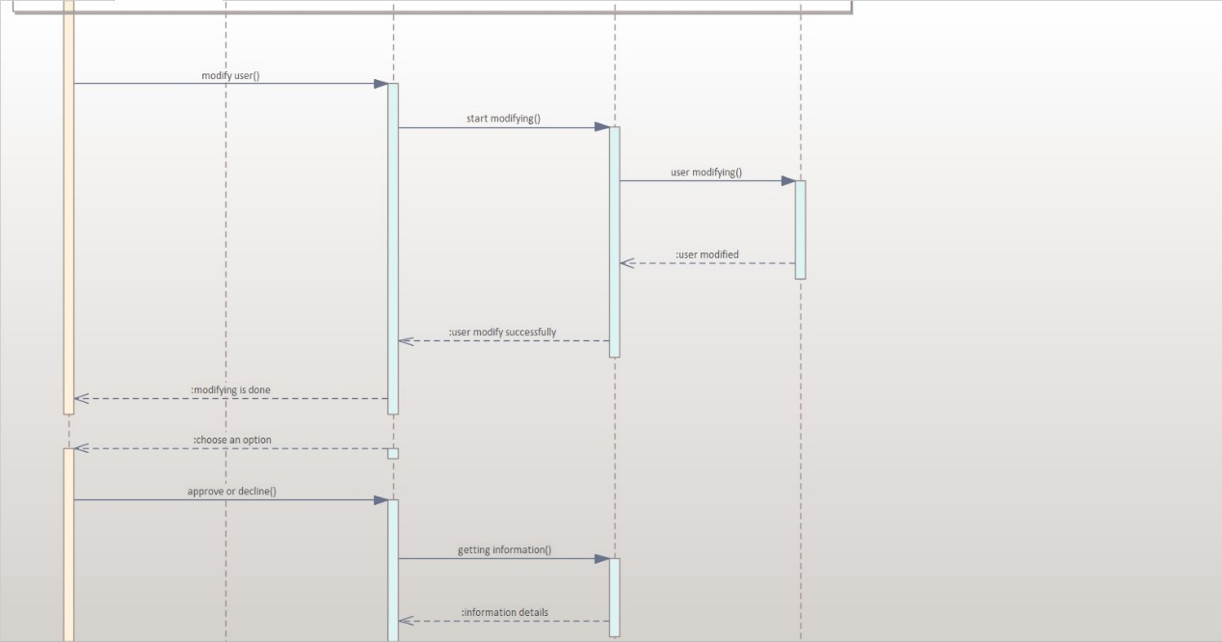

Class diagram

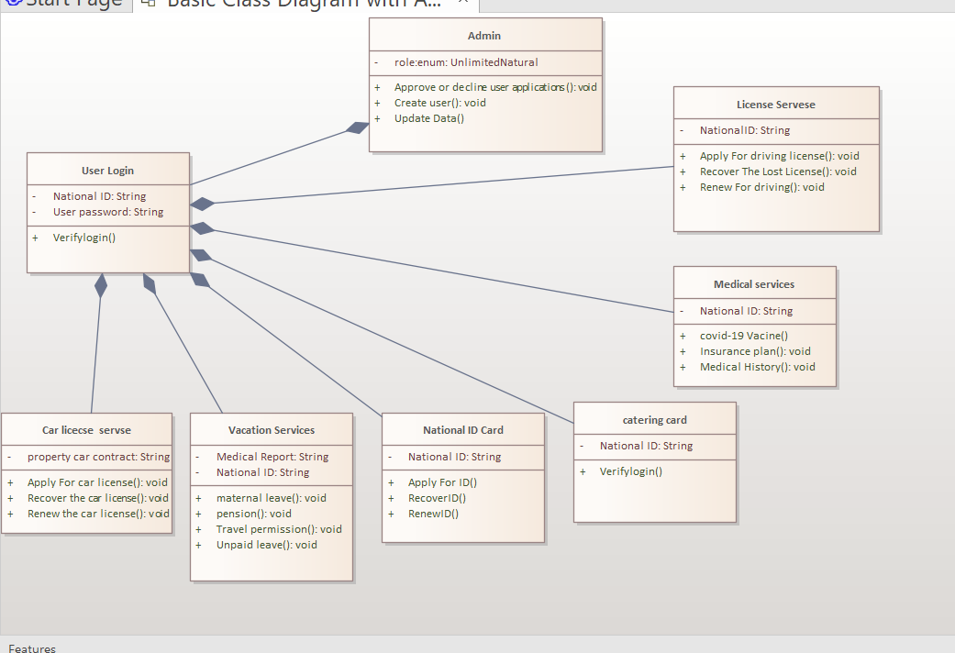

https://nileuniversity-my.sharepoint.com/:v:/g/personal/sal_ayman_nu_edu_eg/EQhffWxfY1JMqieRVPglOKIBjt5Yl_NaKzp6z7gCJlH9Bw?e=kJWcnn