1.git clone after creating new repository

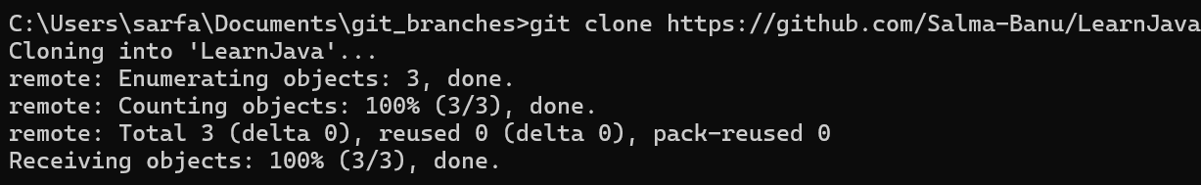

2.go into the repository using cd command with repository name



3.create branches on repository

Check u r in which branch

Using git branch command and

switched to the branch using Git checkout branchname command

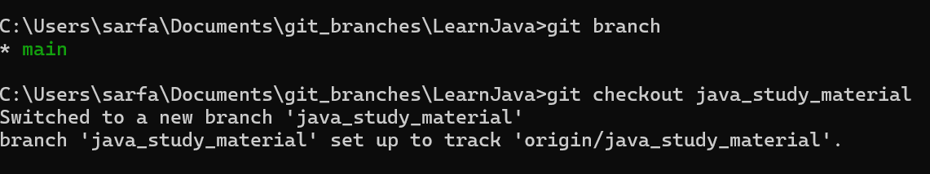

4.create folder text document in learn java

5.check git status

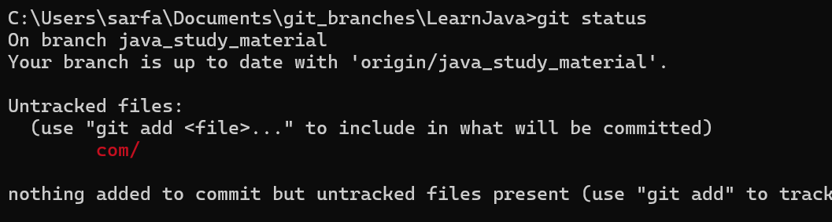

6.git add .

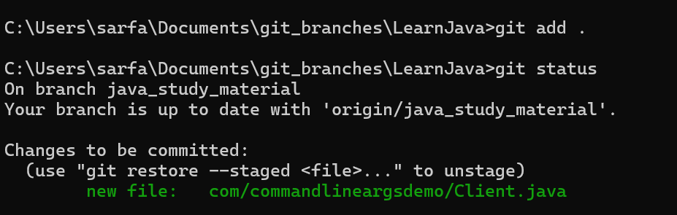

7.git commit -m “first commit”

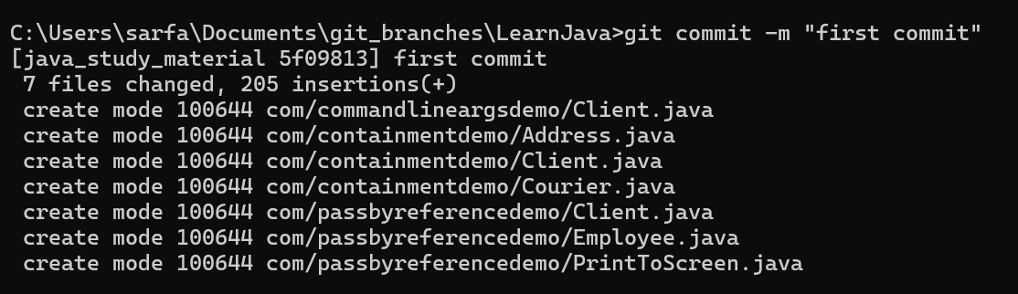

8.git push

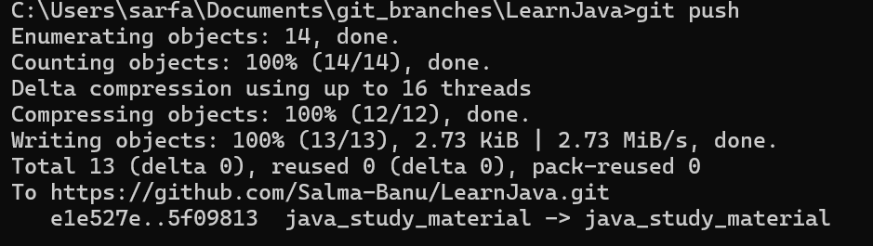

9.check in repository branch whether it has been added or not

10.create pull request from git account

11.create pull request and merge request

12.now check in main branch it has been added or not

13.if u r adding branch after cloning git repository then use git pull to get uptodate creation of branches

14.continue the remaining process.

15.u can delete git branch

git branch -D branchname