3-node Cassandra cluster before doing the consistency experiments:
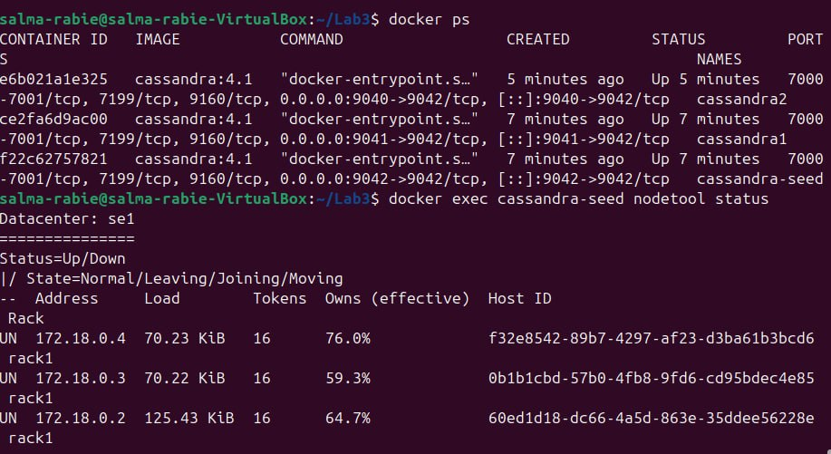

A) RF=1 setup:
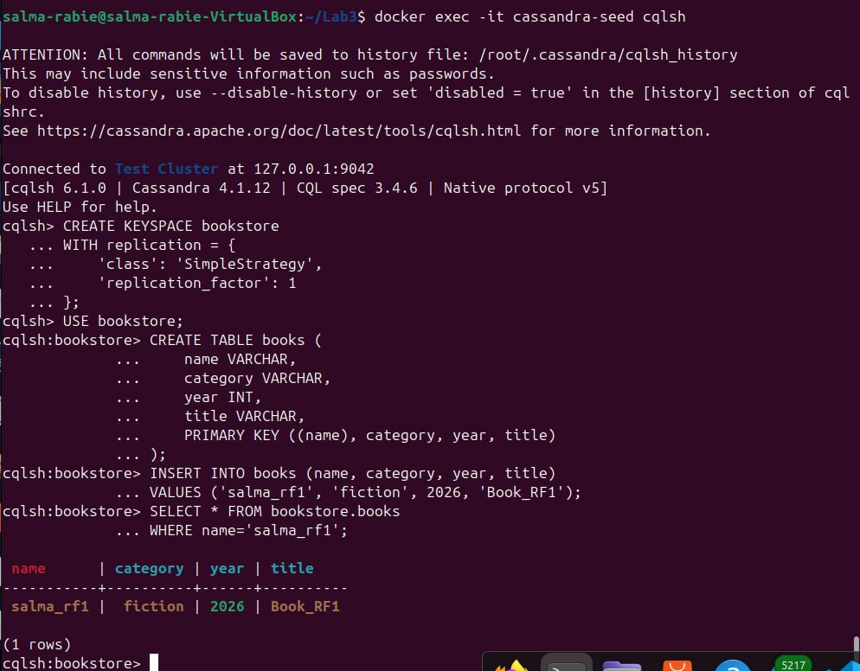

1- Node 1 down:
Pause Node 1:
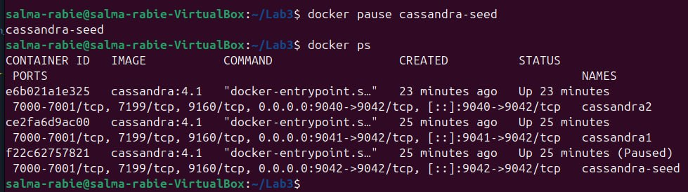
Connect to Node 2:
- Consistency level = QUORUM
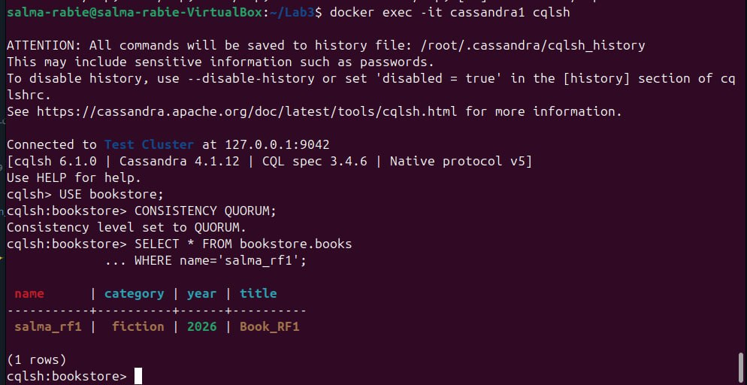

QUORUM = SUCCESS

- Consistency level = ONE
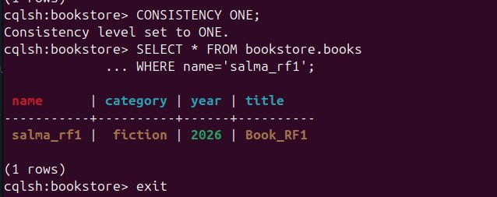
ONE = SUCCESS

2- Node 2 down:
Unpause Node 1 and Pause Node 2:
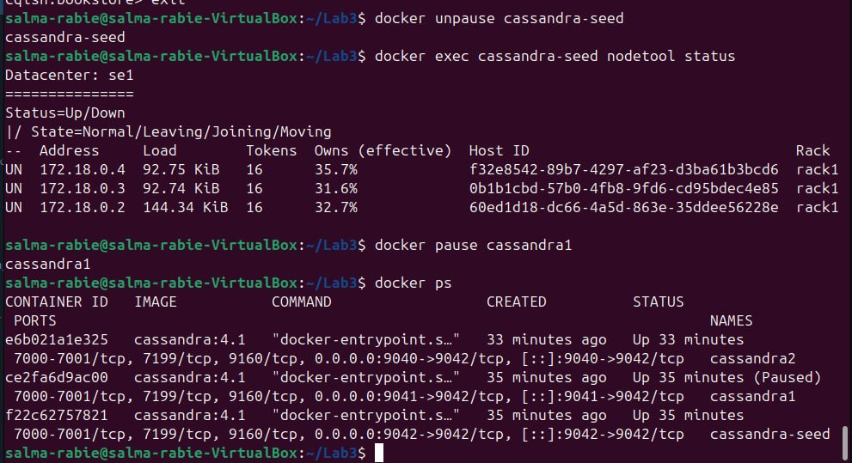

Connect to Node 3:
- Consistency level = QUORUM
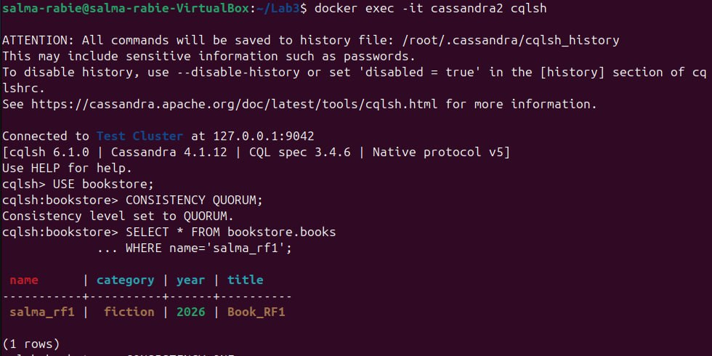
QUORUM = SUCCESS
- Consistency level = ONE
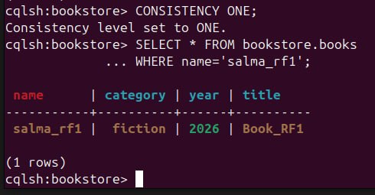
ONE = SUCCESS

3- Node 3 down:
Unpause Node 2 and Pause Node 3:
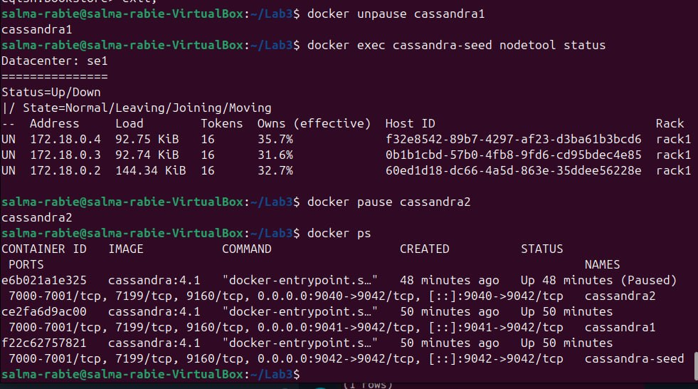
Connect to Node 1:
- Consistency level = QUORUM
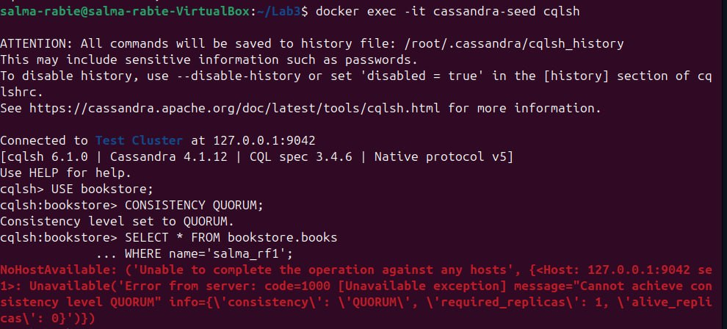
QUORUM = FAILURE
- Consistency level = ONE
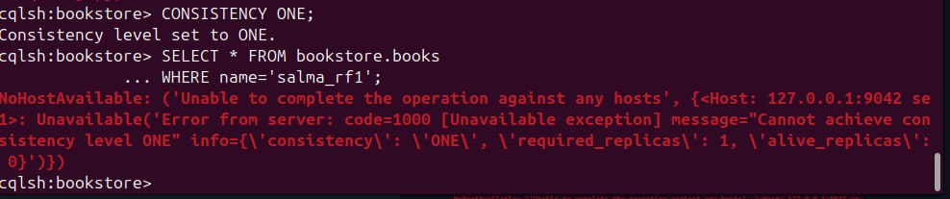
ONE = FAILURE

Nodes Down | RF = 1, QUORUM | RF = 1, ONE
Node 1 | SUCCESS | SUCCESS
Node 2 | SUCCESS | SUCCESS
Node 3 | FAILURE | FAILURE

CONCLUSION:
Because RF=1 stores only one replica, when that particular replica which is in Node 3 is on the failed node, lowering the consistency level from QUORUM to ONE cannot help. There are zero live replicas available.

A) RF=2 setup:
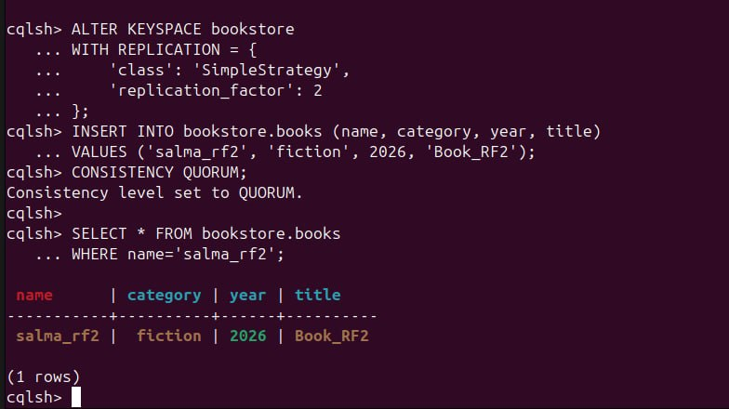
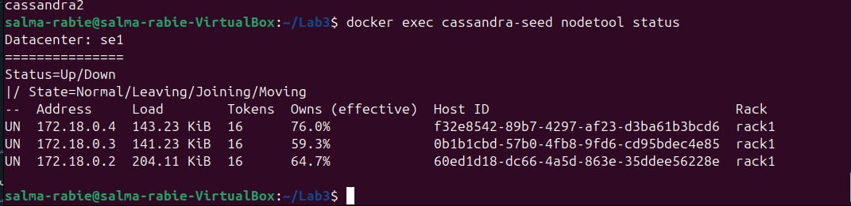

1- Node 1 down:
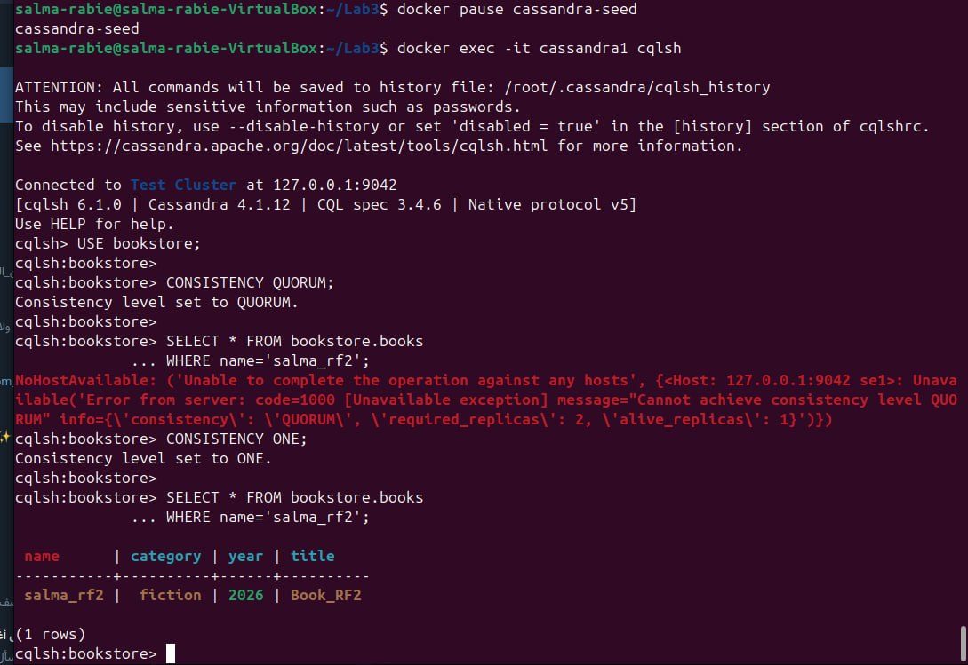
2- Node 2 down:
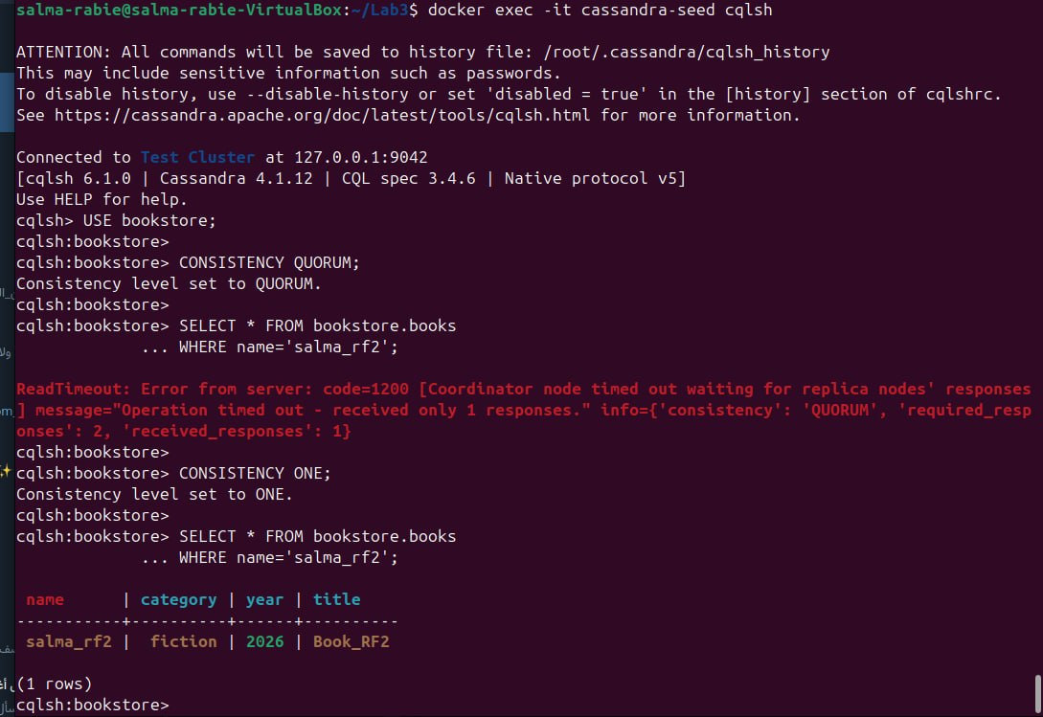
3- Node 3 down:
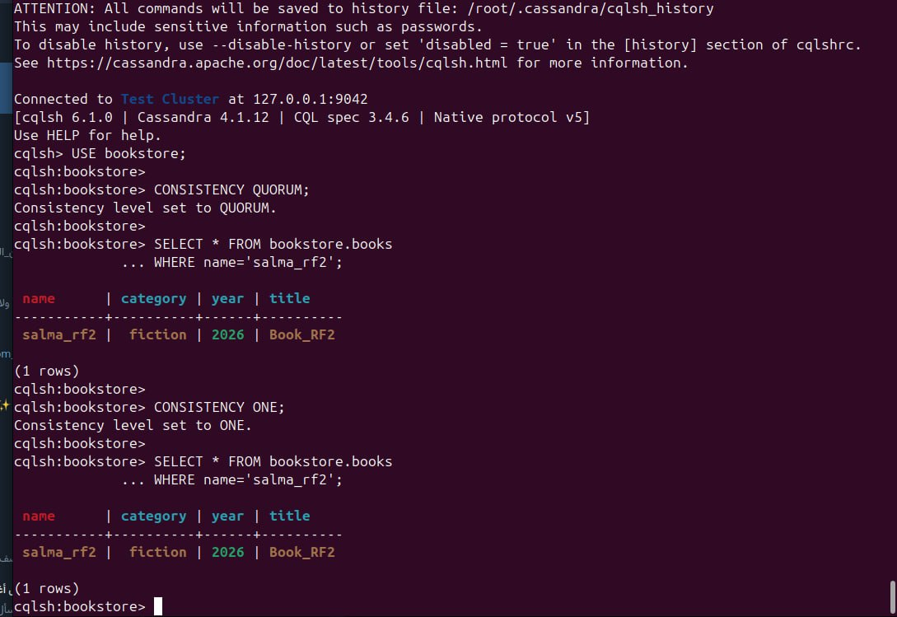
4- Node 1 and Node 2 down:
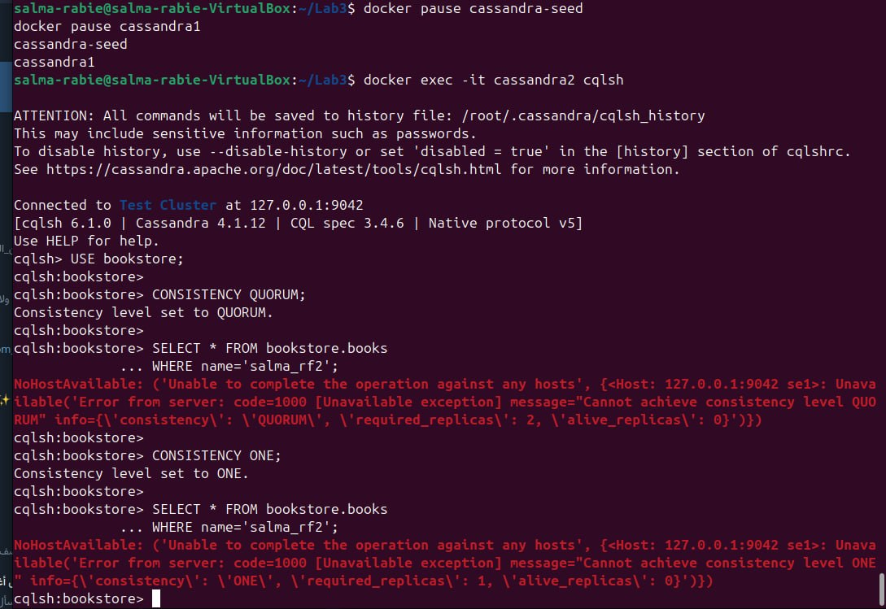
5- Node 1 and Node 3 down:
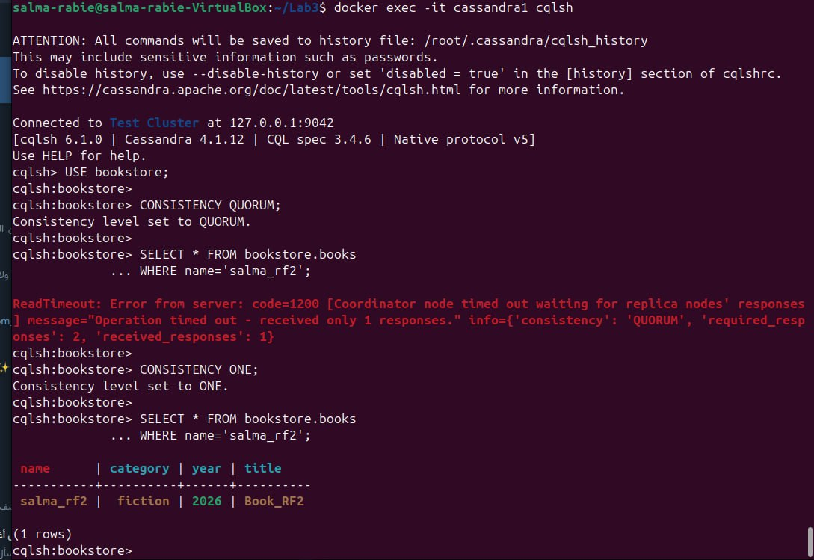
6- Node 2 and Node 3 down:
Nodes Down | QUORUM | ONE
Node 1 | FAILURE | SUCCESS
Node 2 | FAILURE | SUCCESS
Node 3 | SUCCESS | SUCCESS
Nodes 1 & 2 | FAILURE | FAILURE
Nodes 1 & 3 | FAILURE | SUCCESS
Nodes 2 & 3 | FAILURE | SUCCESS

A) RF=3 setup:
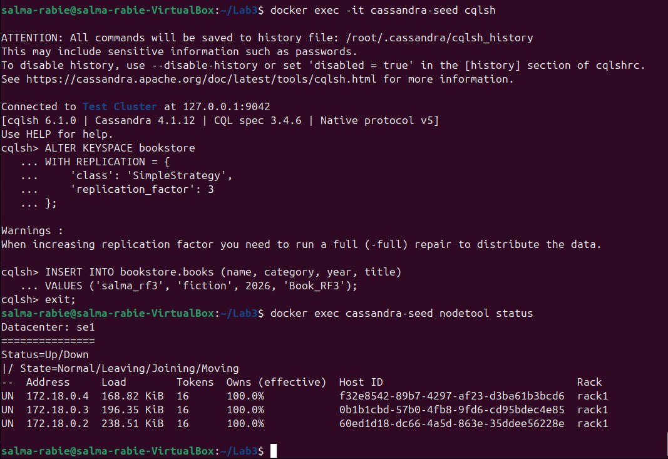
1- Node 1 down:
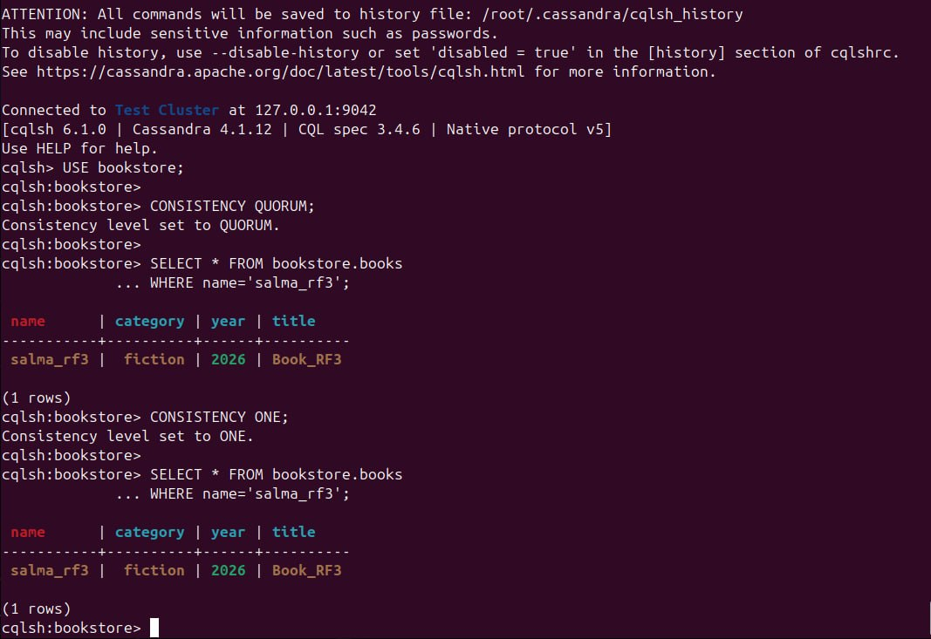
2- Node 2 down:
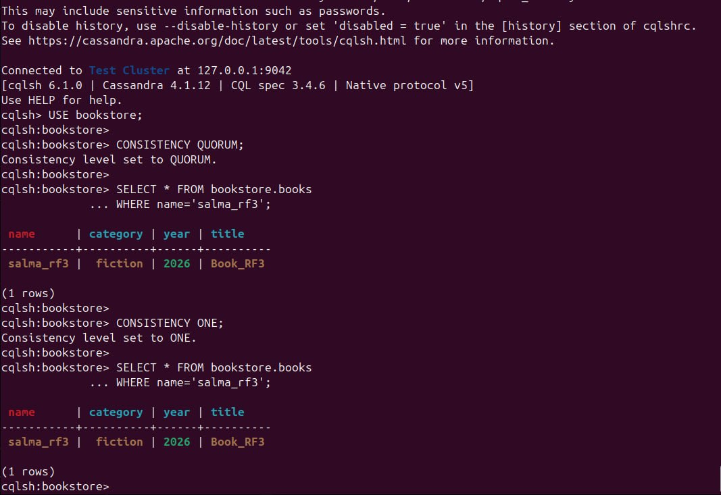
3- Node 3 down:
4- Node 1 and Node 2 down:
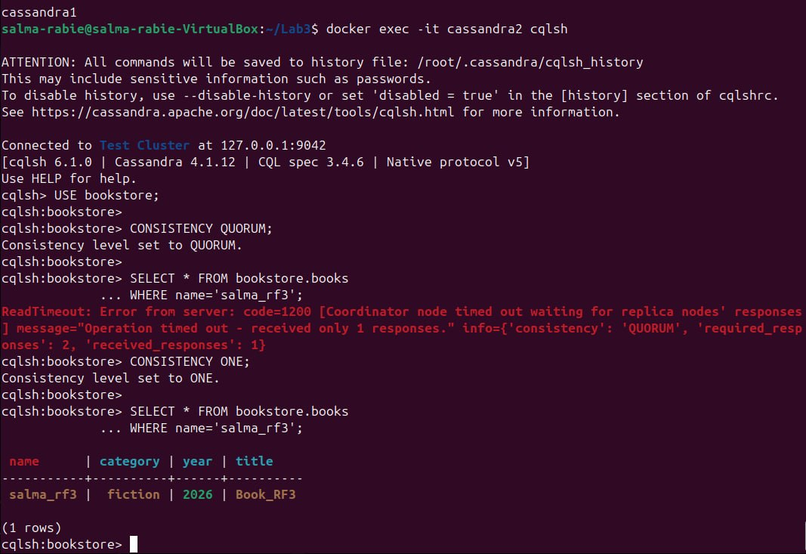
5- Node 1 and Node 3 down:
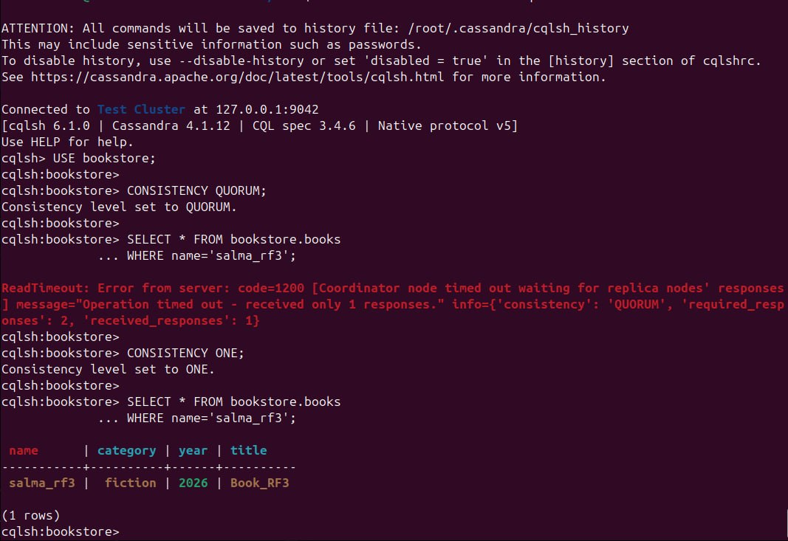
6- Node 2 and Node 3 down: 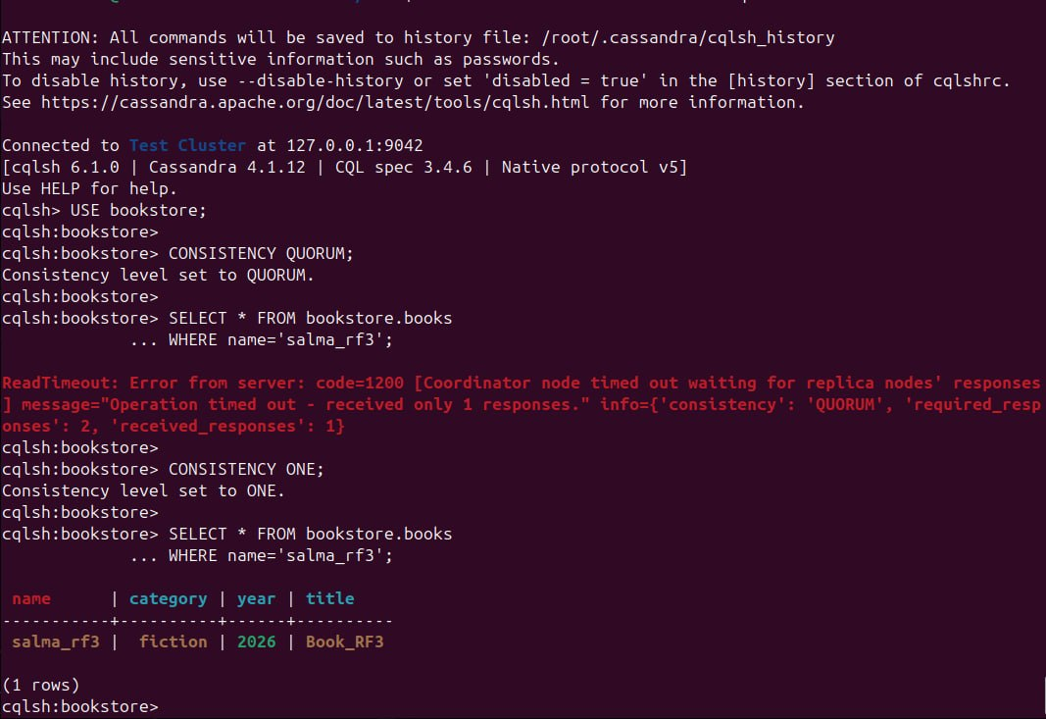
Nodes Down | QUORUM | ONE
Node 1 | SUCCESS | SUCCESS
Node 2 | SUCCESS | SUCCESS
Node 3 | SUCCESS | SUCCESS
Nodes 1 & 2 | FAILURE | SUCCESS
Nodes 1 & 3 | FAILURE | SUCCESS
Nodes 2 & 3 | FAILURE | SUCCESS
MATRIX D:
Nodes Down | RF = 1 | RF = 2 | RF = 3
Node 1 down | SUCCESS | FAILURE | SUCCESS
Node 2 down | SUCCESS | FAILURE | SUCCESS
Node 3 down | FAILURE | SUCCESS | SUCCESS
Nodes 1 & 2 | SUCCESS | FAILURE | FAILURE
Nodes 1 & 3 | FAILURE | FAILURE | FAILURE
Nodes 2 & 3 | FAILURE | FAILURE | FAILURE

