Social Informatics
Technical Report
Eye Disease Classification System
Team Name : Maybe!
Team Members :
Salma Yasser Mostafa
Ola Farhat Ibrahim
Nouran Atef Hashad
Nermeen Mohamed
Supervisors :
Dr. Asmaa Saad
Eng. Yasmeen Elfike

Table of Contents
1. Project Overview
2. Dataset Description
3. Data Preprocessing
4. Machine Learning Workflow
5. Deep Learning Workflow
6. Results and Model Comparison
7. Comparison with Kaggle Reference Notebook
8. Deployment Workflow
9. Conclusion
10. Output Screenshots

1. Project Overview
This project aims to build an eye disease classification system using retinal fundus images. The model classifies each image into one of four classes: cataract, diabetic retinopathy, glaucoma, or normal. The work includes dataset exploration, preprocessing, training six models, evaluating the models using medical classification metrics, and deploying the selected model as a Streamlit web application inside a Docker container on Hugging Face Spaces.
The system is designed as both a research experiment and a deployable prototype. The research notebook compares traditional machine learning and deep learning approaches, while the deployed application uses the best practical model for fast CPU inference.

Project Objectives
- Understand and preprocess the retinal image dataset.
- Train three traditional machine learning models using HOG features.
- Train three deep learning models directly on images.
- Compare all models using accuracy, precision, recall, F1-score, and confusion matrix.
- Select the best model for deployment based on performance and deployment suitability.
- Build a GUI using Streamlit and deploy it online using Docker and Hugging Face Spaces.

2. Dataset Description
The dataset contains retinal images divided into four classes: cataract, diabetic retinopathy, glaucoma, and normal. Each class contains approximately one thousand images. The dataset is based on retinal fundus images collected from different public sources used for eye disease recognition tasks, such as IDRiD, ocular recognition sources, and HRF-like retinal image collections.

Class Distribution
Class | Number of Images
cataract | 1038
diabetic_retinopathy | 1098
glaucoma | 1007
normal | 1074
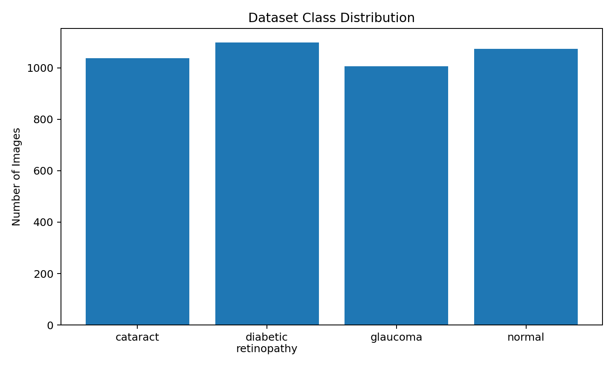
Figure 1. Dataset class distribution.

Dataset Split
Class | Train | Validation | Test
cataract | 726 | 155 | 157
diabetic_retinopathy | 768 | 164 | 166
glaucoma | 704 | 151 | 152
normal | 751 | 161 | 162
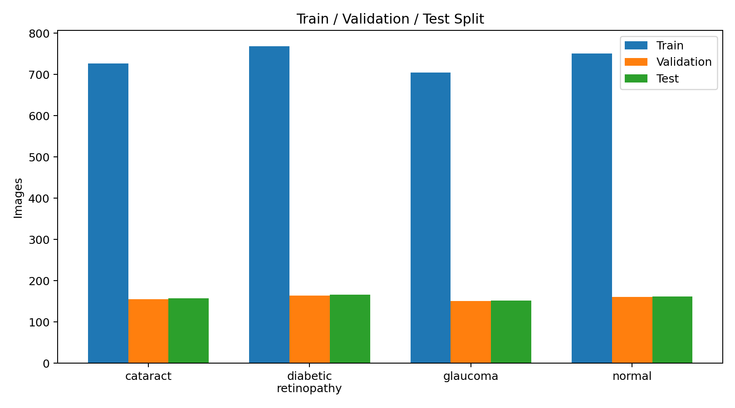
Figure 2. Train/validation/test split distribution.
The dataset was split into 70% training, 15% validation, and 15% testing. This split provides a separate validation set for tuning and a final unseen test set for fair model evaluation.

3. Data Preprocessing
The preprocessing steps differed slightly between traditional machine learning and deep learning models. For machine learning, HOG features were extracted from grayscale resized images. For deep learning, images were resized and augmented using ImageDataGenerator.

Common Dataset Checks
- Counted images in each class to check class balance.
- Visualized random images from each class to understand image appearance.
- Checked image sizes to confirm the need for resizing.
- Checked corrupted images using PIL image verification. No corrupted images were found.
- Created train, validation, and test folders using splitfolders.

Machine Learning Preprocessing
- Resize each image to 128 × 128 pixels.
- Convert the image to grayscale.
- Extract HOG features using 9 orientations, 8 × 8 pixels per cell, and 2 × 2 cells per block.
- Scale HOG features using StandardScaler.
- Encode class names using LabelEncoder.

Deep Learning Preprocessing
- Resize images to 128 × 128 for Lightweight CNN to reduce CPU load.
- Resize images to 160 × 160 for MobileNetV2 and EfficientNetB0 transfer learning.
- Apply augmentation such as rotation, zoom, shift, and horizontal flip.
- Use model-specific preprocessing for MobileNetV2 and EfficientNetB0.

4. Machine Learning Workflow
Traditional machine learning models cannot automatically learn spatial features from images like CNNs. Therefore, handcrafted HOG features were extracted first and then used as input to classical classifiers.
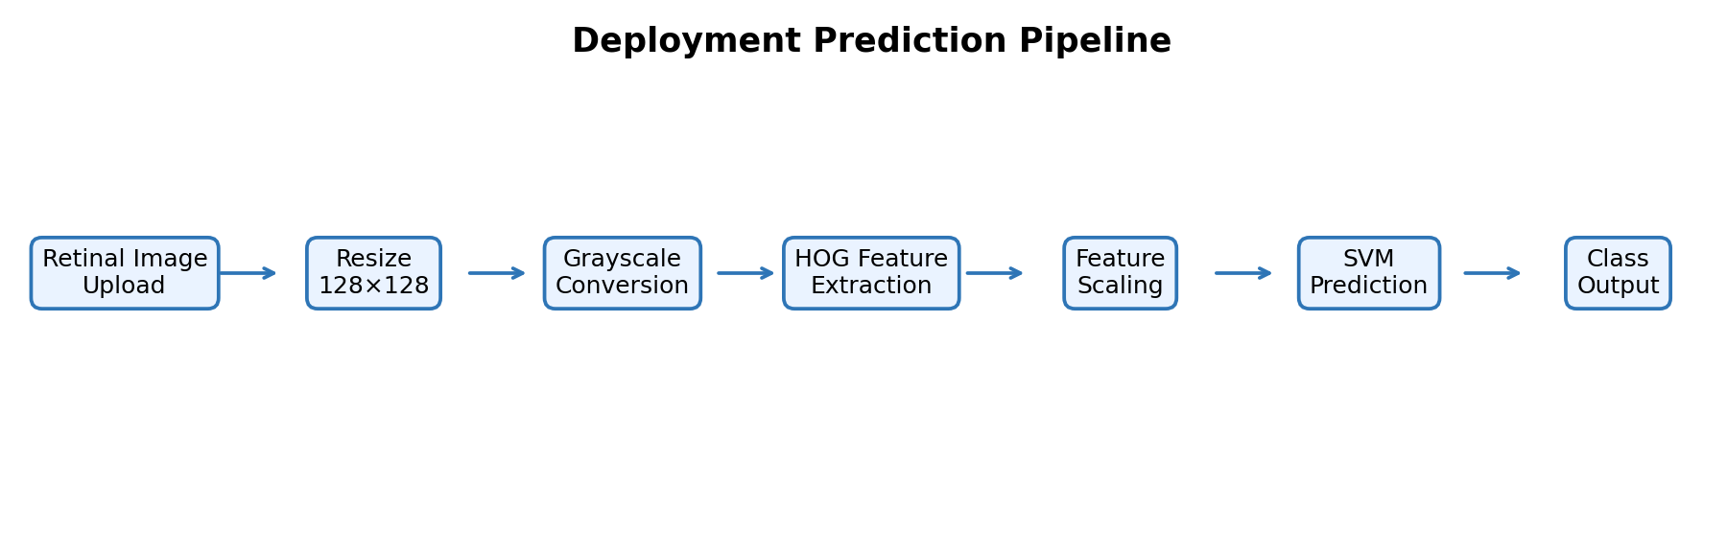
Figure 3. SVM + HOG deployment prediction pipeline.

Models Implemented
Model | Feature Extraction | Notes
Logistic Regression | HOG | Linear baseline classifier with scaled features.
SVM | HOG | Best performing model using RBF kernel.
Random Forest | HOG | Tree-based ensemble model with balanced class weights.
The best traditional machine learning model was SVM + HOG with 85.71% test accuracy and weighted F1-score of 0.85.
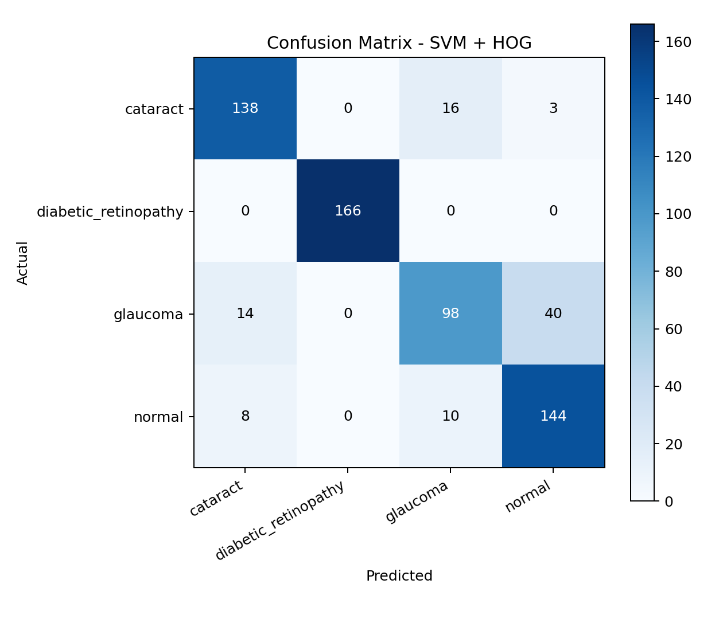
Figure 4. Confusion matrix for SVM + HOG.

5. Deep Learning Workflow
Three deep learning models were trained and evaluated. The first model was a lightweight CNN trained from scratch. The second and third models used transfer learning with MobileNetV2 and EfficientNetB0. Due to running on native Windows CPU, the models were configured with smaller image sizes and batch sizes to reduce computational load.
Model | Image Size | Approach | Result Summary
Lightweight CNN | 128 × 128 | CNN from scratch with GlobalAveragePooling2D | Low performance; used as DL baseline.
MobileNetV2 | 160 × 160 | Transfer learning with frozen base model | Better than CNN but below SVM.
EfficientNetB0 | 160 × 160 | Transfer learning with frozen base model | Similar to MobileNetV2; better glaucoma recall.
The lightweight CNN achieved only 52.43% accuracy, showing that a simple CNN trained from scratch was not sufficient. MobileNetV2 achieved 75.98%, while EfficientNetB0 achieved 75.51%.
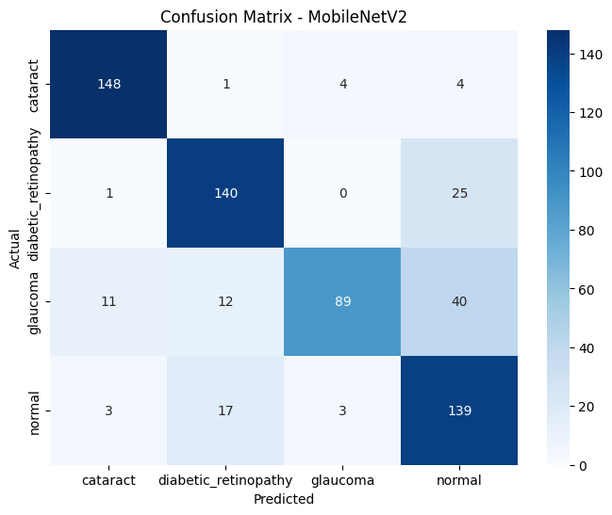
Figure 5. Example confusion matrix from MobileNetV2 experiment.

6. Results and Model Comparison
Model | Type | Test Accuracy | Weighted F1 | Glaucoma Recall
Logistic Regression + HOG | Machine Learning | 81.95%
SVM + HOG | Machine Learning | 85.71% | 0.85 | 0.64
Random Forest + HOG | Machine Learning | 81.79%
Lightweight CNN | Deep Learning | 52.43% | 0.47 | 0.03
MobileNetV2 | Deep Learning | 75.98% | 0.75 | 0.49
EfficientNetB0 | Deep Learning | 75.51% | 0.76 | 0.62
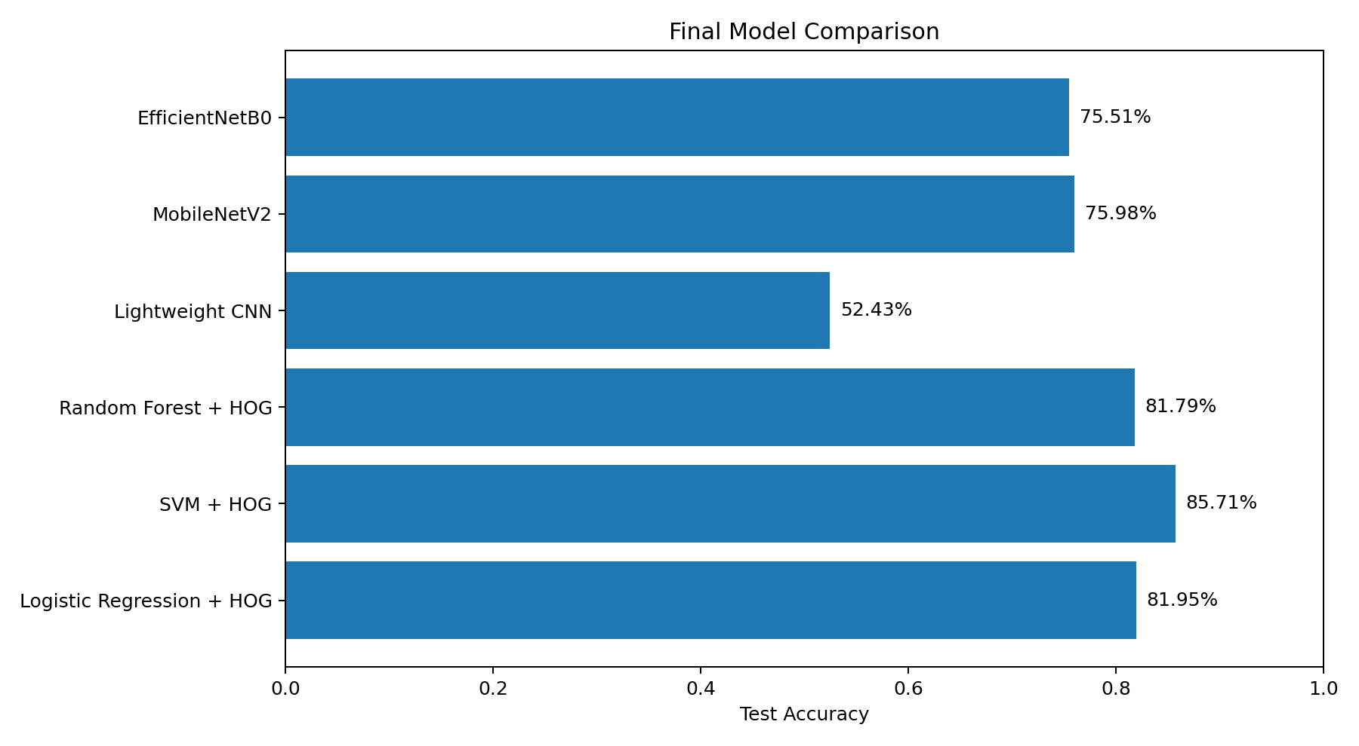
Figure 6. Final comparison between machine learning and deep learning models.
The SVM + HOG model achieved the best overall test accuracy of 85.71%. It also had the best practical deployment suitability because it is lightweight, fast on CPU, and does not require TensorFlow during inference.

Medical Interpretation
Across several models, glaucoma was the most challenging class. Many glaucoma images were misclassified as normal. This is medically important because missing a diseased case is more critical than producing a false alarm. Therefore, glaucoma recall was considered an important metric during model comparison.

7. Comparison with Kaggle Reference Notebook
The Kaggle reference notebook used EfficientNetB3 as a transfer learning model. It used an 80/10/10 split, image size 256 × 256, data augmentation including rotation, horizontal flip, vertical flip, and brightness adjustment, and trained EfficientNetB3 for 15 epochs. The reported final training accuracy was approximately 80.97% and validation accuracy was approximately 81.99%.

Improvements Added in Our Work
- Implemented a full comparison between six models instead of using one model only.
- Added traditional ML baselines using HOG features: Logistic Regression, SVM, and Random Forest.
- Added deep learning baselines: Lightweight CNN, MobileNetV2, and EfficientNetB0.
- Evaluated models on an independent test set using classification report and confusion matrix.
- Focused on medical metrics such as recall, especially for glaucoma.
- Selected the deployment model based on accuracy, F1-score, model size, CPU speed, and deployment practicality.
- Built a Streamlit GUI and deployed the selected model using Docker on Hugging Face Spaces.
Although the Kaggle notebook achieved strong validation accuracy using EfficientNetB3, our work added a broader experimental workflow and showed that SVM + HOG achieved the best test accuracy in our setup. This made SVM + HOG the most suitable model for deployment.

8. Deployment Workflow
The final deployed system uses the SVM + HOG model. The application was built with Streamlit, containerized with Docker, pushed to GitHub using Git LFS for large model files, and deployed on Hugging Face Spaces as a Docker Space.

Deployment Components
File / Folder | Purpose
app.py | Streamlit GUI and prediction logic.
requirements.txt | Python dependencies required by the app.
Dockerfile | Defines the reproducible container environment.
README.md | Hugging Face Space metadata and project overview.
saved_models/svm_hog.pkl | Trained SVM model.
saved_models/hog_scaler.pkl | Scaler used to normalize HOG features.
saved_models/label_encoder.pkl | Class label encoder.
results/final_models_comparison.csv | Final comparison table shown in the app.
reports/svm_report.txt | Classification report for the selected model.
The prediction flow in the deployed app is: image upload, resize to 128 × 128, grayscale conversion, HOG feature extraction, feature scaling, SVM prediction, then displaying the predicted disease class in the GUI.

9. Conclusion
This project implemented a complete workflow for eye disease classification. The final system compared six machine learning and deep learning models. SVM + HOG achieved the highest test accuracy and was selected for deployment because it is accurate, lightweight, and efficient on CPU. The final prototype demonstrates both model experimentation and real deployment through Streamlit, Docker, GitHub, and Hugging Face Spaces.

10. Output Screenshots
This section includes selected screenshots and visual outputs from the project implementation, model evaluation, and deployment process.
https://salmayasser-eye-disease-classification.hf.space/
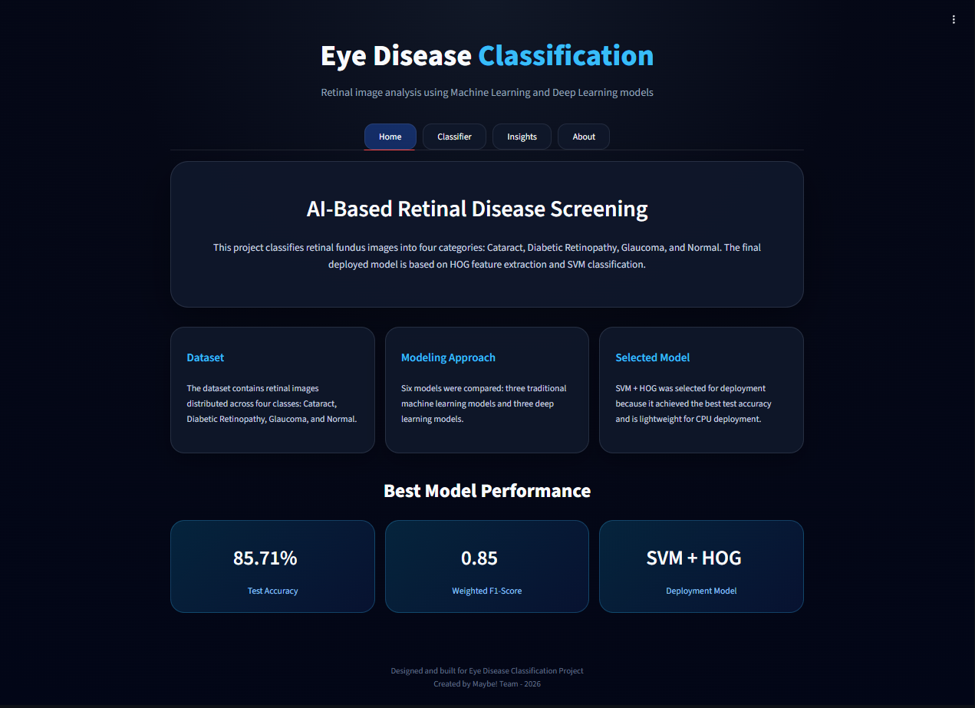
Figure 7.
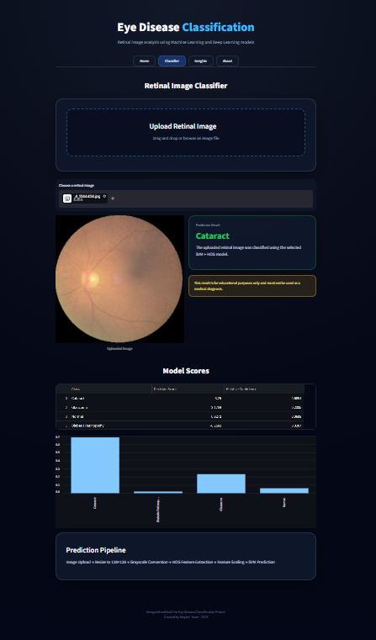
Figure 8.
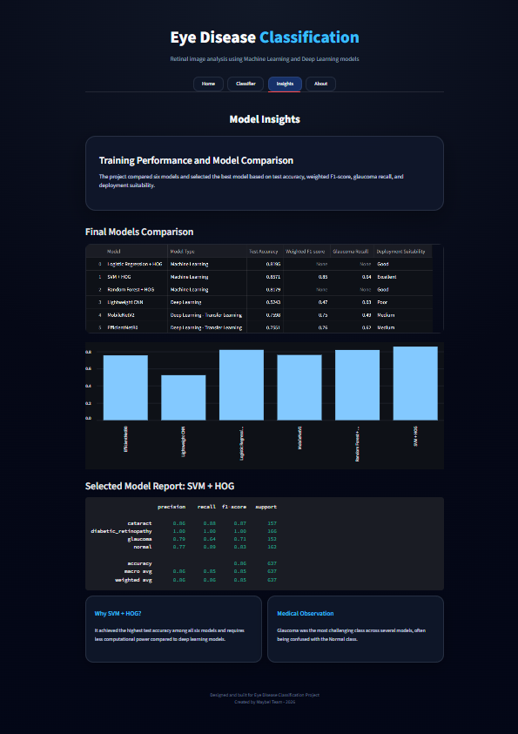
Figure 9.

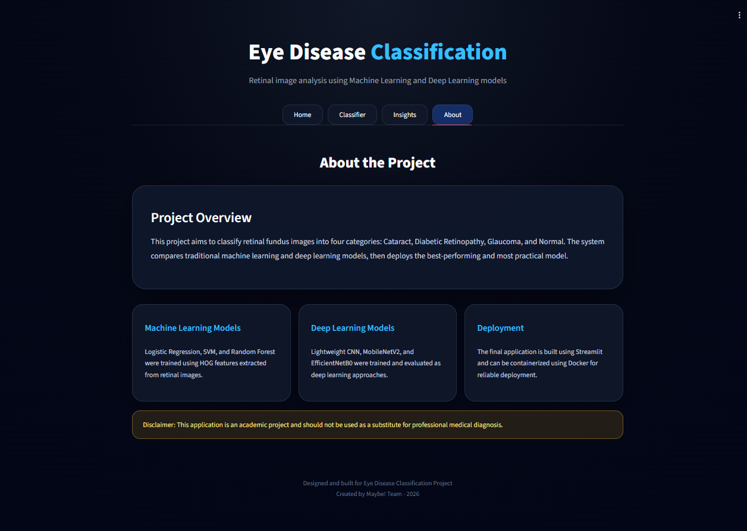
Figure 10.

References
- Kaggle reference notebook: Eye Diseases Classification by Mahnaz Arjmand.
- Kaggle dataset: Eye Diseases Classification Dataset.
- Streamlit documentation for web app development and deployment.
- Hugging Face Spaces documentation for Docker Spaces deployment.

