

Project Report
Personalized Email Generator using GPT-Neo

Submitted by:
Mohammed Afra Firdous – 23BCE9806
Syed Muskan – 23BCE7305
Shaik Salma – 23BCE20344
Aditi Sinharoy – 22BAI10124

Date of Submission: 5th July 2025



Table of Content

1. Introduction.......................................................................................................1
2. Objective...........................................................................................................2
3. Tools and Technologies Used...........................................................................3
4. Methodology / Working....................................................................................3
5. Coding Snap shots and Output Results.............................................................4
6. Challenges Faced and Solutions.......................................................................8
7. Conclusion........................................................................................................9
8. References.........................................................................................................9

Introduction
In today's fast-paced academic and professional environments, email remains a crucial medium of communication. Whether it involves corresponding with professors, inviting speakers to events, or sending official announcements, the ability to draft formal, structured emails is a fundamental skill. However, crafting professional emails consistently can be time-consuming and cognitively demanding, especially for individuals who are not confident in formal writing or who must send similar messages repeatedly. This project addresses that need by developing an AI-based tool that automates the generation of personalized formal emails using Natural Language Processing (NLP).
The core technology behind this project is GPT-Neo (1.3B), an open-source, transformer-based language model developed by EleutherAI. It is capable of understanding human language patterns and generating coherent text based on a given prompt. By leveraging this model, we have created a solution that takes minimal input from the user—such as the recipient's name, the event or context of the message, and a brief description—and returns a complete, well-structured, and grammatically accurate email. The generated emails are tailored to sound professional, clear, and contextually relevant, which makes them suitable for immediate use in formal communication.
To make the system accessible to a broader audience, we have built a web-based user interface using Streamlit, a popular Python framework for building interactive data applications. This interface is simple and intuitive, requiring no programming knowledge. Users only need to enter the required information into input fields and click a button to generate a complete email. The entire experience is designed to be seamless and user-friendly, ensuring that even those without technical backgrounds can benefit from the system's capabilities.
An important aspect of this project is the concept of prompt engineering, which involves crafting the right input for the language model to guide it toward producing the desired output. We designed a structured prompt format that begins with a greeting and includes placeholders for the recipient's name and other relevant details. The prompt ends with a predefined stopping point to prevent the model from generating irrelevant or repetitive content. This method ensures that the output remains focused, relevant, and polished.
Overall, this project showcases how large language models can be applied to real-world tasks that involve natural language generation. By combining AI capabilities with a practical user interface, we have created a tool that not only enhances productivity but also democratizes access to advanced NLP technology. The Personalized Email Generator serves as a proof of concept for how AI can simplify everyday tasks, reduce manual effort, and support users in communicating more effectively.

Objectives
- To build an interactive email generator using a transformer-based NLP model (GPT-Neo): The primary aim of this project is to leverage the capabilities of transformer-based architectures—specifically GPT-Neo (1.3B)—to create an AI-powered system that can generate human-like text. By integrating this language model with a user interface, the tool is able to understand structured inputs and generate coherent and grammatically correct formal emails. This objective highlights the fusion of deep learning and real-world application development.
- To simplify the process of writing formal communication by minimizing manual effort: Drafting formal emails can be a repetitive and time-intensive process, particularly for students, professionals, and administrative staff. This project aims to reduce that burden by automating the writing process. By generating complete emails from just a few input fields, users can save significant time and mental effort, especially in situations that require frequent communication like sending invitations, requests, or official updates.
- To implement a web interface that collects key details like recipient name, event name, and additional instructions: Accessibility and ease of use are crucial for practical tools. This objective focuses on building a web-based graphical interface using Streamlit that allows users to input minimal but essential information required to draft an email. The interface ensures that the system is intuitive and usable even by non-technical individuals, thus expanding the reach and utility of the tool.
- To demonstrate real-world usage of large language models in daily productivity tasks: Beyond theoretical knowledge, this project aims to showcase how advanced NLP models can be integrated into simple tools to solve everyday problems. The email generator is a practical demonstration of how AI can enhance productivity in real-life scenarios. This objective also reflects the growing trend of using AI to automate routine digital tasks in both academic and professional domains.

Tools and Technologies

Category | Tools used
IDE | Visual Studio Code
Language | Python
Libraries | Transformers, Streamlit, Torch
Model | GPT-Neo (EleutherAI/gpt-neo-1.3B)
Interface | Streamlit

Methodology / Working
- Model Loading: The GPT-Neo 1.3B model and GPT-2 tokenizer are loaded from the Hugging Face Transformers library. The pad_token is set to eos_token to prevent generation issues.
- User Interface: Built using Streamlit, the UI includes fields to enter the recipient's name, event, and extra instructions. It also includes a “Generate Email” button that initiates the generation process.
- Prompt Engineering: The user inputs are structured into a prompt that begins with:
To: [Recipient]
Subject: Invitation to [Event]

Dear [Recipient],

I hope this message finds you well...

A delimiter --- is added at the end to signal the model to stop generating.
- Text Generation: The prompt is tokenized and passed to the GPT-Neo model. Generation parameters such as temperature, top_k, top_p, and repetition_penalty are tuned for quality output.
- Output Cleaning: The decoded output is trimmed using the --- delimiter to remove irrelevant trailing text. Any duplicated lines are also filtered for readability.
- Display: The final formatted email is rendered directly on the Streamlit interface, allowing users to copy and use it easily.

Coding Snap shots and Output Results

Step 1: Install Required Libraries
We begin by installing the necessary Python libraries to use the GPT-Neo model, run inference, and build the UI using Streamlit.
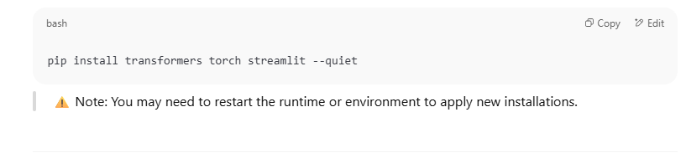
Step 2: Load the GPT-Neo Model and Tokenizer
We load the pre-trained GPT-Neo 1.3B model and its tokenizer from Hugging Face. We also set the pad_token to prevent generation issues.
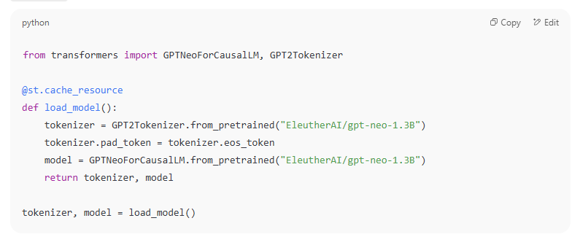
Step 3: Collect Input from User via Streamlit Interface
We use Streamlit's UI widgets to allow users to input the recipient name, event name, and extra information for the email.

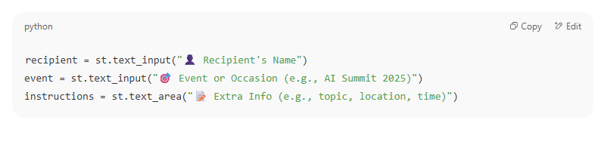
Step 4: Construct Prompt for Email Generation
We define a detailed prompt with a clean format that includes "To", "Subject", and "Body". The --- separator is used to avoid irrelevant trailing text.
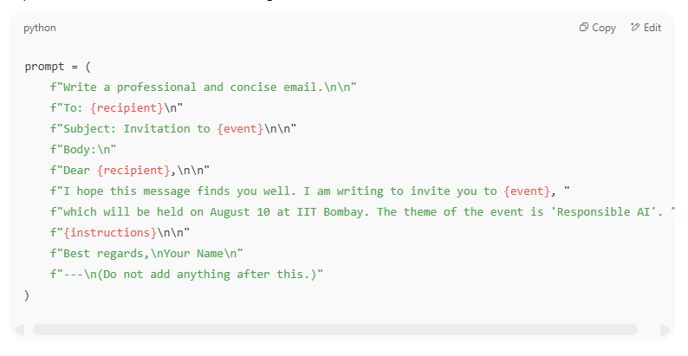
Step 5: Generate the Email Response
We tokenize the prompt and use the model to generate an appropriate formal email.
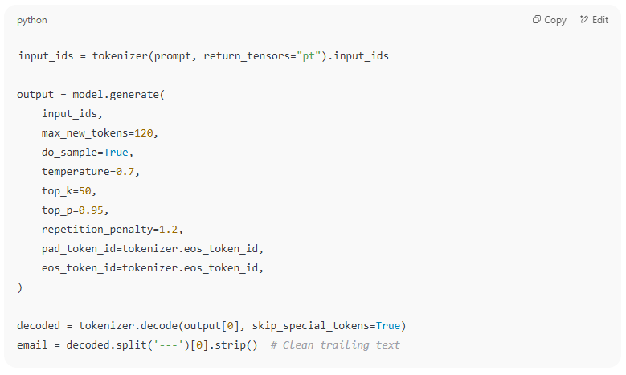
Step 6: Clean and Display Output
A function removes duplicate lines and formats the text for better readability before displaying it in Streamlit.
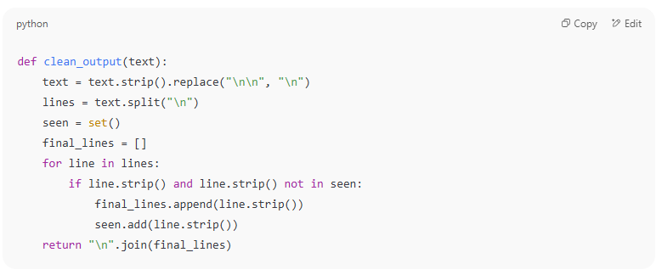
Step 7: Final Output Display in Streamlit
The cleaned email is shown on the screen when the user clicks the “Generate Email” button.
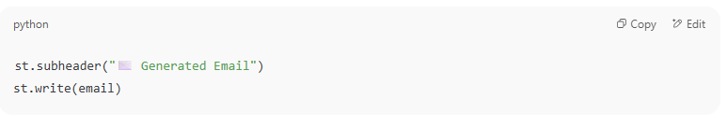
Sample Output
Input:
- Recipient: Dr. Mehta
- Event: AI Summit 2025
- Extra Info: It will start at 10 AM and feature sessions on Responsible AI.
Generated Output:
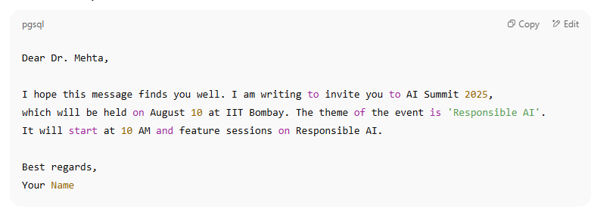
Github link:
https://github.com/aditi030105/email-generator-gpt-neo/tree/main/email-generator-gptneo
Output Screenshots:
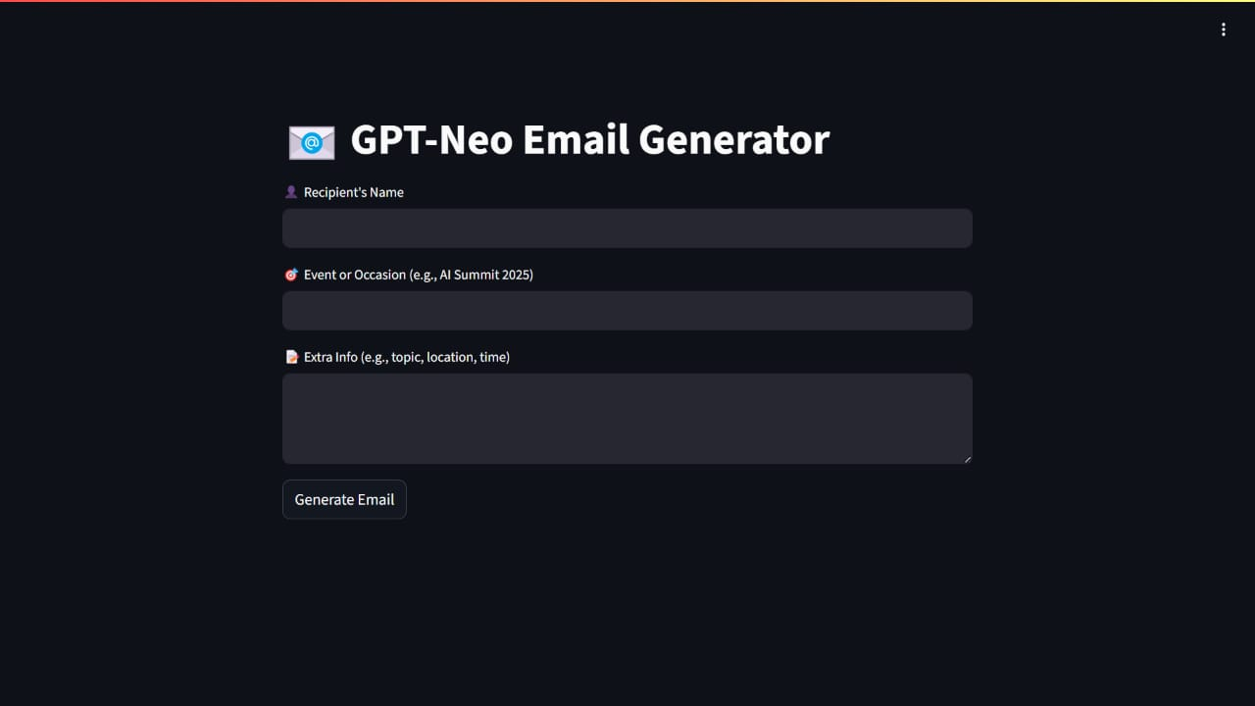
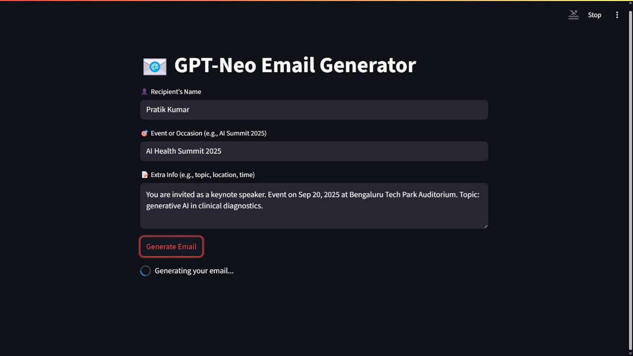
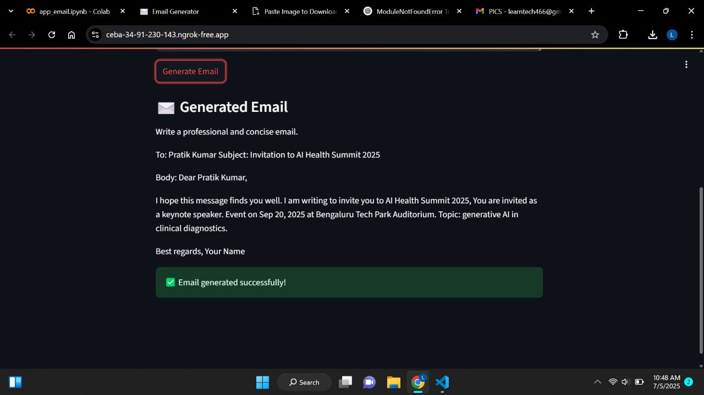

Challenges Faced and Solutions
During the development of the personalized email generator, several technical and user-experience challenges were encountered. Below are the key issues faced and the corresponding solutions implemented:
- Repetitive outputs: Initially, the generated emails often contained repeated lines or phrases. This issue was addressed by applying a repetition_penalty during generation and introducing a stopping delimiter (---) at the end of the prompt to guide the model where to stop.
- Slow performance: Loading the GPT-Neo model and tokenizer caused noticeable delays during runtime, especially on repeated usage. To mitigate this, the model loading function was wrapped using @st.cache_resource, allowing Streamlit to cache the components and significantly reduce loading time on subsequent runs.
- Poor prompt generation: Early prompt formats led to inconsistent or off-topic responses. This was improved by designing a structured and consistent prompt format including clear fields like “To”, “Subject”, and “Body” which provided better guidance to the model during text generation.
- Input confusion: Users were initially unclear about what to enter into each field. To resolve this, the UI was refined with clearer labels, placeholders, and warning messages to ensure mandatory fields like recipient name and event were not left blank.

Conclusion
This project successfully demonstrates the potential of large language models like GPT-Neo (1.3B) in automating formal communication tasks. By integrating the model with a user-friendly Streamlit interface, we developed an intelligent email generator that significantly reduces the time and effort involved in composing professional emails. The tool requires only minimal input from the user—such as the recipient’s name, event details, and additional instructions—and returns a grammatically correct, context-aware, and formally structured email within seconds.
Throughout the project, we addressed multiple real-world challenges, including repetitive outputs, slow loading times, and prompt inconsistencies. These were resolved through careful parameter tuning, prompt engineering, and effective caching techniques. The improvements made not only enhanced the quality of generated content but also streamlined the user experience.
Beyond serving as a standalone utility, this project illustrates a broader application of NLP in enhancing productivity and reducing manual workload in everyday tasks. It stands as a foundation for more advanced features such as multi-tone email generation (formal, casual, persuasive), multilingual support, and integration with email services like Gmail or Outlook for direct sending capabilities.
In summary, the personalized email generator is a practical, scalable, and efficient application of modern AI, showcasing how open-source NLP models can be transformed into real-world productivity tools.

References
Hugging Face. (n.d.). Transformers Documentation. Retrieved from https://huggingface.co/transformers/
EleutherAI. (n.d.). GPT-Neo Model (1.3B). Retrieved from https://huggingface.co/EleutherAI/gpt-neo-1.3B
Streamlit Inc. (n.d.). Streamlit Documentation. Retrieved from https://docs.streamlit.io/
PyTorch. (n.d.). PyTorch: An open source machine learning framework. Retrieved from https://pytorch.org/
GitHub Repository. (2025). Email Generator using GPT-Neo. Retrieved from https://github.com/aditi030105/email-generator-gpt-neo

