TP3: Declarative itemset mining
Group2: Salma Alkhalily - Nagham Abuwarda - Djoud El Hak Belkhir

Question2:
- Dataset: to open a Dataset and see its statistics.
- Model: is to build the model, add constraints, with the ships in simple mode, or expressions in advanced mode.
- Dashboard: is to run/stop the search, watch live counters and the chart and see the results.
- SPMF is to run classic algorithms (ex:LCM) and to compare with the CP model.
- History: is to see past runs.
Question3:
Result: 8 items, 5 transactions, with CoverSize (min frequency 20%) and CoverClosure, the search finds 9 closed frequent itemsets, exploring 29 nodes in about 0.004 s. The app rounds execution time to 0.00s, the 0.004 s comes from the end of the chart's time axis.
Here are the results:
Itemset | Length | Support | Frequency
{1} | 1 | 3 | 60.0%
{1, 4} | 2 | 2 | 40.0%
{2, 7} | 2 | 2 | 40.0%
{3, 8} | 2 | 2 | 40.0%
{1, 3, 4, 8} | 4 | 1 | 20.0%
{2, 3, 7, 8} | 4 | 1 | 20.0%
{1, 5, 6} | 3 | 1 | 20.0%
{5, 6} | 2 | 2 | 40.0%
{2, 5, 6, 7} | 4 | 1 | 20.0%
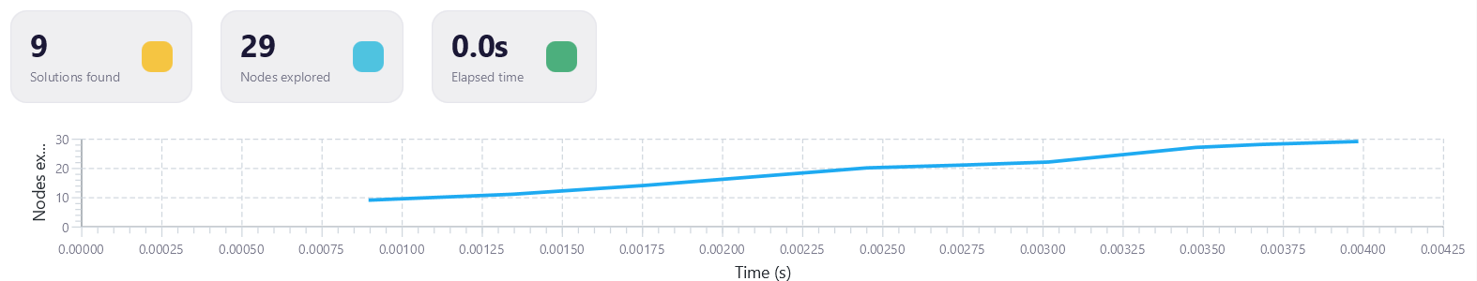
Question4:
We set the time limit to 300
- Muchroom Dataset:
MinFreq = 10%
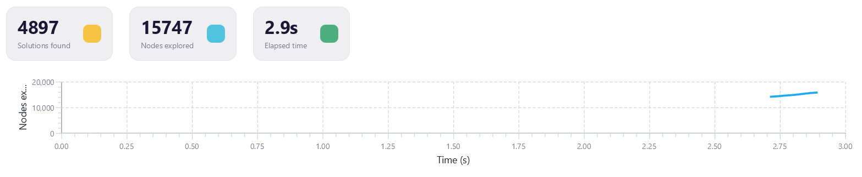
MinFreq = 20%
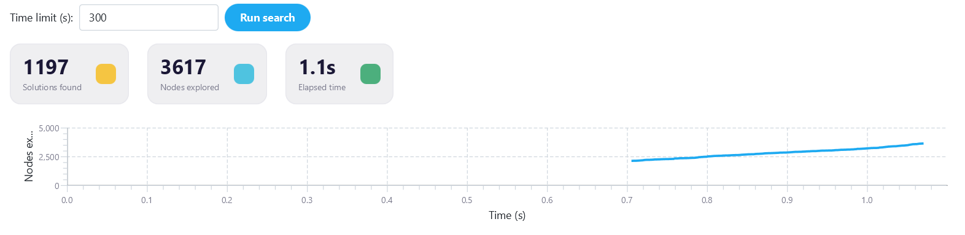
MinFreq = 50%
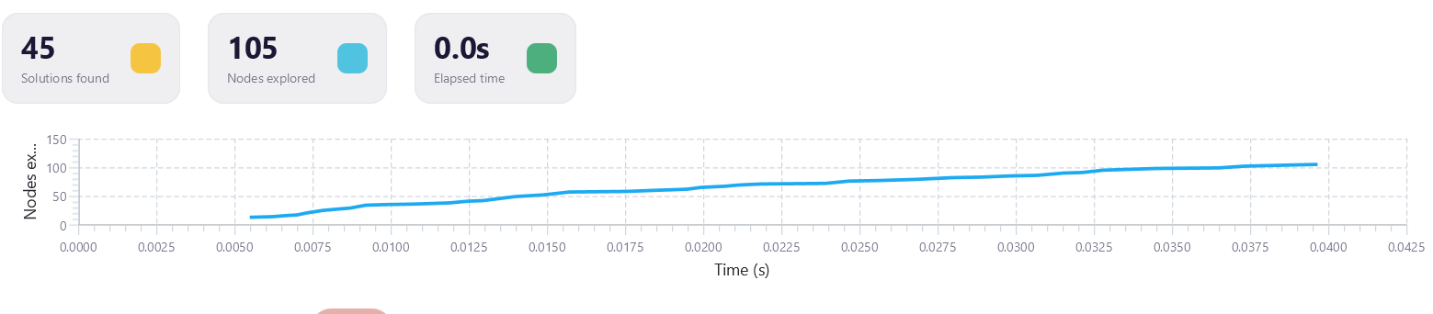
We ran CoverSize + CoverClosure on muchroom.dat (8124 transactions) with different minimum frequencies:
Min frequency | Min support (transactions) | Patterns | Nodes | Time
50% | 4062 | 45 | 105 | 0.04 s
20% | 1625 | 1,197 | 3,617 | 1.1 s
10% | 812 | 4,897 | 15,747 | 2.9 s
As the threshold decreases, the number of patterns, the number of nodes and the execution time all increase. The growth is much faster than the threshold's decrease: going from 50% to 10% divides the threshold by 5, but multiplies the number of patterns by about 109. This is consistent with the anti-monotonicity of frequency. If an itemset is frequent, all its subsets are frequent, and if it is infrequent, all its supersets are infrequent. So a high threshold prunes large parts of the search space, while a lower threshold lets more itemsets pass. Every pattern found at a high threshold is still found at a lower one, because closure does not depend on the threshold, so the number of patterns can only grow. More patterns also mean more nodes to explore, which is why the time increases too.
- Chess Dataset:
MinFreq = 70%
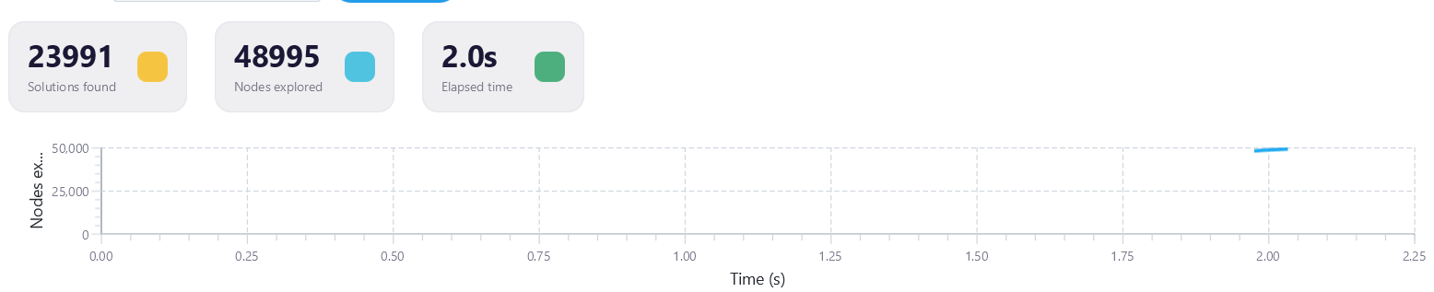
MinFreq = 80%
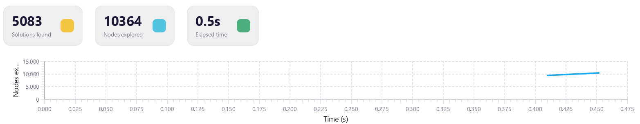
MinFreq = 95%
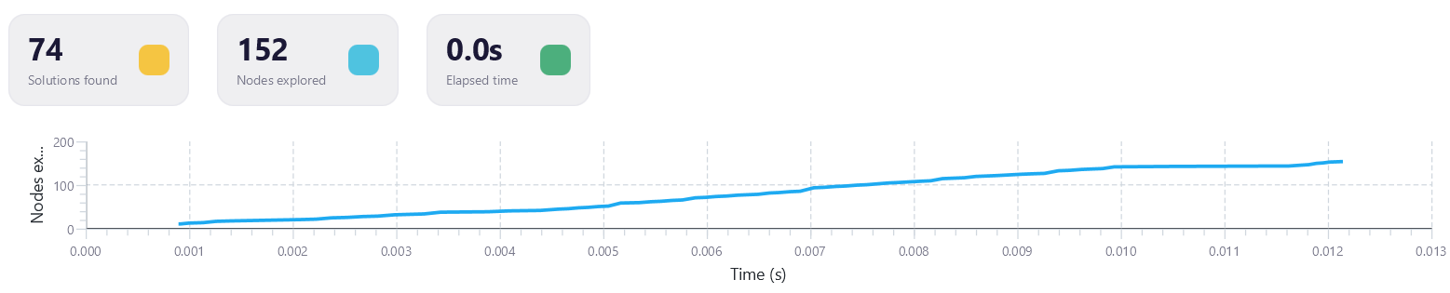
We ran the same experiment on chess-kr-vs-kp.dat (3196 transactions):
Min frequency | Min support (transactions) | Patterns | Nodes | Time
95% | 3036 | 74 | 152 | 0.01 s
80% | 2557 | 5,083 | 10,364 | 0.45 s
70% | 2237 | 23,991 | 48,995 | 2.0 s
The evolution is the same as on muchroom, as the threshold decreases, the number of patterns, the number of nodes and the execution time all increase. Going from 95% to 70% multiplies the number of patterns by about 324. Chess produces many more patterns than mushroom at much higher thresholds, because it is denser: each transaction contains 37 of its 75 items, against 23 of 119 for mushroom. At 10% on chess, the search did not finish: it reached the 300 s time limit with 2,714,125 patterns found and 7,119,211 nodes explored, so the result is incomplete.
Question5:
We ran LCM in the SPMF section on the same datasets and thresholds as in Question 4, and compared it with CoverSize + CoverClosure (CP) runs:
Dataset | Min frequency | CP patterns | LCM patterns | CP time | LCM time
Mushroom | 50% | 45 | 45 | 0.04 s | 0.12 s
Mushroom | 20% | 1,197 | 1,197 | 1.1 s | 0.56 s
Mushroom | 10% | 4,897 | 4,885 | 2.9 s | 1.5 s
Chess | 95% | 74 | 73 | 0.01 s | 0.07 s
Chess | 80% | 5,083 | 5,083 | 0.45 s | 1.7 s
Chess | 70% | 23,991 | 23,892 | 2.0 s | 6.3 s
The counts match at 50% and 20% on muchroom and at 80% on chess. They differ at the other three thresholds because the app rounds a percentage to the nearest number of transactions, while SPMF rounds up: 10% of 8124 is 812.4, so CP used 812 transactions and LCM used 813. With minimum supports of 0.0999, 0.9499 and 0.6999, LCM uses the same numbers of transactions as CP and finds the same counts (4,897, 74 and 23,991). The times give no clear winner: LCM is about twice as fast on mushroom at 20% and 10%, while CP is faster in the other four runs. This comparison is not fair. The app's time covers only the solver's search, while SPMF's time also includes writing every pattern to a file. SPMF starts a new Java process for every run, while the CP runs use the app's process, which is already running. Each time also comes from a single run. Finally, LCM is a specialised algorithm, while CP is a general solver.
Exercise 2 - Question1:
We created a new Maven project, added the choco-solver 4.10.18 and chocominer-core 3.0.0 dependencies to its pom.xml, and mvn compile finished with BUILD SUCCESS.
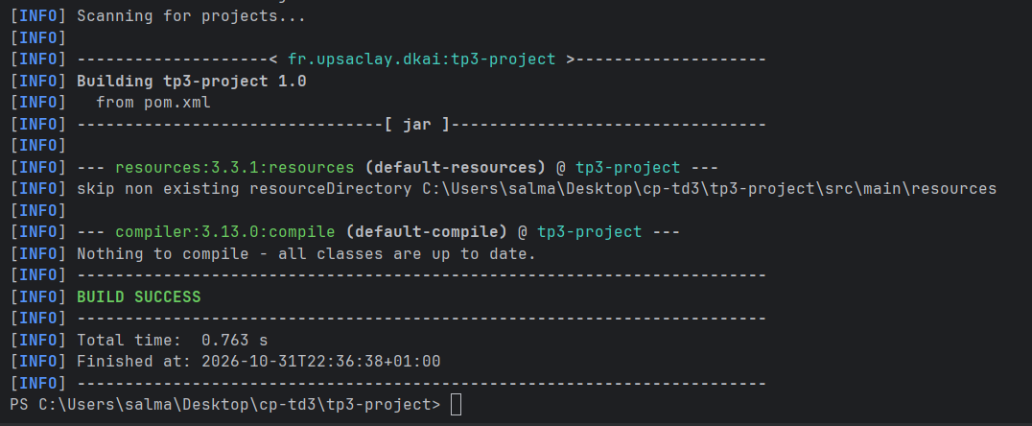
Exercise 2 - Question2:
Main class mines the closed itemsets of contextPasquier99.dat and finds 6 patterns. With the same two constraints, the app finds 7 patterns at its default threshold of 0%. The extra pattern is {1, 2, 3, 4, 5} with frequency 0: no transaction contains it, and the code excludes it because freq starts at 1. At 20%, which also requires at least 1 transaction, the app finds 6 patterns, the same number as the code.
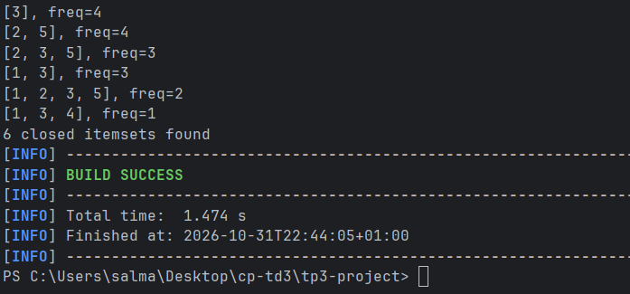
MinFreq = 0%
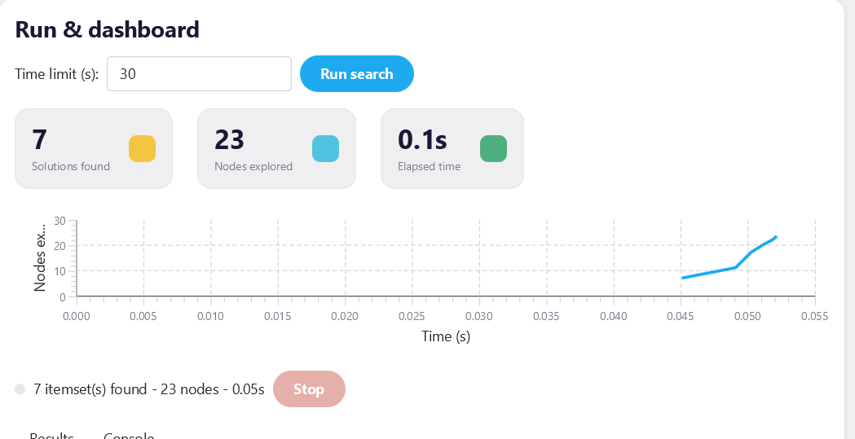
App, MinFreq = 20%


