Linear algebra:

What is linear algebra?
- When formalizing intuitive concepts, a common approach is to construct a set of objects (symbols) and a set of rules to manipulate these objects. This is known as an algebra.
- Linear algebra, is the type of algebra that deals with Vectors and there properties:
Object: vectors v
Operations: their additions (v + w ) and scalar multiplication (k v )
- Examples
Geometric vectors
- High school Linear algebra
Polynomials
Audio signals
Elements of Rn
- Polynomials are vectors? Yes for example:
Consider the polynomial:
This polynomial can be represented as a list of its coefficients:
Now, compare this to a vector in 3-dimensional space:
Why Polynomials Are Vectors?:
- Addition: Add two polynomials by adding their coefficients:

Same as vector addition:

- Scalar Multiplication: Multiply a polynomial by a scalar (number):

Same as scalar multiplication for vectors:

- Zero Polynomial (Zero Vector): The polynomial is represented as:

So what is a vector?
We can say that vectors are an arrow in 2d space (if the vector have only 2 numbers) but it must start from the origin and points to a specific point, we also can say that a vector is a way of representing a certain movement and it’s direction in space, but we will stick with the arrow perspective for now.
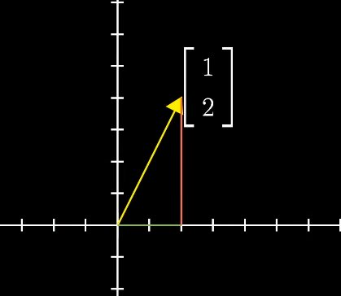Figure 1: 2D vector
If we say we have a vector then we can represent it like in Fig 1.

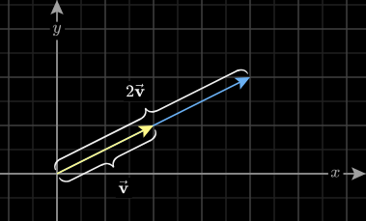
Vector scaling is when we multiply a vector by a scalar, it’s like stretching it in the same direction it was pointing towards before.

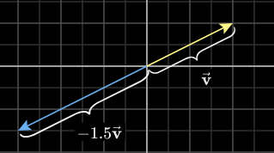
And for the negative numbers it changes it’s direction like this:

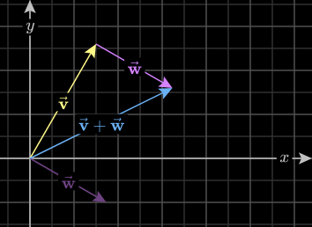
when adding two vectors, it’s like calculating the total movement in x direction and the total movement in the y direction, we can shift one of the vectors to better see it.

System of linear equations:
- An equation that has the highest degree of 1 is known as as linear equation
- when asking about if the system of linear equations have no solution, one unique solution or Infinitely many solutions there is 2 options:
- Equations with 2 variables representing lines in 2D space:
here you can compare the slop of the lines to see if and how they intersect.
Example:
  - for those 2 lines, if we divided the second line by 2 we get the first equation, so this system of linear equations have infinitely many solutions

  - If the slopes are the same but the intercepts are different then there is no solution, as the two lines would be parallel but through different intercepts to the y-axis.

  - If The slopes are different, so the lines are not parallel and must intersect at one point.

- Equations with 3 or more variables in higher dimensions:
we will know about those later with matrices, but conceptually from a geometry point of view it’s the same.

RECAP!!
For calculating the slop of line ax+by=c → M = -, as the general formula of the equation is where m is the slop and c is y-axis intercept.

Matrix representation:
Example system of equations:

we can express these equations with a matrices like this:
→ this means

This representation have 2 meanings:
- Linear Transformation: (We will talk about this more in Linear Mapping)
- The matrix A transforms the input vector x into the output vector b.
- Geometric intuition: A "moves" or "stretches" x to produce b.
- the equationasks: "What input 𝑥 should I give A to reach b?
- Intersection of Geometric Objects:
- Each row of A represents a linear equation (e.g., a line in 2D or a plane in 3D).
- The solution x lies at the intersection of these geometric objects, where all the constraints are satisfied.
- The equationasks: "Where do all the lines/planes intersect?"
Matrix: Addition and multiplication:
Let then:

matrix multiplication have a special meaning in linear transformation, it’s about combining 2 transformations into a single matrix, Imagine we have a vector v that we want to stretch it then collapse it “transforming it in vector space” we can combine the two transformations into a single matrix by multiplying them together. (we will discuss this farther in the linear mapping section).
For example if you have an instruction move upwards (A) and another instruction move forward(B) then matrix multiplication is like moving upwards then moving forward “A complete combination of the two transformations).

when adding two matrices, it’s like applying Av + Bv, where A and B are the matrices I’m adding and v is the vector I’m trying to transform “rotate or stretch” with matrices A and B. (like we said before a matrix is a transformation).
Imagine pulling a cart in two directions:
- One force (A) pulls to the right.
- Another force (B) pulls upward.
- The resulting motion combines these forces into a new direction and magnitude that’s neither purely right nor purely upward—it’s something in-between.
The resulting vector Av+Bv is biased toward the stronger transformation. This bias comes from the relative lengths (magnitudes) and directions of Av and Bv.
So as summary adding matrices is like combining transformations but without considering order and the result is a completely different output, it gives us another transformation that is effected but by the original A and B but doesn’t completely describe them like multiplication does, it’s a completely new matrix and result.

Why order matters in Matrix multiplication?
If we redefined what a matrix is, we would say it’s a way of transforming a vector in 2D space, rotating it scaling it etc.
Example: Rotate Then Reflect vs. Reflect Then Rotate
Given v = and the following matrices:
- Matrix A: Rotates the vector 90∘ counterclockwise.

- Matrix B: Reflects the vector across the x-axis.

Scenario 1: Rotation Then Reflection (BA)
- Apply Rotation (Matrix A):
Which is in the Second quadrant.
- Apply Reflection to the result (Matrix B)
Which is in the Third quadrant.
Scenario 2: Reflection Then Rotation (AB)
- Apply Rotation (Matrix B):
Which is in the Forth quadrant.
- Apply Reflection to the result (Matrix A)
Which is in the First quadrant.
So, we can say see that the vector ended in a completely different place based on the order of multiplying, ie applying matrices on a vector.

References:
- Mathematics for machine learning book: https://mml-book.github.io/book/mml-book.pdf
- 3Blue1Brown Series:
https://www.youtube.com/watch?v=fNk_zzaMoSs&list=PLZHQObOWTQDPD3MizzM2xVFitgF8hE_ab
- https://www.3blue1brown.com/lessons/vectors continue scrolling for the explination

