**NAME : SALMA RANI**

**SAPID : 54194**

**Lab2 : WAD**

**SUBMITTED TO : MAM NAYAB**

**Task 1:**

 <!DOCTYPE html>

<html lang="en">

<head>

    <meta charset="UTF-8">

    <meta name="viewport" content="width=device-width, initial-scale=1.0">

    <title>Simple Form</title>

</head>

<body>

    <form>

        <label for="first-name">First Name:</label>

        <input type="text" id="first-name" name="first-name" required><br><br>

        <label for="last-name">Last Name:</label>

        <input type="text" id="last-name" name="last-name" required><br><br>

        <label for="city">City:</label>

        <input type="text" id="city" name="city" required><br><br>

        <label for="zip">Zip Code:</label>

        <input type="text" id="zip" name="zip" maxlength="4" required><br><br>

        <label for="dob">Date of Birth:</label>

        <input type="date" id="dob" name="dob" required><br><br>

        <input type="submit" value="Submit">

    </form>

</body>

</html>

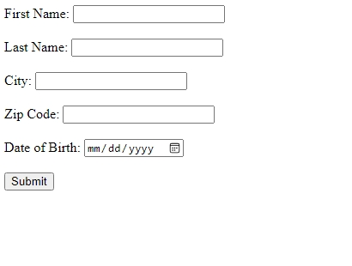

**Task 2:**

<!DOCTYPE html>

<html lang="en">

<head>

    <meta charset="UTF-8">

    <meta name="viewport" content="width=device-width, initial-scale=1.0">

    <title>Student Academic Records</title>

    <style>

        table {

            width: 50%;

            border-collapse: collapse;

            margin: 20px 0;

        }

        th, td {

            border: 1px solid black;

            padding: 10px;

            text-align: left;

        }

        th {

            background-color: #f2f2f2;

        }

    </style>

</head>

<body>

    <h2>Student Academic Records</h2>

    <table>

        <tr>

            <th>Name</th>

            <th>Subject</th>

            <th>Grade</th>

        </tr>

        <tr>

            <td>John Doe</td>

            <td>Math</td>

            <td>A</td>

        </tr>

        <tr>

            <td>Jane Smith</td>

            <td>Science</td>

            <td>B+</td>

        </tr>

        <tr>

            <td>Michael Brown</td>

            <td>History</td>

            <td>A-</td>

        </tr>

        <tr>

            <td>Emily Davis</td>

            <td>English</td>

            <td>B</td>

        </tr>

        <tr>

            <td>David Wilson</td>

            <td>Physics</td>

            <td>A</td>

        </tr>

    </table>

</body>

</html>

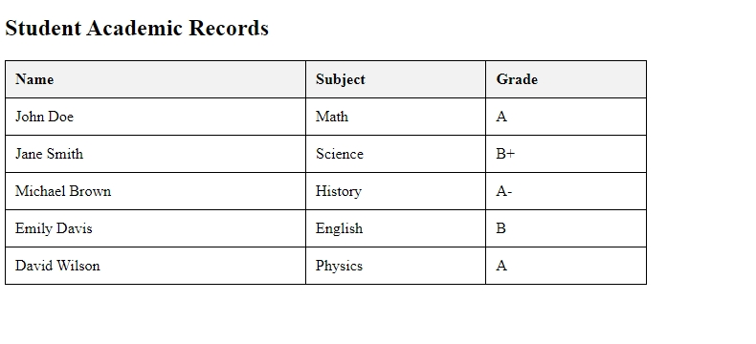

**Task 3:**

<!DOCTYPE html>

<html lang="en">

<head>

    <meta charset="UTF-8">

    <meta name="viewport" content="width=device-width, initial-scale=1.0">

    <title>Registration Page</title>

    <style>

        body {

            font-family: Arial, sans-serif;

            display: flex;

            justify-content: center;

            align-items: center;

            height: 100vh;

            background-color: #f4f4f4;

        }

        .container {

            background: white;

            padding: 20px;

            border-radius: 8px;

            box-shadow: 0 0 10px rgba(0, 0, 0, 0.1);

        }

        input {

            width: 100%;

            padding: 10px;

            margin: 5px 0;

            border: 1px solid #ccc;

            border-radius: 5px;

        }

        button {

            width: 100%;

            padding: 10px;

            background: blue;

            color: white;

            border: none;

            border-radius: 5px;

            cursor: pointer;

        }

        a {

            display: block;

            text-align: center;

            margin-top: 10px;

        }

    </style>

</head>

<body>

    <div class="container">

        <h2>Register</h2>

        <form action="login.html" method="POST">

            <input type="text" name="fullname" placeholder="Full Name" required>

            <input type="email" name="email" placeholder="Email" required>

            <input type="password" name="password" placeholder="Password" required>

            <input type="password" name="confirm_password" placeholder="Confirm Password" required>

            <button type="submit">Register</button>

        </form>

        <a href="login.html">Already have an account? Login here</a>

    </div>

</body>

</html>

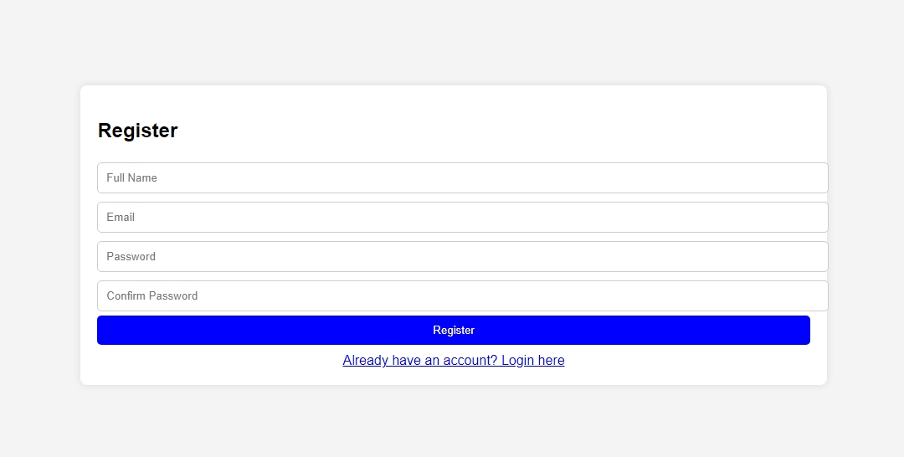

**Task 4:**

<!DOCTYPE html>

<html lang="en">

<head>

    <meta charset="UTF-8">

    <meta name="viewport" content="width=device-width, initial-scale=1.0">

    <title>Seasons</title>

    <style>

        body {

            font-family: Arial, sans-serif;

            margin: 40px;

        }

        h1 {

            font-size: 24px;

            font-weight: bold;

        }

        h2 {

            font-size: 20px;

            font-weight: bold;

        }

        p {

            font-size: 16px;

        }

    </style>

</head>

<body>

    <h1>Seasons</h1>

    <h2>Spring</h2>

    <p>This can be a really long description of spring, taking up an entire paragraph's worth of space.</p>

    <p>There can even be several paragraphs.</p>

    <h2>Summer</h2>

    <p>You can also have one or more paragraphs describing summer.</p>

</body>

</html>

