**Cairo University **

**Faculty of Computers and Information**

**CS251**

**Software Engineering I**

Learnable

**Team HSSN**

|  |  |  |  |
| --- | --- | --- | --- |
| **ID** | **Name** | **Email** | **Mobile** |
| **20140144** | **Salma Samy Mahmoud** | **salma.al.emam96@gmail.com** | **01120842320** |
| **20140147** | **Seif Al-Eslam Gamal Ismail** | **seifgamal007@gmail.com** | **01113244234** |
| **20140103** | **Hussien Hamdy Hussien** | **koryhussien43@gmail.com** | **01155374203** |
| **20140297** | **Nourhan Mohamed Hussan** | **noormohamed.28.96@gmail.com** | **01119348356** |

GitHub Link: https://github.com/SalmaSamy/SW-project

Contents

Team 3

Document Purpose and Audience 3

System Models 3

I. Class diagrams 3

Important Algorithm 5

II. Sequence diagrams 5

Class - Sequence Usage Table 7

**Document Purpose**

This document is created show the website important functions sequences and the classes used with their description and relations.

**Document Audience**

The audience includes the client, the users, the project management, the system analysts (i.e., the developers who participate in the requirements), and the system designers (i.e., the developers who participate in the system design).

# System Models

## Class diagrams

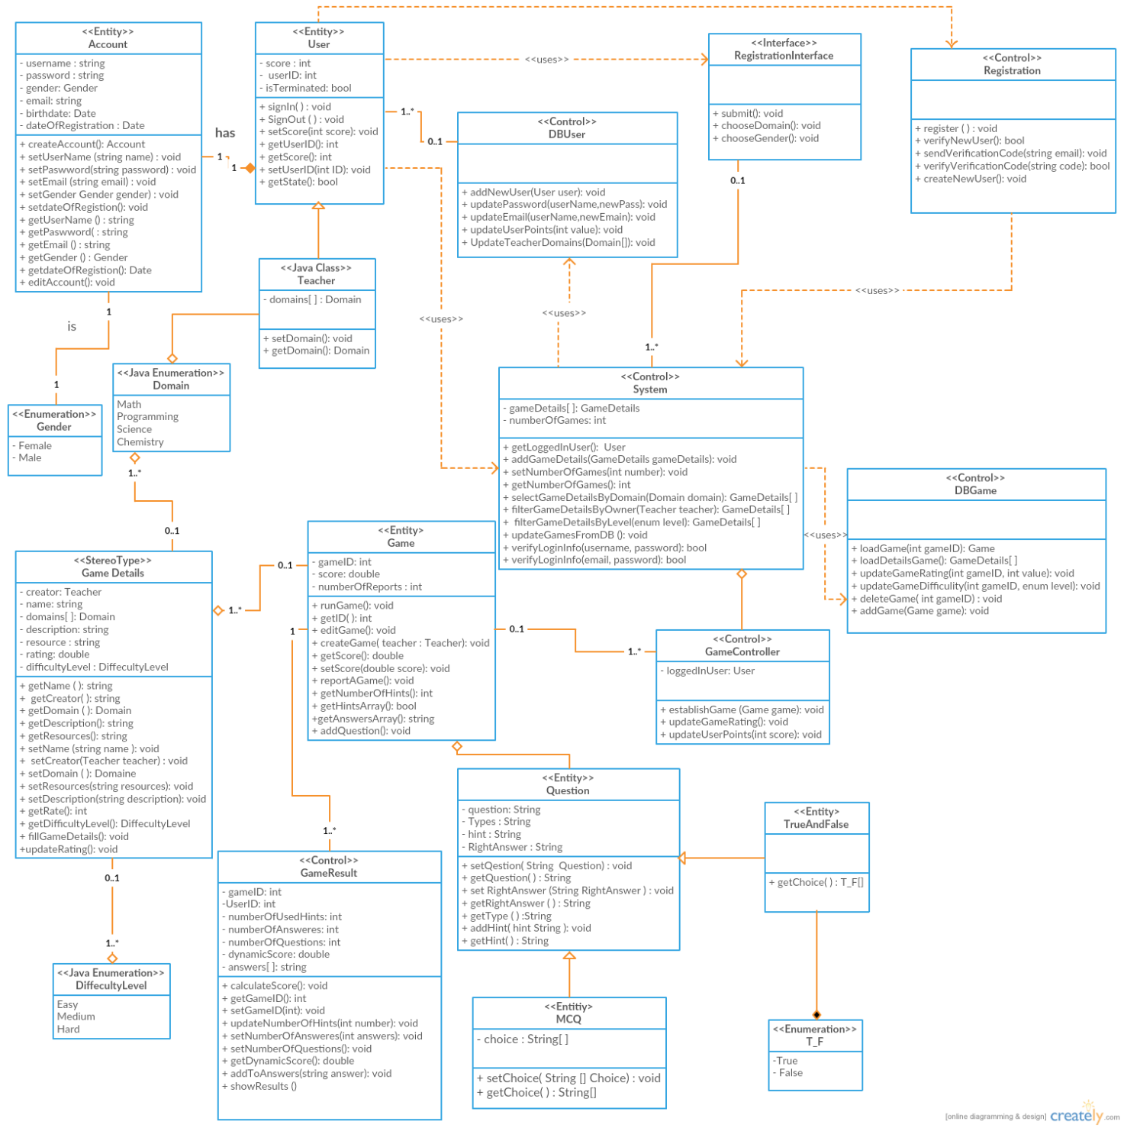

|  |  |  |
| --- | --- | --- |
| **Class ID** | **Class Name** | **Description & Responsibility** |
| 1 | Account | * This class used for filling user’s account information. (e.g. password, username, gender, email). |
| 2 | User | * User is of type Student or Teacher, each has an account and his own score. * Both can play games. |
| 3 | Teacher | * Is a User and also belongs to one or more available Domains |
| 4- | System | * Is a control class to manage what to be shown in the page. |
| 5- | Game | * Run the selected game * System modify any game through this class. |
| 6- | GameResult | * It’s used for updating user’s interaction with the running game. |
| 7- | DBGame | * This class manipulating the Game information in the database. |
| 8- | UserDB | * This class manipulating the User information in the database. |
| 9- | Rigistration | * Verify new User’s input |
| 10- | Domain | * Teacher specify his domain(s) and game is also of type a specific domain(s) through this class. |
| 11- | Question | * Game has an array of questions that user answer it on the game. |
| 12- | RegistrationInterface | * An interface class that User interact with through website. |
| 13- | GameDetails | * Detailed information about game like it’s name, rating.. etc |

### Important Algorithm

## II. Sequence diagrams

1. **Register**

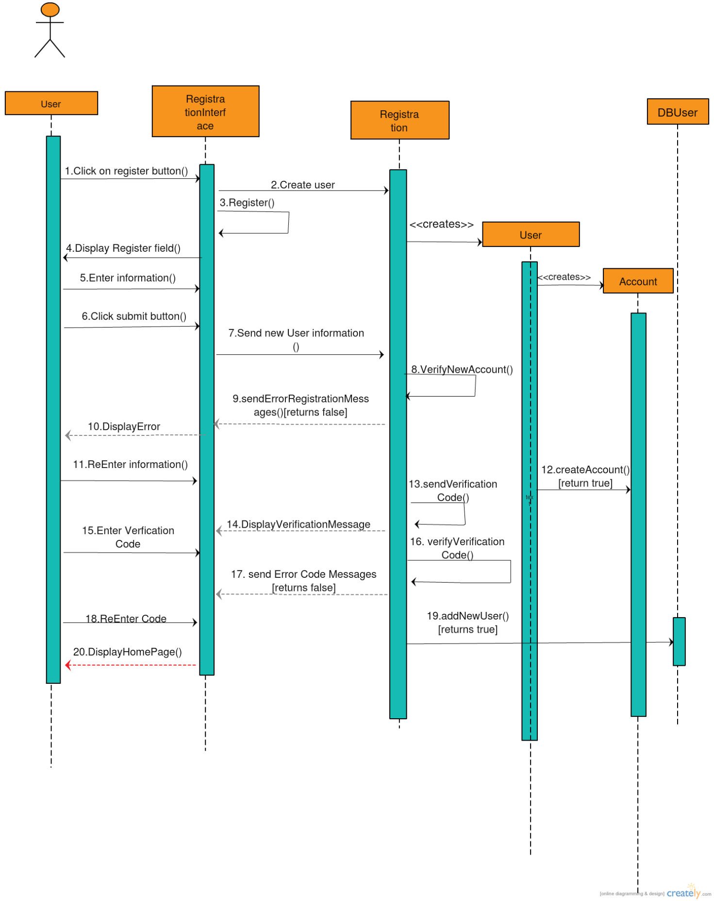

1. **Play Game**

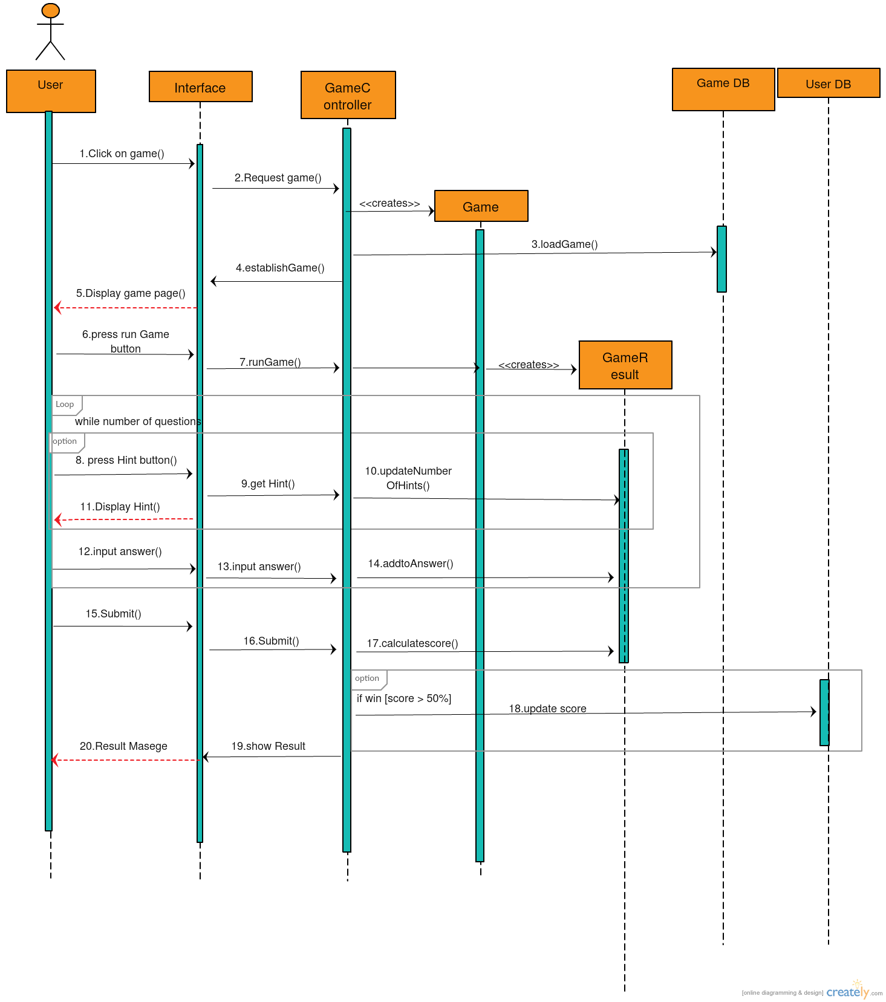

1. **Create Game**

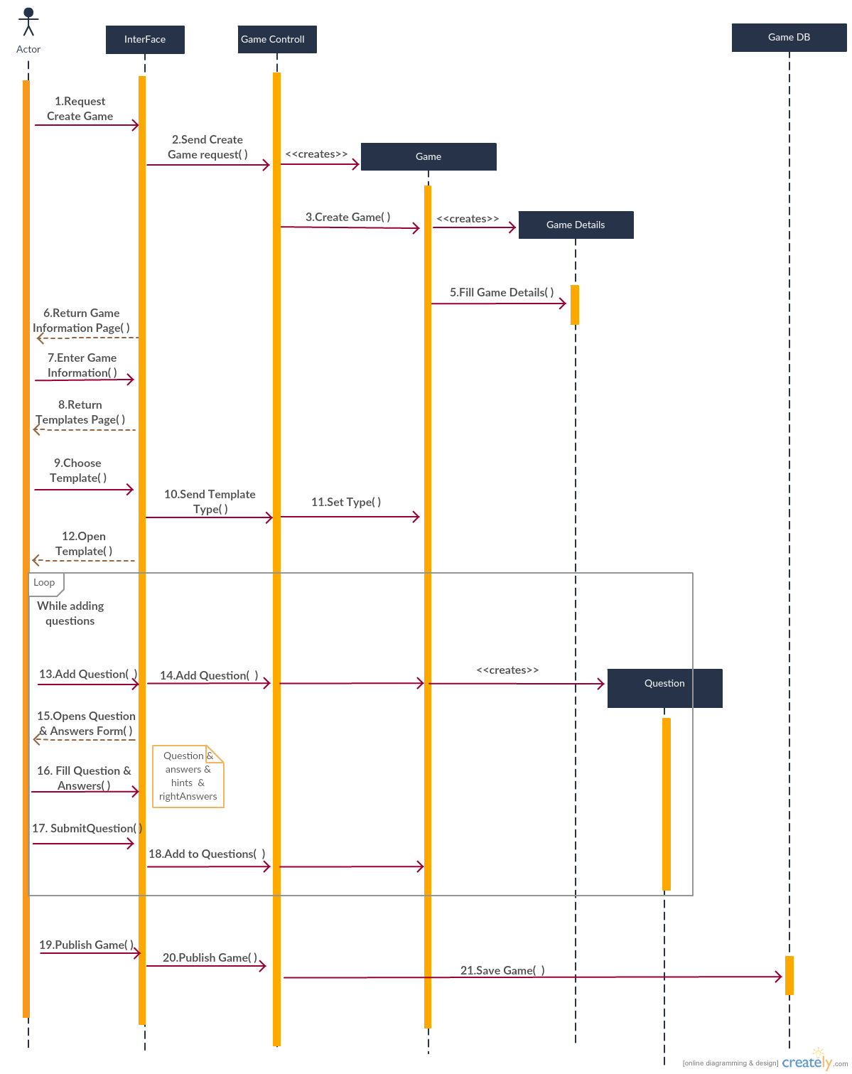

### Class - Sequence Usage Table

| **Class Name** | **Sequence Diagrams** | **Overall used methods** |
| --- | --- | --- |
| Account | 1 | createAccount |
| User | 1 | register |
| Game | 2,3 | runGame, createGame,  addQuestion |
| GameResult | 2 | calculateScore, updateNumberOfHints, addToAnswers, showResults |
| GameController | 2 | establishGame, updateUserPoints |
| DBGame | 2,3 | leadGame , addGame |
| UserDB | 1,2 | addNewUser, updateUserPoints |
| Rigistration | 1 | createNewUser, verifyNewUser, sendVerificationCode, verifyVerificationCode |
| Question | 3 | Setters |
| RegistrationInterface | 1 | submit,  chooseDomain, chooseGender |
| GameDetails | 3 | filGameDetails |