Cairo University 

Faculty of Computers and Information

**CS251**

**Software Engineering I**

Learnable

# Team HSSN

|  |  |  |  |
| --- | --- | --- | --- |
| **ID** | **Name** | **Email** | **Mobile** |
| **20140144** | **Salma Samy Mahmoud** | **salma.al.emam96@gmail.com** | **01120842320** |
| **20140147** | **Seif Al-Eslam Gamal Ismail** | **seifgamal007@gmail.com** | **01113244234** |
| **20140103** | **Hussien Hamdy Hussien** | **koryhussien43@gmail.com** | **01155374203** |
| **20140297** | **Nourhan Mohamed Hussan** | **noormohamed.28.96@gmail.com** | **01119348356** |

GitHub Link: https://github.com/SalmaSamy/SW-project

# Content

**Document Purpose****3**

**Document Audience****4**

**Introduction****4**

Software Purpose 4

Software Scope 5

**Definitions****5**

Student 5

Teacher 6

**Functional Requirements****6**

General functions (Teacher & Student) 6

Login 6

Sign up 7

Choose domain 7

Choose subdomain 7

Filter a game 7

Choose game 7

Play a game 7

Start game 7

View hint 8

Win game 8

Lose game 8

Rate a game 8

view Profile 8

View played games 8

View progress graphs 8

Edit profile 8

Log out 8

Report a game 9

Write a comment 9

Send a message 9

Get notification 9

View messages 9

View conversation 9

Delete conversation 9

View groups 9

Search 9

Student 9

Join a group 9

Leave a group 10

Teacher 10

Write a reply. 10

Create game 10

Choose a template. 10

Fill game requirements 10

Add hint 10

Publish game 10

View created games 10

Edit game 10

Remove game 11

Create a group 11

Add student to group. 11

Show statistics for a group. 11

Add games to group. 11

Remove group 11

**Non Functional Requirements****12**

Privacy 12

Performance 12

Security 12

Usability 12

Availability 13

Scalability 13

Maintainability 13

**Use Case Model:****14**

1. Playing a game 15

2. Create a game 16

3. Create a group 18

4. Send a message 19

5. Sign Up 21

6. View graphs 22

# 

# 

# Document Purpose

This document is created to provide a detailed description of the website and give an easy access to website characteristics and requirements like its purpose, scope, stakeholders.

# Document Audience

The audience includes the client, the users, the project management, the system analysts (i.e., the developers who participate in the requirements), and the system designers (i.e., the developers who participate in the system design).

# Introduction

The project is an educational website for anyone who wants to learn or spread his knowledge.

## Software Purpose

The purpose of this website is to help students for better learning through online games. Student can choose some domain of his/her interests and play games on a topic of that domain, watch videos and see its resources.

Teachers also can use this website to create games on their fields, communicate with their students, and group them together to follow up their performance.

## Software Scope

This website is free, so any student at any age, who is successfully registered in this website, can use all features that are allowed for students including:

* Playing educational games
* Join/Leave learning groups
* Communicating with teachers and students

Similarly, registered teachers can use all features which allowed for them including:

* + Playing educational games
  + Create/Remove his own game
  + Create/Remove a learning group
  + Communicate with students and other teachers

The website has many domains: Math, Science, Technology and Programming. Each domain has its subdomains, (i.e. Math domain includes: Algebra, Geometry, Statistics and others).

The user can choose any domain then subdomain if any, to play the games in it, or even create a game if the user is a teacher, also the user can filter games on the subdomain according to the game owner or difficulty level.

# Definitions

## Student

Students -at any age- who are interested in learning through games.

## Teacher

Any Teacher or Someone who have knowledge and he wants to spread it, not only with explained document/resource or video but also by creating a game explaining some subject easily in a fun way to attract student.

# Functional Requirements

## General functions (Teacher & Student)

### Login

If the user is registered then he can login by entering his/her Email and the chosen Password to access his/her account. In case of entering wrong Email/password he will be notified and asked to re-enter again. Then it will take the user to the main page after logging in.

### Sign up

The user should register by filling some information (e.g. email, username, password ,birthdate and country) to create an account and be able to use the website features.

In this stage the user chooses if he is a “Student” which can only play games, or he is a “Teacher” who can also create games and groups.

### Choose domain

The user will be able to choose a specific domain that he/she wants to learn about from the main page.

### Choose subdomain

The user will be able to choose a specific subject from the domain he/she wants to learn.

### Filter a game

User can filter games of the subdomain by difficulty level or the game owner.

### Choose game

User selects the game to play it, and he will see its information and resources.

### Play a game

#### Start game

On pressing “Start Game” the game window will open and load the interface.

#### View hint

While playing if the player gets to some point where he can’t find a solution, then he can press the “Hint” button which will show him/her the next step but will cost him 10 points of his/her total score.

#### Win game

The player wins the game if he finishes it successfully and then his score will increase by some amount depending on the game level.

#### Lose game

The player loses the game if he can’t finish it successfully, but his/her score won’t be affected.

#### Rate a game

The player can rate the game starting from 1 to 5 stars.

### View Profile

It will open the user's own page that includes his photo, information, groups, games he played and his progress graphs.

You can enter other’s profile to see his visible information.

#### View played games

Will show the user his latest played games and his score in it.

#### View progress graphs

The user can choose some topic and it will show him a graph of his progress in that topic depending on the amount of finished games in it and his scores.

**c. View visable information**

Including age, total score, Country and gender

**Note: if the user is of type Teacher additional information will be shown like:**

1. **View Created games**
2. **Domain(s) of the teacher**

### Edit profile

It will ask the user to enter the password first, then allow him to make changes to his information.

### Log out

It logouts from user account so multi users could use this website from same computer with different accounts.

### Report a game

If the game has some problem, wrong teaching, something offending or bad the user can report it by pressing the “Report” button and choosing why he did so, or write his own reasons.

### Write a comment

On each game a student can add a comment, note or a question and the teacher who created this game will be notified with it.

### Send a message

The user can send a message to any other user to communicate with him and the receiver will be notified with it.

### Get notification

The user will get notifications of anything that is related to him (messages, invitations, comments and replies).

### View messages

The user can press on “Messages” to view it, which will show him the names of the people he talked to.

#### View conversation

It opens the messaging details between the logged in user and the other user.

#### Delete conversation

Itdeletes the chosen message with all its conversations and details.

### View groups

Show all groups which the user is a member in it.

### Search

Search for Specific thing in website user, game or group.

## Student

### Join a group

A student can be added to a group by a teacher to play some chosen games by his teacher.

### Leave a group

The student is allowed to leave the group at any time, and all his information will be removed from the group.

## Teacher

### Write a reply.

The teacher can reply to students comment to clarify or answer their questions.

### Create game

A teacher has the ability to create a game in some subdomain teaching some subject.

#### Choose a template.

The teacher must choose a template for his own game, each domain may have different templates.

Templates can be: Multiple choices, cards flipping, run game code, matching.

#### Fill game requirements

The teacher must fill all required info for the game to be published like name, description and resources.

#### Add hint

The teacher can add hints to his game to help the player in some step.

#### Publish game

It adds the created game to the subdomain in the chosen level.

### View created games

The user can see a list of games created by him if any.

### Edit game

The teacher can edit description, hints, resources, info and steps of his game.

### Remove game

The teacher who created the game can remove it (i.e. its page, name, and all its information will be no longer appear).

### Create a group

Any Teacher can create group to teach some specific students about some subjects he chooses its games.

#### Add student to group.

By sending an invitation for student to do so, the group creator has to press ‘invite user’ and type student’s username.

According to student response for this invitation (accept or refuse) the student will be added to this group or not.

#### Show statistics for a group.

The group creator can see his group members performance (i.e. who solved what?), He can also download a file containing these information.

#### Add games to group.

The group creator can add games by their ID (it appears in URL of the page) if the game is found then it will be successfully added and then members can view/solve it.

### Remove group

The Group creator can remove a group ( i.e. all its members will not be able to use this group again, group statistics and information will be lost).

# Non Functional Requirements

## Privacy

* + User can hide any personal information except:

1. His type (student or teacher).
2. Photo.
   * Statistics appears only to group creator.

## Performance

* + The loading time:
    - For any page of the website must be less than 10 seconds at all.

and refreshed in less than 5 seconds.

* + - For any game to be less than 30 minutes.
    - For getting statistics less than 5 seconds.
  + Graphs and students points must be updated in 5 seconds after playing a game.
  + Loading time for import/export data is at most 5 seconds..

## Security

* + Register on this website must confirm his email to let him use website features.
  + Access permissions for application data may only be changed by the system’s data administrator
  + Password must be at least 8 characters containing at least one small character and one capital character and at least one number.
  + System data backed up every *24* hours and copies stored to restore it in case of any problems.
  + All external communications between the system’s data server and clients must be encrypted.
  + All Data must be protectively marked and stored / protected.

## Usability

* + Games rules should be simple and clear and each game must has its description, hint, resources.
  + Creating games will be easy as there are templates to choose from in each domain.

## Availability

* + Website should be available 24/7 with no down time if possible.
  + Website is available for any operating system.
  + Available for everyone within any location.

## Scalability

* + Website should be handling over thousand operations on a day without any problem or performance issues.

## Maintainability

* + Conformance to Technical design standards.
  + Conformance to coding standards.
  + Modifying the source code should be flexible.

# Use Case Model:

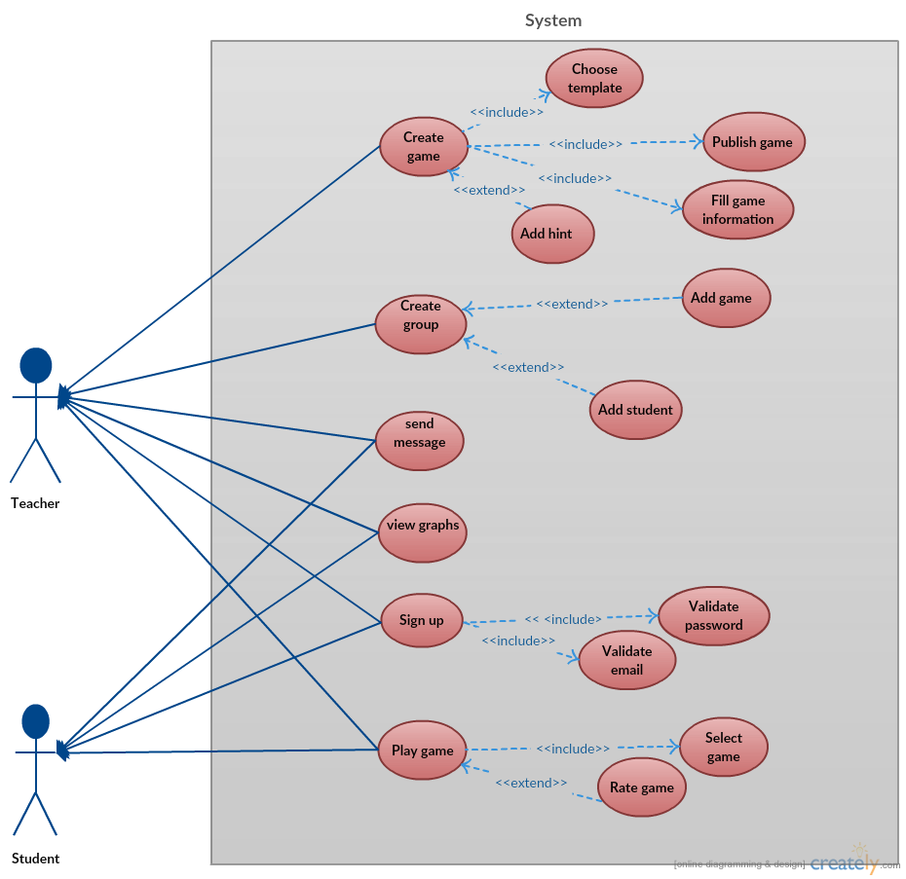

**Actors:**

Teacher and Student were specified before.

**Tables:**

## 1. Playing a game

|  |  |  |
| --- | --- | --- |
| **Use Case ID:** | **1** | |
| **Use Case Name:** | **Playing a game** | |
| **Actors:** | **Teacher, Student** | |
| **Pre-conditions:** | **User choose domain, subdomain and opens the game page.** | |
| **Post-conditions:** | **ٍSystem updates user’s number of points and his graph on that field.** | |
| **Flow of events:** | **User Action** | **System Action** |
| **1- User press ‘play’ button** |  |
|  | **2- Game is in active mode** |
| **3- User solve and play the game** |  |
|  | **4- System increases his points** |
| **5- User can’t solve and ask for hint** |  |
|  | **6- System inform user that he’ll lose some of total points of the game** |
| **7- user can press ‘ok’** |  |
|  | **8- System shows hints and decrease the total number of points of this game for this user** |
| **9- User press ‘close’ button** |  |
|  | **10- System end the game and update points & user graphs.** |
| **11- User rate this game.** |  |
|  | **12- System update overall rate for this game** |
| **13- User report this game** |  |
|  | **14- System receives User’s report messages and apply some validation on it.** |
| **Exceptions:** | **User Action** | **System Action** |
| **1- User lost internet connection while playing.** |  |
|  | **2- System saves his work so far, when connection is back he can continue the game.** |
| **Includes:** | **Select a game, close game, rate game, view hint.** | |
| **Notes and Issues:** | * **For Users to Report a game means select some reason determined by the system or type another reason.** | |

## 2. Create a game

|  |  |  |
| --- | --- | --- |
| **Use Case ID:** | **2** | |
| **Use Case Name:** | **Create a game** | |
| **Actors:** | **Teacher** | |
| **Pre-conditions:** | **The user is logged in and opens Create game page.** | |
| **Post-conditions:** | **The game will be added in the subdomain** | |
| **Flow of events:** | **User Action** | **System Action** |
| **1- The teacher chooses “Create game”** |  |
|  | **2- The available templates in this domain opens** |
| **3- The teacher chooses some template** |  |
|  | **4- The user is asked to fill the game requirements** |
| **5- The teacher clicks “Start Creating game”** |  |
|  | **6- The information is saved and The template opens for editing** |
| **7- The teacher chooses “Add hint”** |  |
|  | **8- A square block of text area is opened in the current page of the game** |
| **9- The teacher presses “Finish”** |  |
|  | **10- The game is created and gets a unique ID** |
| **11- The teacher presses “Publish”** |  |
|  | **12- The game is added in the domain in the chosen level** |
| **Exceptions:** | **User Action** | **System Action** |
| **1- User lost internet connection while creating game.** |  |
|  | **2- System saves his work so far, when connection is back he can continue.** |
| **Includes:** | **Choose template, Fill requirements, Add hint, Publish game** | |
| **Notes and Issues:** | * **Fill requirements of a game including its name, score, description, level and at least one resource( link or upload file)** | |

## 

## 3. Create a group

|  |  |  |
| --- | --- | --- |
| **Use Case ID:** | **3** | |
| **Use Case Name:** | **Create a group** | |
| **Actors:** | **Teacher** | |
| **Pre-conditions:** | **The user is logged in and opens the My Groups page.** | |
| **Post-conditions:** | **The created group will be shown in group list of all of its members.** | |
| **Flow of events:** | **User Action** | **System Action** |
| **1- User press ‘create new group’ button** |  |
|  | **2- System asks the teacher to fill information of the new group: name, description, and info.** |
| **3- User fill all required information** |  |
|  | **4- System validate teacher’s input, if any field is not ok.** |
| **5- Teacher’s refill the missed or incorrect required fields until system accept it.** |  |
| **6- Teacher press ‘done’** |  |
|  | **7- System give this group a unique ID** |
|  | **8- System opens the group page and offer teacher to invite new users or add new games** |
| **9- Teacher add new user and type his username** |  |
|  | **10- System validate if this username is exists**  **If yes user will be added , if not system will ask teacher to re enter the username.** |
| **11- User press ‘add new game’** |  |
|  | **12- System will ask teacher to enter the ID of the game** |
| **13- Teacher enter the ID of the game** |  |
|  | **14- System validate if the game is exists, and add it** |
| **Exceptions:** | **User Action** | **System Action** |
| **1- Teacher invite user that is already a member** |  |
|  | **2- System inform the teacher and let him re-enter the username** |
| **3- member left this group** |  |
|  | **4- all data of this user will be removed and System will update statistics.** |
| **Includes:** | **Add students , add games , show statistics** | |
| **Notes and Issues:** | * **Statistics are typically who (from the members) solve what and when, how many users solve each game and so on.** * **Adding a game is the same as user but the creator enter the ID for the game.** | |

## 4. Send a message

|  |  |  |
| --- | --- | --- |
| **Use Case ID:** | **4** | |
| **Use Case Name:** | **Send a message** | |
| **Actors:** | **Teacher, Student** | |
| **Pre-conditions:** | **User opens Message box** | |
| **Post-conditions:** | **System informs message is submitted.** | |
| **Flow of events:** | **User Action** | **System Action** |
| **1- User press Message box** |  |
|  | **2- System opens Messages form** |
| **3- User press ‘compose a message’** |  |
|  | **5- System opens new form for new message having two fields: to, text** |
| **5- User enters the username in ‘to’ field.** |  |
|  | **6- System validate username.** |
| **7- User type his message in ’text’ field** |  |
| **8- User press ‘send’** |  |
|  | **9- message will be sent** |
| **Exceptions:** | **User Action** | **System Action** |
| **1- User lost internet connection in submitting time.** |  |
|  | **2- System inform user that message is failed to be sent.** |
| **Includes:** |  | |
| **Notes and Issues:** | * **User can choose an old conversation and click on it to see his messages or send new message.** | |

## 5. Sign Up

|  |  |  |
| --- | --- | --- |
| **Use Case ID:** | **5** | |
| **Use Case Name:** | **Sign Up** | |
| **Actors:** | **Teacher, Student** | |
| **Pre-conditions:** | **User on the main page of the website** | |
| **Post-conditions:** | **User can use website features and Homepage will be opened** | |
| **Flow of events:** | **User Action** | **System Action** |
| **1- User press ‘Sign Up’** |  |
|  | **2- System opens SignUp page** |
| **3- User enters his username** |  |
|  | **4- System validate if the username is not used before.** |
| **5- User enters enters his e-mail** |  |
|  | **6- System verify email if exits and not used** |
| **7- User enters required fields** |  |
| **8- if the user is a teacher he must fill his fields of knowledge.** |  |
| **9- User enters ‘SignUp’** |  |
|  | **10- confirmation email will be sent an ask for verify** |
|  | **11- Homepage will be opened** |
| **Includes:** | **Validate email, validate password** | |
| **Notes and Issues:** | * **User must verify his email to use website features.** | |

## 6. View graphs

|  |  |  |
| --- | --- | --- |
| **Use Case ID:** | **6** | |
| **Use Case Name:** | **View graphs** | |
| **Actors:** | **Teacher, Student** | |
| **Pre-conditions:** | **The user is Logged in , profile is opened** | |
| **Flow of events:** | **User Action** | **System Action** |
| **1- The user selects some domain** |  |
|  | **2- The system views a graph of the user progress in that domain** |