Project 3: Fabric/Textile Defect Inspection System
Task 2: Baseline Trained Model, Training Logs & Evaluation Results
Group members: Hussain S., Fataki I., Hlangu L., Dube N.K.

1. Dataset and Preprocessing Summary
The Week 1 work-plan committed to the AITEX dataset. During Week 2, the team switched to the TILDA fabric-defect dataset (64×64 patches, 5 classes: good, hole, objects, oil spot, thread error) after determining that our chosen hardware could not handle AITEX's larger 4096×256 strip images. This substitution is within the project brief's stated allowance for substituting datasets provided the core learning objectives which is the data preparation, model training/evaluation, and a working demo are preserved.
The dataset is heavily imbalanced at the raw level (23,170 “good” images vs. as few as 337 “hole” images, a ~69:1 ratio). To address this, the “good” class was capped at 3,000 images during the training-set rebuild, while all available images for the four rare classes were retained. This reduced the imbalance to ~10.5:1 and reduced total training data volume.
Class | Raw total | Test | Train (final) | Train/Test overlap
good | 23,170 | 3,477 | 3,000 (capped) | 0
hole | 337 | 52 | 285 | 0
objects | 837 | 127 | 710 | 0
oil spot | 636 | 96 | 540 | 0
thread error | 620 | 93 | 527 | 0

2. Model Architecture and Training Approach
Two models were trained, so the effect of the improvements made could be measured directly rather than assumed. Both use transfer learning from a ResNet18 pretrained on ImageNet, with class-weighted cross-entropy loss (weights set inversely proportional to each class's frequency in the training split) to further correct the residual ~10.5:1 imbalance left after the data-preparation step above.

2.1 Baseline (v1)
- Backbone frozen entirely; only a new final layer (5 outputs) is trained.
- Input size 224×224 (standard ImageNet-scale input for this architecture).
- Augmentation: random horizontal flip only.
- Optimizer: Adam, learning rate 1e-3, on the final layer only.
- 10 epochs, batch size 32.

2.2 Improved model (v2)
- Backbone mostly frozen, but the last residual block (layer4) is unfrozen and fine-tuned, in addition to the new final layer allowing pretrained features to adapt to fabric texture rather than staying fixed at generic-photo features.
- Input size reduced to 128×128 (closer to the data's native 64×64 resolution, reducing computation to afford the extra cost of fine-tuning layer4).
- Augmentation: horizontal flip + random rotation (±15°) + brightness/contrast jitter, to give the model more varied examples of the rare classes.
- Optimizer: Adam with two learning rates: 1e-3 for the new final layer and 1e-4 for the fine-tuned layer4 (a smaller rate since those weights are already good and only need adjusting, not learning from scratch).
- 15 epochs, batch size 32.

2.3 Environment
- Python 3.13, PyTorch 2.13.0, torchvision 0.28.0, scikit-learn, matplotlib which was installed in a project-local virtual environment.
- Trained on CPU only (no GPU available on the training machine).
- Fixed random seed (42) used throughout for a reproducible train/validation split and initialization.

3. Training Logs
15% of the training set was held out as a validation set to monitor learning during training; the test set was never used until the separate evaluation step in Section 4. Full per-epoch logs are provided in logs/training_log.csv and logs/training_log_v2.csv.
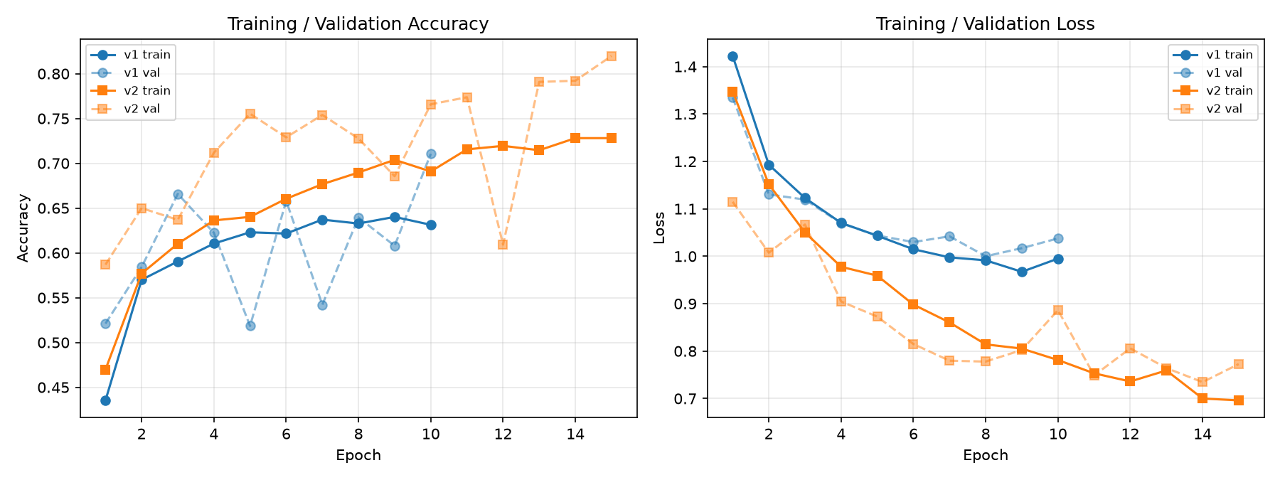
v1's validation accuracy is noisy across epochs (52%–71%), consistent with a baseline that only adjusts one layer and is evaluated on a small validation set (760 images). v2's validation accuracy climbs far more consistently, reaching 82.0% by epoch 15, evidence that unfreezing layer4 and adding augmentation genuinely helped the model learn, rather than just changing the accuracy/recall trade-off.

 | v1 (baseline) | v2 (improved)
Epochs | 10 | 15
Best validation accuracy | 71.05% (epoch 10) | 81.97% (epoch 15)
Final training accuracy | 63.1% | 72.8%

4. Evaluation Results
Both models were evaluated on the 3,845-image test set, which was never used during training or validation. As a reference point: a model that always predicts “good” (the majority class) would score 90.4% accuracy on this test set while catching zero real defects which is why accuracy alone is not a sufficient metric here, and per-class precision/recall/F1 are reported alongside it.
Metric | v1 (baseline) | v2 (improved)
Overall test accuracy | 81.48% | 89.83%
Macro-average precision | 0.413 | 0.621
Macro-average recall | 0.607 | 0.737
Macro-average F1-score | 0.460 | 0.654

4.1 Per-class F1-score
Class | v1 F1 | v2 F1
good | 0.905 | 0.950
hole | 0.442 | 0.748
objects | 0.365 | 0.590
oil spot | 0.256 | 0.387
thread error | 0.335 | 0.593

V1 shows the expected effect of class-weighted loss on a frozen backbone: recall on rare classes is reasonable (up to 69% for hole) but precision is low (as low as 15.8% for oil spot), meaning many false alarms. V2 improves both precision and recall for every single class simultaneously which does not simply trade accuracy for recall, it is a genuinely better model, most plausibly because fine-tuning layer4 lets the network learn fabric-specific features instead of relying on generic ImageNet features.

4.2 Confusion matrices
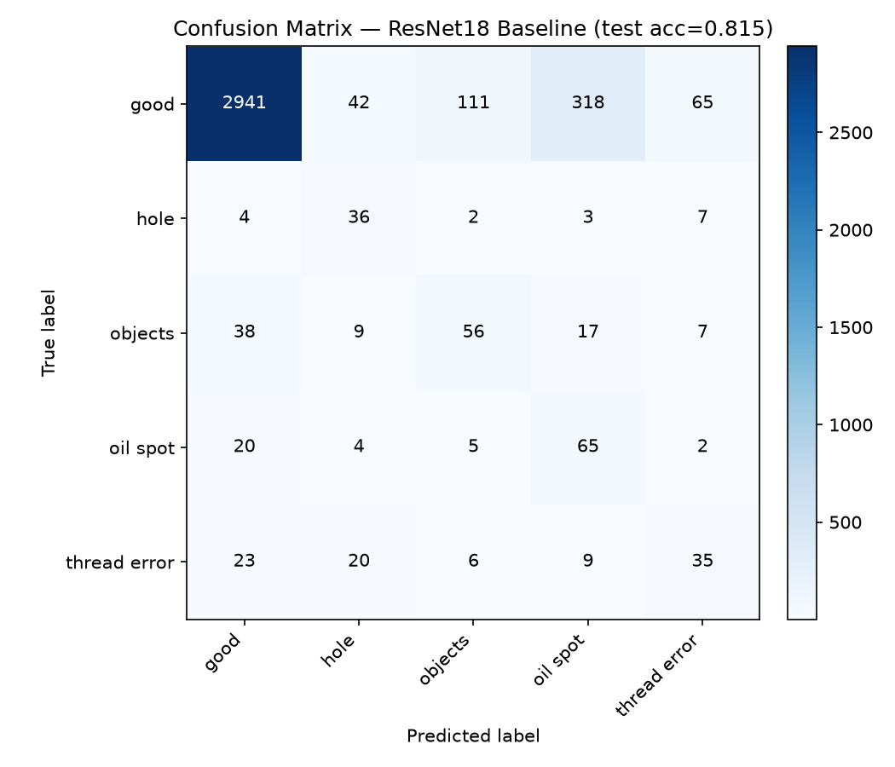
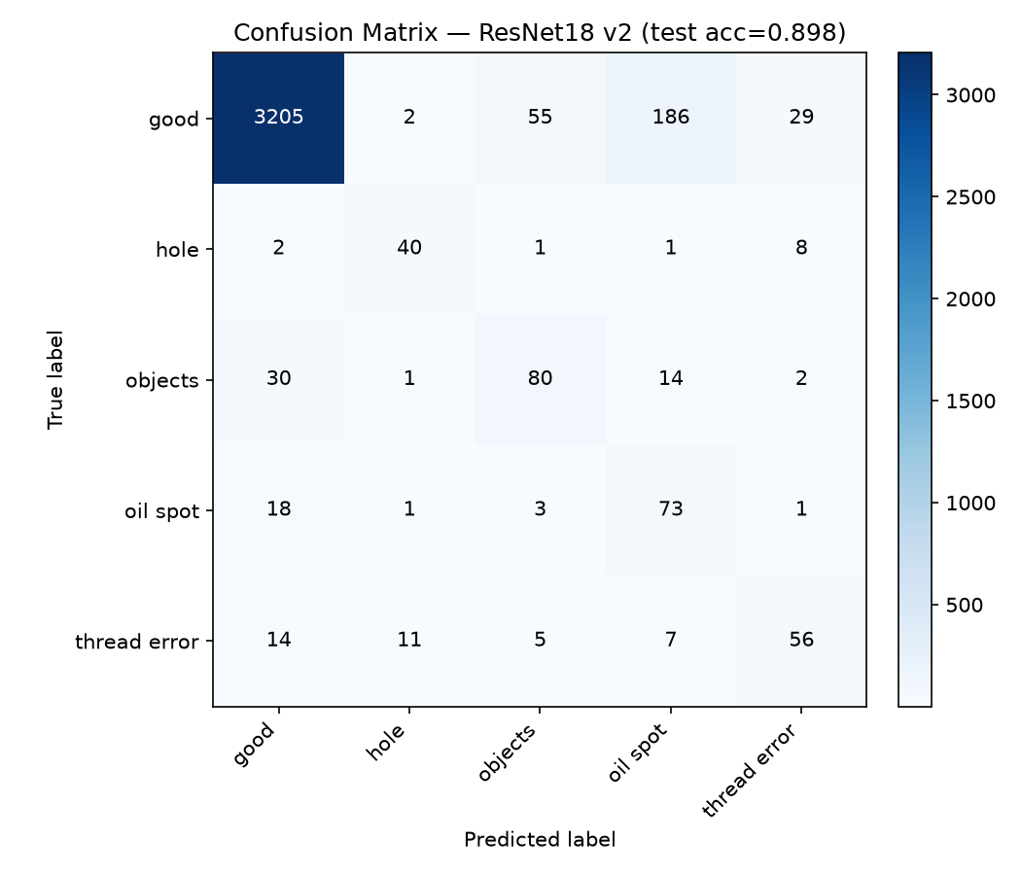
“Oil spot” remains the weakest class in both versions (v2 precision 26.0%): the model over-flags other classes as oil spot, even though it does catch 76% of true oil-spot images. This is noted as a known limitation in Section 6.

5. Reproducibility
All scripts referenced above are included in scripts. To reproduce these results from raw data:
- 1. build_train_split.py - rebuilds the training set from raw data (all 5 classes, “good” capped at 3,000, seed=42).
- 2. train_resnet18.py - trains the v1 baseline; train_resnet18_v2.py - trains the v2 improved model.
- 3. evaluate_resnet18.py / evaluate_resnet18_v2.py - evaluate the corresponding trained model on the held-out test set.
- 4. make_training_curves.py - generates the comparison chart in Section 3.

6. Limitations and Next Steps
- “Oil spot” precision remains the weakest metric (26.0% in v2) which candidates for improvement include further augmentation targeted at this class or restructuring as a two-stage model (binary defective/non-defective, then defect-type classification only on flagged images).
- Both models were trained and evaluated on pre-cut 64×64 patches; scanning a full-size camera frame for the demo will require a sliding-window approach to apply the classifier across a larger image, which has not yet been implemented.
- The demo integration (webcam/conveyor-belt simulation, dashboard, defect logging) is planned for the following weeks per the teamwork-plan and has not started.
- Using TILDA's 5-class taxonomy instead of AITEX's 12-class taxonomy is a scope trade-off driven by data availability and hardware constraints; this should be stated explicitly in the final report as a deliberate, justified decision.

