**Name: Salman Irfan**

**Roll no: 2021-MSCS-511**

**Course: Artificial Neural Networks**

**Submitted To: Dr. Muhammad Awais Hassan**

**Assignment 3**

**Part 1: -**

C++ program take input two parameter 𝜃0 and 𝜃1 of a hypothesis function and display total cost based on the given data.

**Source Code: -**

#*include* <iostream>

#*include* <fstream>

#*include* <sstream>

#*include* <cmath>

using namespace std;

// *global variables*

*const* double ALPHA = 0.01;// *learning rate*

int n;// *number of data points*

*const* int MAX_ROWS = 100;

*const* int MAX_COLS = 100;

int globalNumRows = 0;// *dynamically gets number of rows from file*

int globalNumCols = 0;// *dynamically gets number of cols from file*

double x[MAX_ROWS], y[MAX_COLS];// *input data*

double theta0, theta1;// *hypothesis parameters*

string globalFileName;

bool isFileExist = false;

double globalInputArray[MAX_ROWS];

double globalOutputArray[MAX_ROWS];

// *input file from user*

string *chooseFile*()

{

    string fileName;

    cout *<<* "File to Train = ";

    cin *>>* fileName;

*return* fileName;

}

// *function to read csv file*

bool *readCsvFile*(double data[MAX_ROWS][MAX_COLS], string fileName)

{

    int numRows = 0;

    int numCols = 0;

    ifstream *file*(fileName);

*if* (file.*is_open*())

    {

        cout *<<* "\033[32m" *<<* fileName *<<* " is opened successfully"

*<<* "\033[0m" *<<* *endl*;

        string line;// *storing each line of the file*

        int row = 0;// *to keep track the current row, by default representing first row*

// *getline (input stream, line by line, delimiter)*

*while* (*getline*(file, line) && row < MAX_ROWS)

        {

            stringstream *ss*(line);// *Use stringstream to split each line into fields*

            string field;// *store each field / csv of the line*

            int col = 0;// *to keep track the current col, by default representing first col*

*while* (*getline*(ss, field, ',') && col < MAX_COLS)

            {// *read fields upto maximum number of columns*

                data[row][col] = *stod*(field);// *storing the data in the respective column*

                col++;

            }

            row++;

            numRows++;

*if* (col > numCols)

            {

                numCols = col;

                globalNumCols = numCols;

            }

        }

        file.*close*();

        isFileExist = true;

    }

*else*

    {// *if the file was not opened successfully*

        cout *<<* "\033[31m"

*<<* "Failed to open file: " *<<* fileName *<<* "\033[0m" *<<* *endl*;

    }

    globalNumRows = numRows;

*return* isFileExist;

}

void *printArray*(double data[MAX_ROWS][MAX_COLS])

{

*for* (int i = 0; i < globalNumRows; i++)

    {// *for each row*

*for* (int j = 0; j < globalNumCols; j++)

        {// *for each column*

            cout *<<* data[i][j] *<<* " ";

        }

        cout *<<* *endl*;

    }

}

// *computes the predicted value of y for a given value of x*

double *predict*(double xValue)

{

    double yPred = theta0 + theta1 * xValue;// *hypothesis function*

*return* yPred;

}

// *computes the cost of the hypothesis function with parameters theta0 and theta1*

double *computeCost*()

{

    double cost = 0;

*for* (int i = 0; i < globalNumRows; i++)

    {

        double h = *predict*(globalInputArray[i]);// *hypothesis function*

        double diff = h - globalOutputArray[i];// *difference between hypothesis and actual value*

        cost += diff * diff;// *squared difference*

    }

    cost /= (2 * n);// *average squared difference*

*return* cost;

}

// *computes the cost of the hypothesis function with parameters theta0 and theta1*

double *computeCost*(double t0, double t1)

{

    double cost = 0;

*for* (int i = 0; i < globalNumRows; i++)

    {

        double h = t0 + t1 * globalInputArray[i];// *hypothesis function*

        double diff = h - globalOutputArray[i];// *difference between hypothesis and actual value*

        cost += diff * diff;// *squared difference*

    }

    cost /= (2 * globalNumRows);// *average squared difference*

*return* cost;

}

// *updates the hypothesis parameters using gradient descent*

void *updateParameters*()

{

    double theta0Sum = 0, theta1Sum = 0;

*for* (int i = 0; i < globalNumRows; i++)

    {

        double h = *predict*(globalInputArray[i]);// *hypothesis function*

        double diff = h - globalOutputArray[i];// *difference between hypothesis and actual value*

        theta0Sum += diff;// *partial derivative of cost with respect to theta0*

        theta1Sum += diff * globalInputArray[i];// *partial derivative of cost with respect to theta1*

    }

    theta0 -= ALPHA * theta0Sum / globalNumRows;// *update theta0*

    theta1 -= ALPHA * theta1Sum / globalNumRows;// *update theta1*

}

// *trains the hypothesis function using gradient descent*

void *train*()

{

*for* (int i = 0; i < MAX_ROWS; i++)

    {

        double prev_cost = *computeCost*();// *compute previous cost*

*updateParameters*();// *update hypothesis parameters*

        double curr_cost = *computeCost*();// *compute current cost*

*if* (prev_cost - curr_cost < 1e-6)

        {// *check for convergence*

*break*;

        }

    }

}

int *main*()

{

    string fileName = *chooseFile*();

    globalFileName *=* fileName;

// *storing data from file*

    double data[MAX_ROWS][MAX_COLS];

*readCsvFile*(data, fileName);// *calling function for reading file*

*printArray*(data);

*if* (isFileExist)

    {

        double inputArray[MAX_ROWS];

        cout *<<* "input1Array \n";

*for* (int i = 0; i < globalNumRows; i++)

        {

            inputArray[i] = data[i][0];

            globalInputArray[i] = inputArray[i];

            cout *<<* inputArray[i] *<<* "\n";

        }

        double outputArray[MAX_ROWS];

        cout *<<* "outputArray \n";

*for* (int i = 0; i < globalNumRows; i++)

        {

            outputArray[i] = data[i][1];

            globalOutputArray[i] = outputArray[i];

            cout *<<* outputArray[i] *<<* "\n";

        }

    }

// *read hypothesis parameters*

    cout *<<* "enter hypothesis parameters: " *<<* *endl*;

    cout *<<* "theta0 = ";

    cin *>>* theta0;

    cout *<<* "theta1 = ";

    cin *>>* theta1;

// *train the hypothesis function*

*train*();

// *test the hypothesis function*

    double xValue;

    cout *<<* "enter x value to predict y: ";

    cin *>>* xValue;

    double yPred = *predict*(xValue);

    cout *<<* "predicted y value: " *<<* yPred *<<* *endl*;

// *compute cost*

    double costModel = *computeCost*(theta0, theta1);

    cout*<<*"costModel = "*<<* costModel *<<* "\n";

*return* 0;

}

**Output: -**

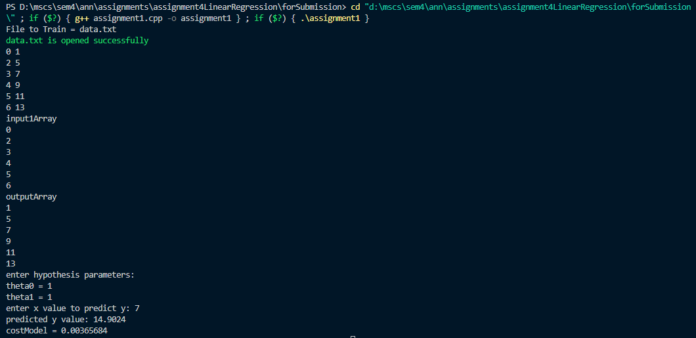

**Part 2: -**

Extend the previous assignment 01, now it should take parameters of two models and return the parameters of best model.

**Source Code: -**

#*include* <iostream>

#*include* <fstream>

#*include* <sstream>

#*include* <cmath>

using namespace std;

// *global variables*

*const* double ALPHA = 0.01;// *learning rate*

int n;// *number of data points*

*const* int MAX_ROWS = 100;

*const* int MAX_COLS = 100;

int globalNumRows = 0;// *dynamically gets number of rows from file*

int globalNumCols = 0;// *dynamically gets number of cols from file*

double x[MAX_ROWS], y[MAX_COLS];// *input data*

double theta0, theta1;// *hypothesis parameters*

string globalFileName;

bool isFileExist = false;

double globalInputArray[MAX_ROWS];

double globalOutputArray[MAX_ROWS];

// *input file from user*

string *chooseFile*()

{

    string fileName;

    cout *<<* "File to Train = ";

    cin *>>* fileName;

*return* fileName;

}

// *function to read csv file*

bool *readCsvFile*(double data[MAX_ROWS][MAX_COLS], string fileName)

{

    int numRows = 0;

    int numCols = 0;

    ifstream *file*(fileName);

*if* (file.*is_open*())

    {

        cout *<<* "\033[32m" *<<* fileName *<<* " is opened successfully"

*<<* "\033[0m" *<<* *endl*;

        string line;// *storing each line of the file*

        int row = 0;// *to keep track the current row, by default representing first row*

// *getline (input stream, line by line, delimiter)*

*while* (*getline*(file, line) && row < MAX_ROWS)

        {

            stringstream *ss*(line);// *Use stringstream to split each line into fields*

            string field;// *store each field / csv of the line*

            int col = 0;// *to keep track the current col, by default representing first col*

*while* (*getline*(ss, field, ',') && col < MAX_COLS)

            {// *read fields upto maximum number of columns*

                data[row][col] = *stod*(field);// *storing the data in the respective column*

                col++;

            }

            row++;

            numRows++;

*if* (col > numCols)

            {

                numCols = col;

                globalNumCols = numCols;

            }

        }

        file.*close*();

        isFileExist = true;

    }

*else*

    {// *if the file was not opened successfully*

        cout *<<* "\033[31m"

*<<* "Failed to open file: " *<<* fileName *<<* "\033[0m" *<<* *endl*;

    }

    globalNumRows = numRows;

*return* isFileExist;

}

void *printArray*(double data[MAX_ROWS][MAX_COLS])

{

*for* (int i = 0; i < globalNumRows; i++)

    {// *for each row*

*for* (int j = 0; j < globalNumCols; j++)

        {// *for each column*

            cout *<<* data[i][j] *<<* " ";

        }

        cout *<<* *endl*;

    }

}

// *computes the predicted value of y for a given value of x*

double *predict*(double xValue)

{

    double yPred = theta0 + theta1 * xValue;// *hypothesis function*

*return* yPred;

}

// *computes the cost of the hypothesis function with parameters theta0 and theta1*

double *computeCost*(double t0, double t1)

{

    double cost = 0;

*for* (int i = 0; i < globalNumRows; i++)

    {

        double h = t0 + t1 * globalInputArray[i];// *hypothesis function*

        double diff = h - globalOutputArray[i];// *difference between hypothesis and actual value*

        cost += diff * diff;// *squared difference*

    }

    cost /= (2 * globalNumRows);// *average squared difference*

*return* cost;

}

// *updates the hypothesis parameters using gradient descent*

void *updateParameters*()

{

    double theta0Sum = 0, theta1Sum = 0;

*for* (int i = 0; i < globalNumRows; i++)

    {

        double h = *predict*(globalInputArray[i]);// *hypothesis function*

        double diff = h - globalOutputArray[i];// *difference between hypothesis and actual value*

        theta0Sum += diff;// *partial derivative of cost with respect to theta0*

        theta1Sum += diff * globalInputArray[i];// *partial derivative of cost with respect to theta1*

    }

    theta0 -= ALPHA * theta0Sum / globalNumRows;// *update theta0*

    theta1 -= ALPHA * theta1Sum / globalNumRows;// *update theta1*

}

// *trains the hypothesis function using gradient descent*

void *train*()

{

*for* (int i = 0; i < MAX_ROWS; i++)

    {

        double prevCost = *computeCost*(theta0, theta1);

*updateParameters*();

        double currCost = *computeCost*(theta0, theta1);

*if* (prevCost - currCost < 1e-6)

        {

*break*;

        }

    }

}

int *main*()

{

    string fileName = *chooseFile*();

    globalFileName *=* fileName;

// *storing data from file*

    double data[MAX_ROWS][MAX_COLS];

*readCsvFile*(data, fileName);// *calling function for reading file*

*printArray*(data);

*if* (isFileExist)

    {

        double inputArray[MAX_ROWS];

        cout *<<* "input1Array \n";

*for* (int i = 0; i < globalNumRows; i++)

        {

            inputArray[i] = data[i][0];

            globalInputArray[i] = inputArray[i];

            cout *<<* inputArray[i] *<<* "\n";

        }

        double outputArray[MAX_ROWS];

        cout *<<* "outputArray \n";

*for* (int i = 0; i < globalNumRows; i++)

        {

            outputArray[i] = data[i][1];

            globalOutputArray[i] = outputArray[i];

            cout *<<* outputArray[i] *<<* "\n";

        }

    }

// *read hypothesis parameters*

    cout *<<* "enter hypothesis parameters: " *<<* *endl*;

    cout *<<* "theta0 = ";

    cin *>>* theta0;

    cout *<<* "theta1 = ";

    cin *>>* theta1;

    double theta0ModelOne = theta0;

    double theta1ModelOne = theta1;

// *train the hypothesis function*

*train*();

    double xValue;

    cout *<<* "enter x value to predict y: ";

    cin *>>* xValue;

    double yPred = *predict*(xValue);

    cout *<<* "predicted y value: " *<<* yPred *<<* *endl*;

// *compute cost*

    double costModel1 = *computeCost*(theta0, theta1);

    cout*<<*"costModel1 = "*<<* costModel1 *<<* "\n";

// *train another model*

    cout *<<* "enter hypothesis parameters for model two: " *<<* *endl*;

    cout *<<* "theta0 = ";

    cin *>>* theta0;

    cout *<<* "theta1 = ";

    cin *>>* theta1;

    double theta0ModelTwo = theta0;

    double theta1ModelTwo = theta1;

// *train the hypothesis function*

*train*();

    yPred = *predict*(xValue);

    cout *<<* "predicted y value: " *<<* yPred *<<* *endl*;

// *compute cost*

    double costModel2 = *computeCost*(theta0, theta1);

    cout*<<*"costModel2 = "*<<* costModel2 *<<* "\n";

// *deciding best model*

*if* (costModel1 < costModel2){

        cout *<<* "the best model is model 1 with \ntheta0 = "*<<* theta0ModelOne *<<* " and \ntheta1 = " *<<* theta1ModelOne *<<* "\n";

    }

*else*{

        cout *<<* "the best model is model 1 with \ntheta0 = "*<<* theta0ModelTwo *<<* " and \ntheta1 = " *<<* theta1ModelTwo *<<* "\n";

    }

*return* 0;

}

**Output: -**

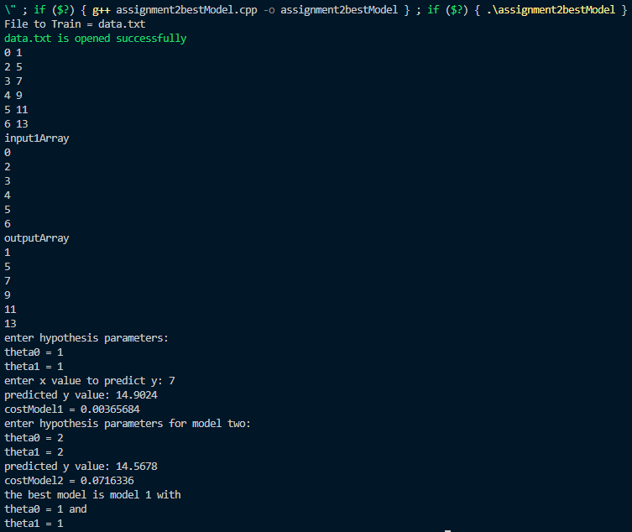

**Part 3: -**

Extend the previous assignments, write a program that read the data and proposed the linear regression parameters.

(You can add range constrain on parameters).

Hint you need to change the first parameter value and keep the second parameter constant.

**Source Code: -**

#*include* <iostream>

#*include* <fstream>

#*include* <sstream>

#*include* <cmath>

using namespace std;

// *global variables*

*const* double ALPHA = 0.01;// *learning rate*

int n;// *number of data points*

*const* int MAX_ROWS = 100;

*const* int MAX_COLS = 100;

int globalNumRows = 0;// *dynamically gets number of rows from file*

int globalNumCols = 0;// *dynamically gets number of cols from file*

double x[MAX_ROWS], y[MAX_COLS];// *input data*

double theta0, theta1;// *hypothesis parameters*

string globalFileName;

bool isFileExist = false;

double globalInputArray[MAX_ROWS];

double globalOutputArray[MAX_ROWS];

// *input file from user*

string *chooseFile*()

{

    string fileName;

    cout *<<* "File to Train = ";

    cin *>>* fileName;

*return* fileName;

}

// *function to read csv file*

bool *readCsvFile*(double data[MAX_ROWS][MAX_COLS], string fileName)

{

    int numRows = 0;

    int numCols = 0;

    ifstream *file*(fileName);

*if* (file.*is_open*())

    {

        cout *<<* "\033[32m" *<<* fileName *<<* " is opened successfully"

*<<* "\033[0m" *<<* *endl*;

        string line;// *storing each line of the file*

        int row = 0;// *to keep track the current row, by default representing first row*

// *getline (input stream, line by line, delimiter)*

*while* (*getline*(file, line) && row < MAX_ROWS)

        {

            stringstream *ss*(line);// *Use stringstream to split each line into fields*

            string field;// *store each field / csv of the line*

            int col = 0;// *to keep track the current col, by default representing first col*

*while* (*getline*(ss, field, ',') && col < MAX_COLS)

            {// *read fields upto maximum number of columns*

                data[row][col] = *stod*(field);// *storing the data in the respective column*

                col++;

            }

            row++;

            numRows++;

*if* (col > numCols)

            {

                numCols = col;

                globalNumCols = numCols;

            }

        }

        file.*close*();

        isFileExist = true;

    }

*else*

    {// *if the file was not opened successfully*

        cout *<<* "\033[31m"

*<<* "Failed to open file: " *<<* fileName *<<* "\033[0m" *<<* *endl*;

    }

    globalNumRows = numRows;

*return* isFileExist;

}

void *printArray*(double data[MAX_ROWS][MAX_COLS])

{

*for* (int i = 0; i < globalNumRows; i++)

    {// *for each row*

*for* (int j = 0; j < globalNumCols; j++)

        {// *for each column*

            cout *<<* data[i][j] *<<* " ";

        }

        cout *<<* *endl*;

    }

}

// *computes the predicted value of y for a given value of x*

double *predict*(double xValue)

{

    double yPred = theta0 + theta1 * xValue;// *hypothesis function*

*return* yPred;

}

// *computes the cost of the hypothesis function with parameters theta0 and theta1*

double *computeCost*(double t0, double t1)

{

    double cost = 0;

*for* (int i = 0; i < globalNumRows; i++)

    {

        double h = t0 + t1 * globalInputArray[i];// *hypothesis function*

        double diff = h - globalOutputArray[i];// *difference between hypothesis and actual value*

        cost += diff * diff;// *squared difference*

    }

    cost /= (2 * globalNumRows);// *average squared difference*

*return* cost;

}

// *updates the hypothesis parameters using gradient descent*

void *updateParameters*()

{

    double theta0Sum = 0, theta1Sum = 0;

*for* (int i = 0; i < globalNumRows; i++)

    {

        double h = *predict*(globalInputArray[i]);// *hypothesis function*

        double diff = h - globalOutputArray[i];// *difference between hypothesis and actual value*

        theta0Sum += diff;// *partial derivative of cost with respect to theta0*

        theta1Sum += diff * globalInputArray[i];// *partial derivative of cost with respect to theta1*

    }

    theta0 -= ALPHA * theta0Sum / globalNumRows;// *update theta0*

    theta1 -= ALPHA * theta1Sum / globalNumRows;// *update theta1*

}

// *find the linear regression parameters with a range constraint of 1 to 10*

void *findLinearRegressionParameters*() {

    double suggestedCost = *INFINITY*;// *initialize to positive infinity*

    double suggestedTheta0, suggestedTheta1;

*for* (int i = 1; i <= 10; i++) {// *range constraint of 1 to 10*

        double theta0 = i;// *first parameter value*

        double theta1 = 0;// *keep the second parameter constant at 0*

        double cost = *computeCost*(theta0, theta1);

*if* (cost < suggestedCost) {

            suggestedCost = cost;

            suggestedTheta0 = theta0;

            suggestedTheta1 = theta1;

        }

    }

    cout *<<* "suggested model: theta0 = " *<<* suggestedTheta0 *<<* ", theta1 = " *<<* suggestedTheta1 *<<* *endl*;

}

// *trains the hypothesis function using gradient descent*

void *train*()

{

*for* (int i = 0; i < MAX_ROWS; i++)

    {

        double prevCost = *computeCost*(theta0, theta1);

*updateParameters*();

        double currCost = *computeCost*(theta0, theta1);

*if* (prevCost - currCost < 1e-6)

        {

*break*;

        }

    }

}

int *main*()

{

    string fileName = *chooseFile*();

    globalFileName *=* fileName;

// *storing data from file*

    double data[MAX_ROWS][MAX_COLS];

*readCsvFile*(data, fileName);// *calling function for reading file*

*printArray*(data);

*if* (isFileExist)

    {

        double inputArray[MAX_ROWS];

        cout *<<* "input1Array \n";

*for* (int i = 0; i < globalNumRows; i++)

        {

            inputArray[i] = data[i][0];

            globalInputArray[i] = inputArray[i];

            cout *<<* inputArray[i] *<<* "\n";

        }

        double outputArray[MAX_ROWS];

        cout *<<* "outputArray \n";

*for* (int i = 0; i < globalNumRows; i++)

        {

            outputArray[i] = data[i][1];

            globalOutputArray[i] = outputArray[i];

            cout *<<* outputArray[i] *<<* "\n";

        }

    }

// *read hypothesis parameters for model one*

    cout *<<* "enter hypothesis parameters: " *<<* *endl*;

    cout *<<* "theta0 = ";

    cin *>>* theta0;

    cout *<<* "theta1 = ";

    cin *>>* theta1;

    double theta0ModelOne = theta0;

    double theta1ModelOne = theta1;

// *train the hypothesis function*

*train*();

    double xValue;

    cout *<<* "enter x value to predict y: ";

    cin *>>* xValue;

    double yPred = *predict*(xValue);

    cout *<<* "predicted y value: " *<<* yPred *<<* *endl*;

// *compute cost*

    double costModel1 = *computeCost*(theta0, theta1);

    cout*<<*"costModel1 = "*<<* costModel1 *<<* "\n";

// *find the linear regression parameters*

*findLinearRegressionParameters*();

// *train another model two*

    cout *<<* "enter hypothesis parameters for model two: " *<<* *endl*;

    cout *<<* "theta0 = ";

    cin *>>* theta0;

    cout *<<* "theta1 = ";

    cin *>>* theta1;

    double theta0ModelTwo = theta0;

    double theta1ModelTwo = theta1;

// *train the hypothesis function*

*train*();

    yPred = *predict*(xValue);

    cout *<<* "predicted y value: " *<<* yPred *<<* *endl*;

// *find the linear regression parameters*

*findLinearRegressionParameters*();

// *compute cost*

    double costModel2 = *computeCost*(theta0, theta1);

    cout*<<*"costModel2 = "*<<* costModel2 *<<* "\n";

// *deciding best model*

*if* (costModel1 < costModel2){

        cout *<<* "the best model is model 1 with \ntheta0 = "*<<* theta0ModelOne *<<* " & \ntheta1 = " *<<* theta1ModelOne *<<* "\n";

    }

*else*{

        cout *<<* "the best model is model 2 with \ntheta0 = "*<<* theta0ModelTwo *<<* " & \ntheta1 = " *<<* theta1ModelTwo *<<* "\n";

    }

*return* 0;

}

**Output: -**

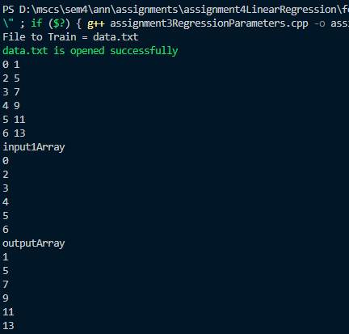

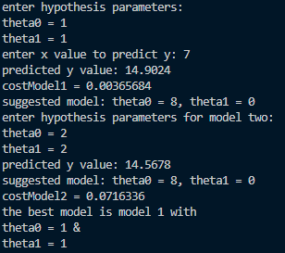

**Part 4: -**

Calculate the runtime of algorithm.

**Source Code: -**

#*include* <iostream>

#*include* <fstream>

#*include* <sstream>

#*include* <cmath>

#*include* <chrono> // *for seconds counting*

using namespace std;

using namespace std::chrono;

// *global variables*

*const* double ALPHA = 0.01;// *learning rate*

int n;// *number of data points*

*const* int MAX_ROWS = 100;

*const* int MAX_COLS = 100;

int globalNumRows = 0;// *dynamically gets number of rows from file*

int globalNumCols = 0;// *dynamically gets number of cols from file*

double x[MAX_ROWS], y[MAX_COLS];// *input data*

double theta0, theta1;// *hypothesis parameters*

string globalFileName;

bool isFileExist = false;

double globalInputArray[MAX_ROWS];

double globalOutputArray[MAX_ROWS];

// *input file from user*

string *chooseFile*()

{

    string fileName;

    cout *<<* "File to Train = ";

    cin *>>* fileName;

*return* fileName;

}

// *function to read csv file*

bool *readCsvFile*(double data[MAX_ROWS][MAX_COLS], string fileName)

{

    int numRows = 0;

    int numCols = 0;

    ifstream *file*(fileName);

*if* (file.*is_open*())

    {

        cout *<<* "\033[32m" *<<* fileName *<<* " is opened successfully"

*<<* "\033[0m" *<<* *endl*;

        string line;// *storing each line of the file*

        int row = 0;// *to keep track the current row, by default representing first row*

// *getline (input stream, line by line, delimiter)*

*while* (*getline*(file, line) && row < MAX_ROWS)

        {

            stringstream *ss*(line);// *Use stringstream to split each line into fields*

            string field;// *store each field / csv of the line*

            int col = 0;// *to keep track the current col, by default representing first col*

*while* (*getline*(ss, field, ',') && col < MAX_COLS)

            {// *read fields upto maximum number of columns*

                data[row][col] = *stod*(field);// *storing the data in the respective column*

                col++;

            }

            row++;

            numRows++;

*if* (col > numCols)

            {

                numCols = col;

                globalNumCols = numCols;

            }

        }

        file.*close*();

        isFileExist = true;

    }

*else*

    {// *if the file was not opened successfully*

        cout *<<* "\033[31m"

*<<* "Failed to open file: " *<<* fileName *<<* "\033[0m" *<<* *endl*;

    }

    globalNumRows = numRows;

*return* isFileExist;

}

void *printArray*(double data[MAX_ROWS][MAX_COLS])

{

*for* (int i = 0; i < globalNumRows; i++)

    {// *for each row*

*for* (int j = 0; j < globalNumCols; j++)

        {// *for each column*

            cout *<<* data[i][j] *<<* " ";

        }

        cout *<<* *endl*;

    }

}

// *computes the predicted value of y for a given value of x*

double *predict*(double xValue)

{

    double yPred = theta0 + theta1 * xValue;// *hypothesis function*

*return* yPred;

}

// *computes the cost of the hypothesis function with parameters theta0 and theta1*

double *computeCost*(double t0, double t1)

{

    double cost = 0;

*for* (int i = 0; i < globalNumRows; i++)

    {

        double h = t0 + t1 * globalInputArray[i];// *hypothesis function*

        double diff = h - globalOutputArray[i];// *difference between hypothesis and actual value*

        cost += diff * diff;// *squared difference*

    }

    cost /= (2 * globalNumRows);// *average squared difference*

*return* cost;

}

// *updates the hypothesis parameters using gradient descent*

void *updateParameters*()

{

    double theta0Sum = 0, theta1Sum = 0;

*for* (int i = 0; i < globalNumRows; i++)

    {

        double h = *predict*(globalInputArray[i]);// *hypothesis function*

        double diff = h - globalOutputArray[i];// *difference between hypothesis and actual value*

        theta0Sum += diff;// *partial derivative of cost with respect to theta0*

        theta1Sum += diff * globalInputArray[i];// *partial derivative of cost with respect to theta1*

    }

    theta0 -= ALPHA * theta0Sum / globalNumRows;// *update theta0*

    theta1 -= ALPHA * theta1Sum / globalNumRows;// *update theta1*

}

// *find the linear regression parameters with a range constraint of 1 to 10*

void *findLinearRegressionParameters*()

{

    double suggestedCost = *INFINITY*;// *initialize to positive infinity*

    double suggestedTheta0, suggestedTheta1;

    int iterations = 0;

    auto old = steady_clock::*now*();// *start timer*

*for* (int i = 1; i <= 10; i++)

    {// *range constraint of 1 to 10*

        double theta0 = i;// *first parameter value*

        double theta1 = 0;// *keep the second parameter constant at 0*

        double cost = *computeCost*(theta0, theta1);

        iterations++;

*if* (cost < suggestedCost)

        {

            suggestedCost = cost;

            suggestedTheta0 = theta0;

            suggestedTheta1 = theta1;

        }

    }

    auto dur = steady_clock::*now*() *-* old;// *stop timer*

    auto duration = *duration_cast*<seconds>(dur).*count*();

// *don't know the details about chrono header, auto keyword, steady_clock,*

// *followed this link*

// *https://www.youtube.com/watch?v=QYaQStudgnE*

// *from 9 minutes*

    cout *<<* "\n";

    cout *<<* "total iterations = " *<<* iterations *<<* ", duration = " *<<* duration *<<* " seconds" *<<* *endl*;

    cout *<<* "suggested parameters = theta0 = " *<<* suggestedTheta0 *<<* ", theta1 = " *<<* suggestedTheta1 *<<* *endl*;

}

// *trains the hypothesis function using gradient descent*

void *train*()

{

*for* (int i = 0; i < MAX_ROWS; i++)

    {

        double prevCost = *computeCost*(theta0, theta1);

*updateParameters*();

        double currCost = *computeCost*(theta0, theta1);

*if* (prevCost - currCost < 1e-6)

        {

*break*;

        }

    }

}

int *main*()

{

    string fileName = *chooseFile*();

    globalFileName *=* fileName;

// *storing data from file*

    double data[MAX_ROWS][MAX_COLS];

*readCsvFile*(data, fileName);// *calling function for reading file*

*printArray*(data);

*if* (isFileExist)

    {

        double inputArray[MAX_ROWS];

        cout *<<* "input1Array \n";

*for* (int i = 0; i < globalNumRows; i++)

        {

            inputArray[i] = data[i][0];

            globalInputArray[i] = inputArray[i];

            cout *<<* inputArray[i] *<<* "\n";

        }

        double outputArray[MAX_ROWS];

        cout *<<* "outputArray \n";

*for* (int i = 0; i < globalNumRows; i++)

        {

            outputArray[i] = data[i][1];

            globalOutputArray[i] = outputArray[i];

            cout *<<* outputArray[i] *<<* "\n";

        }

    }

// *read hypothesis parameters for model one*

    cout *<<* "enter hypothesis parameters: " *<<* *endl*;

    cout *<<* "theta0 = ";

    cin *>>* theta0;

    cout *<<* "theta1 = ";

    cin *>>* theta1;

    double theta0ModelOne = theta0;

    double theta1ModelOne = theta1;

// *train the hypothesis function*

*train*();

    double xValue;

    cout *<<* "enter x value to predict y: ";

    cin *>>* xValue;

    double yPred = *predict*(xValue);

    cout *<<* "predicted y value: " *<<* yPred *<<* *endl*;

// *compute cost*

    double costModel1 = *computeCost*(theta0, theta1);

    cout *<<* "costModel1 = " *<<* costModel1 *<<* "\n";

// *find the linear regression parameters*

*findLinearRegressionParameters*();

// *train another model two*

    cout *<<* "enter hypothesis parameters for model two: " *<<* *endl*;

    cout *<<* "theta0 = ";

    cin *>>* theta0;

    cout *<<* "theta1 = ";

    cin *>>* theta1;

    double theta0ModelTwo = theta0;

    double theta1ModelTwo = theta1;

// *train the hypothesis function*

*train*();

    yPred = *predict*(xValue);

    cout *<<* "predicted y value: " *<<* yPred *<<* *endl*;

// *find the linear regression parameters*

*findLinearRegressionParameters*();

// *compute cost*

    double costModel2 = *computeCost*(theta0, theta1);

    cout *<<* "costModel2 = " *<<* costModel2 *<<* "\n";

// *deciding best model*

*if* (costModel1 < costModel2)

    {

        cout *<<* "the best model is model 1 with \ntheta0 = " *<<* theta0ModelOne *<<* " & \ntheta1 = " *<<* theta1ModelOne *<<* "\n";

    }

*else*

    {

        cout *<<* "the best model is model 2 with \ntheta0 = " *<<* theta0ModelTwo *<<* " & \ntheta1 = " *<<* theta1ModelTwo *<<* "\n";

    }

*return* 0;

}

**Output: -**

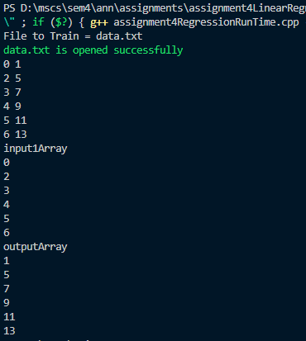

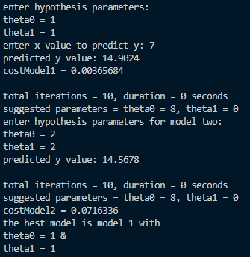

**Part 5: -**

Repeat the Experiment for following ranges of parameters and fill the table.

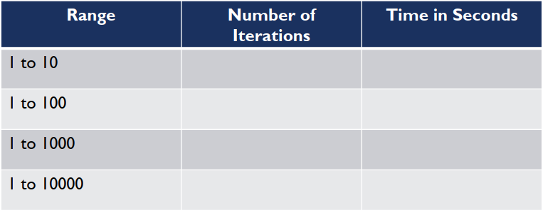

**Source Code: -**

#*include* <iostream>

#*include* <fstream>

#*include* <sstream>

#*include* <cmath>

#*include* <chrono> // *for seconds counting*

using namespace std;

using namespace std::chrono;

// *global variables*

*const* double ALPHA = 0.01;// *learning rate*

int n;// *number of data points*

*const* int MAX_ROWS = 100;

*const* int MAX_COLS = 100;

int globalNumRows = 0;// *dynamically gets number of rows from file*

int globalNumCols = 0;// *dynamically gets number of cols from file*

double x[MAX_ROWS], y[MAX_COLS];// *input data*

double theta0, theta1;// *hypothesis parameters*

string globalFileName;

bool isFileExist = false;

double globalInputArray[MAX_ROWS];

double globalOutputArray[MAX_ROWS];

// *input file from user*

string *chooseFile*()

{

    string fileName;

    cout *<<* "File to Train = ";

    cin *>>* fileName;

*return* fileName;

}

// *function to read csv file*

bool *readCsvFile*(double data[MAX_ROWS][MAX_COLS], string fileName)

{

    int numRows = 0;

    int numCols = 0;

    ifstream *file*(fileName);

*if* (file.*is_open*())

    {

        cout *<<* "\033[32m" *<<* fileName *<<* " is opened successfully"

*<<* "\033[0m" *<<* *endl*;

        string line;// *storing each line of the file*

        int row = 0;// *to keep track the current row, by default representing first row*

// *getline (input stream, line by line, delimiter)*

*while* (*getline*(file, line) && row < MAX_ROWS)

        {

            stringstream *ss*(line);// *Use stringstream to split each line into fields*

            string field;// *store each field / csv of the line*

            int col = 0;// *to keep track the current col, by default representing first col*

*while* (*getline*(ss, field, ',') && col < MAX_COLS)

            {// *read fields upto maximum number of columns*

                data[row][col] = *stod*(field);// *storing the data in the respective column*

                col++;

            }

            row++;

            numRows++;

*if* (col > numCols)

            {

                numCols = col;

                globalNumCols = numCols;

            }

        }

        file.*close*();

        isFileExist = true;

    }

*else*

    {// *if the file was not opened successfully*

        cout *<<* "\033[31m"

*<<* "Failed to open file: " *<<* fileName *<<* "\033[0m" *<<* *endl*;

    }

    globalNumRows = numRows;

*return* isFileExist;

}

void *printArray*(double data[MAX_ROWS][MAX_COLS])

{

*for* (int i = 0; i < globalNumRows; i++)

    {// *for each row*

*for* (int j = 0; j < globalNumCols; j++)

        {// *for each column*

            cout *<<* data[i][j] *<<* " ";

        }

        cout *<<* *endl*;

    }

}

// *computes the predicted value of y for a given value of x*

double *predict*(double xValue)

{

    double yPred = theta0 + theta1 * xValue;// *hypothesis function*

*return* yPred;

}

// *computes the cost of the hypothesis function with parameters theta0 and theta1*

double *computeCost*(double t0, double t1)

{

    double cost = 0;

*for* (int i = 0; i < globalNumRows; i++)

    {

        double h = t0 + t1 * globalInputArray[i];// *hypothesis function*

        double diff = h - globalOutputArray[i];// *difference between hypothesis and actual value*

        cost += diff * diff;// *squared difference*

    }

    cost /= (2 * globalNumRows);// *average squared difference*

*return* cost;

}

// *updates the hypothesis parameters using gradient descent*

void *updateParameters*()

{

    double theta0Sum = 0, theta1Sum = 0;

*for* (int i = 0; i < globalNumRows; i++)

    {

        double h = *predict*(globalInputArray[i]);// *hypothesis function*

        double diff = h - globalOutputArray[i];// *difference between hypothesis and actual value*

        theta0Sum += diff;// *partial derivative of cost with respect to theta0*

        theta1Sum += diff * globalInputArray[i];// *partial derivative of cost with respect to theta1*

    }

    theta0 -= ALPHA * theta0Sum / globalNumRows;// *update theta0*

    theta1 -= ALPHA * theta1Sum / globalNumRows;// *update theta1*

}

// *find the linear regression parameters with a range constraint of 1 to max_theta0*

void *findLinearRegressionParameters*(int range) {

    double suggestedCost = *INFINITY*;// *initialize to positive infinity*

    double suggestedTheta0, suggestedTheta1;

    int iterations = 0;

    auto old = steady_clock::*now*();// *start timer*

*for* (int i = 1; i <= range; i++) {// *range constraint of 1 to range*

*for* (int j = 0; j <= range; j++) {

            double theta0 = i;// *first parameter value*

            double theta1 = j;// *second parameter value*

            double cost = *computeCost*(theta0, theta1);

            iterations++;

*if* (cost < suggestedCost) {

                suggestedCost = cost;

                suggestedTheta0 = theta0;

                suggestedTheta1 = theta1;

            }

        }

    }

    auto dur = steady_clock::*now*() *-* old;// *stop timer*

    auto duration = *duration_cast*<seconds>(dur).*count*();

// *don't know the details about chrono header, auto keyword, steady_clock,*

// *followed this link*

// *https://www.youtube.com/watch?v=QYaQStudgnE*

// *from 9 minutes*

    cout *<<* "Range 1 to " *<<* range *<<* ": ";

    cout *<<* "total iterations = " *<<* iterations *<<* ", duration = " *<<* duration *<<* " seconds" *<<* *endl*;

    cout *<<* "suggested model: theta0 = " *<<* suggestedTheta0 *<<* ", theta1 = " *<<* suggestedTheta1 *<<* *endl*;

}

// *trains the hypothesis function using gradient descent*

void *train*()

{

*for* (int i = 0; i < MAX_ROWS; i++)

    {

        double prevCost = *computeCost*(theta0, theta1);

*updateParameters*();

        double currCost = *computeCost*(theta0, theta1);

*if* (prevCost - currCost < 1e-6)

        {

*break*;

        }

    }

}

int *main*()

{

    string fileName = *chooseFile*();

    globalFileName *=* fileName;

// *storing data from file*

    double data[MAX_ROWS][MAX_COLS];

*readCsvFile*(data, fileName);// *calling function for reading file*

*printArray*(data);

*if* (isFileExist)

    {

        double inputArray[MAX_ROWS];

        cout *<<* "input1Array \n";

*for* (int i = 0; i < globalNumRows; i++)

        {

            inputArray[i] = data[i][0];

            globalInputArray[i] = inputArray[i];

            cout *<<* inputArray[i] *<<* "\n";

        }

        double outputArray[MAX_ROWS];

        cout *<<* "outputArray \n";

*for* (int i = 0; i < globalNumRows; i++)

        {

            outputArray[i] = data[i][1];

            globalOutputArray[i] = outputArray[i];

            cout *<<* outputArray[i] *<<* "\n";

        }

    }

// *read hypothesis parameters for model one*

    cout *<<* "enter hypothesis parameters: " *<<* *endl*;

    cout *<<* "theta0 = ";

    cin *>>* theta0;

    cout *<<* "theta1 = ";

    cin *>>* theta1;

    double theta0ModelOne = theta0;

    double theta1ModelOne = theta1;

// *train the hypothesis function*

*train*();

    double xValue;

    cout *<<* "enter x value to predict y: ";

    cin *>>* xValue;

    double yPred = *predict*(xValue);

    cout *<<* "predicted y value: " *<<* yPred *<<* *endl*;

// *compute cost*

    double costModel1 = *computeCost*(theta0, theta1);

    cout *<<* "costModel1 = " *<<* costModel1 *<<* "\n";

// *find the linear regression parameters for various ranges*

*findLinearRegressionParameters*(10);

*findLinearRegressionParameters*(100);

*findLinearRegressionParameters*(1000);

*findLinearRegressionParameters*(10000);

// *train another model two*

    cout *<<* "enter hypothesis parameters for model two: " *<<* *endl*;

    cout *<<* "theta0 = ";

    cin *>>* theta0;

    cout *<<* "theta1 = ";

    cin *>>* theta1;

    double theta0ModelTwo = theta0;

    double theta1ModelTwo = theta1;

// *train the hypothesis function*

*train*();

    yPred = *predict*(xValue);

    cout *<<* "predicted y value: " *<<* yPred *<<* *endl*;

// *find the linear regression parameters for various ranges*

*findLinearRegressionParameters*(10);

*findLinearRegressionParameters*(100);

*findLinearRegressionParameters*(1000);

*findLinearRegressionParameters*(10000);

// *compute cost*

    double costModel2 = *computeCost*(theta0, theta1);

    cout *<<* "costModel2 = " *<<* costModel2 *<<* "\n";

// *deciding best model*

*if* (costModel1 < costModel2)

    {

        cout *<<* "the best model is model 1 with \ntheta0 = " *<<* theta0ModelOne *<<* " & \ntheta1 = " *<<* theta1ModelOne *<<* "\n";

    }

*else*

    {

        cout *<<* "the best model is model 2 with \ntheta0 = " *<<* theta0ModelTwo *<<* " & \ntheta1 = " *<<* theta1ModelTwo *<<* "\n";

    }

*return* 0;

}

**Output: -**

