**Coding Problem: -**

In the popular **Minesweeper** game you have a board with some mines and those cells that don't contain a mine have a number in it that indicates the total number of mines in the neighboring cells. Starting off with some arrangement of mines we want to create a **Minesweeper** game setup.

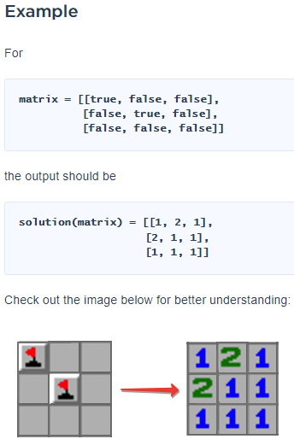

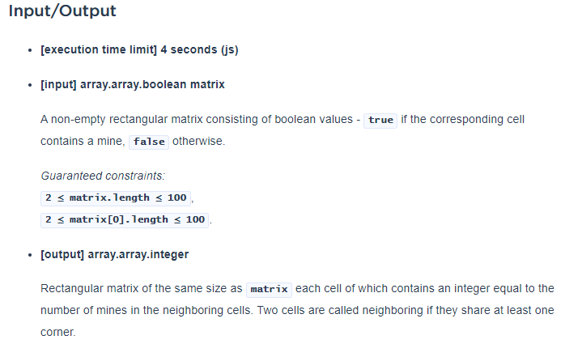

**Test Cases: -**

**Test Case 1: -**

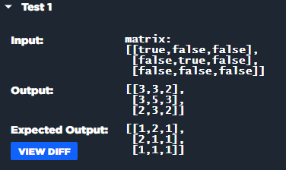

**Test Case 2: -**

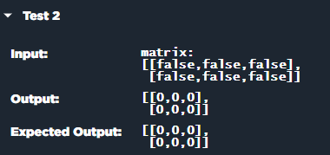

**Test Case 3: -**

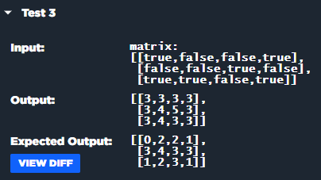

**Test Case 4: -**

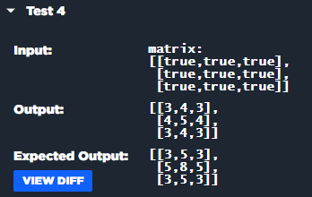

**Test Case 5: -**

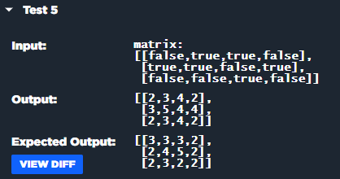

**Test Case 6: -**

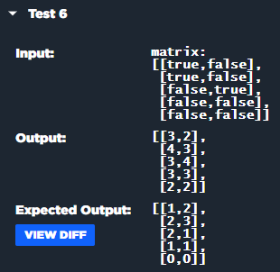

**My Solution: -**

function solution(matrix) {

    let rowsLength = matrix.length -1

    let colsLength = matrix[0].length -1

    let matrixCopy = [...matrix]

    for (let i in matrixCopy){

        for (let j in matrixCopy[i]){

            if(matrixCopy[i][j]){

                matrixCopy[i][j] = 1

            }else{

                matrixCopy[i][j] = 0

            }

        }

    }

    console.log(matrixCopy)

    for (let i = 0; i <= rowsLength; i++) {

    for (let j = 0; j <= colsLength; j++) {

        if (matrixCopy[i][j]) { // if matrix has true value, converts their neighbors with ++

            if (i == 0) { // checking if it is first row

                if( j == 0) { // checking if its first column of row first

                    matrixCopy[i+1][j]++ // incrementing its bottom element

                    matrixCopy[i][j+1]++ // increment its next element

                }else if (j == colsLength) { // checking if its last column of first row

                    matrixCopy[i+1][j]++ // incrementing its bottom element

                    matrixCopy[i][j-1]++ // increment its previous element

                }else { // if the column lies in between the first row

                    matrixCopy[i+1][j]++ // incrementing its bottom element

                    matrixCopy[i][j+1]++ // increment its next element

                    matrixCopy[i][j-1]++ // increment its previous element

                }

            }else if (i == rowsLength) { // checking if it is last row

                if( j == 0) { // checking if its first column of last first

                    matrixCopy[i-1][j]++ // incrementing its upper element

                    matrixCopy[i][j+1]++ // increment its next element

                }else if (j == colsLength) { // checking if its last column of last row

                    matrixCopy[i-1][j]++ // incrementing its upper element

                    matrixCopy[i][j-1]++ // increment its previous element

                }else { // if the column lies in between the first row

                    matrixCopy[i-1][j]++ // incrementing its upper element

                    matrixCopy[i][j+1]++ // increment its next element

                    matrixCopy[i][j-1]++ // increment its previous element

                }

            }else { // if the rows are in between

                if (j == 0) { // if it exists first column of any row

                    matrixCopy[i+1][j]++ // incrementing its bottom element

                    matrixCopy[i-1][j]++ // incrementing its upper element

                    matrixCopy[i][j+1]++ // incrementing its next element

                }else if (j == colsLength) {

                    matrixCopy[i+1][j]++ // incrementing its bottom element

                    matrixCopy[i-1][j]++ // incrementing its upper element

                    matrixCopy[i][j-1]++ // incrementing its previous element

                }else {

                    matrixCopy[i+1][j]++ // incrementing its bottom element

                    matrixCopy[i-1][j]++ // incrementing its upper element

                    matrixCopy[i][j+1]++ // incrementing its next element

                    matrixCopy[i][j-1]++ // incrementing its previous element

                }

            }

        }

    }

}

    console.log(matrixCopy)

    return matrixCopy

}

**What I understand from the Problem: -**

There is an input array in the form of “true”, “false”

Assign default value of true => 1 & false => 0

for (let i in matrixCopy){

        for (let j in matrixCopy[i]){

            if(matrixCopy[i][j]){

                matrixCopy[i][j] = 1

            }else{

                matrixCopy[i][j] = 0

            }

        }

    }

Now we’ve this type of data

|  |  |  |  |  |  |  |
| --- | --- | --- | --- | --- | --- | --- |
| True | False | False |  | 1 | 0 | 0 |
| False | True | false | 0 | 1 | 0 |
| False | False | False | 0 | 0 | 0 |

Now making increment of 1 to all of those elements that are neighbors of “true”.

**For true [1] [1]: -**

* There is no upper row
* There is no column behind

**Output: -**

|  |  |  |
| --- | --- | --- |
| 1 | 1 | 0 |
| 1 | 1 | 0 |
| 0 | 0 | 0 |

Now for the second time:

|  |  |  |
| --- | --- | --- |
| 1 | 2 | 0 |
| 2 | 1 | 1 |
| 0 | 1 | 0 |

**Comparison: -**

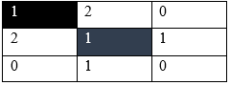

**Another Issue: -**

**Why there are “1” in these positions?**

**And another misconception in understanding the problem: -**

