Week 1: -

Lecture 1: -

Topic: -

Introduction:

Native App Development Frameworks

and Cross Platform App Development Frameworks,

Features: -

|  |  |
| --- | --- |
| Flutter | React Native |
| Dart | Java Script |
| static type | Dynamic type  let anyVar = 123  anyVar= ‘abc’ |
|  |  |

Native App Development Frameworks: -

Android platform (Java, Kotlin)

iOS platform (swift)

Cross Platform App Development Frameworks: -

Both android and iOS apps using a single code base: -

1. Dart, Flutter

2. Java Script, React Native

Features: -

|  |  |
| --- | --- |
| Native App | Cross Paltform App |
| performance wise better as compared to cross platform |  |
| High development cost as compared to cross platform |  |
|  |  |

Week 1: -

Lecture 2: -

Comparison of Cross platform technologies in the market and their features, Advantages: -

|  |  |
| --- | --- |
| Flutter | React Native |
| Google | Facebook |
| Static typed (Dart) | Dynamic typed (Java Script) |

Week 2: -

Lecture 3: -

Introduction to React Native, Features of React Native: –

Java Script Framework,

Features of React Native: -

React Native component based Architecture:-

Flutter, widgets, => React Native => components

Dynamic Components: => props

Week 2: -

Lecture 4: -

Installation, IDE and Environment Setting, Project Architecture andCreation of New Project.

Installation: -

JS, Run Time of JS => Node Js.

How to install Node JS.

<https://nodejs.org/en/download/prebuilt-installer>

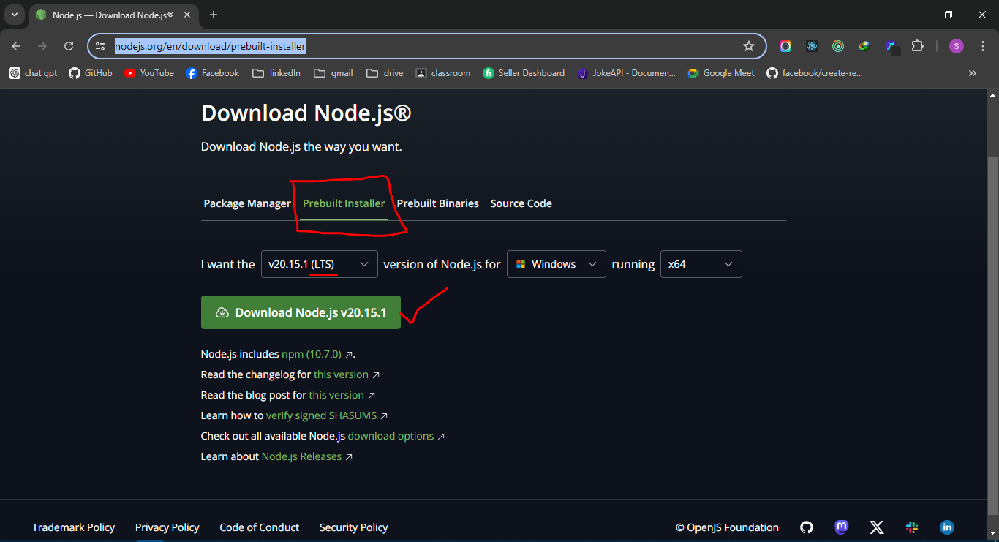

Installer File: -

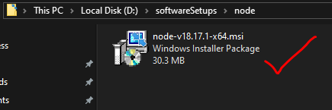

Double click, next next yes yes

Warning: -

Chocolately install krna hai? By default un check ho ga,

Is ko uncheck hi rakna hai

How to verify it?

Open cmd: -

Cmd in windows is just like terminal in Linux.

1. Node –v



2. npm –v



NPM: Node Package Manager

How to create a new React Native Project: -

|  |  |
| --- | --- |
| Bare React Native Project | Using Expo Cli |
| require high resources | require less hardware resources |

React Native with Expo Cli: -

Search: React Native: -

<https://reactnative.dev>

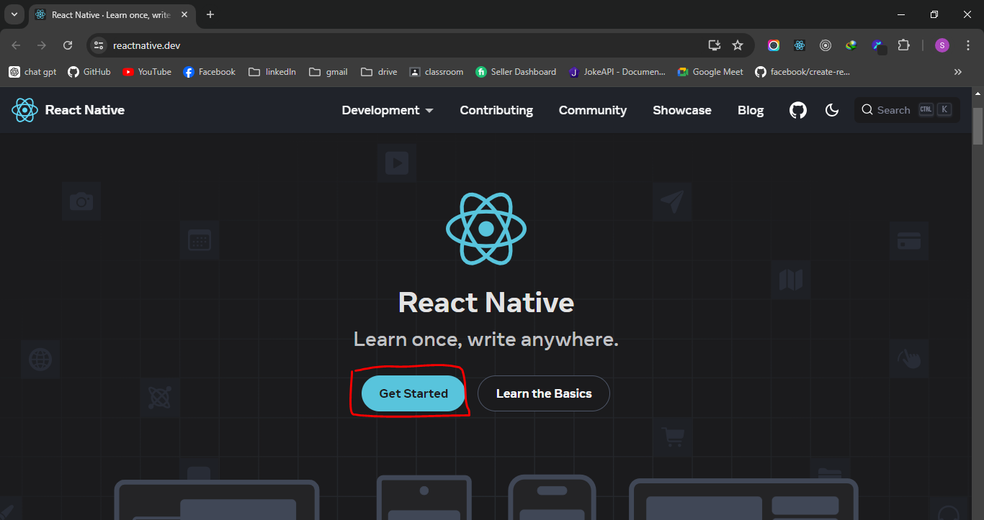

Paste this command in either

1. windows cmd

2. VS Code integrated terminal

3. Git Bash terminal

4. Linux terminal

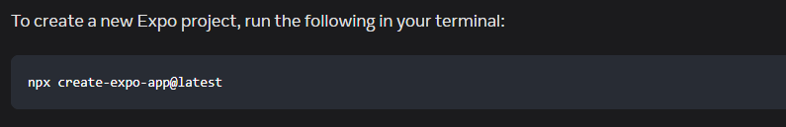

This command will download the pre written code of react native expo cli in our system

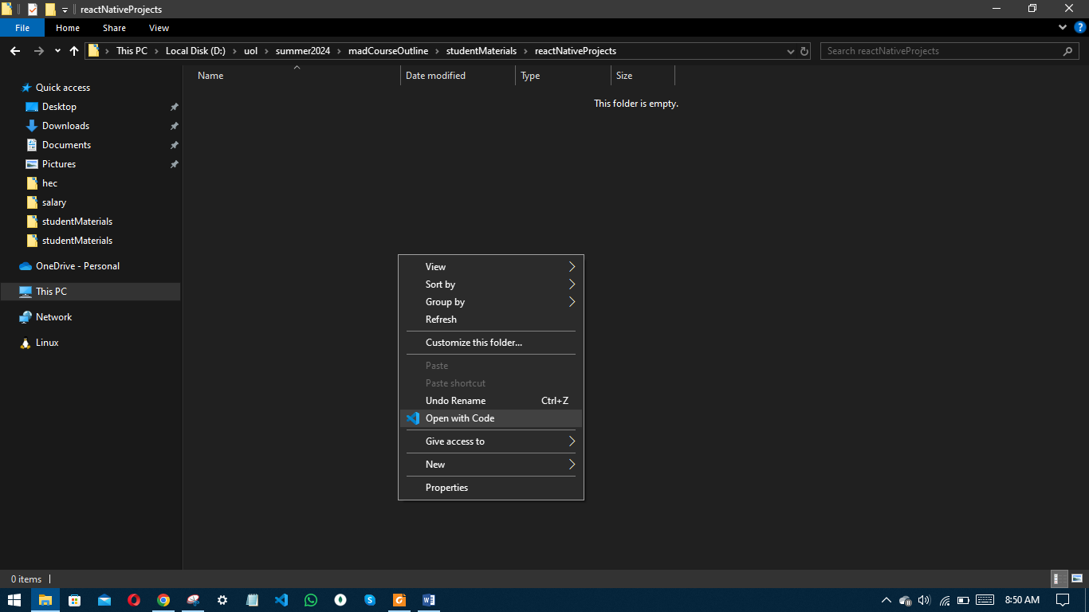

Open new terminal in vs code: -

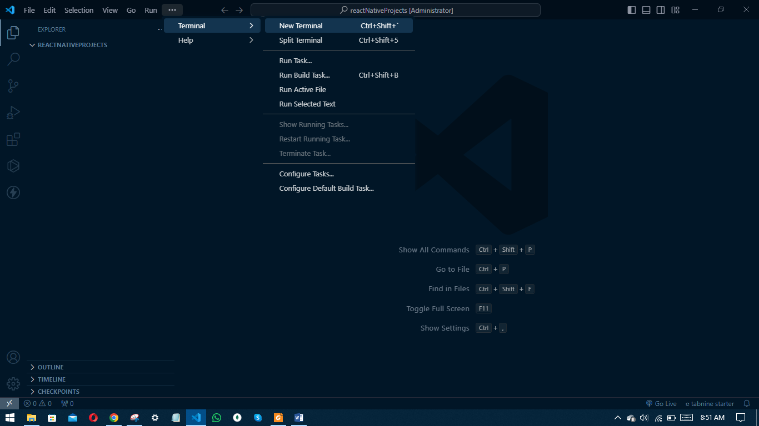

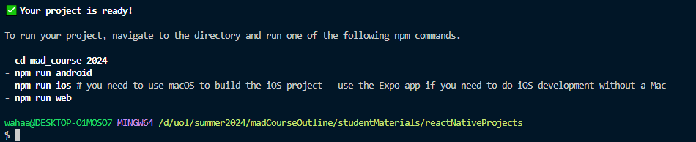

1. Now close the vs code,

2. Navigate to the project directory.

3. And again open that folder in vs code.

1. node modules (change nhi krna, delete kar skty hain)

2. package-lock.json (changes nhi krni, delete kr do)

3. package.json, (ye file kisi b node js k project ki pehchaan hai)

How pkg-lock.json and node_modules will be recovered after deletion?

Pkg.json koi dependency li as an example

expo-router

jab ham terminal py liken gy

npm i

node modules of lock file ko delete krny k bad

to pkg.json mei jitni b dependencies hain

un sab ko bari bari search kry ga

<https://npmjs.org>

if founded its exact match

code => files / folders => node_modules

dependency, dependants => in name ko rak dy ga pkg-lock.json ki file

how run app in development?

Mobile playstore or app store

Expo go

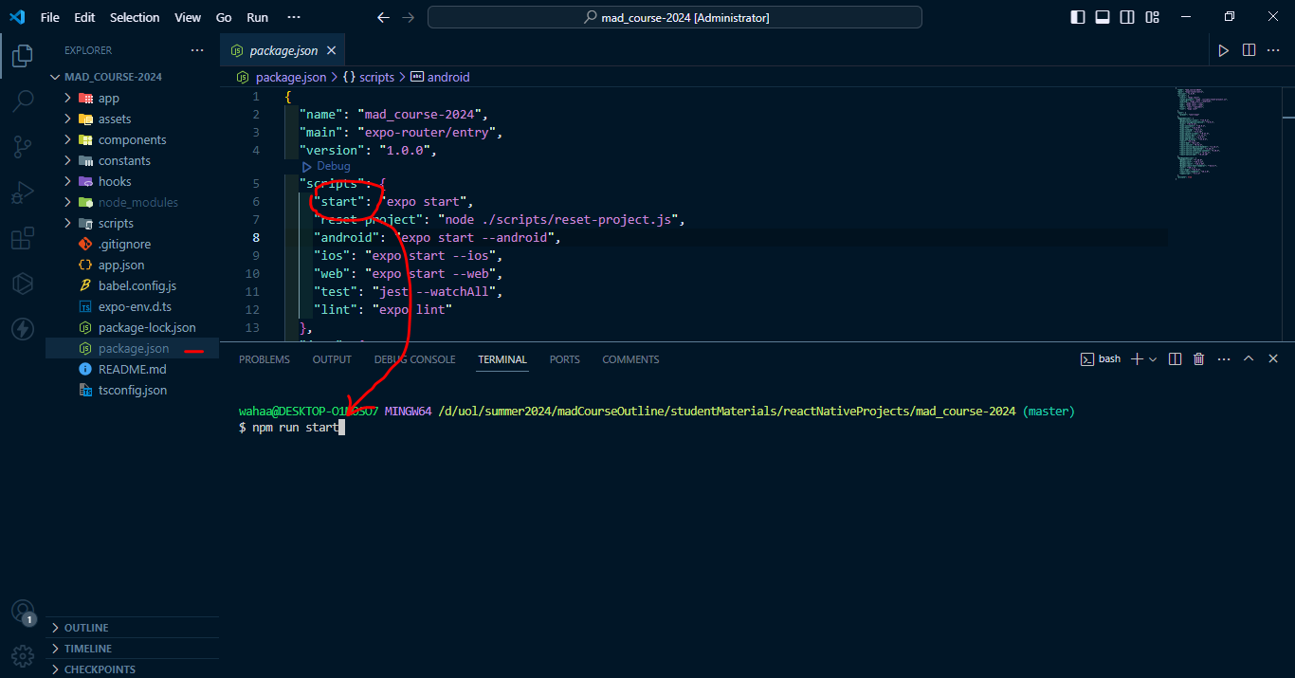

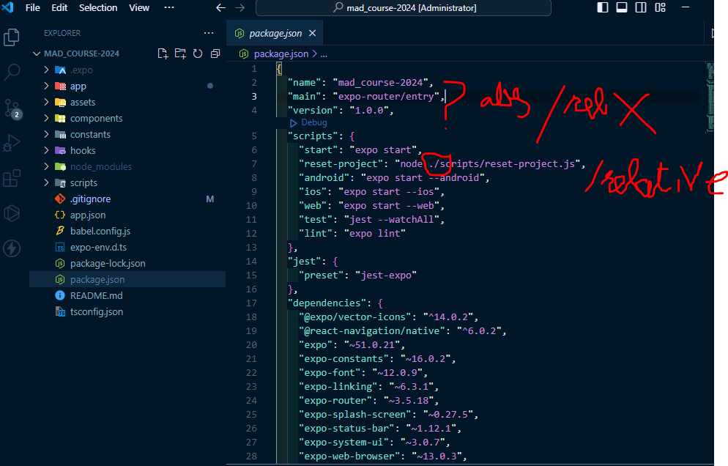

How to add a new tab screen?

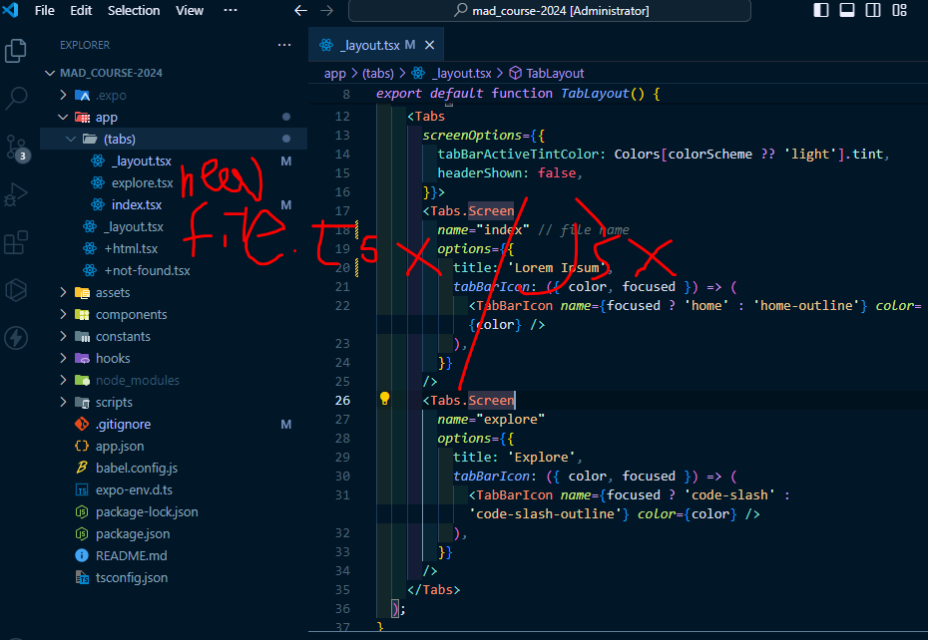

JS Fundamentals: -

Replica of concepts of Programming Fundamentals in CPP: -

|  |  |
| --- | --- |
| CPP | JS |
| variables  int num = 123  string sentenece = “my name is falan” | varibales  let numInJs = 123  let senInJs = “my name is js” |

RAM: -

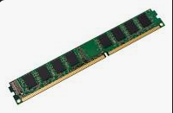

Addresses: -

|  |  |  |  |  |  |  |  |  |  |
| --- | --- | --- | --- | --- | --- | --- | --- | --- | --- |
| 0xa1 | 0xa2 |  |  |  |  |  |  |  | 0xa9 |
| 0xb1 | 0xb2 |  |  |  |  |  |  |  |  |
|  |  |  | num=123 |  |  |  |  |  |  |
|  |  |  |  |  |  | sentence = “my name is “ |  |  |  |
|  | numInJs = 123 |  |  | senInJs = “my name is js” |  |  |  |  |  |
|  |  |  |  |  |  |  |  |  |  |
|  |  |  |  |  |  |  |  |  |  |
| 0xh9 | 0xh2 |  |  |  |  |  |  |  | 0xh9 |

Loops: -

Counter loop (for loop) : -

Conditional loop (while loop) : -

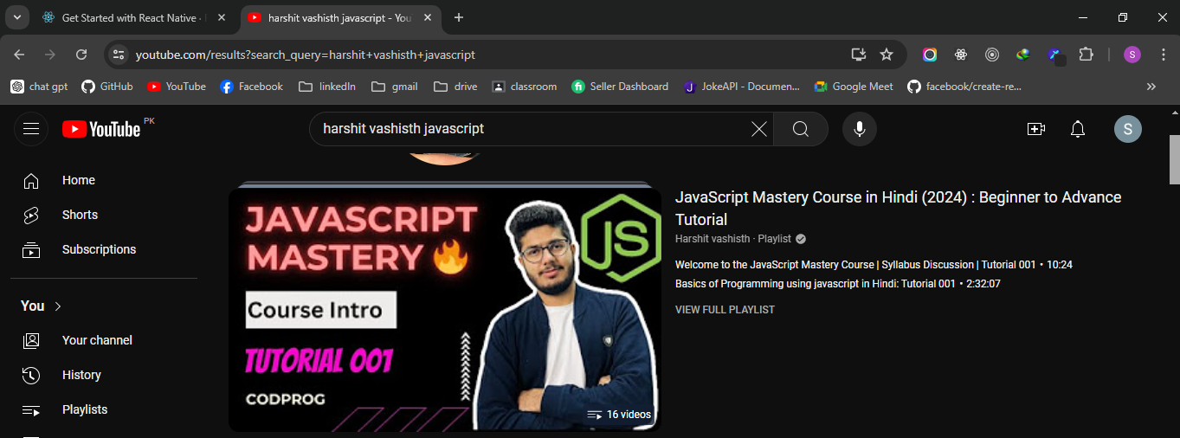

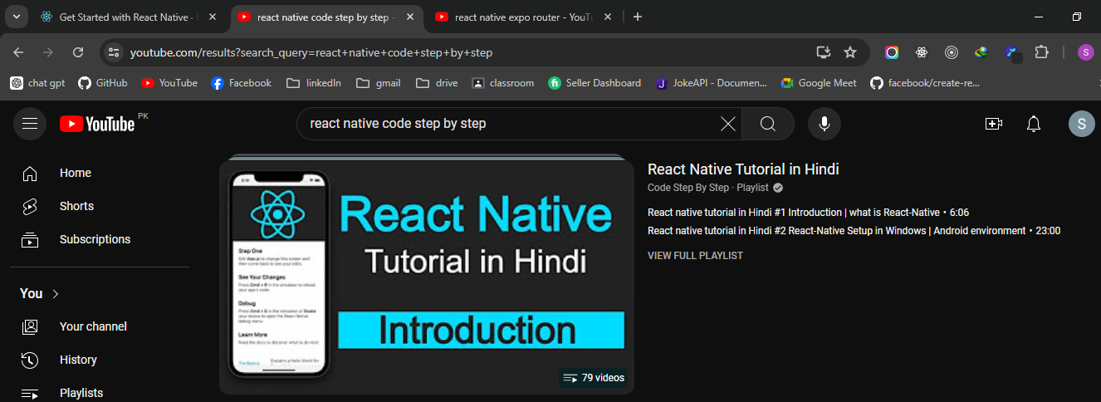

Git github: -

For version control system, source code management

Zubaani yad kr lena

Git add .

Git commit –m “any relevant message”

Git push –u origin main