Muhammad Hassan Al-naimi est.

Comprehensive analysis on Sales Data

Contents

Introduction 1

Products 1

Place 1

Customers 2

Marketing Department 2

Price/Revenue 2

Process 2

Implementation of Marketing Analytics 3

Marketing 3

Sales 3

Total Sales and Last Month Sales by Month Year 6

Total Sales by Product 6

Total Sales by City 7

Total Sales by Month 7

Total Sales by Status 8

Total Sales by City and Status 9

Customer Relationship 9

Forecasting Sales 11

Total sales by City Map 11

Analytical Software 12

Power BI 12

KNIME Analytics 12

Decision Tree 12

Implication Of Marketing Analytics 16

Development of Strategy 16

Tools and Visualization 16

Cross functional Teams 16

Check and Balance of Sales 16

Challenges In Implementing Analytics 17

Amount of data being collected 17

Collecting meaningful and real time data 17

Visual representation of data 17

Data from multiple sources 17

Inaccessible Data 17

Poor quality data 18

Shortage of Skills 18

Conclusions 18

Hassan Al-Naimi Trading Est.

# Introduction

Hassan Al-Naimi, a leading supplier that operates in UAE and Saudi Arabia and provides hygiene products and commercial & industrial cleaning equipment. They have advanced logistics facility and large warehouse for fast distribution and delivery of the desired cleaning equipment or hygiene product. They are into this business for more than 30 years, the company offers a variety of cleaning equipment in UAE and Saudi Arabia which includes, dustbins, buckets, mop, housekeeping trolleys, brush heavy duty, disposable gloves, dustbin ashtray, floor pad, wiper, brush, cleaning solutions, etc. They have famous customer base.

They provide high quality after sales service that is unique in the industry. Their professional technicians have the ability to provide a detailed consultation.

They are very flexible and deliver to the clients: whenever, wherever, and however the customers need, and want it. At Hassan Al-Naimi, they strongly believe in the concept of ‘CHANGE’.

## Products

The products which they provide are:

* Buckets
* Trolleys
* Cleaning brushes
* Gloves
* Floor pad
* Dustbins
* Wipers
* Cleaning solutions

These are the products that Hassan Al-Naimi Est. provides to their customers.

Place  
Hassan Al-Naimi is currently operational in Saudi Arabia and UAE with its presence and customer base in the following three major cities of Saudi Arabia including their capital city.

The three cities are:

* Riyadh
* Jeddah
* Dammam

## Customers

It is operating as a supplier of cleaning and hygiene products and has a total of 96 customers in the three major cities of Saudi Arabia. Classifying it further, it has 48 clients in Riyadh, 43 clients in Jeddah and 7 clients in Dammam. This information clearly tells us that the most business is carried out in the capital city of Riyadh.

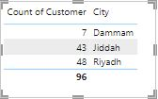

## Marketing Department

The company consists of different departments that almost every company has. Every department is busy in performing their duties and there is a very strong inter departmental communication so that the operations is run smoothly. For example, marketing department is the one whose responsibility is the tasks related to the advertisement campaigns, promotions, etc.

## Price/Revenue

Business’s main goal is to generate revenue and earn profits. People, nowadays can have an estimate of the price from different suppliers by just clicking a few buttons on their electronic device sitting in their home. Competition in price is very aggressive these days.

## Process

After an order is placed by the customer, Hassan Al-Naimi Est. then follows a specific process for the successful delivery of the order. Following are the steps of the process:

1. Initially, a request for quotation (RFQ) is received from the customer which is provided by Hassan Al-Naimi Est.
2. Customer after doing a comparison analysis, if wants to place an order he places an order.
3. After the order is received to the sales team of Hassan Al-Naimi Est., they verify the order, check the availability of the product and deliver it.
4. After the product is received by the customer, they ensure that the ordered product’s quality is not compromised and is according to the requirement. If it is not according to the requirement a complaint is made and Al-Naimi has to arrange a replacement or either process the refund.
5. At last, after the quality check the product is received by the customer in their data and the invoice sent by Al-Naimi is cleared as per the agreed payment terms.

# Implementation of Marketing Analytics

Hassan Al-Naimi sales data for the three main cities of Saudi Arabia were observed. The main focus was to analyze the sales data and the customer relationship because they always try their best to retain a customer as retaining a customer is easier than acquiring a new one. It is identified that marketing analytics concept can be applicable to two areas i.e.

1. Marketing
2. Sales
3. Customer Relationship

## Marketing

When the sales data is analysed, it becomes easier for the marketing professionals to devise a strategy according to the customer’s need and track their effectiveness. It helps in identifying the trend of the customer to a specific product when a specific advertisement or promotion strategy is opted.

It has been seen through research that 58% of Chief Marketing Officers prefer effective search engine optimization strategies as being clear beneficiaries of advancements in data analytics. The more the appropriate data is, the more information marketeers have about consumers behaviour, the more effective strategies they can devise.

## Sales

The sales data is considered to be the main part of the company’s revenue generation. Al-Naimi sales data is from the delivery of products. The data helps us in reviewing the pricing strategies, customer responsiveness, public engagement with the brand, sales lead quality and loyalty to products over time.

Businesses with the help of different marketing campaigns and strategies they try to bring awareness about their new products. They do this to increase their revenue which is the ultimate goal of every business by increasing their sales volume. After implementation of the marketing strategies, they consider the output of that strategy by looking the customer’s response. Feedback, a very important method in increasing sales is very important in today’s era. After doing a detailed analysis, on MS Excel and Power BI, we found out the behavior of the customers which is a very important factor in increasing sales.

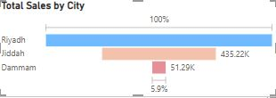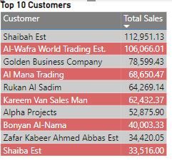

By looking at the above table we can see who were the top 10 customers in terms of revenue generation for Hassan Al-Naimi Est. Also, we can identify the city wise sales as well. This data helps us in identifying which customers are to be more focused, which customers are about to be lost and some effective strategy is needed to revive their relationship. In this way we would be easily identifying our ways to increase sales. Therefore, by analyzing city wise sales data, we would be developing more effective strategies on how to boost our sales in those cities which are not generating enough revenue like Dammam.

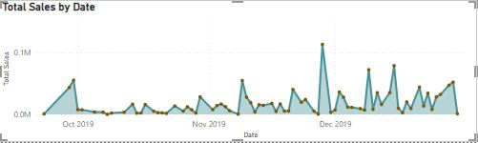

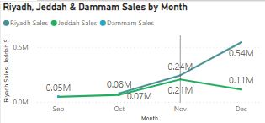

While analysing the monthly city wise sales, it was seen that Dammam had only sales in the month of September, After September, there was no revenue generation from Dammam which was a potential loss in sales for the company. Customers should be inquired through various means that what led them to not repurchase form them, was it high cost, product quality or some other factor. Proper data collection and a detailed analysis could help Hassan Al-Naimi Est. in reviving their customer base in the city of Dammam.

While talking about Jeddah, the sales increased from September till November but a declining trend was seen in the last month of the year, December. Jeddah, being a very big and busy city as a lot of businesses are based in Jeddah. As, in all the four months sales were being carried out in Jeddah which clearly shows that it has a lot of potential customers which can help in increasing revenue. Proper strategies should be formed by the top management to revive the sales in Jeddah.

Riyadh being the capital of Saudi Arabia has the highest sales but they have no sales in the month of September. Having absolutely no sale in a particular city for a month, could be an alarming situation for a business, it has to depend on other city sales for that month.

Proper strategies or discount methods should be applied in order to not have a month with zero sales.

## Total Sales and Last Month Sales by Month Year

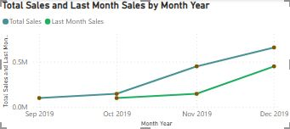

If we look at Total Sales and Last Month Sales by Month Year, we can see that **December 2019** had maximum number of Total Sales of 657011.00 compared to Last Month Sales of 449068.84. This shows us that December 2019 was very effective for the company. Whereas we can see that October 2019 generated the second lowest number of Total Sales of 145775.13 compared to Last Month Sales of 99525.98 which was the lowest. This shows that December 2019 proved to be a very effective month compared to the level of Sales generated and the business must have come up with a strategy to attract more customers.

## Total Sales by Product

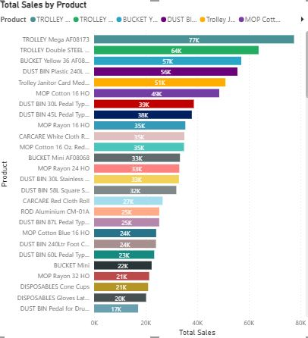

By the visual demonstration of Total Sales by Product we can see that the Product TROLLEY Mega AFO8173 has the highest Sales by Product of 77496.93 Sales. We can also see that CARCARE Red Cloth Roll has the lowest Sales by Product of 26550.41 which is very less. This shows us that CARCARE Red Cloth Roll is not considered to be a better product and the customers are also not attracted towards it. Moreover, we can see that TROLLEY Double Steel AFO8071 has Total Sales of 63767.50 which is the second greatest number of Sales generated by product. The diagram and values show us that Product TROLLEY Mega AFO8173 is considered to be highly revenue generating product and so this could be beneficial for the company when targeting the customers.

## Total Sales by City

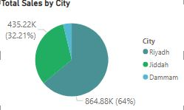

By looking at the diagram, Riyadh has maximum number of Total Sales of 864876.42 followed by Jeddah with Total Sales of 435217.33 and then with Dammam with lowest number of Total Sales of 51287.19. This shows that Riyadh produces maximum number of Sales and there is a wide range of consumer attraction towards the products. The company policy could also be well-maintained according to market needs and this results in better performance in terms of Total Sales. Whereas Dammam possess lowest number of Total Sales and the reason behind could lack of proper business methods, the lack of technological methods due to which most of tasks are performed manual and hence lack of customer satisfaction could develop accordingly.

## Total Sales by Month

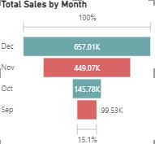

By the visual representation, December has maximum number of Total Sales of 657.01K followed by November with Total Sales of 449.07K, October with Total Sales of 145.78K and lastly with September of 99.53K. This proves that December generated an increase from November of 207.94K. September generated the lowest number of Sales and this could be due to lack of proper techniques. Moreover, the management might not possess enough technological improvement in their tasks which might have led to delays in the production process.

## Total Sales by Status

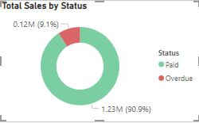

If we look at the Total Sales by Status, we can see that the Overdue of Total Sales are 0.12M which is 9.1%. Whereas the Amount Paid of Total Sales that is received by the company are 1.23M which is 90.9%. This shows that the Paid Amount is significant and the company has been efficient in obtaining the sales amount from the credit customers. However, the Overdue Amount of 0.12M which is about 9% is also an alarming sign since some of the customers turned out to be bad debts and haven’t paid the cash amount to the company. This resulted in 0.12M financial loss for the company.

## Total Sales by City and Status

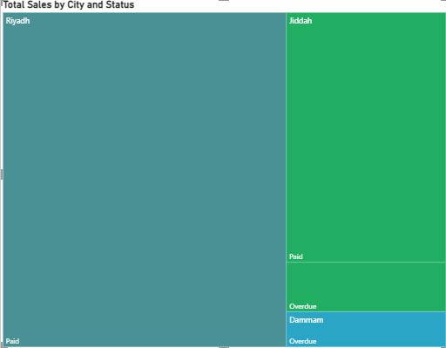

Among the cities, Riyadh is the only City that has all the amount of Sales Status shown as Paid of 864876.42 which is an incredible sign that they generated a huge number of Sales. This could be due to an effective management and due to them not providing too much of the credit Sales. Riyadh could also have used an effective technological method due to which they kept a proper track regarding the customer payment. Whereas Jeddah has Paid Total Sales of 363538.30 and Overdue Total Sales of 71679.04. This shows that Jeddah might lack effective methods to obtaining all the required amount of cash by their credit customers. There is a possibility that some of credit customers turned out to be bad debts and were unable to pay them back due to their own issues. Dammam has all Overdue Total Sales of 51287.20 which shows that their performance has been very poor as they were unable to generate liquid cash from their credit customers. Their in-ability to properly manage their business is going to be a huge issue.

## Customer Relationship

Customer is the main source of revenue for every business. A customer’s feedback can give a business the idea about the effectiveness of their campaigns. After analysing their responses, it is the duty of the company to bring changes in their strategy according to the results of the data analysis. Feedback from customers also help in identifying the relationship between customers and the company.

Businesses always try to find new leads in the form of customers and retain them so that they can give a good Customer Lifetime Value. Retaining a customer is easier than finding a new one. After sales services matter a lot in having a healthy relationship between a customer a company.

A customer can be source of bringing in several new customers by positive word of mouth and at the same time he can be a source of negative word of mouth also therefore loosing potential customers.

We analyzed the data of the recurring customers. This helped us in identifying the most loyal customers.

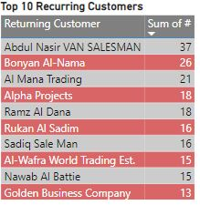

The data clearly tells us that Abdul Nasir was the most recurring customer that is he purchased items 37 times. So, he is a potential customer and should not be lost as he could be a source of bringing in in new customers thus increasing sales.

The customers which were not buying items frequently like Golden Business Company should be asked for feedback and then some special strategies or discounts should be made for them so that they become a significant part of the Hassan Al-Naimi Est.’s revenue.

## Forecasting Sales

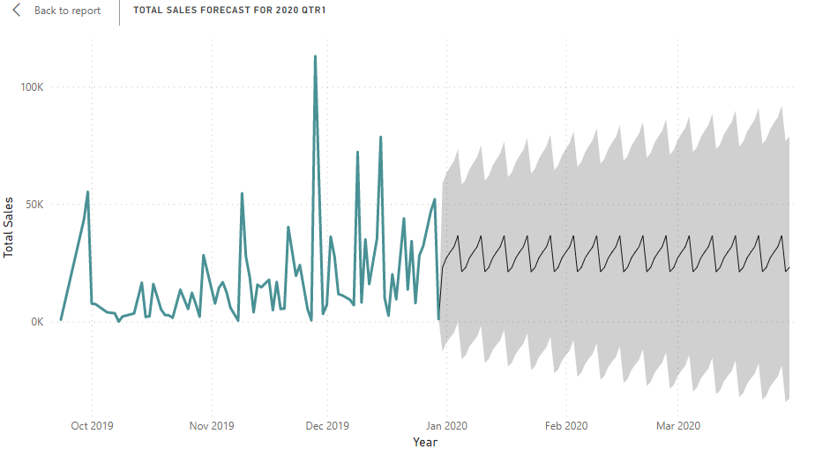

We have done forecasting for sales for the next quarter. With confidence level of 95%. And seasonality set to auto. The forecast is for 36,588; with the highest upper bound of 92,000 and the lowest upper bound 58,700. Furthermore, the highest lower bound at -34,111 and the lowest at -294.

## Total sales by City Map

This here is a geographical depiction of sales for Al-Naimi Trading Est. We can see that the bubble is the largest in Riyadh that’s where the highest sales are at and then Jiddah which has the second highest sales, whilst Dammam being the smallest bubble with the smallest sales. The bubble size is related to the total sales, which is why it varies in size for all three cities. Furthermore, the Location and Legends both are set against city.

# Analytical Software

The analytical software which this company should use is Power BI.

## Power BI

This software is so effective that it would provide the company, HASSAN AL-NAIMI TRADING EST. with immediate data that it could use for the measurement of its performance. Moreover, it would provide the firm to understand of the type of operational metrics that prove to be more beneficial for the company and hence it creates more opportunities and ability to achieve growth. It also provides with elegant dash boards and modern features for data representation hat has a difficult to understand management system. Moreover, it is considered suitable for that particular company which possess smaller products and hence it can be more conveniently used. The data management system of HASSAN AL-NAIMI TRADING EST. is able to properly handle from the basic level to the main level and do it in an effective manner. It is important to note that HASSAN AL-NAIMI TRADING EST. should have access to POWER BI for better, clear and precise visualization of their real time data.

## KNIME Analytics

KNIME Analytics, an easy to use and open-source data analysis tool was also used to perform analysis on the data set. It has various functions and different type of nodes which can be used in the workspace according to the need. *Predictive analysis* can be done by using this software in the form of a *Decision Tree* which builds a simple prediction/classification model. There are many other functions which can be used as per the need like partitioning the data, column filtering, column deletion and many more.

## Decision Tree

This is a prediction model which is depicted in the form of a tree like structure of decisions and their probable outputs. After importing the data in *File Reader* node in KNIME Analytics, it was linked to the decision tree node and the view of decision tree model having the first real statistics and further the possible outcomes were viewed which looked as below:

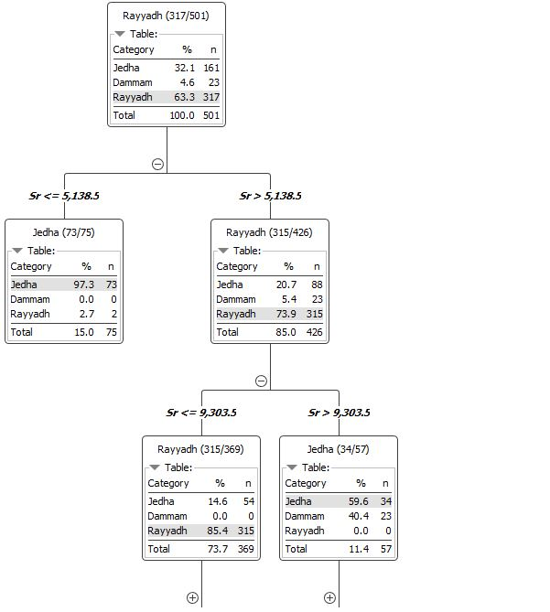

The model starts form the real time data according to the data set that is 63.3% Riyadh, 32.1% Jeddah and 4.6% Dammam. Based on this data, it further predicts the sales and suggests the possible outcomes, that is there is a 15% possibility that only 75 orders are received and a very high possibility of 85% that 426 orders are received. In this way this goes on.

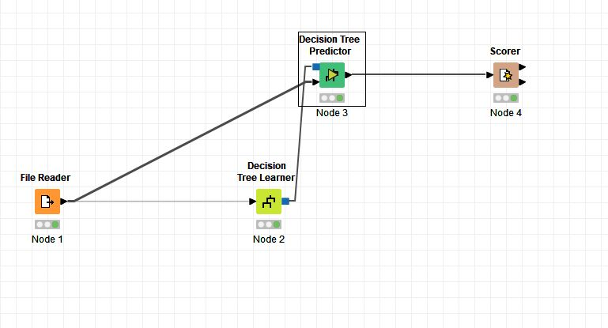

This is the linking of the nodes to view the predictive analysis. A confusion matrix was thus created with following results.

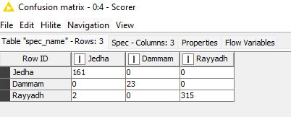

This means that 161 orders were predicted to be placed form Jeddah and actually also there were 161 orders from Jeddah. Similarly, 23 orders were predicted to be placed from Dammam and actually also they were 23.

315 orders were predicted from Riyadh and Riyadh had actually more than 315 orders that is there was a wrong prediction of 2 orders from Jeddah but they were actually from Riyadh making it 317 orders from Riyadh in total. In this way, precision that is accuracy can be identified.

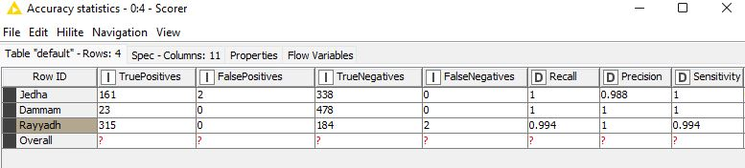

This matrix tells us the accuracy statistics.

A *true positive* outcome is a correctly predicted positive class by the model. 161 orders of Jeddah, 23 of Dammam and 315 of Riyadh were the actual orders and same was predicted by the model.

A *false positive* outcome is an incorrectly predicted positive class by the model. 2 orders of Jeddah were false positive that is they were not of Jeddah but recorded in Jeddah.

A *true negative* outcome is a correctly predicted negative class by the model. 338 orders of Jeddah, 478 of Dammam and 184 of Riyadh were true negative.

A *false negative* outcome is an incorrectly predicted negative class by the model. 2 orders of Riyadh were false negative that is they were of Riyadh but recorded in Jeddah.

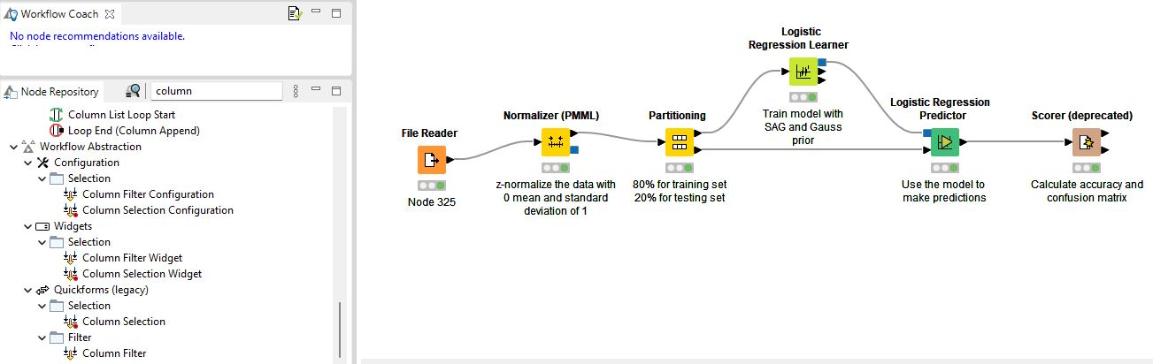

# Implication Of Marketing Analytics

## Development of Strategy

Marketing analytics provides a clearer picture of the firm’s sales statistics and performance which helps in building business, marketing and sales strategy. It also leads to the firm being able to properly understand its resources that it possesses and come up with a strategy.

## Tools and Visualization

The tools and visualization features of analytics software are integrated in such a manner that facilitates the organization or a firm in executing business strategy throughout the company without leaving behind any operating metrics of the firm. They are important in making sure that the business strategy that is already developed by the company is properly considered and the features of analytics software are well- maintained. Such as for marketing and sales strategy could involve the number of sales could be stored in the excel, power bi software which could be illustrated using diagrams. Such tools could help in understanding the capabilities for marketing analyst in properly conducting pricing, advertisements and to know about the customer buying patterns.

## Cross functional Teams

It is a very useful method that enables the company employees having extraordinary skills set to work as a team by exchanging relevant information and real time data to perform specific tasks that require full coordination from all the departments of the company. This method also enables the company to be more of value for the employees as they could contribute to good ideas for decision making process.

## Check and Balance of Sales

It forecast and present properly the sales data of a specific company, how many sales occurred in a specific year, month, week or a day. How many sales return is there? Sales amount is overdue or paid? It helps companies in managing their sales data to create balance between supply and demand of the products. Moreover, this results in the company being able to identify how many of the total sales occurred and whether they are proving to be of value to the company in the form of profits. The amount of sales returns, level of customer satisfaction could also be obtained by seeing the number of sales and then comparing it with the sales returns.

# Challenges In Implementing Analytics

## Amount of data being collected

The manual system of collection of data is a very outdated and time consuming process so there is a need of some automated system which should collect and transform the data into the system on auto basis. This should help to make things easier for the company by easy accessible data being available online.

## Collecting meaningful and real time data

If employees do not dig deep into the information provided by the research analysts and do not collects the actual data which truly adds value then perhaps, they go for an easy way to collect data without going through the insights thoroughly and deeply. This can eventually create challenge in implementation of analytics into the business. Since they are not aware of the important tasks to be performed so they won’t be able to proper deal with the situation.

## Visual representation of data

Some data requires better visualization through charts and graphs and building manual charts and graphs is a timing taking process and might not give better results in the end. A better analytical software would help in the effective illustration and representation of data. This could also attract the person observing the visual data and hence could have an impact on the company image.

## Data from multiple sources

Combining a data manually from several separate sources is a time taking process. A centralized system can eventually help in removing such issue and hence can provide better results in less time. A centralized system could also result in better source of data received which could be utilized for important operational tasks.

## Inaccessible Data

Sometimes it happens in a company where information is being handled in a centralized manner. Therefore it is difficult to access maximum amount of data which results in employees not being able to access that information and so it results in a challenge regarding of dealing with real time and marketing analytics data.

## Poor quality data

Data which is of poor quality cannot give better results. Bad input can never give you appropriate output. This leads to an immense difficulty in properly obtaining a proper system where you input your data to obtain appropriate results.

## Shortage of Skills

There is a need for some companies to have appropriate skills to run the tasks properly. Some companies must take in consideration the number of skills set that their employees should possess regarding the completion of important, technical tasks.

# Conclusions

What we would like to recommend is for Hasan Al-Naimi to create a more prominent online presence. Have a website developed, provide discounts on bulk purchases, especially when products are being sold in the Dammam region. This is the region that has the least number of sales and is lagging behind the other two cities. They need to increase their customer base there as well. The need to develop better credit recovery terms for Dammam as well since most of the payment for sales in Dammam is overdue, whilst Riyadh is fully paid and the majority of payments in Jeddah are paid, and a small portion is overdue.