Nlightn

Turn A Page to Turn Your Life

FAST NUCES

FYP

**Acknowledgment**

I hereby acknowledge that I am doing my final year project on the title of NlightN under the guidance & supervision of Dr. Zia Khan.

I hereby confirm that I am working in strict conformity with all the conditions set by my advisor. I also acknowledge that a part or whole of this work may be used in any research project undertaken by my advisor. The advisor will also have the ultimate right and discretion to assign any or no formal acknowledgement to this work as part of any future research project, depending upon the nature, quality, and scope of this work.

Contents

**List of Tables v**

**List of Figures vi**

**List of Acronyms viii**

**1 Executive summary 1**

**1.1 Vision 2**

**1.2 Mission 2**

**2 Why NlightN? 3**

**3 Market Analysis 3**

**3.1 Industry Analysis 4**

**3.1.1 Current Industry Size 5**

**3.1.2 Future Industry Size 5**

**3.2 Market Analysis via SWOT Analysis 6**

**3.2.1 Strengths: 6**

**3.2.2 Weakness 7**

**3.2.3 Opportunities 7**

**3.2.4 Threats 8**

**3.3 Porter’s Five Force Model 8**

**3.3.1 Bargaining power of supplier 9**

**3.3.2 Bargaining power of customers 9**

**3.3.3 Rivalry against existing business 9**

**3.3.4 Threat of substitute 10**

**3.3.5 Threat of new entrants 11**

**4 Company Description 11**

**5 Marketing Plan 12**

**5.1 Marketing Objectives & Strategies 12**

**5.2 Target Market 13**

**5.3 4P’s of Marketing 13**

**5.3.1 Product 13**

**5.3.2 Price 14**

**5.3.3 Place 15**

**5.3.4 Promotion 16**

**6 Demand Analysis 17**

**7 Segmentation 17**

**7.1 Types of Segmentation 17**

**8 Operational Plan 18**

**9 PESTEL Analysis 23**

**9.1 Political 23**

**9.2 Economic 24**

**9.3 Sociocultural 24**

**9.4 Technological 24**

**9.5 Environmental 25**

**9.6 Legal 25**

**10 Product Rational Analysis: 25**

**10.1 Price 25**

**10.2 Product 25**

**10.3 Delivery System 27**

**10.4 Packaging 27**

**10.5 Labelling 27**

**10.6 Promotion 27**

**10.7 B2C 28**

**11 Management & Ownership 28**

**11.1 Staff Members 28**

**11.2 Legal Structure of the Business 30**

**12 Sustainable Development Goals 30**

**13 Market Analysis 32**

**14 Financial Data 41**

**14.1 Business Cost 41**

**14.2 Income Statement 43**

**14.3 Balance Sheet 45**

**14.4 Cash Flows 47**

**15 Risk Analysis 48**

**15.1 Cyberattacks 48**

**15.2 Competitor Risk 48**

**15.3 Payment risks 49**

**15.4 Delivery Risk 49**

**15.5 Reputation Risk 49**

**16 References 50**

**17 Appendix: Website URL 52**

# List of Tables

**Table 1 Business Cost 41**

**Table 2 Income Statement 43**

**Table 3 Balance Sheet 45**

**Table 4 Cash Flows 47**

# List of Figures

**Figure 1 Sponsored Books 15**

**Figure 2 Home Page 16**

**Figure 3 Best Sellers 18**

**Figure 4 Book Page 19**

**Figure 5 Seller Description 20**

**Figure 6 Seller Contact Info 20**

**Figure 7 Cart information 21**

**Figure 8 Checkout Section 22**

**Figure 9 Sustainable Development Goals 31**

**Figure 10 Donation Button 31**

**Figure 11 Donation Section 32**

**Figure 12 Survey Question 1 33**

**Figure 13 Survey Question 2 33**

**Figure 14 Survey Question 3 34**

**Figure 15 Survey Question 4 35**

**Figure 16 Survey Question 5 35**

**Figure 17 Survey Question 6 36**

**Figure 18 Survey Question 7 37**

**Figure 19 Survey Question 8 37**

**Figure 20 Survey Question 9 38**

**Figure 21 Survey Question 10 39**

**Figure 22 Survey Question 11 39**

**Figure 23 Survey Question 12 40**

**Figure 24 Survey Question 13 41**

# List of Acronyms

**ALP:** Alternative Learning Pathways

**ECE:** Early Childhood Education

**MOFEPT:** Ministry of Federal Education & Professional Training

**NGO:** Non-governmental organization

**OOSC:** Outside-of-School Children

**ROAS:** Return on AdSense

**UNESCO:** United Nations Educational, Scientific and Cultural Organization

**UNICEF:** United Nations Children's Fund

**URL:** Uniform Resource Locator

NlightN

# Executive summary

“[**NlightN**](https://nlightn-online.vercel.app/index.html)” is a business-to-student (business to customer) and student-to-student (customer to customer) Internet marketplace providing students of any background with the opportunity to buy, sell and trade college textbooks, novels, and journals; and buy products for schools, colleges, and universities. The IT industry is the fastest growing industry in the world. There is many small scale, medium scale companies and Silicon Valley Unicorns startups in this business. Some of these unicorn startups include Revolut, Canva, Epic Games, Shein, Discord, GoPuff, AirBnB, Facebook etc. The IT industry is emerging in Pakistan as well. Especially the e-commerce sector. The government is enabling an environment where Payment Service Providers and Payment Service Operators can operate and establish an effective e-commerce setup. Some of the larger players of e-commerce in Pakistan include, OLX, Daraz, PakWheels, Zameen etc.

Bloomberg claims that Pakistan's higher proportion of young people to the overall population has contributed to the fast-growing consumer market, which now numbers more than 200 million people. presenting potential of expansion for businesses like Daraz, an e-commerce company whose market estimate shows positive growth of 8.2% each year through 2021 with increased disposable incomes.

Pakistan right now has several bookstores, some of the more popular bookstores have online presence as well, like Kitabain, BukhariBooks, readings, liberty books and Bookberry etc. but most of them do not. So there is an emerging trend and a huge gap to be filled in the ecommerce market for books.

This is why I will be establishing an online internet marketplace for the purchase and selling of books. At the initial stage we will be operating in Lahore because it is the second most populous city of Pakistan and has several schools, colleges and universities meaning more potential clients. and then gradually expand to Islamabad and Karachi and eventually to other major cities as well. This online bookstore will enable students to buy, sell, and trade used textbooks directly to other students, by-passing the university/local bookstores. By selling textbooks to other students, the seller can receive more money than the bookstore will pay, and the buyer can pay less than the bookstore charges. All in all, it increases the monetary value of the book.

Our higher management will include CEO Mr. Muhammad Salman Tipu, CFO Mr. Usama Tariq, Chief Marketing Officer Muhammad Ejaz ul Hassan, Chief Technology Officer Waqas Wasi, Head of Public relations Zia Idrees. The financial plan for NlightN will be based on 100% equity investment.

## Vision

To foster a community where individuals can connect, share, and discover books easily, while promoting literacy and knowledge-sharing.

## Mission

Our mission is to offer a user-friendly online marketplace where individuals can buy and sell both new and used books.  By developing a community where users can talk about books and recommend others' reading material, we hope to promote a sense of community among book enthusiasts. Moreover, we aim to encourage literacy by collaborating with groups that support education and giving readers of all ages and socioeconomic backgrounds affordable access to books.

# Why NlightN?

Most students in today’s world face a similar problem of Purchasing & Selling their Books. Especially in selling their used books. Since the most convenient way to get rid of used books is to sell them as wastepaper at junkyards. Students nowadays spend a lot on their books. To reduce this cost, they need to be able to interact with other students on an internet marketplace, which is easily accessible and has a good user interface.

Demand for online book sales is rising as more individuals than ever before shop online, which has led to a major rise in demand in recent years. It's a good market to enter because this trend is probably going to last. Books appeal to a wide range of people, including avid readers, students, educators, and professionals. An online marketplace can attract a large consumer base by offering a diverse range of books at reasonable pricing.

When compared to a traditional bookstore, an online marketplace can operate with relatively modest overhead costs. This can lead to increased pricing flexibility and a competitive advantage in the market. Furthermore, by creating an effective online book marketplace we can help create a community who are passionate about books. Customers may become more loyal as a result, and users may have more fun buying.

# Market Analysis

In the very beginning before a startup of any business, a detailed market analysis has to be done in order to get valuable insights and detailed market structure which helps the entrepreneurs in evaluation of feasibility of their business idea.

## Industry Analysis

If we observe the industry analysis of bookstores in Pakistan, we can make a proper presumption that it is on the rise. The literacy rate of Pakistan is rising since 2018, it rose from 58% (UNESCO, 2022) to now in 2023 to 62.3% (Training, 2023). Nevertheless, despite the increase in literacy rate and industry's expansion, the market for purchasing and selling books online in Pakistan is still moderately on a small-scale. This in itself, presents an opportunity of a lifetime to enter a market which has not been tapped into yet and exploit this market with a strong footing. There about 10.6 million boys and 8.6 million girls in schools in Pakistan. (Zaidi, 2021) which is growing at a modest rate.

If we observe Lahore, there are multiple places where individuals sell books via traditional offline stores. One of the most prominent places to look at is Urdu Bazar which can be traced back to the times of the Mughal Era as well. (Juman, 2016)This market has multiple vendors and deals in selling used and new books. Making profit out of each sale and buying the books from customers at the cheapest rate. But what we want to do is to give students an opportunity to buy and sell books to one another, removing the third party altogether so that, the seller can make the maximum return on the sale and the buyer doesn’t have to pay something that a local bookstore would have charged him.

The online bookstore market in Pakistan is still in its infant stage, although there are a couple of big internet marketplaces where individuals interact with one another to buy and sell products, these massive websites include but are not limited to Daraz & Olx. These sites do sell books, but they do not specialize in selling books. Our major competitors are the following,

1. LibertyBook
2. Kitabain
3. Fabingo
4. Readings
5. BukhariBooks
6. BookBerry

These stores deal only in the selling of new books, for example Readings, BukhariBooks and LibertyBook deal only in selling new books, although most of them have an internet presence as well. We too will be selling our own products as well, these products will include and are not limited to stationary item, books, and school uniforms etc.

### Current Industry Size

The current industry size of an internet marketplace that specializes in the selling and reselling of books is at its infant stage. The market is up for grabs. The generation of bookstores are limited to local bookstores but some of them have made an online presence as well. But they still deal in the selling of new books, rather than giving a platform to buy and sell their books online.

### Future Industry Size

The future of this industry is extremely promising. The government is working with multiple NGOs to increase the literacy rate of Pakistan. They are trying to establish one hundred and seventy thousand literacy centers for adults including Gilgit Baltistan and Azad Jammu and Kashmir. Equipping these institutes with one hundred and seventy thousand trained literacy professionals to help grow and educate the populous. (Training, 2023)

Furthermore, Pakistan as partnered with UNICEF to increase the literacy rate of children, UNICEF is working with Pakistan to reduce the number of Out of School Children (OOSC). They are focusing on ECE which is early childhood education that will help in inclination towards going to schools (UNESCO, 2022). They are also working on ALP (UNESCO, 2022) which is called Alternative Learning Pathways for basic education.

An online marketplace will capitalize on this expanding market and position itself as a major force in the sector by offering a user-friendly and practical platform for buying and selling new and used books.

## Market Analysis via SWOT Analysis

The four main concepts of this analysis are strengths, weaknesses, opportunities, and threats of a business. This analysis is the approach towards planning and predicting new business opportunities and incapacitating challenges.

The main objective of this analysis is to help organizations understand factors that affect their decision-making. In the 1960s, Albert Humphrey of the Stanford Research Institute created this tactic because of his research into the reasons for poor company planning. The SWOT analysis has grown to become one of the more credible tools for entrepreneurs launching and expanding their companies. (Schooley, 2023)

### Strengths:

In the SWOT analysis, strengths are what the company stand out in sets itself apart from competition, for example a strong brand, a loyal clientele, a strong balance sheet, etc. (Schooley, 2023) The online marketplace for buying and selling books have several strengths that contribute to its potential success. There are several advantages that the Pakistani online book market offers that could help it succeed. First of all, the marketplace provides an extensive range of books that cater to different genres and interests, which helps draw in a broad range of users. Additionally, the platform guarantees users accessibility and convenience by enabling them to search for and purchase books from the comfort of their homes. The platform's user-friendly layout improves the entire user experience by making it simple for buyers and sellers to navigate around. Additionally, the marketplace provides sellers with a fair and affordable venue to sell their books.

### Weakness

A company's weaknesses are places or characteristics where they are less advantageous than their competitors. Examples of areas where the business has to address in order to be competitive include a poor brand image, bad supply chain, high turnover or a shortage of capital. (Schooley, 2023) The online market has potential, but it also has some drawbacks. Due to the market's relative infancy and possible lack of exposure, one major vulnerability is limited brand awareness. It will be vital to increase brand recognition through efficient marketing and promotion initiatives. Additionally, if the market expands its activities, ensuring operational efficiency could be difficult. Additionally, because the business to customer transactions is dependent on outside suppliers, any delays in the supply chain could affect inventory control and fulfilment.

### Opportunities

The literacy Rate of Pakistan is increasing since the last 10 years and, now 2017-2018 is 58% with the growth of literacy rate we can say that the number of educated people in Pakistan as a whole, are increasing and with this rising number students, adults who love reading books while sipping a cup of coffee will increase. The framework in which the online market place functions offers several chances for growth. E-commerce in Pakistan is rapidly rising, providing a favourable climate for the industry to take advantage of the growing popularity of online purchases. Working with publishers and authors offers a chance to draw in unique book listings, boost the marketplace's reputation, and take part in marketing campaigns. Additionally, the growing use of smartphones presents a chance to easily access the website, giving users a seamless and customised experience.

### Threats

Threats are external, negative forces that may impede or postpone the completion of the company's objectives. These are external factors that endanger the operations of an organization (GURL, 2017). An online marketplace has advantages and future potential, but it also poses certain threats. Pakistan's existing online marketplaces present a big challenge to the business, forcing it to stand out through distinctive features, niche marketing tactics, and specialized services. Fraudulent actions and fake books are other potential risks that need to be addressed. User reviews and strong verification procedures can be implemented to reduce the risk of counterfeit books and dishonest merchants. Additionally, Pakistan's political unrest and economic volatility may be a threat to the market, which could have an effect on customer buying habits.

## Porter’s Five Force Model

A business analysis framework called Porter's Five Forces can help to understand why different industries are able to maintain varying levels of profitability. (Porter, 2009)

The Five Forces model is frequently used to evaluate a company's corporate strategy as well as its industry structure. Porter identified five fundamental forces that have a say in the development of every market. (Team, 2023)

### Bargaining power of supplier

The idea that suppliers may exert pressure on businesses by reducing product quality or availability or raising product costs is known as the negotiating power of suppliers. (Cook, 2023)

Since there are many suppliers available in the market, there is competition among them to choose the right retailer. Because of this humungous number of suppliers, we have the advantage of switching suppliers for low cost.

### Bargaining power of customers

The number of buyers is increasing day by day. But since we are providing an online marketplace, the bargaining power of customers can be neutral, as they will be negotiating the prices with one another. If the customers are purchasing the products from us then the bargaining power of the customer is less.

### Rivalry against existing business

As far as we have researched, we have found out that there is not a large amount of Online Book Stores in Pakistan. And especially not the ones that are selling used books. We have an ample amount of competition in our field. Our major competitors are.

1. LibertyBook
2. Kitabain
3. Fabingo
4. Readings
5. BukhariBooks
6. BookBerry

All these stores, i.e LibertyBook, Kitabain, Fabingo, Readings, BukhariBooks and BookBerry deal only in the selling of new books and stationary item for both offices and schools, for example Readings, BukhariBooks and LibertyBook deal only in selling new books in store and online as well. All of them have an internet presence. LibertyBooks and Readings have about 3 operating branches in Lahore. BukhariBooks has 2 branches. Whilst Kitabain, BookBerry and Fabingo only have an online presence. Amongst the competitors our major rivals are LibertyBooks and Readings as they are the most popular bookstores.

Although all of them have an internet presence as well. We too will be selling our own products as well, these products will include and are not limited to stationary item, books, and school uniforms etc. But our unique characteristic, which we are providing a platform where students can engage in student-to-student transactions, where they can sell, trade used books.

### Threat of substitute

In a growing market the threat of substitutes will always remain. Same is the case for Online Book Retailing. The substitute of online Book store is a local Book store. A local bookstore is a traditional bookstore where a customer must go himself whereas on an online bookstore, he can order a book online whenever he wants to. The substitute can offer membership schemes, could offer safe and free distribution, and could offer the best possible prices.

### Threat of new entrants

The threat of new entrants is high as this market is not yet developed. New competitors can emerge with bigger investments, more features and can cause some major problems for our company.

# Company Description

The world is moving faster in the breakthrough of technology. People want faster, cheaper, environmentally friendly, and easy to handle solutions to their modern problems. Technology has covered our life immensely and we cannot deny this fact and every facet of our life has a direct impact from technology. The ease of online purchasing has completely changed how we buy and sell products in today's digital age. We may now acquire a wide range of products from all around the world with the press of a button. The same holds true for the world of books, where online marketplaces have made it easier than ever to buy and sell books of all kinds. This has given book lovers access to books from all over the world and given them the opportunity to share their love of literature with others. In addition to convenience, an online marketplace for the purchasing and selling of books supports literacy by making books accessible to everyone at reasonable prices. Users can interact with one another, recommend books to one another, and build communities with others who share their interests. The prototype of the website is: “[NlightN](https://nlightn-online.vercel.app/index.html)” See Appendix for url.

Additionally, a successful online book marketplace involves more than just the exchange of physical books. It also involves creating a group of like-minded people who are enthusiastic readers and learners. Such online marketplaces can establish a space where individuals can talk about books, exchange recommendations, and interact with people who have similar interests through forums, book clubs, and other online events.

Considering this, the vision and mission statement of an online marketplace for books should have an emphasis on fostering community, promoting reading, and sharing knowledge.

# Marketing Plan

The marketing plan will outline strategies that will promote the online marketplace that specializes in buying and selling of books. The objective is to boost the number of site traffic, registrations and revenue while establishing the marketplace as a dependable and practical platform for customers. It will be perfectly aligned with the strategic goals of our business, which include targeting the primary market of students studying at different universities, colleges, and schools. This market will include students and book readers.

## Marketing Objectives & Strategies

Our marketing and objectives are to create a polished and user-friendly website that highlights the advantages and features of the marketplace. Improve the website's organic presence by optimizing it for search engines. Produce interesting and educational content on issues relating to books, reading, and literature. Create content for the marketplace's website, such as blogs, articles, and videos, and promote it on social media. Ensure that the marketplace is the go-to location to find book-related content. Utilize well-known social media sites like Facebook, Instagram, and Twitter to interact with the target demographic. Share book recommendations and attractive cover photos of books to attract customers. Run targeted ad campaigns to reach specific audience segments. Collaborate with well-known book bloggers and literary influencers. Use email marketing to build relationships with our consumers. Encourage customers to leave reviews and testimonials. And finally use customer retention strategies e.g., loyalty programs and targeted offers for returning customers.

## Target Market

Our target audience is made up of a diverse age range, ranging from young students looking for educational resources to working adults and retirees who enjoy leisure reading. Since different people have different reading preferences, our marketplace provides a wide range of books, including fiction, non-fiction, educational & self-help books. Furthermore, we also want to target parents to use our website to buy or sell their children’s used books. Since they can browse and buy books whenever and wherever they choose, our target market values the convenience and accessibility of online buying. Our target audience is technologically sophisticated and utilizes digital platforms, such as websites and mobile applications, as their main method of making purchases and interacting with content.

## 4P’s of Marketing

The 4P’s of marketing or the marketing mix, include a variety of characteristics that are influenced when marketing a product or service. This can include public perception of the product or service, does the product or service meet the needs of its customers, are the customers satisfied with the product or service and what customer wants (Twin, 2023).

### Product

The products we are offering are basically a service in the form of an online internet marketplace. Where individuals can interact with one another to buy, sell or even exchange books. The product will be marketed as a user-friendly platform which is convenient and easy to use for students and book lovers alike.

Furthermore, we will be selling products on this platform as traditional bookstores do online. These products line will include and will not be limited to the following,

1. Art Supplies
2. Paper & Notebooks
3. School Supplies
4. Writing Tools
5. Limited Editions
6. Office Supplies

Also, each product line will have multiple SKUs. The products displayed on the website will look something like this,

### Price

We will not be charging any fees for ads placed on the website to sell books or other items alike. Although we will be charging customers a premium fee in case, they want their book to be promoted on the front page of the platform or the search result.

The two premium options we will offer our customers who want to promote their books on the front page of the platform are,

1. Featured Listing
2. Sponsored Listing

The prices will be dependent on how long they want to post the ad on the front page, we will make sure that they can see analytics on how many customers have viewed their book.

Following is a screenshot of how the sponsored books will be published on the front page of the website.

Figure 1 Sponsored Books

Source 1 Author's own working

Furthermore, we will be selling our own products on the website as well. We will have numerous SKUs under multiple Product Lines, all their prices will be according to their market value at the time.

### Place

It will be a virtual marketplace on the internet. The home page of the [NlightN](https://nlightn-online.vercel.app/index.html) will looks something like this,

Figure 2 Home Page

Source 2 Author's own working

We will make sure that it is a user-friendly website, which will be easy to use and remember. Furthermore, we will be limiting our services to Lahore only in the start and then gradually expand to Islamabad and Karachi and then to all major cities in Pakistan.

### Promotion

To promote the business various platforms, such as social media, email marketing, and internet advertising, will be used to promote the business. Furthermore, to raise brand awareness and draw in new customers, influencer marketing and content marketing will also be utilized. We will be utilizing the marketing funnel to go from understanding customers to turning them into loyal customers.

We will be using paid media and search engine marketing, to generate ads online, for customers to view and build traffic on our platform. We will be monitoring all the touchpoint customers interact with when they are on the website and further analyze if any point needs to be adjusted or reevaluated. We will be constantly monitoring our ROAS. And constantly improving our performance marketing.

# Demand Analysis

The relationship between customer demand for products and services and their prices on the market is called Demand Theory. (HAYES, 2020) History shows that throughout the last two centuries, education has grown significantly around the world. Over the past two centuries, there has been an increase in the number of people in the world who are literate, mostly due to rising enrollment in primary education. The average number of years spent in secondary and postsecondary education has increased dramatically and is today far more than it was a century ago. The economic survey of Pakistan shows literacy remains much higher in urban areas 74% than in rural areas 49%. This trend shows that the number of people acquiring education is increasing. With the rise of students, we can say that most of the students are into reading books. And our unique service is that we provide student-to-student transactions, through which they can sell, trade their old books, novels, etc.

# Segmentation

Dividing a market into multiple groups that may require separate goods or marketing strategies due to their differing demands, traits, or behaviors. We are segmenting based on the following bases.

## Types of Segmentation

1. Gender
2. Age
3. Occupation
4. Education
5. Generation

# Operational Plan

NlightN is an online virtual marketplace where individuals can reach out to one another to buy and sell books. The website will direct customer to what books they are looking for and will follow the following steps.

When they land on the home page of [NlightN](https://nlightn-online.vercel.app/index.html) they will see new arrivals, best sellers, and sponsored listing. Since this is a prototype website, we will be considering that the user wants to buy a book amongst the given example,

Figure 3 Best Sellers

Source 3 Author's own working

When a customer taps on a book they want to view it will show the details of the book, its synopsis, and the quantity available to be purchased,

Figure 4 Book Page

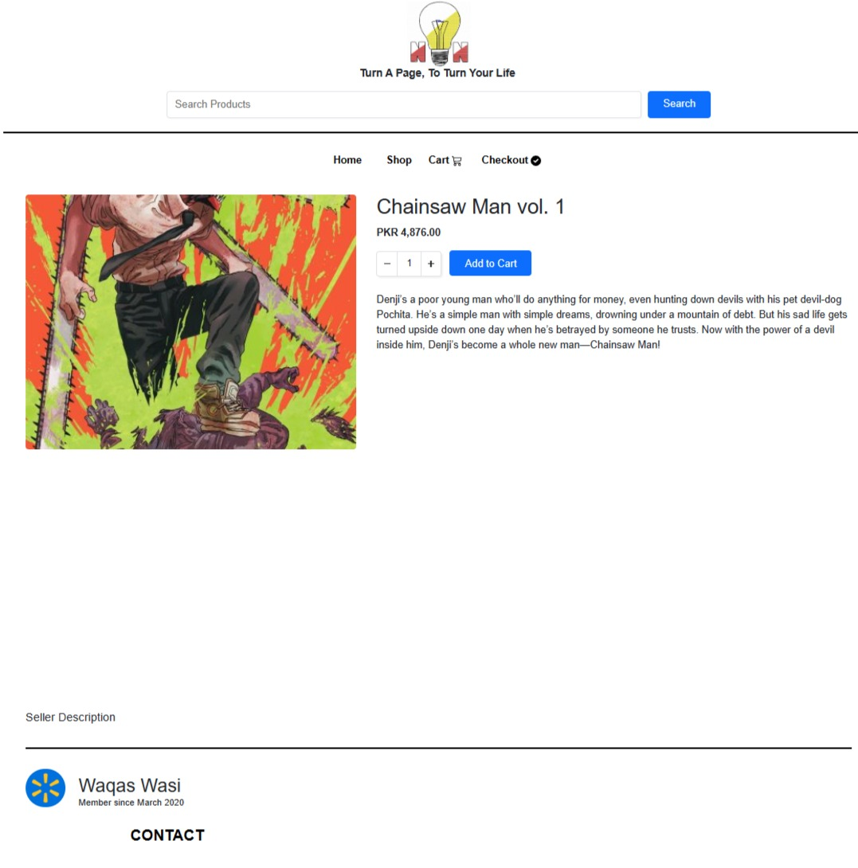

Source 4 Author's own working

The same page will also show the name of the seller and means to contact them. If there are no sellers, meaning the product was owned by NlightN and is being sold by NlightN, they will not see seller contact information and will be guided straight to the checkout section of the website.

Figure 5 Seller Description



Source 5 Author's own working

The same page will also provide information on the seller as well. When you tap on the name of the seller it will prompt a new page where you will see the seller’s details, and where we can contact the seller on site as well,

Figure 6 Seller Contact Info

Source 6 Author's own working

If they wish to contact the seller, they can do this and finalize the purchase by adding the book in Cart and then going to Checkout section of the website.

Figure 7 Cart information

Source 7 Author's own working

Assuming the product is owned by us, and we will be shipping the product to the customer, they will need to enter their personal details as well. After they tap on checkout, the website will ask them to provide those details and the transaction will be completed.

Figure 8 Checkout Section

Source 8 Author's own working

The means of payments will be via

1. Jazz Cash
2. Visa & MasterCard
3. Card on Delivery
4. Cash on Delivery
5. Union Pay

We will also be adding Card transactions as well, so that people can pay via their cards as well, if they wish to do so. For people who want to promote their books via featured or sponsored listing, they will pay before the book is promoted on the front of the website or top of the searches via card.

Regarding the supply chain of our company, most of the products we will be selling are related to books and stationary items. So, we will be procuring our inventories from local vendors and publishers. We will be buying those products on credit and paying them back according to the contract. We will be storing those products in a local warehouse, where a warehouse handler will be handling all the products. And delivering the products via bike. Since we are limiting our reach only to Lahore at launch, we will hire riders and have them deliver the books that customers buy online.

# PESTEL Analysis

The PESTEL Analysis comprises of political, economic, socio-culture, technological, environmental, and legal aspects of the business.

## Political

The political turmoil in Pakistan has never been this high as it is right now. The country is devolving into complete and utter chaos, but even still the government has always supported the digital segment of the market. What I see is that even though Pakistan is in a bad situation, government policies have always supported e-commerce and online marketplaces, which is why companies like OLX, Daraz, Zameen, PakWheels have flourished so much.

## Economic

Pakistan is indeed under an economic collapse; the USD rate is increasing by the day but the economic circle for our business venture is still high. The market for purchasing and selling books online in Pakistan is still relatively small. Which presents a gap in the market to be exploited as this market has not been tapped yet. One of the major issues is rising inflation, this will factor in when we are selling our own products to customers. Prices of everyday item are rising because of the rise in inflation.

## Sociocultural

Pakistan’s literacy rate is 62.3% which has been increasing since 2018. This shows a growing interest in education. More people are educated, which provides a favorable environment for a book marketplace. There is a growing trend in online shopping e.g., for groceries. There are multiple websites and apps that offer this service. Some of them include Alftah, Pandamart, Jalal Sons etc. A recent survey showed that there is a growing interest in reading novels and manga amongst the community.

## Technological

Pakistan supports technological ventures. A couple of years ago, the industry went up to 1 billion USD. The growth in technology has made it easier to operate an online marketplace. It is easier to understand where in the website the customer is spending more time than usual. Creating touchpoints evaluating those touch points and rectifying mistakes. Smartphone devices are common in this generation, since we are providing a service on a website, it should be easily accessible.

## Environmental

Although the environment may be impacted by the creation and distribution of books, this market is unlikely to be overly concerned about impacting the environment.

## Legal

There are no strict legal obligations to be fulfilled in starting this business. We will be complying with privacy and data protection laws. Compliance with these laws is an absolute must to run and virtual marketplace.

# Product Rational Analysis:

## Price

1. The price of books will vary with each book as each purchase / transaction.
2. Delivery charges will be Rs 150/=, and these charges will be waived off at every transaction exceeding Rs 2,000/=

## Product

Along with the service we will be providing we will be selling our own products as well. These products will range in multiple product lines with different SKUs. Our product lines will include.

1. **Art Supplies**
   1. Brushes
   2. Crayons
   3. Glue guns
   4. Canvas
   5. Art sheets
   6. Oil pastels
   7. Watercolors
   8. Paints
   9. Acrylics
   10. Spray paints
   11. Fabric paints
   12. Glass paints
   13. Poster paints
   14. Water paints
2. **Paper & Notebooks**
   1. Sketch pads
   2. Notebooks
   3. Crepe paper
   4. Chart paper
   5. Notepads
   6. Printing paper
   7. Drafting pads
   8. Sticky notes
   9. Register & copies
3. **School Supplies**
   1. Uniforms
   2. Geometry box
   3. School bags
   4. Lunch box
   5. Water bottles
   6. Clipboards
   7. Pouch
4. **Writing Tools**
   1. Compass
   2. Calligraphy
   3. Erasers & corrector
   4. Highlighters
   5. Ink & refills
   6. Leads & refills
   7. Markers
   8. Fiber tip markers
   9. Permanent markers
   10. White board markers
5. **Limited Editions**
   1. Diaries
   2. Executive Pens
   3. Unique Pencils
   4. Bookmarks
   5. Unique Markers
6. Office Supplies
   1. Account books
   2. Book ends
   3. Tapes
   4. Clips
   5. Paper punchers
   6. Paper binding machines
   7. Calculators
   8. Printers
   9. Pen stand
   10. Sharpeners
   11. Shredders
   12. Staplers

## Delivery System

The delivery system will only be available for books/stationery bought from NlightN meaning only for B2C transactions & will not be available for C2C transactions. Customers engaging with other customers will need to decide amongst themselves where they need to meet up for the transaction. The standard delivery time is three working days.

## Packaging

Books will be delivered in a poly bag with the company logo and name.

## Labelling

Labelling will include our tag line which is “**Turn a page, to turn your Life**”

## Promotion

Advertisement through social media, influencers, pamphlets and above all word of mouth.

## B2C

Selling of New books included college textbooks, novels, art supplies, school supplies, office supplies, writing tools, etc.

# Management & Ownership

Our business management includes professionals and skillful people who can perform well in new business opportunities as they are young and highly motivated individuals with broad market knowledge and clear ambitions in their mind. Our management team includes,

* CEO Mr. Muhammad Salman Tipu
* CFO Mr. Usama Tariq
* The Head of Procurement Zia Idrees
* Chief Technology Officer Waqas Wasi
* Chief Marketing Officer Muhammad Ejaz ul Hassan

The CEO of the firm will create the business strategy and will act as the protagonist. The CFO will analyze and govern tax and finance related functions in the business. The Procurement Head will watch over the entire supply chain system of the business. Chief Marketing Officer will generate and execute marketing and advertising strategy, campaigns, and initiatives. And the Chief Technology Officer will handle all queries related to IT aspect of the business.

## Staff Members

We will hire 8 individuals who are as follows,

* 2 delivery riders
* 1 warehouse executive
* 1 dispatch officer
* 1 accountant
* 1 IT specialist
* 1 security officer
* 1 public relation officer

The delivery riders will be responsible for delivering products purchased from us to customers. These products are to be delivered safely and

The warehouse executive will be responsible for ensuring efficient and effective handling, storage, and distribution of products within the warehouse. They will be responsible for inventory management and warehouse organization.

The dispatch officer will be responsible for dispatching the product customers bought from the warehouse to the customer address via delivery riders. They will be in direct communication with the rides. They will be planning the route of the riders and tracking and monitoring the dispatched products.

The accountant will handle queries related to company accounts and all financial transactions related to payments. Their responsibility will be to ensure accurate and timely processing of payments and maintain financial records. The accountant will also perform invoice processing, payment authorization, bookkeeping, financial reporting and cashflow management.

The IT specialist will handle various tasks including website management, website maintenance and troubleshooting. He will develop and deploy the website. Work on maintaining it and updating it. Will be responsible for server hosting management and integration with third party services.

The public relation officer’s main responsibility is to build and keep up positive relationships with the community, the media, and the general-public. They will handle all queries related to complaints from customers, media relations, publicity and promotions, social media and online presence, internal communications. They will be responsible for public image and reputation management.

The security guard will be responsible for security concerns of the office.

## Legal Structure of the Business

The legal structure of our business is partnership where we are incorporating our complimentary skills, financial resources, and connections to make this venture a success. We will be combining our resources, investments, profits, and losses equally.

# Sustainable Development Goals

NlightN will help contribute to the resolution of the 4th Goal, Quality Education, in the United Nations Sustainable Development Goals. What NlightN will ensure is to provide students with equitable learning opportunities by providing them with an internet marketplace where they can buy and sell old textbooks. This project will also ensure that if somebody wants to donate their books, they can easily do so by posting under the donations tab and those who need those books could easily search and reach out to them.

The literacy rate of Pakistan sits at 62.3%, which gives an estimation of 80 million individuals in Pakistan who cannot read or write. To make education more accessible, students need a platform where they can buy and sell their old books without the need for a third party.

Furthermore, to give back to the community, after NlightN has crossed its breakeven point, what I intend to do is to provide a certain portion of profit to NGOs working in the educational sector of Pakistan. NGOs like

1. Iqra Educational Trust
2. Balochistan Education Foundation (BEF)

Figure 9 Sustainable Development Goals

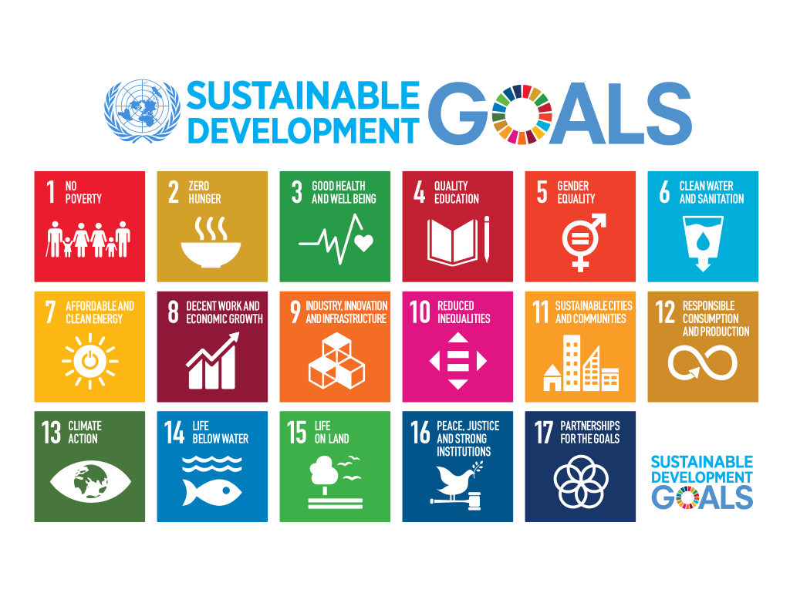

Source Sustainable Development Goals

Implementing a charity section, to raise funds to acquire uniforms and books for students. We already have a donation section set up on our website. Individuals need to go to the home page of the website and tap on the donate button.

Figure 10 Donation Button

Source 10 Author's own working

After tapping on the donate button, a new window will open and ask the user to provide information about the book they want to donate.

Figure 11 Donation Section

Source 11 Author's own working

# Market Analysis

This analysis was conducted via a survey which had about 64 respondents.

**Question 1**

The first question was to understand the gender demographic of my survey as we can see 65% were male and 34.4% were female. Meaning majority respondents were men.

Figure 12 Survey Question 1

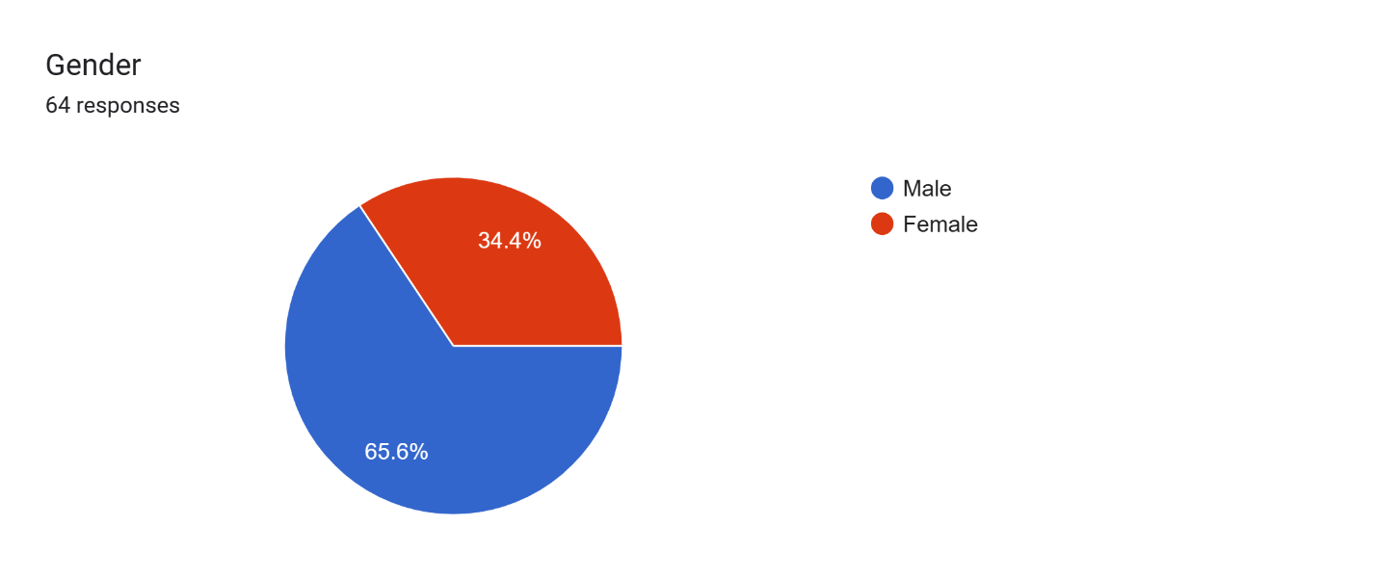

Source 12 Author's own working

**Question 2**

Figure 13 Survey Question 2

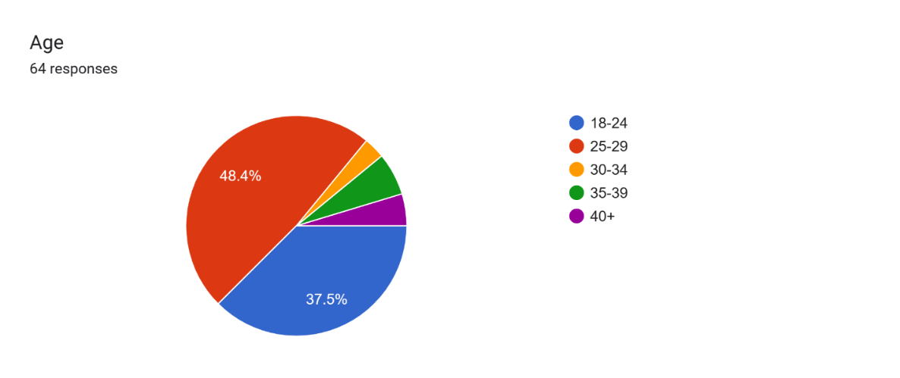

Source 13 Author's own working

We had a wide variety of individuals of different age groups. The majority of them were from the age 25-29 and 18-24 meaning most of them are in the age demographic where we want to operate our business.

**Question 3**

Figure 14 Survey Question 3

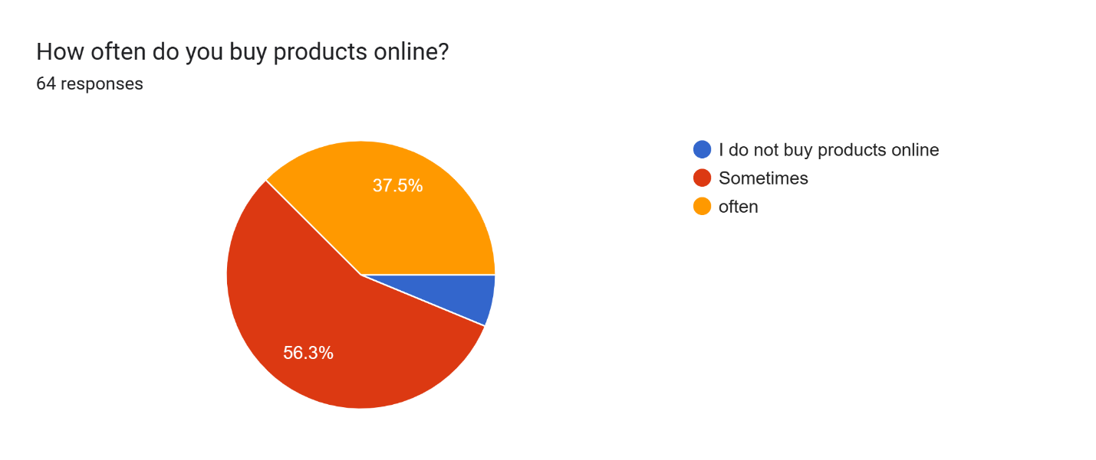

Source 14 Author's own working

This question was meant to understand whether our respondents purchased products online. This was a general question to grasp if they are even interested in buy products online. And most of them were. Most of them said sometimes and 37% said often and a small portion was not interested in buying products online.

**Question 4**

Figure 15 Survey Question 4

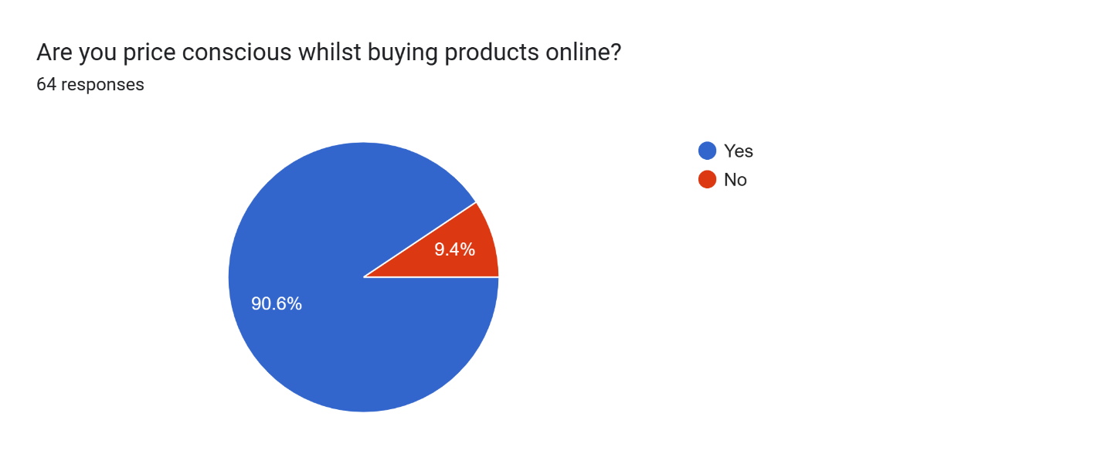

Source 15 Author's own working

This was to understand if our customers are price conscious buying products online. And a staggering 90% of them were. Meaning we cannot overcharge our customers.

**Question 5**

Figure 16 Survey Question 5

Forms response chart. Question title: How often do you buy books for yourself or your family members?
. Number of responses: 64 responses.

Source Author's own working

This was to understand if the respondents even bought books for themselves or their families at all. Most of them did buy books.

**Question 6**

Figure 17 Survey Question 6

Forms response chart. Question title: Would you be interested in purchasing used books?
. Number of responses: 63 responses.

Source 17 Author's own working

This question was to ascertain whether our respondents were interested in buying used books. This was our main question and our business model depended on it. The result was positive and about 90% agreed on buying used books.

**Question 7**

This question was to confirm if the respondents buy books online, and surprisingly most of them said sometimes they did buy books online, but a large portion did not buy books online. This shows a gap in the market to be exploited.

Figure 18 Survey Question 7

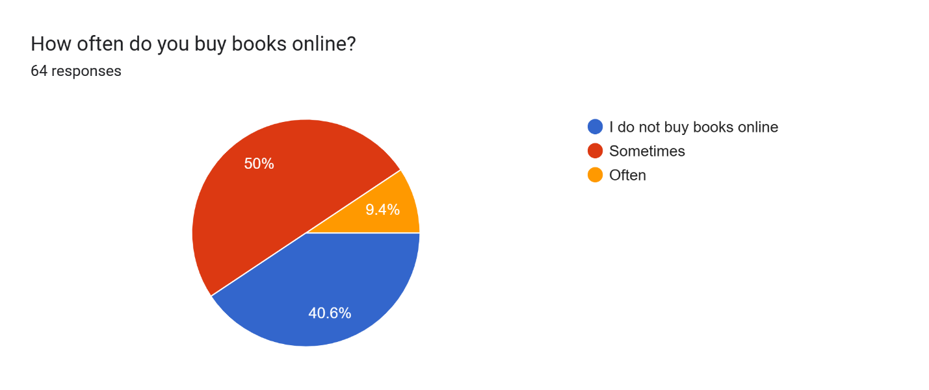

Source 18 Author's own working

**Question 8**

Figure 19 Survey Question 8

Forms response chart. Question title: Would you consider buying books from an online marketplace that specializes in the buying and selling of books?
. Number of responses: 64 responses.

Source Author's own working

The next question was to confirm our business model and most of the respondents agreed to buy books from an online marketplace that specializes in the buying and selling of books. Although there is a significant portion of respondents who were neutral to the idea, I believe this give an opportunity to convert them to new customers with appropriate marketing.

**Question 9**

Figure 20 Survey Question 9

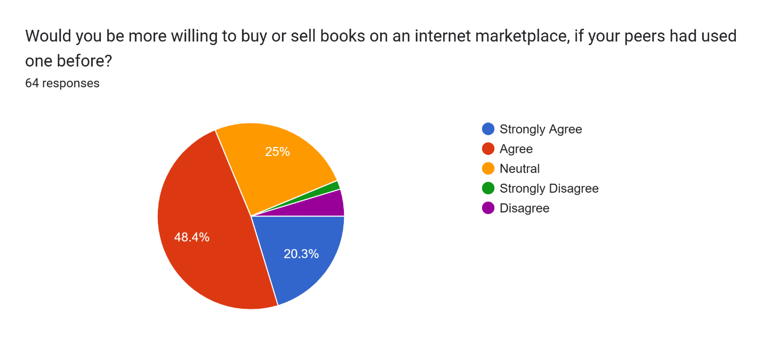

Source 20 Author's own working

A large part of our marketing depends on word-of-mouth marketing. And this question was made to confirm the feasibility of that marketing strategy. Most of the respondents agreed that if their peers had used one before and they recommended it, they would use this platform. Although 25% were still neutral, there is a decrease from 30% when their peers did not recommend it.

**Question 10**

Figure 21 Survey Question 10

Forms response chart. Question title: What are the most important factors you consider when choosing an online marketplace for the buying or selling books?
. Number of responses: 64 responses.

Source 21 Author's own working

Most of the respondents agreed that price, convenience, and UI are important for an online marketplace.

**Question 11**

Figure 22 Survey Question 11

Forms response chart. Question title: Depending on the book (Expensive) you are selling online, would you be willing to pay a small fee to an online marketplace to promote the book on the front page?
. Number of responses: 64 responses.

Source 22 Author's own working

This question was made to confirm one of the revenue models of our business i.e., sponsored listing and featured listing. The majority of them agreed to the sentiment that if the book is expensive or a collector’s eddition they would pay a small fee to market the product to a wider audience and promote the ad to the home page. This means our revenue model is feasible.

**Question 12**

Figure 23 Survey Question 12

Forms response chart. Question title: what types of books would you like to buy online?
. Number of responses: 63 responses.

Source 23 Author's own working

This was a general question of what types of books they buy online and most of them replied with novels and then educational books. Meaning we should also focus on novels and self-help books because both combined make most books, respondents are looking for.

**Question 13**

The last question was to understand whether the question about community building is even important to our customers. The respondents agreed that it is something that they look out for.

Figure 24 Survey Question 13

Forms response chart. Question title: How important is it to you to have a sense of community or social connection when buying books online?
. Number of responses: 64 responses.

Source 24 Author's own working

# Financial Data

The financial plan of NlightN is based on 100% equity. The equity will be the initial investment made by the five partners Mr. Salman Tipu, Mr. Zia Idrees, Mr. Ejaz ul Hassan, Mr. Usama Tariq, Mr. Waqas Wasi. The initial investment is made on the basis of developing the website, procuring the initial inventory and marketing.

## Business Cost

Table 1 Business Cost

|  |  |
| --- | --- |
| **Business Cost** |  |
| **Equity** | **PKR 1,250,000.00** |
| Business Registration | PKR 70,000.00 |
| Website Development | PKR 150,000.00 |
| Website Hosting | PKR 100,000.00 |
| Inventory (SKUs) | PKR 130,000.00 |
| Office Supplies | PKR 120,000.00 |
| Advertisement | PKR 250,000.00 |
| Rent Expense | PKR 250,000.00 |
| **Total Cost** | **PKR 1,070,000.00** |
| **Cash on hand** | **PKR 180,000.00** |

Source 25 Author's own working

We would need an initial investment of **PKR 1,250,000.00** to run the business. The first task is to start developing a website which will cost a total of PKR 150,000 including the developer’s salary. And a further PKR 100,000 to host the website. The hosting of the website will be via shared hosting. This way we can save about PKR 200,000 from not hosting on a private AWS server. After the development of the website, we would need to set up the office and procure inventory and spend pm advertisement of the website, as our success factor initially depends on how much traffic we can bring on the platform. Office supplies include Chairs, tables and other accessories. Advertisement expense include advertising on Facebook, TikTok, Instagram and YouTube. Advertisement will be done based for all of Lahore for the first year, this will cost us about PKR100,000 based on per day charges of PKR 300. For the Video production it will cost us PKR 30,000. We will be marketing on YouTube as well where per view could cost about PKR 50, we will set aside a budget of PKR 90,000 for YouTube and it’s the same for Instagram, but we will drop our budget to PKR 20,000 and TikTok Budget will be set aside for PKR 10,000

This will bring a total cost of about PKR 1,070,000/= deducting it from out equity it will bring our initial cash on hand to **PKR 180,000/=**

We will be using the percentage of sales method to forecast the figures for the future in the income statement. Furthermore, since this is a startup there is no historical sales data. However, sales are based on the number of people reaching out through our social media marketing, influencer marketing and online word of mouth.

## Income Statement

Since we are using the percentage of sales method the sales increment is for 10%, cost of goods sold increment is for 25% each year for four years. 5% increase in rent expense and 1% increase in office expense every year.

Table 2 Income Statement

|  |  |  |  |  |  |  |
| --- | --- | --- | --- | --- | --- | --- |
|  | **2023** | **2024** | **2025** | **2026** | **2027** | **2028** |
| **Revenue** |  |  |  |  |  |  |
| Sales | PKR 1,600,000 | PKR 1,760,000 | PKR 1,936,000 | PKR 2,129,600 | PKR 2,342,560 | PKR 2,576,816 |
| Cost of Goods Sold | PKR 300,000.00 | PKR 440,000.00 | PKR 484,000.00 | PKR 532,400.00 | PKR 585,640.00 | PKR 644,204.00 |
| Gross Profit | **PKR 1,300,000** | **PKR 1,320,000** | **PKR 1,452,000** | **PKR 1,597,200** | **PKR 1,756,920** | **PKR 1,932,612** |
| **Operating Expenses** |  |  |  |  |  |  |
| Salaries & Wages | PKR 500,000.00 | PKR 500,000.00 | PKR 500,000.00 | PKR 500,000.00 | PKR 500,000.00 | PKR 500,000.00 |
| Office Expenses | PKR 20,000.00 | PKR 20,200.00 | PKR 20,402.00 | PKR 20,606.02 | PKR 20,812.08 | PKR 21,020.20 |
| Rent Expense | PKR 100,000.00 | PKR 105,000.00 | PKR 110,250.00 | PKR 115,762.50 | PKR 121,550.63 | PKR 127,628.16 |
| Utility Bills | PKR 100,000.00 | PKR 100,000.00 | PKR 100,000.00 | PKR 100,000.00 | PKR 100,000.00 | PKR 100,000.00 |
| Maintenance Expenses | PKR 30,000.00 | PKR 30,000.00 | PKR 30,000.00 | PKR 30,000.00 | PKR 30,000.00 | PKR 30,000.00 |
| Advertising Expenses | PKR 400,000.00 | PKR 400,000.00 | PKR 400,000.00 | PKR 400,000.00 | PKR 400,000.00 | PKR 400,000.00 |
| Depreciation | PKR 10,000.00 | PKR 10,000.00 | PKR 10,000.00 | PKR 10,000.00 | PKR 10,000.00 | PKR 10,000.00 |
| **Total Operating Expenses** | PKR 1,160,000 | PKR 1,165,200 | PKR 1,170,652 | PKR 1,176,368 | PKR 1,182,362 | PKR 1,188,648 |
| Income from Operations | PKR 140,000.00 | PKR 154,800.00 | PKR 281,348.00 | PKR 420,831.48 | PKR 574,557.29 | PKR 743,963.64 |
| Income Tax Expense |  |  |  |  |  |  |
| **Net Income** | **PKR 140,000.00** | **PKR 154,800.00** | **PKR 281,348.00** | **PKR 420,831.48** | **PKR 574,557.29** | **PKR 743,963.64** |

Source 26 Author's own working

Sales consist of AdSense, featured listing, sponsored listing, B2C transaction. We are projecting the sales to go up to PKR 1,600,000 in the first year, with a constant 10% increase in the preceding year. The initial gross profit will be PKR 1,300,000 after COGS is deducted from sales. Salaries will be set at PKR 500,000. Office expenses will include A4 papers, printer ink, laptop expenses etc. Maintenance expense is set for website maintenance. We expect our website to be regularly updated. Advertisement expenses will include video production of ads. We will be partnering with a marketing firm to create our video ad. Which should cost about 30,000. Facebook ads will cost about 100,000 to run for the year in all of year. We will be marketing on youtube as well where per view could cost about PKR 50, we will set aside a budget of PKR 150,000 for Youtube and for Instagram this is the same as well, but we will trickle down our budget to PKR 100,000 and TikTok Budget will be set aside for PKR 50,000. We will be using BTL approach to target these customers. Depreciation for PKR 10,000 is set aside for office equipment which includes laptop and printers etc. Which brings to a total operating expense at PKR 1,160,000 And a net income of PKR 140,000.

## Balance Sheet

Table 3 Balance Sheet

|  |  |  |  |  |  |  |
| --- | --- | --- | --- | --- | --- | --- |
|  | **2023** | **2024** | **2025** | **2026** | **2027** | **2028** |
| **Current Assets** |  |  |  |  |  |  |
| Cash | PKR 175,000.00 | PKR 192,500.00 | PKR 211,750.00 | PKR 232,925.00 | PKR 256,217.50 | PKR 281,839.25 |
| Inventory | PKR 150,000.00 | PKR 165,000.00 | PKR 181,500.00 | PKR 199,650.00 | PKR 219,615.00 | PKR 241,576.50 |
| Other Current Assets | PKR 50,000.00 | PKR 50,000.00 | PKR 50,000.00 | PKR 50,000.00 | PKR 50,000.00 | PKR 50,000.00 |
| **Total Current Assets** | PKR 375,000.00 | PKR 407,500.00 | PKR 443,250.00 | PKR 482,575.00 | PKR 525,832.50 | PKR 573,415.75 |
| **Long-term Assets** |  |  |  |  |  |  |
| Machinery & Equipment & vehicle | PKR 250,000.00 | PKR 237,500.00 | PKR 225,000.00 | PKR 212,500.00 | PKR 200,000.00 | PKR 187,500.00 |
| Furniture | PKR 12,500.00 | PKR 12,500.00 | PKR 12,500.00 | PKR 12,500.00 | PKR 12,500.00 | PKR 12,500.00 |
| **Total Long-term Assets** | PKR 250,000.00 | PKR 237,500.00 | PKR 225,000.00 | PKR 212,500.00 | PKR 200,000.00 | PKR 187,500.00 |
| **Total Assets** | **PKR 625,000.00** | **PKR 645,000.00** | **PKR 668,250.00** | **PKR 695,075.00** | **PKR 725,832.50** | **PKR 760,915.75** |
|  |  |  |  |  |  |  |
| **Liabilities and Capital** | PKR 2,023.00 | PKR 2,024.00 | PKR 2,025.00 | PKR 2,026.00 | PKR 2,027.00 | PKR 2,028.00 |
| **Current Liabilities** |  |  |  |  |  |  |
| Accounts Payable | PKR 125,904.00 | PKR 138,494.40 | PKR 152,343.84 | PKR 167,578.22 | PKR 184,336.05 | PKR 202,769.65 |
| Current Borrowing | PKR 100,000.00 | PKR 110,000.00 | PKR 121,000.00 | PKR 133,100.00 | PKR 146,410.00 | PKR 161,051.00 |
| Subtotal Current Liabilities | PKR 225,904.00 | PKR 248,494.40 | PKR 273,343.84 | PKR 300,678.22 | PKR 330,746.05 | PKR 363,820.65 |
| **Pension liabilities** | PKR 125,000.00 | PKR 137,500.00 | PKR 151,250.00 | PKR 166,375.00 | PKR 183,012.50 | PKR 201,313.75 |
| **Total Liabilities** | PKR 350,904.00 | PKR 385,994.40 | PKR 424,593.84 | PKR 467,053.22 | PKR 513,758.55 | PKR 565,134.40 |
| capital | PKR 274,096.00 | PKR 259,006.00 | PKR 243,656.00 | PKR 228,022.00 | PKR 212,074.00 | PKR 195,781.00 |
| **Total Liabilities and capital** | **PKR 625,000.00** | **PKR 645,000.40** | **PKR 668,249.84** | **PKR 695,075.22** | **PKR 725,832.55** | **PKR 760,915.40** |

Source Author's own working

Cash we will have is PKR 175,000, inventory we will hold is for 175,000 this will be for our SKUs we will be selling our customer. Our current assets will include office equipment. Our fixed assets will include office car, furniture, computer hardware etc.

For current liabilities, accounts payable are for the inventory and office goods we bought on credit from the seller. There will be no interest expense for this. For long term liabilities we will be paying compensation liabilities to our employees.

## Cash Flows

Table 4 Cash Flows

|  |  |  |  |  |  |  |
| --- | --- | --- | --- | --- | --- | --- |
|  | **2023** | **2024** | **2025** | **2026** | **2027** | **2028** |
| **Cashflows** |  |  |  |  |  |  |
| Operating Profit | PKR 140,000.00 | PKR 154,800.00 | PKR 281,348.00 | PKR 420,831.48 | PKR 574,557.29 | PKR 743,963.64 |
| Non-Cash Adjustments |  |  |  |  |  |  |
| Depreciation | PKR 10,000.00 | PKR 10,000.00 | PKR 10,000.00 | PKR 10,000.00 | PKR 10,000.00 | PKR 10,000.00 |
| Provision for doubtful debt | PKR 20,000.00 | PKR 20,000.00 | PKR 20,000.00 | PKR 20,000.00 | PKR 20,000.00 | PKR 20,000.00 |
| Changes working capital changes | PKR - | PKR (9,909.60) | PKR (10,900.56) | PKR (11,990.62) | PKR (13,189.68) | PKR (14,508.65) |
| **Cash Generated** | **PKR 170,000.00** | **PKR 174,890.40** | **PKR 300,447.44** | **PKR 438,840.86** | **PKR 591,367.62** | **PKR 759,455.00** |

Source 28 Author's own working

Cash flow statements purpose is to identify the cash inflow and outflow for 5 years a due to company’s operational activities. The company set the target of four to five years in the 5th year cash flows shows that there is growth in business this expansion and growth in terms of product innovation and business expansion as we will be expanding in more cities.

# Risk Analysis

Every business comes with a certain set of risks. The process for evaluating the probability of any unfavorable events that could harm an organization and the environment is known as risk analysis (Hayes, 2023). Following are the potential risk NlightN could come across.

## Cyberattacks

Online markets are susceptible to cybersecurity risks like hacking, data breaches and scams. These attacks can affect our business as well since we will primarily have an online presence. These cyberattacks can be in the form of DDOS, hackers may attempt to steal personal and financial information, leading to potential financial loss and loss of customer trust. To safeguard user's data and thwart cyberattacks, we will make sure that it has strong cyber security measures in place, such as data encryption and two-factor authentication.

## Competitor Risk

It is always possible that bigger fishes in the pond that are already established brands see the success of our brand and start providing this service as well. Brands like Readings, LibertyBooks, SaeedBooks, BukhariBooks are already established brands with decades of experience in this market. For example, An established online retailer may provide a greater selection of books or more affordable prices, luring people away from us. But what we can do is to differentiate our selves from the rest of the competition via differentiating the online marketplace by providing unique features, personalized customer experience, accessible website layout, partnering with publishers and authors.

## Payment risks

To avoid fraud and guarantee smooth payment processing, the virtual marketplace must make sure that it has safe payment solutions in place. For instance, a buyer can assert that they didn't receive a book or contest its condition, resulting in losses in money and potential disputes. We can either offer our own payment gateway, which would involve additional security and regulatory compliance requirements, or we use third-party payment gateways like jazzcash, union pay, Visa & Mastercard etc. What we can do is also offer cash/card or delivery payment systems as well.

## Delivery Risk

To guarantee that products are delivered on time and in excellent condition, we must ensure that we have dependable logistics and a delivery system in place. For example, if the goods are not delivered on time or are damaged they will be returned and will cause a financial loss. What we can do to mitigate this is by carefully planning the route the rider has to take and make sure that the rider safely arrives at the buyers place to complete the order.

## Reputation Risk

Internet marketplaces rely significantly on the trust they develop with their customers. Negative reviews can harm NlightN’s reputation as a reliable internet marketplace for books and deter new potential customers. If a website hosts fraudulent activities, it will harm its reputation. When customers are dissatisfied, it changes the overall perception of the brand equity (Hatler, 2022). What we can do about this is being transparent without customers on how the business operates, that they must meet with the sellers at a crowded place and make sure the product is to their liking before making the purchase.

# References

Cook, B. (2023, 4 2). *Bargaining Power of Suppliers: Overview & Strategy*. Retrieved from tipalti: https://tipalti.com/bargaining-power-of-suppliers/

GURL, E. (2017, 08 11). SWOT analysis: A theoratical review. *dspacedirect*. Retrieved from dspacedirect: http://hdl.handle.net/10673/792

Hatler, A. (2022, 8 26). *How much can a bad review hurt your business?* Retrieved from techtarget: https://www.techtarget.com/whatis/feature/How-much-can-a-bad-review-hurt-your-business

HAYES, A. (2020, 11 21). *Demand Theory: Definition in Economics, Meaning, and Examples*. Retrieved from investopedia: https://www.investopedia.com/terms/d/demand_theory.asp

Hayes, A. (2023, 1 5). *Risk Analysis: Definition, Types, Limitations, and Examples*. Retrieved from investopedia: https://www.investopedia.com/terms/r/risk-analysis.asp

Juman, A. (2016, 10 21). *Urdu Bazaar's Evolution, from the Mughal Times to the Present*. Retrieved from youlinmagazine: https://www.youlinmagazine.com/article/urdu-bazaar-evolution-from-the-mughal-times-to-the-present/Njg4

Porter, M. E. (2009, 11 4). Competitive Strategy: Techniques for Analyzing Industries and Competitors. *SSRN*. Retrieved from SSRN: https://papers.ssrn.com/sol3/papers.cfm?abstract_id=1496175#

Schooley, S. (2023, 2 21). *SWOT Analysis: What It Is and When to Use It*. Retrieved from businessnewsdaily: https://www.businessnewsdaily.com/4245-swot-analysis.html

Team, T. I. (2023, 3 31). *Porter's 5 Forces Explained and How to Use the Model*. Retrieved from Invesopedia: https://www.investopedia.com/terms/p/porter.asp

Training, M. o. (2023). *ADULT LITERACY*. Retrieved from Ministry of Federal Education & Professional Training mofept: http://mofept.gov.pk/ProjectDetail/NjQ4ZTg2NjItOWM2NC00Y2IxLTkzMDgtMjU2OTFhMjA4NzNh

Twin, A. (2023, 3 28). *The 4 Ps of Marketing and How To Use Them in Your Strategy*. Retrieved from investopedia: https://www.investopedia.com/terms/f/four-ps.asp

UNESCO. (2022, 10 22). *Literacy rate - Pakistan*. Retrieved from MacroTrends: https://data.worldbank.org/indicator/SE.ADT.LITR.ZS?locations=PK

Zaidi, A. (2021). *Education*. Retrieved from unicef: https://www.unicef.org/pakistan/education

# Appendix: Website URL

Website URL: <https://nlightn-online.vercel.app/index.html>