**Phase1**

**Report**

**Web development Fundamentals**

**CMPS 350**

**Spring 24**

**L02**

**Dr. Mucahid Kutlu**

**Group name**: Phonable

**Group members:**

**Mohammed Albazeli 202006253**

**Salman Mohammed 201909507**

**Abdullah Abdullah 201905315**

**Phonable website**



GitHup link: <https://github.com/Salman-st1909507/CMPS350-Phase1-Project>

Phonable: It is a website for buying and selling mobile phones.

Application design: The design documentation provides a comprehensive overview of the Customer and Seller entities within the web application by know their attributes and functionalities. Our website has 5 interfaces

1. Login

­­­­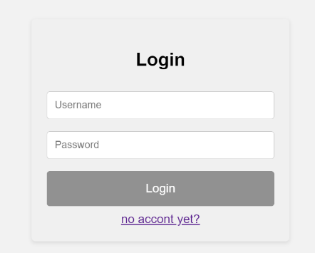

2. Account. An account for the customer and an account for the seller

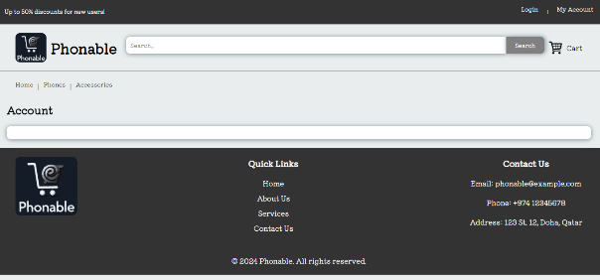

3. Home page

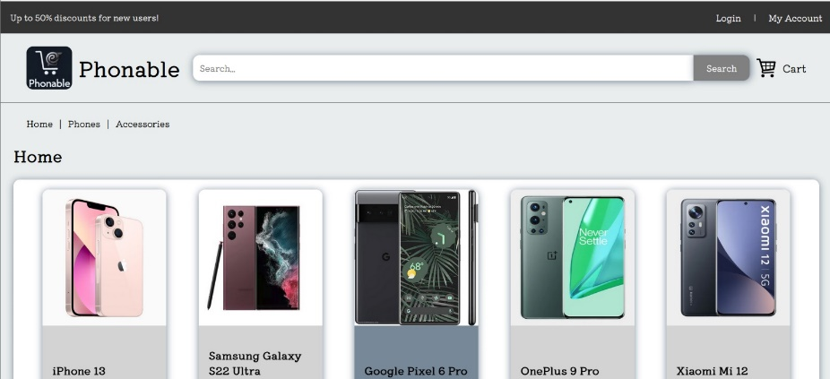

4. Cart

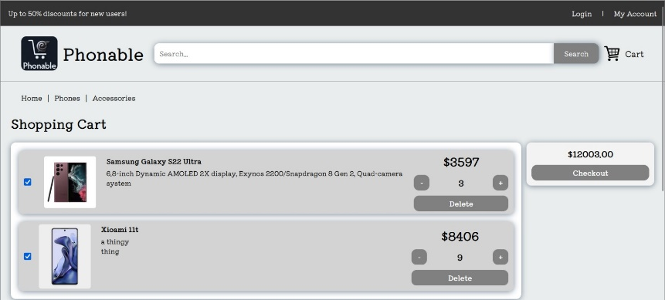

5. Item details

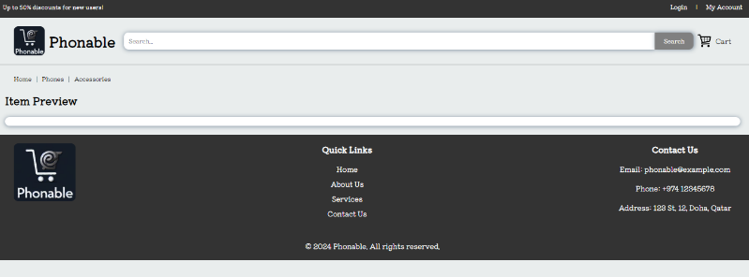

6. Upload an Item

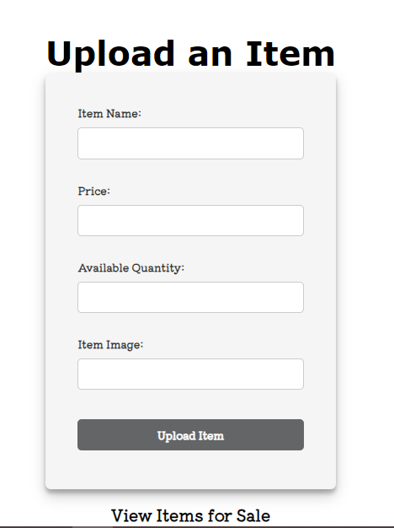

We use a local storage instead of web API

Class Diagram:

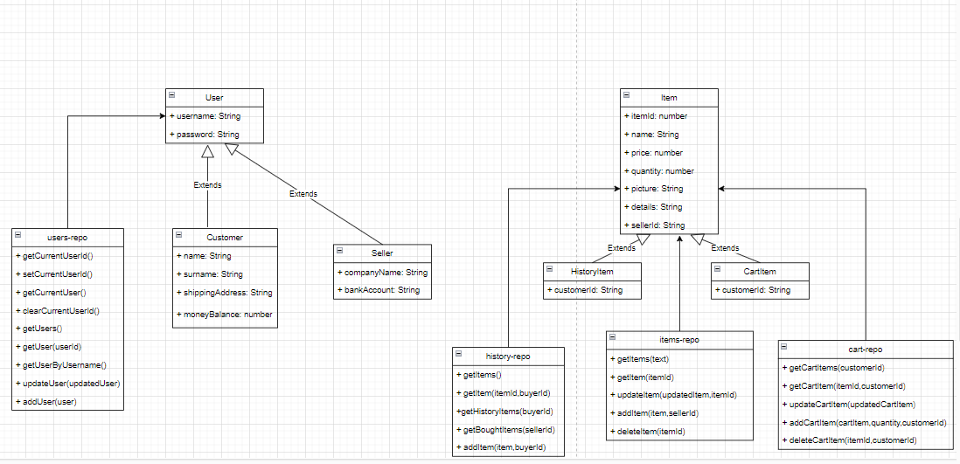

• The platform has the following use-cases:

1. Login

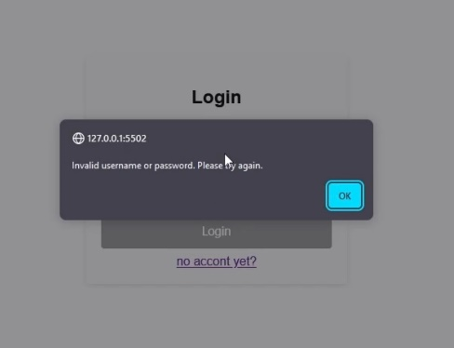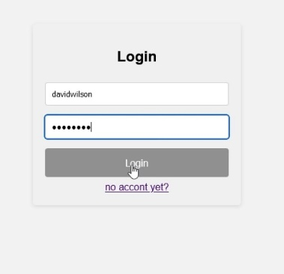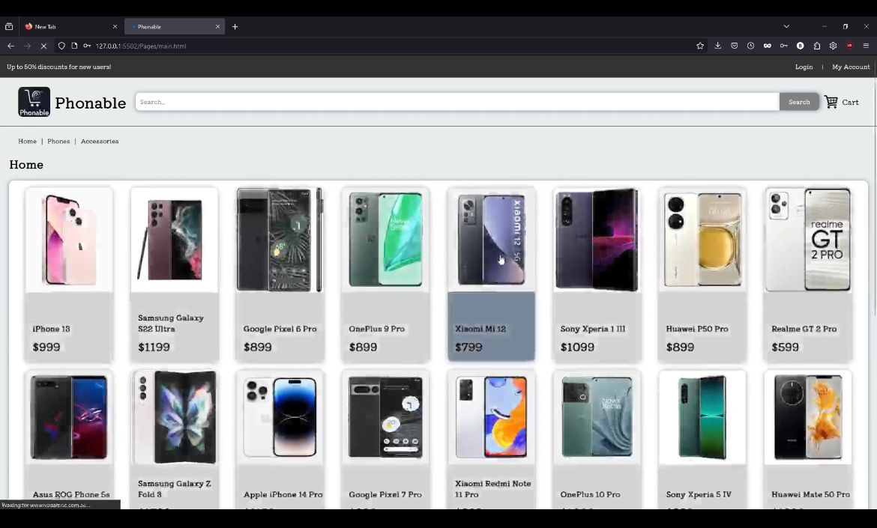

1. Search available items

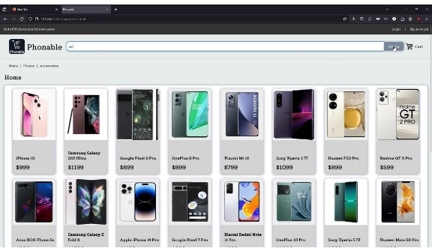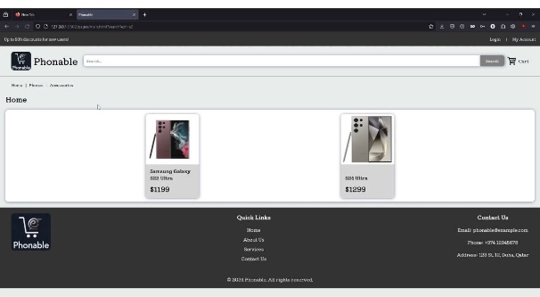

1. Purchase an item

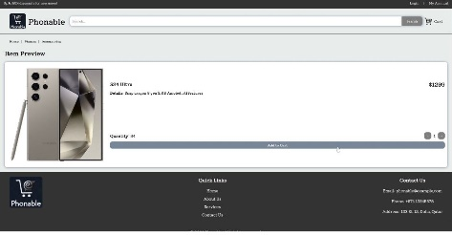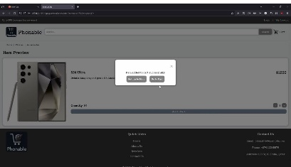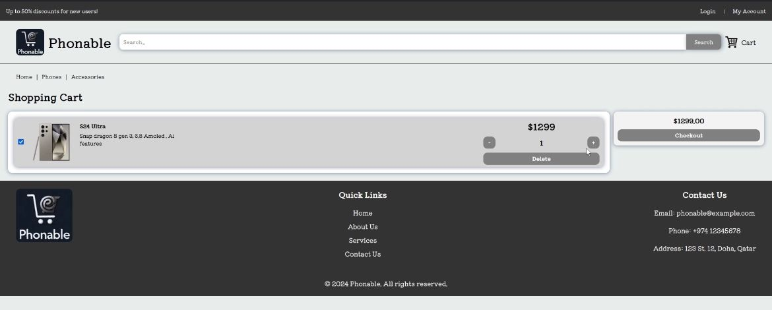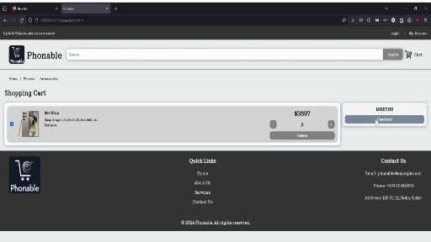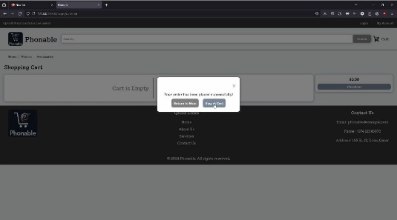

1. View the purchase history

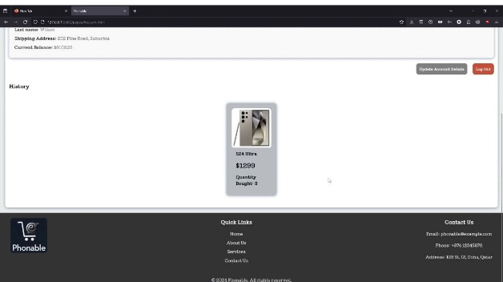

1. View available items on sale and sale history

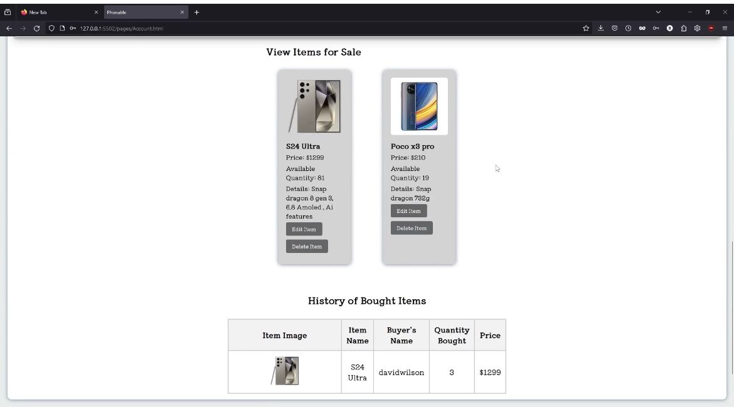

1. Upload an item to be sold

