**Test -2**

**Please solve the below question accordingly using Pandas**

1. **Imagine you work for an e-commerce company that has collected customer reviews for its products. The data is stored in a list of dictionaries, where each dictionary represents a customer review with the following structure**

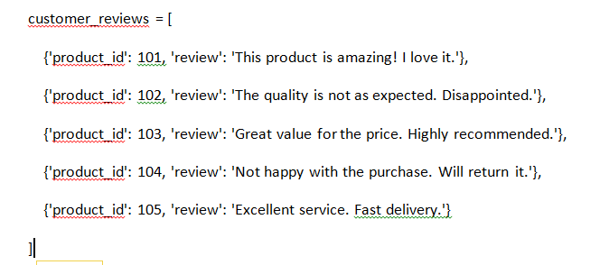

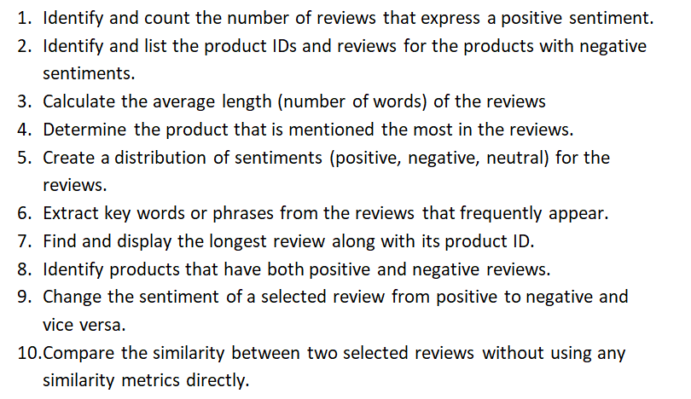

1. **Let's consider a scenario related to real estate data. Suppose you have a dataset containing information about real estate properties, and the data is stored in a list of dictionaries. Each dictionary represents a property with details such as the property type, size, location, number of bedrooms, and price. Here's the scenario and some questions:**

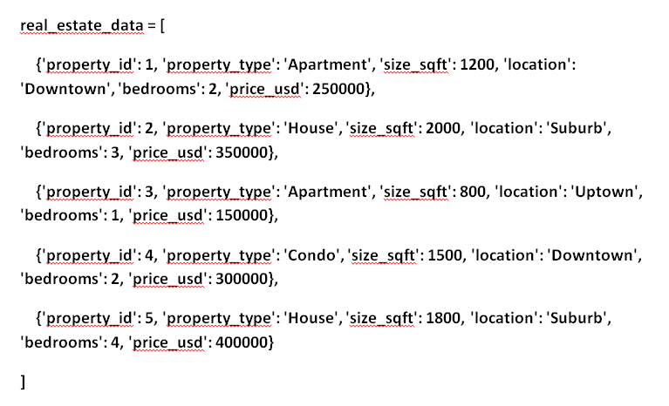

**Question:**

