**Chittagong University of Engineering & Technology**



**Department of Computer Science & Engineering**

**Course Title:** Database Management System(Sessional)

**Course Code:** CSE-252

| **Submitted by:**  **Kowshik Chowdhury (1804119)**  Salman Farsi (1804102)  Md. Sajidul Mowla (1804100)  Antu Chowdhury (1804112) | **Submitted to:**  **Md. Shafiul Alam Forhad**  Professor, Department of CSE, CUET  **Md. Atiqul Islam Rizvi**  Lecturer, Department of CSE, CUET |
| --- | --- |

**Group No. :** 02

**CONTENTS**

* INTRODUCTION
* MOTIVATION
* ER DIAGRAM
* RELATIONAL MAPPING
* NORMALIZATION
* TABLES
* SQL QUERIES
* CONCLUSION

**Introduction**

This program is built on top of a website where moviegoers can buy tickets online. Anyone may purchase movie tickets for any theater in the country using our simple online booking system.

This system's goal is to provide moviegoers with information about a wide range of recently released films while also facilitating the sale of cinema tickets. Online booking is the foundation of the whole system.

**Motivation**

Booking movie tickets online using an internet platform is an appealing and comfortable experience. It enables us to reserve and buy tickets that are relevant to our film interests, all while enjoying at home on a regular basis day or night. We worked on this database project to get fresh experience.

## 

## ER Diagram

## Description:

Our proposed database management system will have these following strong entities:

* Admin (admin_id, admin_name, admin_desc)
* Movie (movie_name, movie_id, movie_dur, movie_type, movie_lang, movie_desc)
* User (user_id, user_email, user_mobile, f_name, l_name)
* Booking (booking_id, booking_type, booking_sum)
* Payment (pay_id, pay_date, pay_amount)
* Showtime(show_id, start_time, end_time)
* Theater (th_id, th_name, th_rating, th_ad)
* Hall (hall_no, hall_capacity, hall_seat_no, hall_type)

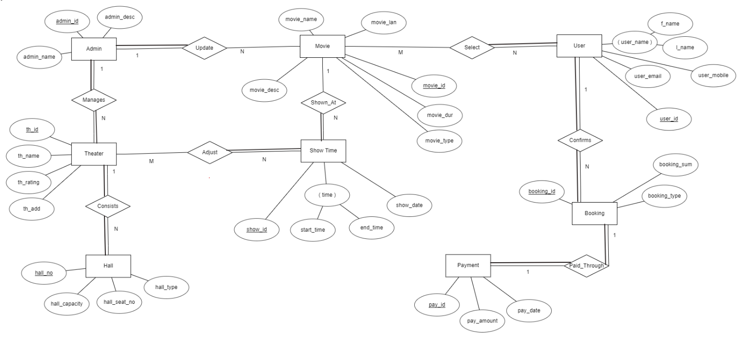

***Figure 1:*** *ER Diagram of Online movie ticket booking system*

**MAPPING**

**STEP 1: Mapping of Regular Entity Types**

**STEP 2: Mapping of Weak Entity Types**

**STEP 3:** **Mapping of Binary 1:1 relationship Types**

**STEP 4:** **Mapping of Binary 1:N Relationship Types**

**STEP 5:** **Mapping of M:N relationship type**

**STEP 6:** **Mapping of Multivalued attributes**

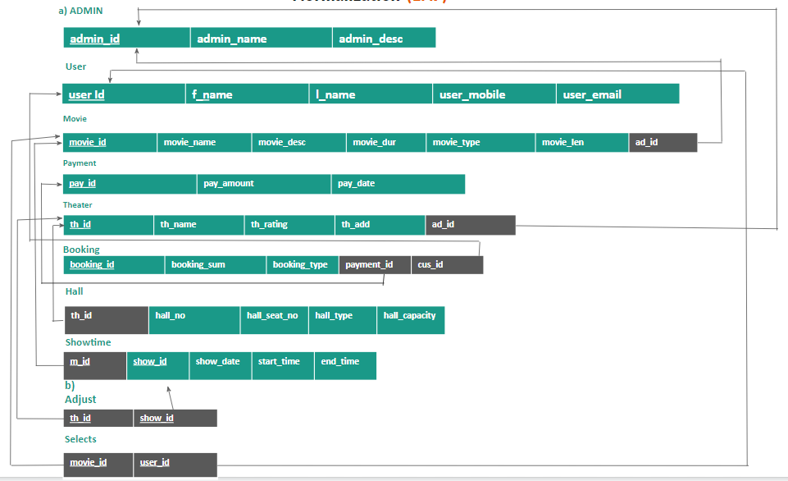

*Fig: Relational Mapping*

**NORMALIZATION**

Normalization is the process of reorganizing data in a database so that it meets some basic requirements.

**1 NF:**

First normal form is violated if a relation comprises composite or multi-valued characteristics, while first normal form is present when no composite or multi-valued attributes are present. If every attribute in a relation is a single-valued attribute, the connection is in first normal form.

After mapping, in relation the schema becomes atomic valued. So, it becomes 1 NF.



***Fig-01:*** *1 NF*

**2 NF:**

A relationship must be in first normal form in order to be in second normal form, and no partial dependencies may exist inside the relationship. If there is no valid subset of any candidate key of the table that is reliant on any proper subset of any non-prime attribute (attributes that are not part of any candidate key), then the relation is in 2NF.

It's termed partial reliance if a candidate key's suitable subset determines non-prime characteristics.

We don't have any partial dependencies in our model, thus our table stays the same.



***Fig-02:*** *2 NF*

**3 NF:**

A relation is in third normal form, if there is no transitive dependency for non-prime attributes as well as it is in second normal form.

A relation is in 3NF if at least one of the following condition holds in every non-trivial functional dependency X –> Y

1. X is a super key.
2. Y is a prime attribute (each element of Y is part of some candidate key).

As our model does not have any partial dependency so our table remains as it is.



***Fig-03:*** *3 NF*

**Tables**

***Fig-01 : Admin Table***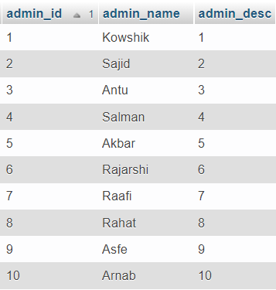

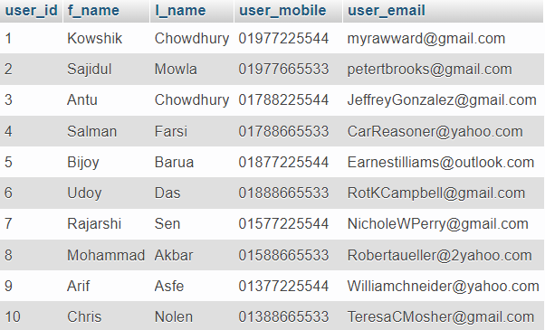

***Fig-02 : User Table***

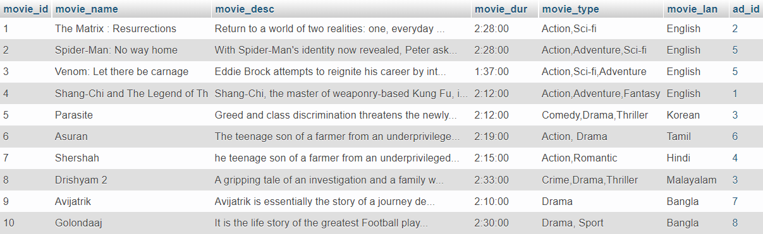

***Fig-03 : Movie Table***

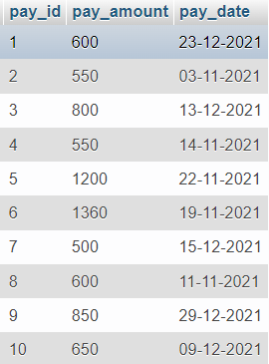

***Fig-04 : Payment Table***

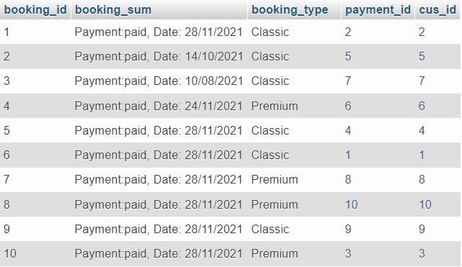

***Fig-05 : Booking Table***

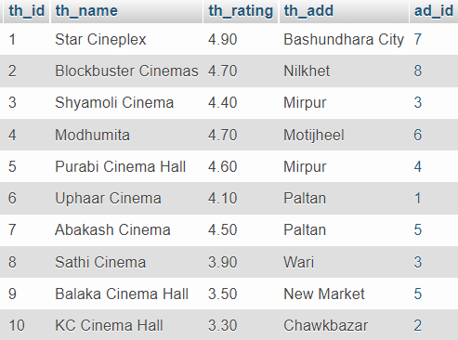

***Fig-06 : Theater Table***

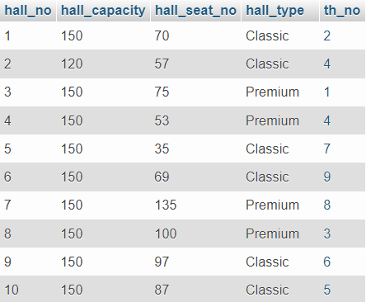

***Fig-07 : Hall Table***

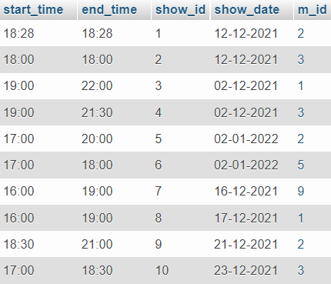

***Fig-08 : ShowTime Table***

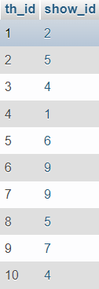 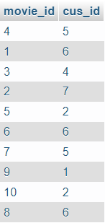

***Fig-09 : Adjust Table Fig-10 : Selects Table***

**SQL Queries**

**Query 1:** Which admin manages which theater?

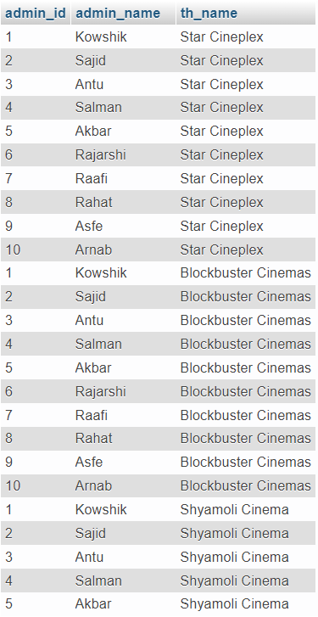

SELECT **admin_id**,**admin_name**,**th_name**

FROM **admin** natural join **theater**

**Query 2:** Which theater adjusts which show time?

SELECT *

from **adjust**

inner join **theater**

on **theater.th_id = adjust.th_id**

inner join **showtime**

on **showtime.show_id = adjust.show_id**

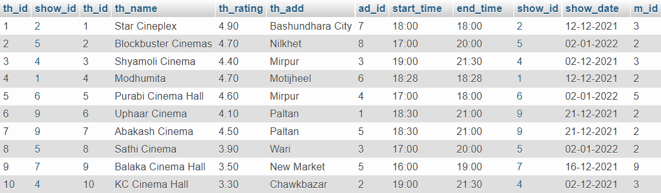

**Query 3:** Which user selects which movies?

SELECT **movie_name**, **movie_type**, **f_name**, **user_mobile**

From **selects** inner join movie

on movie.**movie_id** = selects.**movie_id**

inner join **user**

on user.**user_id** = selects.**cus_id**

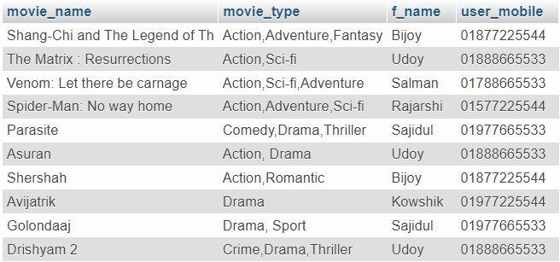

**Query 4:** Which theater has which hall?

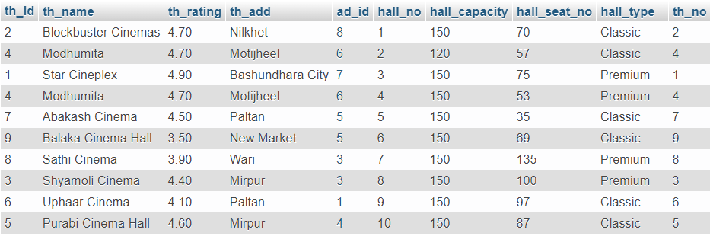

SELECT *

from theater, hall

WHERE theater.**th_id** = hall.**th_no**

**Query 5:** Which booking pays which payment?

SELECT booking.**booking_id**, payment.**pay_id**, payment.**pay_amount**, payment.**pay_date**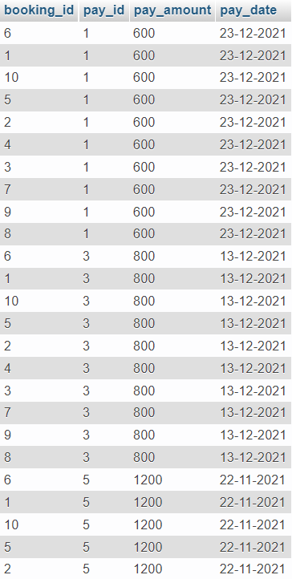

FROM **booking**, **payment**

HAVING payment.**pay_amount** > 550

**CONCLUSION**

Online movie booking ticket systems are useful for any theater owner to manage their ticket booking system via online. By using the movie booking system the admin panel can keep the record of the payments, bookings etc. They can also keep the record of the customers who have bought tickets from their website. Another special feature is that they can track records if a customer expended a certain amount of money for the bookings.

It reduces time for data entry and enables the booking system very fast. It is an efficient way to buy tickets without wasting time and energy.

The system is created to overcome problems like mass jamming in front of movie halls and so on.

Moreover, it will allow the admin panel to extract more profit from our proposed system more efficiently other than that it will create more interest among people. In future, we will try to create the front-end and will try to make it more efficient.