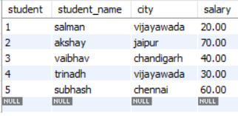

create database practice;

use practice;

create table student(

student int primary key,

student_name varchar(100),

city varchar(30),

);

alter table student add salary decimal(4,2);

describe student;

insert into student values(1,'salman','vijayawada',20.00);

insert into student values(2,'akshay','jaipur',70.00);

insert into student values(3,'vaibhav','chandigarh',40.00);

insert into student values(4,'trinadh','vijayawada',30.00);

insert into student values (5,'subhash','chennai',60.00);

-- select and from

select * from student;

-- specific columns

select student,student_name from student;

-- where to filter the data

select * from student where student_name='salman';

-- where and And

select * from student where city='vijayawada' and salary>10.00;

-- where and OR

Select * from student where city='jaipur' or salary =20.00;

-- between

select * from student where salary between 20.00 and 50.00;

-- IN Operator

select student_name from student where student in

(select student from student where city ='vijayawada');

-- like Operator

select * from student where student_name like '%n';

-- order by

select * from student order by salary asc;

-- order by

select * from student order by salary desc;

-- group by

select city,count(*) as count from student group by city;

-- having clause

select city ,count(*) as count from student group by city having count(*)=1