**ANIMATIONS**

1. We add image to activity using ImageView.

Graphical user interface, application

Description generated with very high confidence

1. Now we get Image in our code and apply animations to it

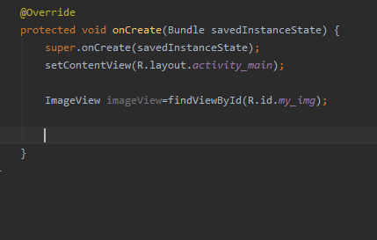

1. Now we add a fading animation to it

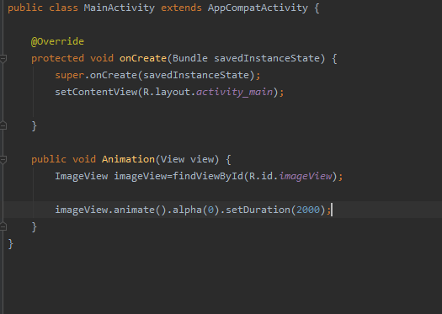

A screenshot of a red car

Description generated with high confidenceA screenshot of a car

Description generated with high confidence