**SQLite**

1. SQLite is a file based system which is used as a database system for android development. It provides all RDBMS functionality and uses Structured Query Language.
2. We add a Customer Model class

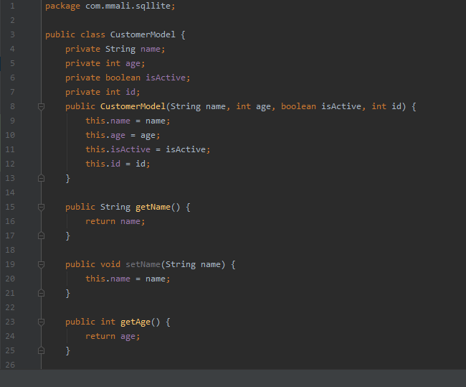

1. Now we add a DBHelper class which inherits SQLDatabaseHelper class to get write database

Text

Description generated with very high confidence

1. Now we add code for adding the customer record