Text

Description generated with very high confidence

1. Now we add code for adding the customer record

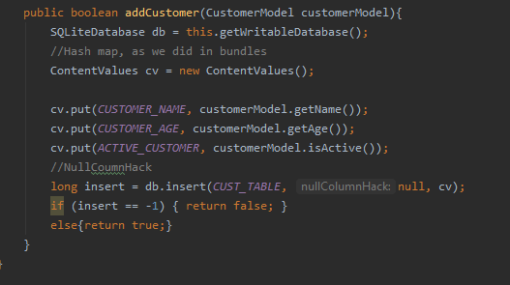

1. Now we add buttons to view and insert record

Text

Description generated with very high confidence

Graphical user interface, application, Teams

Description generated with very high confidence