**MERGE CONFLICTS:-**

Suppose that two people change same line of the file one person change it locally and other on main branch. In this case if we want to push changes to main repository we will get error of merge conflicts which must be resolved before pushing

1. Open the file in text Editor and change a line in it

Text

Description generated with very high confidence

1. Now change the line at main repo and commit

Graphical user interface, text, application, email

Description generated with high confidence

1. Now when we try to push from local repository we get an conflict error message

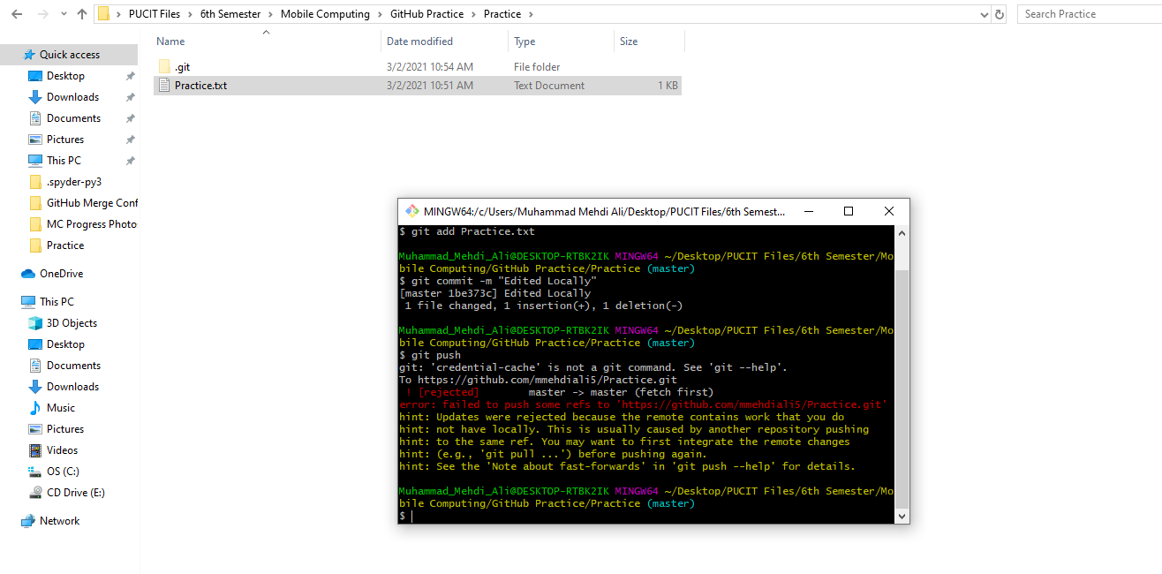

1. To resolve this use git pull to pull the file from main repository

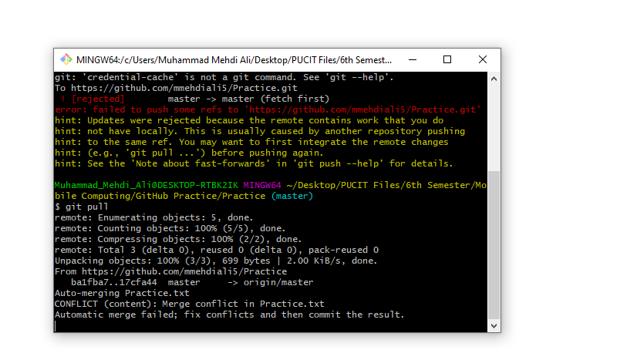

1. When you open the file you will see buttons use me click on the line which you want to retain

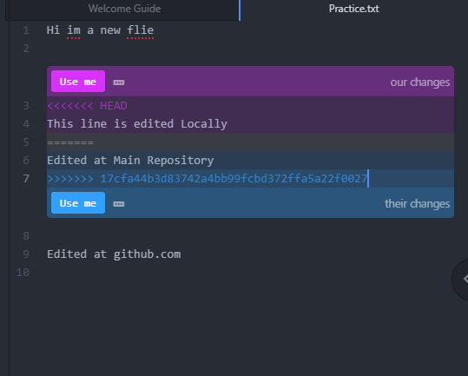

1. Choose one of the lines

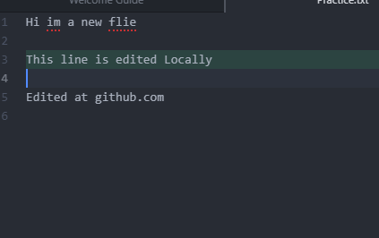

1. Now we can push successfully and merge conflict is resolved

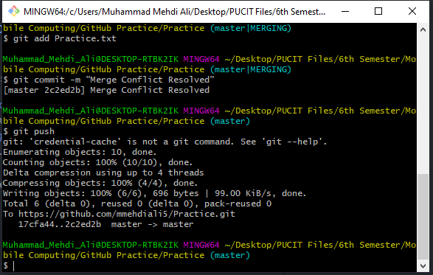

1. Main repo will also be updated

Graphical user interface, application, Word

Description generated with very high confidence

**Youtube Video Lecture 10 List-View Practice**

