1. Project Overview
Sales Performance & Profitability Dashboard is an interactive Excel dashboard developed to analyze sales, profitability, customers, orders, products, regions, categories, and payment methods. The dashboard uses Power Pivot, DAX measures, PivotTables, PivotCharts , slicers, and timelines to provide business insights.

2. Project Objective
The objective of this project is to analyze sales performance and profitability and provide an interactive dashboard that helps identify top-performing products, regions, categories, and payment methods.

3. Dataset
Important Tables Used
Example:
Table | Purpose
Sales | Transaction and sales information
Products | Product information
Customers | Customer information
Sales Jan | January sales data
Sales Feb | February sales data
Sales Mar | March sales data

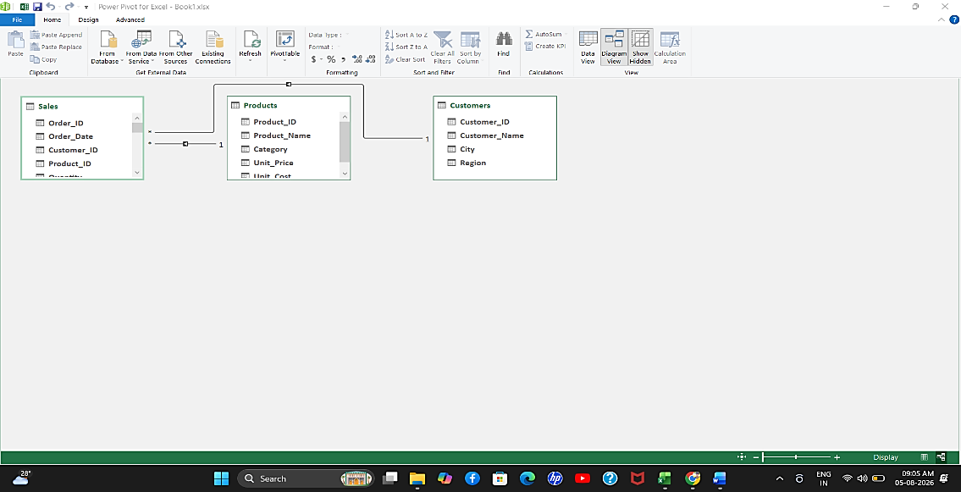

4.Data Preparation
- Imported sales data into Excel
- Organized data into tables
- Connected related tables through the Data Model
- Checked data types
- Prepared fields for analysis
- Created relationships where required
- Used Power Pivot for analysis

5. DAX Measures (</> DAX ) :
This is an important section for your portfolio because it demonstrates that you didn't just c reate charts—you performed data analysis using DAX.
Total Sales :
Total Sales := SUM(Sales[Sales])
Total Profit :
Total Profit := SUM(Sales[Profit])
Total Orders :
Total Orders := DISTINCTCOUNT(Sales[Order_ID])
Total Customers:
Total Customers := DISTINCTCOUNT(Sales[Customer_ID])
Average Order Value:
Average Order Value := DIVIDE([Total Sales], [Total Orders])
Profit Margin % :
Profit Margin % := DIVIDE([Total Profit], [Total Sales])
Top Product :
</> DAX

Top Product :=
VAR ProductSales =
ADDCOLUMNS(
VALUES(Products[Product_Name]),
"SalesAmount", [Total Sales]
)
RETURN
CONCATENATEX(
TOPN(1, ProductSales, [SalesAmount], DESC),
Products[Product_Name],
", "
)

</> DAX

Top Region :=
VAR RegionSales =
ADDCOLUMNS(
VALUES(Customers[Region]),
"SalesAmount", [Total Sales]
)
RETURN
CONCATENATEX(
TOPN(1, RegionSales, [SalesAmount], DESC),
Customers[Region],
", "
)

Top Region :

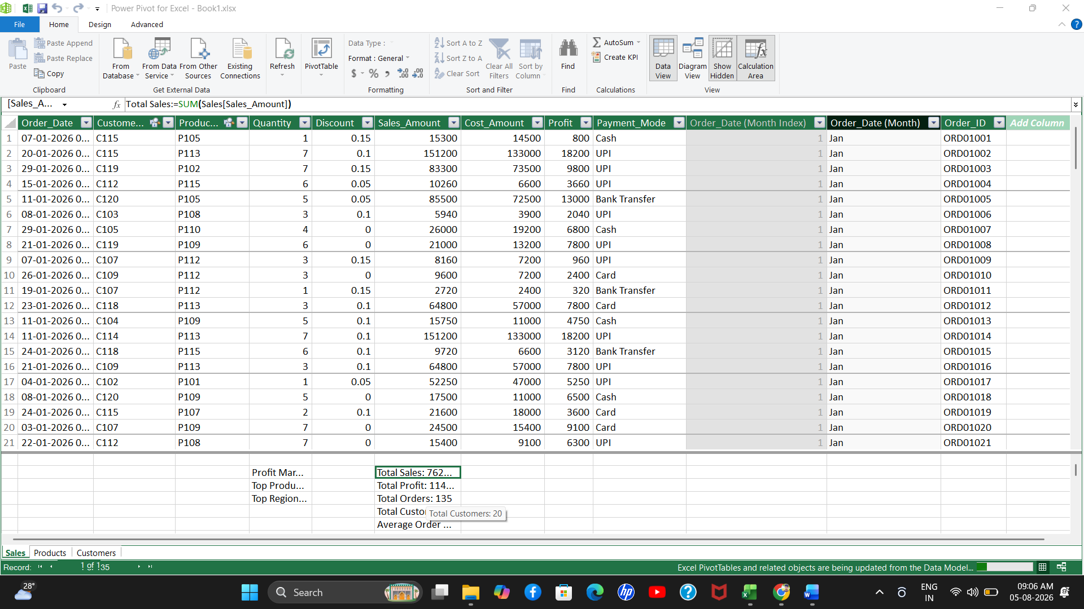

6.KPI Cards :
dashboard contains:
KPI | Result
Total Sales | ₹7,623,750
Total Profit | ₹1,148,940
Total Orders | 135
Total Customers | 20
Average Order Value | ₹56,472
Profit Margin | 15.07%
Top Product | Laptop 15
Top Region | South

7. Dashboard Charts :
final dashboard contains 6 charts:
1. Monthly Sales Trends
Shows sales performance across months.
2. Sales by Region
Compares sales between regions.
3. Sales by Category
Identifies categories generating the highest sales.
4. Top 10 Products
Shows the best-performing products.
5. Profit by Category
Compares profitability across categories.
6. Sales by Payment Mode
Shows sales distribution across payment methods.
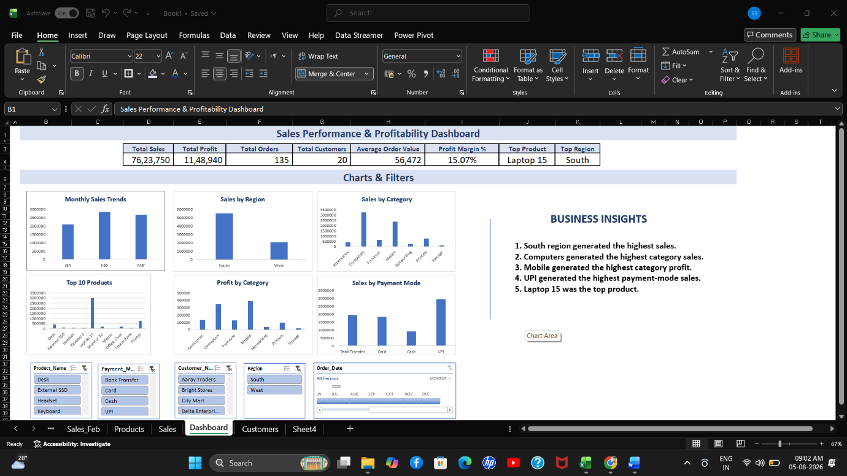

8. Interactive Filters :
dashboard includes:
- Product Name Slicer
- Payment Mode Slicer
- Customer Name Slicer
- Region Slicer
- Order Date Timeline
These allow users to interactively filter the dashboard.

9. Business Insights :
The final five business insights are:
- South region generated the highest sales.
- Computers generated the highest category sales.
- Mobile generated the highest category profit.
- UPI generated the highest payment-mode sales.
- Laptop 15 was the top product.

10. Business Value :
The dashboard enables management to quickly monitor sales and profitability, identify high-performing products and regions, understand customer and payment trends, and make data-driven business decisions.

11. Conclusion :
The Sales Performance & Profitability Dashboard successfully transforms sales data into meaningful business insights using Excel, Power Pivot, DAX, PivotCharts, slicers, and timelines. The dashboard helps analyze sales, profitability, products, regions, categories, customers, and payment methods. It enables users to quickly identify top-performing areas and supports data-driven business decision-making.

