Econ 300 Spring 2020
Problem set 5
Due Wednesday 4/29

Instructions: Please write/type your answers and hand in a hard copy before class starts. The total points for this problem set is 125.
- (10 points) Consider the following policies. For each one, discuss whether the policy provides a potentially good setting for a regression discontinuity research design. Provide justification for your answers based on the two key assumptions supporting the validity of the RD approach.
  - Many charter schools administer a placement exam and only students above a threshold score are offered admission.
  - People become eligible for an ongoing job training program if their prior year’s income falls below 130% of the federal poverty level.

- (25 points) The figure below refers to the effect of age at the time of final exam on exam test score.

The table below gives the effect size using 3 different specifications.

- Interpret the coefficient of -0.092 in varying slopes column.

- What is the value of running a quadratic specification instead of a linear one on either side of the threshold in a RD design as in column 3?

- Are the results from the 3 specifications similar or different? Justify your answer

- What do the results from the 3 specifications tell us about the effect of drinking age on test score?

- Based on the histogram below, do you think there is manipulation of the cut-off age

- Based on the table below, is there an effect of drinking age on SAT test scores?

- (35 points) The following question is adapted from Mastering Metrics “5.1 A Mississippi Experiment”. You are welcome to read the book as a background reference. Research question: Should the Fed lend money to banks or restrict credit during financial crisis? A natural experiment occurred in Mississippi during the 1930s. In November 1930, southern states experienced a serious financial crisis. The the St. Louis Fed, in charge of the 8th District, restricted credit. Atlanta Fed, running the 6th District, however, lent to troubled banks in the crisis. The border between the 6th and 8th Districts happens to run through the middle of Mississippi.

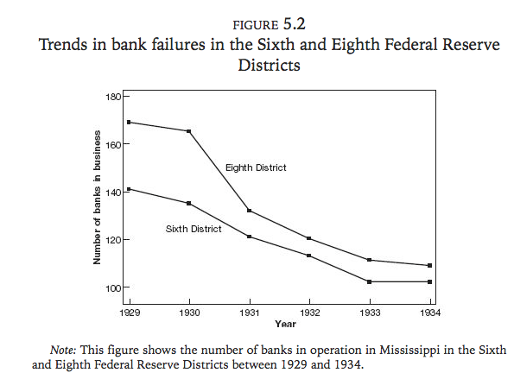
a. What is the parallel trend assumption underlying the DID model in this context.

b. Based on Figure 5.2 does it seem to be the case that assumption in a) holds?

c. Give an example of a scenario, where the assumption in a) would hold but DID estimate would still not give the true causal effect.

d. Do you think lending money to troubled banks during crisis would help save them? Why?

f. Now focus on years 1929-1931. Define Ys,t where s is district and t is year (e.g. Y8,1929 is the outcome in district 8 in 1929). If you simply do a before-after comparison between Y6,1931 and Y6,1929. Do you think it renders the causal effect? Explain.

g. How can you make the naïve comparison (Y6,1931-Y6,1929) causal? (hint: use a control group)

h. Write down the DID estimate using Ys,t notation

4. (10 points)
a) Draw a covariate test (take the covariate of mother’s education level) showing the case when RD is not valid.

b) Draw a covariate test of mother’s income level, showing the case when lower income mothers tend to give birth to babies just below 1500g.

5. (45 point). The earned income tax credit (EITC) is distributed to low-income working families with children aiming at encouraging work and reducing poverty. The credit has dramatically expanded since 1993. This creates a natural experiment for a DID strategy. Low income families with children are affected, but low income families without children are barely affected. We are interested in how this tax credit affect employment.
a. Which group is the treatment and which group is the control?
Look at the means of the four groups in the table below
Employment | Before 1993 | After 1993
Treatment group | 0.67 | 0.85
Control group | 0.84 | 0.87
b. Compare the employment rate for treatment group before 1993 with employment rate for control before 1993. Which one is higher? Does that make sense? Explain.
c. What is the “First Difference”? Is the number positive or negative? Does it make sense? Explain.
d. What is the “Second Difference”? Is the number positive or negative? Does it make sense? Explain.
e. What is the DID estimate? Is the number positive or negative? Does it make sense? Explain.
f. Specify a DID regression. Make sure to label variables correctly.
g. Which parameter is the DID estimate?
h. What identification assumption is necessary to interpret the DID estimate as a causal impact of the EITC on employment? Explain the assumption.
i. What evidence would you like to see to confirm the assumption described in part h? Draw a graph. (Refer to the table to have a general idea of the trends and starting position of both groups

