**Economics 300 – Econometrics**

**Midterm 2**

**April 1, 2020**

**Part I [20 pts]**

1. [5 pts] Between 1995 and 2005, the percentage of Americans without health insurance rose from 50 percent to 79 percent. Explain the change between 1995 and 2005 in percent and in percentage point.
2. [5 pts] Interpret the coefficient of log(income)
$$\hat{test score}=557.8+56.42 log⁡(Income)$$

3. [5 pts] Interpret the coefficient of log(income)
$$\hat{log⁡(test score)}=6.336+0.554 log⁡(Income)$$

4. [5 pts] When would model in part 3 (log-log model) be more useful than model 2 (linear-log model)?

**Part II [35 pts]**

This table summarizes four model specification of regression of **log of hourly earnings**. **The variable of interest is the years of education**. Every regression shows the effect of amount of education on earnings. Notice that the region Northeast omitted from the regression. Every state belongs to one of these regions: Midwest, South, Northeast or West. Female is a binary variable. Potential experience of the worker is measured by years since completion of schooling.

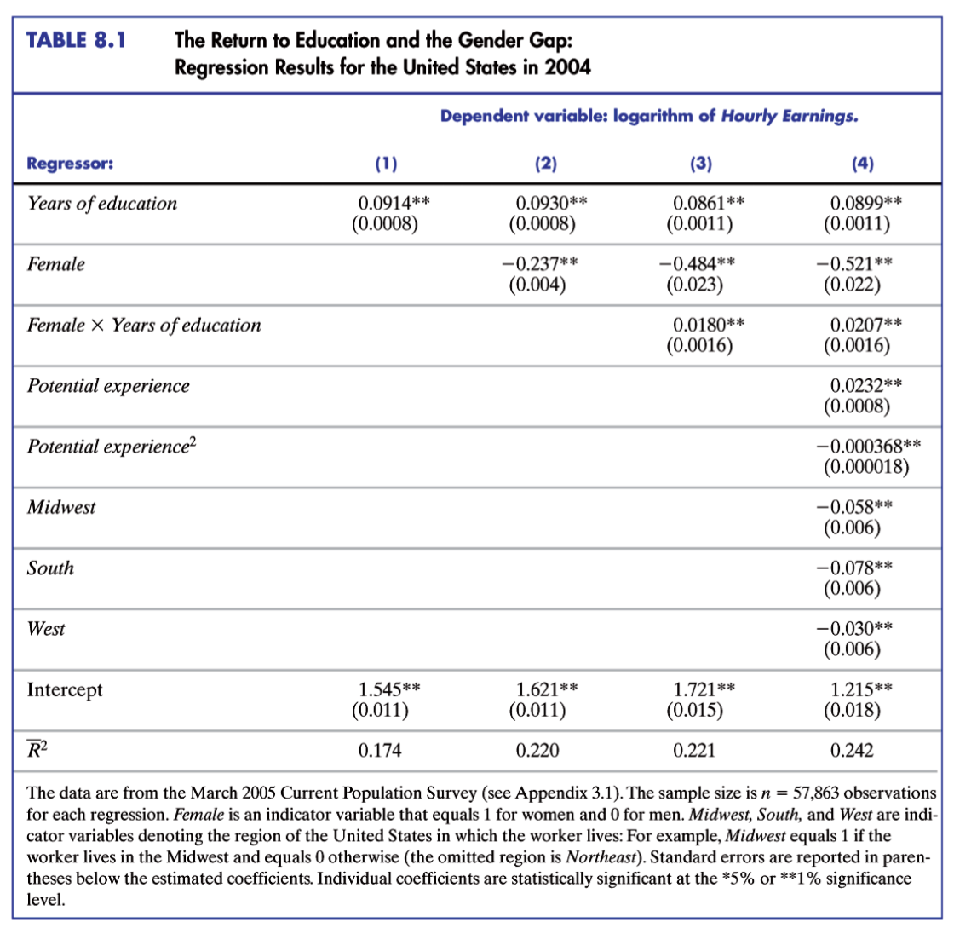

1. [5 pts] Name the problem that would arise if we had included all the regions (Midwest, South, Northeast or West) at the same time in our regression?
2. [5 pts] Explain why we would we not able to estimate the regression due to the problem mentioned in 1?
3. [5 pts] Suggest an alternative way of fixing the problem in 1 above.
4. [5 pts] In regression column (1), interpret the coefficient of years of education.
5. [5 pts] In regression column (2), interpret the coefficient of years of education.
6. [5 pts] Using regression column (3), can you conclude that the return to education is different for females and males? Why?
7. [5 pts] In regression column (4), can you conclude that the impact of potential experiences is non-linear? Why?

**Part III [10 pts]**

1. You work for a retail store and are interested in the relationship between rainy days and sales. Sales is monthly sales in thousands of dollars. Rain is the number of rainy days in a month.

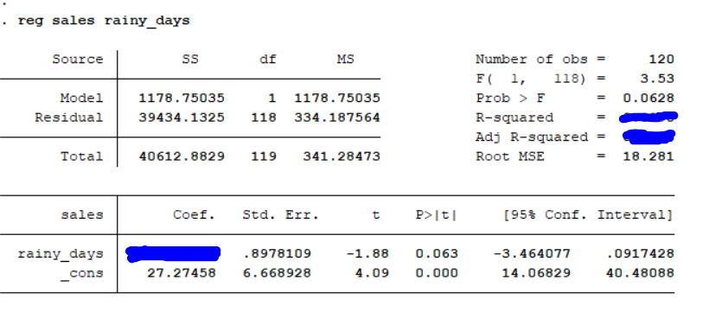

1. [5 pts] From the output shown above calculate the R^2 value. Show your work.
2. [5 pts] Based on the any method of your liking from the table above can you conclude if rainy days’ impact sales? (use α=0.05, and t-critical value = 2)

**Part IV [20 pts]**

In a similar spirit with the RAND health insurance experiment, the state of Oregon randomly selected winners and losers of lotteries, and give free health insurance to lottery winners. This generates a randomized control trial, with the lottery winners being the treatment group and losers being the control group.

The following table shows outcomes from this research for the sample of whole Oregon and the sample of Portland area only. For both samples, the mean of control group and the difference between treatment and control are listed in different columns. **Standard errors reported in parentheses. Treatment effect picks up the difference between control mean and treatment mean.**

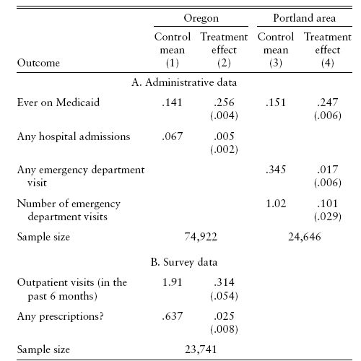

1. [10 pts] Compare the treatment effect estimates (Ever on Medicaid, any emergency department visit) with the control means for the **Portland area**. Explain the estimate **and if possible say something about the size of the effect**.
2. [10 pts] Perform statistical inference on the difference between the treatment **(Ever on Medicaid, Any emergency department)** and control to see if **each of these 2** estimates are statistically significant at =0.05. (Hint: use rule of thumb: compare t-stat with t-critical value of 2).

**Part V (10 points)**

1. [5 pts] Suppose you’re interested in estimating the effect of family income (In thousands of dollars) on number of ideal kids a couple wants to have. Your original model is given as follows: $Number of ideal Kids=β_{0}+β_{1}family income+u$
2. How would you change the model if you think that the effect of family income on number of ideal kids can be different for immigrant and non-immigrant couples?
3. In the modified model in (a), how would you test whether there is a differential effect of family income on the ideal number of kids that a couple wants to have depending on immigrant status? State the null hypothesis and alternative hypothesis.

**Part VI [20 pts]**

**Answer any *four* of the 5 questions.**

1. [5 pts] What does it mean for a study to externally valid? Give an example.
2. [5 pts] How is R-square different from adjusted R-square?
3. [5 pts] Name 5 potential sources of bias in a multiple regression.
4. [5 pts] Explain why the naïve comparison is not misleading in the case of a randomized control trial?
5. [5 pts] How would you check before the experiment that the randomization has been done well?