NATIONAL UNIVERSITY OF COMPUTER AND EMERGING SCIENCES

Object Oriented Analysis & Design (CS-309)

Muhammad Nadeem || Awais Ahmed || Tooba Ali
Muhammad.nadeem@nu.edu.pk || awais.ahmed@nu.edu.pk || tooba.ali@nu.edu.pk

Lab Session # 02
Objectives:

- To understand Domain Model and User Stories.
- Hands-on Domain Model Practice.

INTRODUCTION
User Stories

- A User Story is one or more sentences in the everyday or business language of the end user or user of a system that captures what a user does or needs to do as part of his or her job function.

- It captures the 'who', 'what' and 'why' of a requirement in a simple, concise way, often limited in detail by what can be hand-written on a small paper note card.
- Template: As a <role>, I want <feature> so that <reason>.
- Example: - As a user, I want to upload photos so that I can share photos with others.
- As an administrator, I want to approve photos before they are posted so that I can make sure they are appropriate.

Domain Model

  - A domain is a collection of related concepts, relationships, and workflows.

- Captures the most important types of objects in a system.

- Describing “things” in a system and how these things are related to each other.

- A “thing” can be an object, a class, an interface, a package or a subsystem, which is part of the system being developed.

- Very important process because it is employed throughout the entire system development life cycle

- There is an identification of the concepts, attributes, and associations that are considered noteworthy.

Characteristics of Domain Modeling

- Visual representation of conceptual classes.

- Associations and relationships between concepts (e.g Payment PAYS-FOR Sales).

- Attributes for information content (e.g. Sale records DATE and TIME).

- Does not include operations / functions.

- Does not describe software classes.

- Does not describe software responsibilities.
Steps To Create a Domain Model
- Create User Stories

- Identify candidate conceptual classes

- Draw them in a UML domain model

- Add associations necessary to record the relationships that must be retained

- Add attributes necessary for information to be preserved

- Use existing names for things, the vocabulary of the domain

Monopoly Game - Domain Model Example
Implement basic, key scenario of Play Monopoly Game use cases:
- 2-8 players
- Play for 20 rounds. Each round, each player takes one turn. During a turn, the player advances his/her piece clockwise around the board a number of squares equal to the number rolled on two six-sided dice.
- The results of each player’s roll is displayed: The display includes the name of the player and the value of the roll. When a player lands on a square, the player’s name and the name of the square are displayed
- There is no money, winner, or loser, no properties to buy or rent, no special squares
- There are 40 squares on the board: One is named “Go”, the others are simply numbered as “Square 1”, “Square 2”… “Square 39”
- The only user input required is the number of players
Model Solution
(First identify concepts as classes)
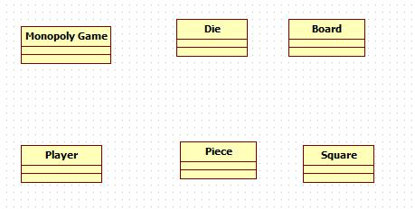

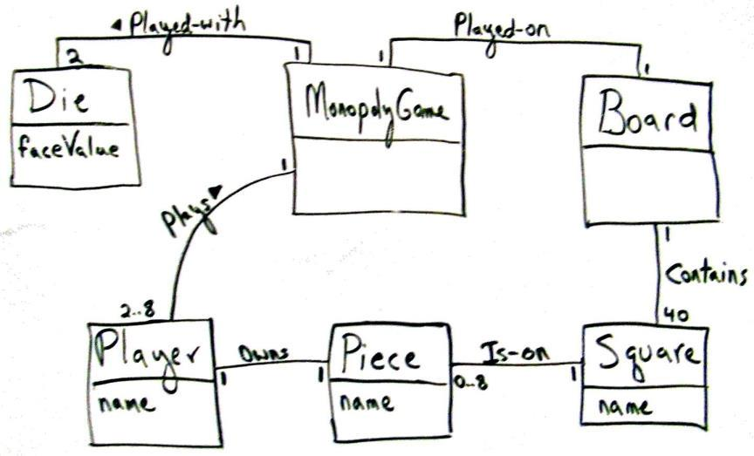

Multiplicity: (Cardinality)

Place multiplicity notations near the ends of an association. These symbols indicate the number of instances of one class linked to one instance of the other class.

Multiplicity can be expressed as,

Exactly one - 1

Zero or one - 0..1
Many - 0..* or *

One or more - 1..*

Exact Number - e.g. 3..4 or 6

a complex relationship – e.g. 0..1, 3..4,6..* would mean any number of objects other than 2 or 5

Visibility:
Use visibility markers to signify who can access the information contained within a class.
- Public +
- Private -

- Protected#
Example

Point of Sale System (POS)
Basic Flow:

- Customer arrives at a POS checkout with goods and/or services to purchase.
- Cashier starts a new sale.
- Cashier enters item identifier.

- System records sale line item and presents item description, price, and running total. Price calculated from a set of price rules.

Cashier repeats steps 2-3 until indicates done.

- System presents total with taxes calculated.
- Cashier tells Customer the total, and asks for payment.
- Customer pays and System handles payment.

- System logs the completed sale and sends sale and payment information to the external accounting (for accounting and commissions) and Inventory systems (to update inventory).
- System presents receipt.
- Customer leaves with receipt and goods (if any).

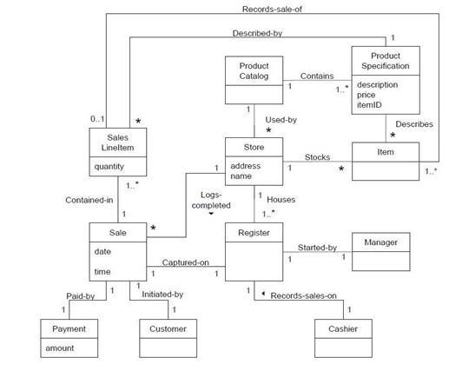
POS: Domain Mo

