Bug #1

The Standard user able to submit an order successfully without adding any product witch would consider a but as it should have been display a message saying like , “ Please add at least one product on the cart before submitting your order”

Bug # 2

The Standard user can add any product from the listing but can not add same product more than one or change the quantity from the cart. That is a bug as use should be able to buy as many of the same product.

Bug #3 Resetting APP state reset the Cart and remove all the added product. However, it does not reset the product status on the product listing. All the products should be shown as Add to card . Please see the attached picture.

Bug # 4

When user leave the browser open for a while without any activity, the user gets auto log out in the back end. However, the user would not know that they are logged off as the page still display as the user is logged in and only would know that they are logged out when they try to do something in there like going to cart. The user get message saying that you can only go to cart while they are logged in. If the page logged out automatically, it should take it back to the login page.

Bug # 5

In the case of user enter wrong credentials, the user gets message indicating the credentials are wrong. However, wrong credentials can not be clear with the X by the user and password box.

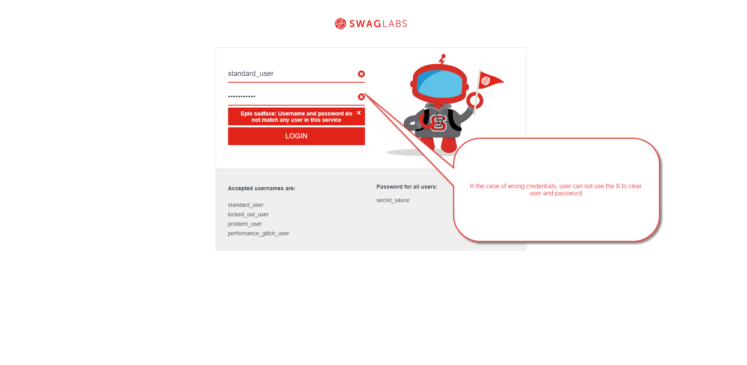

I only used the standard_user to find the bugs and did not spend any time with other users to explore any other issue. Thank you.