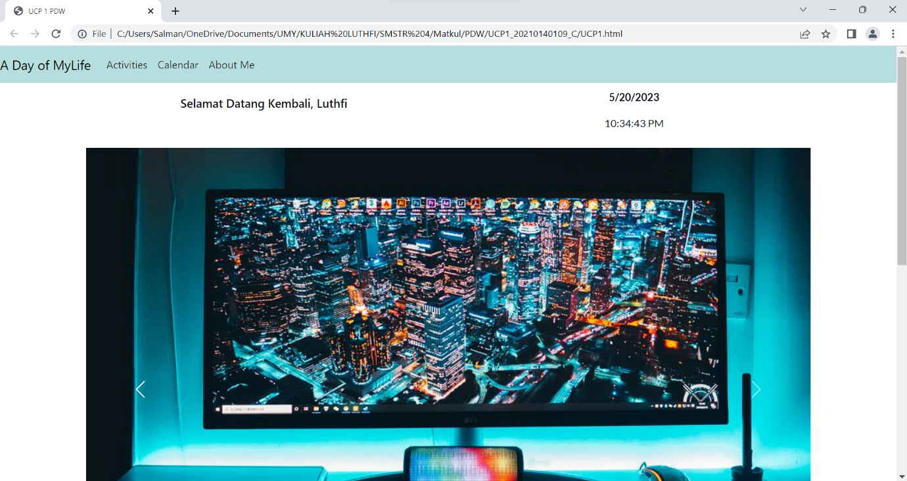

LINK GITHUB = <https://github.com/SalmanLS/UCP1_PDW_109.git>