**Objective Questions**:

1. **In analyzing the provided dataset with Power BI, ensure data cleaning to address inconsistencies and missing values before further analysis.**

**Ans:**

Open the Power BI Desktop. In “Home" tab and clicked on "Get Data."

Selected the appropriate data source (e.g., Excel, CSV, database) and load the dataset into Power BI.

**For inconsistencies:**

* Use Power Query Editor to clean the data.
* Changed wrong data types with correct data types.
* Standardize text values by converting them to a consistent format (e.g., lowercase or uppercase).
* Use functions like "Replace Values" or "Replace Errors" to correct misspelled or incorrect entries.

**For missing values:**

* Replace missing values with appropriate alternatives, such as mean, median, or mode for numerical data, or using contextual information for categorical data.
* If missing values are significant, consider removing the rows with missing values or using advanced techniques like imputation.

1. **Crime Type Analysis:** Assess the frequency of each crime type to identify the most prevalent crimes occurring in the area.

Ans: Based on the provided data showing the count of each crime type, here is the assessment of the frequency of each crime type to identify the most prevalent crimes occurring in the area:

1. THEFT: 19,766 cases

2. BATTERY: 17,190 cases

3. CRIMINAL DAMAGE: 9,910 cases

4. ASSAULT: 8,423 cases

5. OTHER OFFENSE: 6,440 cases

6. DECEPTIVE PRACTICE: 5,682 cases

7. MOTOR VEHICLE THEFT: 5,383 cases

8. WEAPONS VIOLATION: 3,692 cases

9. ROBBERY: 3,384 cases

10. BURGLARY: 2,978 cases

From the above data, it's evident that the most prevalent crimes occurring in the area are THEFT followed by BATTERY, CRIMINAL DAMAGE, and ASSAULT. These crimes have the highest counts and therefore represent the most common types of criminal activities in the area.

It's essential to consider these prevalent crimes when allocating resources and implementing crime prevention strategies to address the safety concerns of the community effectively.

1. **Arrest Rate Evaluation:** Analyze the percentage of reported incidents that have resulted in an arrest to gauge law enforcement effectiveness.

**Ans:** Here Gauge Showing that the 12.42 percent of Arrested.

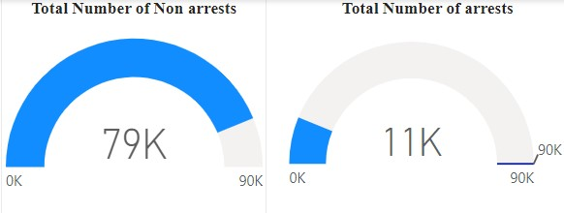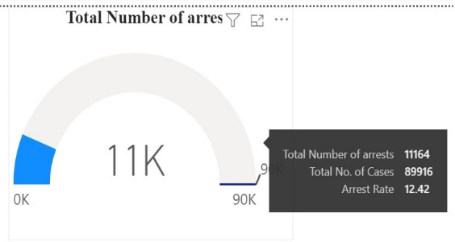

1. **District Crime Distribution Assessment:** Calculate the number of crimes in each district to understand how crime is distributed across the city and identify high-crime areas.

**Ans:**

District 6: 5741

District 8: 5670

District 4: 5213

District 11: 5199

District 12: 5177

District 1: 4841

District 18: 4580

District 3: 4560

District 25: 4536

District 2: 4352

These numbers represent top 10 districts reported crimes. Data to understand the distribution of crimes across different districts and identify areas with higher crime rates for targeted interventions and resource allocation.

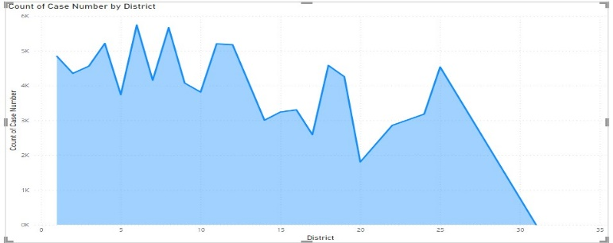

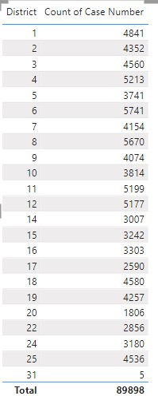

1. **Domestic Crime Proportion Analysis:** Analyze the ratio of domestic-related crimes to other types of crimes to understand the prevalence of domestic incidents.

**Ans:** Here is the ration Between Domestic related crimes to other types of crimes nearly 1:4 Below pie chart represents the ratio of domestic-related crimes to other types of crimes to understand the prevalence of domestic incidents.

1. Is there any “**Location Description**” where the number of crimes is higher than expected? Come up with a table or visualization in which one can judge the frequency of crimes at each Location Description type.

ANS: These are the locations more number of crimes are occur those are higher than expected. Here the graph shows the higher crimes.

|  |  |
| --- | --- |
| **Location Description** | **Count of Case Number** |
| STREET | 23028 |
| APARTMENT | 19019 |
| RESIDENCE | 12018 |
| SIDEWALK | 4302 |
| PARKING LOT / GARAGE (NON RESIDENTIAL) | 3166 |
| SMALL RETAIL STORE | 2929 |
| RESTAURANT | 1914 |
| ALLEY | 1799 |
| DEPARTMENT STORE | 1467 |
| COMMERCIAL / BUSINESS OFFICE | 1372 |
| GAS STATION | 1306 |
| OTHER (SPECIFY) | 1279 |
| VEHICLE NON-COMMERCIAL | 1223 |
| RESIDENCE - PORCH / HALLWAY | 1150 |

1. **What is the average time between reporting and solving a case as per the data?**

ANS: The average time between reporting and solving a case as per the data is 9 days.

1. **In order to reward the patrol officers, find the patrol area where the crimes reported were under control.**

**ANS :** In 187 areas where reported crimes are consistently below 100, indicating relative safety, patrols demonstrate effective deterrence and community engagement. These patrol areas exhibit proactive policing strategies and possibly strong community partnerships, contributing to low crime rates. Recognizing these achievements can boost morale among officers and foster trust within communities, further enhancing public safety initiatives. By maintaining vigilance and collaborative efforts, law enforcement can sustain this positive trajectory, ensuring continued safety and well-being for residents in these areas.

|  |  |
| --- | --- |
| IUCR | Count of Case Number |
| 1035 | 1 |
| 142 | 1 |
| 1435 | 1 |
| 1505 | 1 |
| 1507 | 1 |
| 1512 | 1 |
| 1513 | 1 |
| 1536 | 1 |
| 1549 | 1 |
| 1564 | 1 |
| 1566 | 1 |
| 1670 | 1 |
| 1720 | 1 |
| 1725 | 1 |
| 1791 | 1 |
| 1850 | 1 |
| 1900 | 1 |
| 2015 | 1 |
| 2019 | 1 |
| 2230 | 1 |
| 482 | 1 |
| 487 | 1 |
| 489 | 1 |
| 5003 | 1 |
| 5121 | 1 |
| 5122 | 1 |
| 556 | 1 |
| 927 | 1 |
| 1030 | 2 |
| 1055 | 2 |
| 1135 | 2 |
| 1245 | 2 |
| 1370 | 2 |
| 1481 | 2 |
| 1590 | 2 |
| 2013 | 2 |
| 2018 | 2 |
| 2029 | 2 |
| 2032 | 2 |
| 3100 | 2 |
| 3300 | 2 |
| 3800 | 2 |
| 4310 | 2 |
| 475 | 2 |
| 500E | 2 |
| 5013 | 2 |
| 551 | 2 |
| 552 | 2 |
| 925 | 2 |
| 041B | 3 |
| 1140 | 3 |
| 1205 | 3 |
| 1535 | 3 |
| 1537 | 3 |
| 1661 | 3 |
| 2016 | 3 |
| 2090 | 3 |
| 2091 | 3 |
| 2160 | 3 |
| 275 | 3 |
| 4651 | 3 |
| 1010 | 4 |
| 1541 | 4 |
| 264 | 4 |
| 271 | 4 |
| 4210 | 4 |
| 5132 | 4 |
| 918 | 4 |
| 033B | 5 |
| 1151 | 5 |
| 4220 | 5 |
| 500N | 5 |
| 557 | 5 |
| 865 | 5 |
| 1185 | 6 |
| 2840 | 6 |
| 3760 | 6 |
| 1050 | 7 |
| 1540 | 7 |
| 1565 | 7 |
| 2830 | 7 |
| 2900 | 7 |
| 450 | 7 |
| 5112 | 7 |
| 1170 | 8 |
| 2170 | 8 |
| 4255 | 8 |
| 502T | 8 |
| 558 | 8 |
| 895 | 8 |
| 1025 | 9 |
| 1375 | 9 |
| 1792 | 9 |
| 2012 | 9 |
| 3750 | 9 |
| 4230 | 9 |
| 4860 | 9 |
| 5130 | 9 |
| 555 | 9 |
| 1240 | 10 |
| 5131 | 10 |
| 935 | 10 |
| 2020 | 11 |
| 2023 | 11 |
| 488 | 11 |
| 1755 | 12 |
| 263 | 12 |
| 553 | 12 |
| 1335 | 13 |
| 5004 | 14 |
| 291 | 15 |
| 4388 | 15 |
| 1261 | 16 |
| 1460 | 16 |
| 2860 | 16 |
| 1090 | 17 |
| 1480 | 17 |
| 2031 | 17 |
| 337 | 17 |
| 550 | 17 |
| 1155 | 18 |
| 583 | 18 |
| 031B | 20 |
| 2870 | 20 |
| 1479 | 21 |
| 334 | 21 |
| 3730 | 22 |
| 143C | 23 |
| 1821 | 23 |
| 462 | 23 |
| 1340 | 24 |
| 1544 | 24 |
| 261 | 24 |
| 2851 | 24 |
| 331 | 24 |
| 483 | 24 |
| 5007 | 25 |
| 1195 | 26 |
| 2021 | 26 |
| 2025 | 26 |
| 2017 | 27 |
| 3970 | 27 |
| 1200 | 28 |
| 141C | 28 |
| 143B | 28 |
| 2026 | 28 |
| 2890 | 28 |
| 453 | 28 |
| 461 | 28 |
| 584 | 28 |
| 1790 | 29 |
| 485 | 30 |
| 554 | 31 |
| 3960 | 32 |
| 4389 | 32 |
| 1753 | 33 |
| 1582 | 34 |
| 1478 | 43 |
| 479 | 44 |
| 915 | 44 |
| 1585 | 46 |
| 5110 | 46 |
| 4650 | 47 |
| 1754 | 48 |
| 2028 | 48 |
| 917 | 48 |
| 266 | 49 |
| 051B | 52 |
| 4386 | 54 |
| 2850 | 56 |
| 3710 | 56 |
| 1562 | 61 |
| 501A | 62 |
| 920 | 62 |
| 2250 | 63 |
| 3731 | 70 |
| 265 | 71 |
| 1570 | 75 |
| 1751 | 75 |
| 313 | 85 |
| 440 | 87 |
| 2014 | 88 |
| 1752 | 90 |
| 2092 | 91 |
| 2022 | 94 |
| 1206 | 97 |
| 5001 | 98 |

**Subjective Question:**

1. Is there any **year-wise** change in crime rates? If not, what could be the mistake in that operation?

**Ans:** No. because there is only 2022-year crime the we can not calculate year wise crime rate.

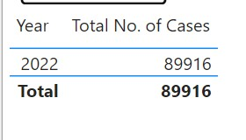

1. How can we reduce the no. of crimes, and which types of crime should we focus on to achieve improvement in the overall number of crimes?

**Ans:** In terms of types of crime to focus on, it's essential to prioritize those that have a significant impact on public safety and community well-being. This can include violent crimes such as homicides, aggravated assaults, and robberies, as well as property crimes such as burglaries, thefts, and motor vehicle thefts. Additionally, addressing crimes related to drugs, gangs, and domestic violence can also have a positive ripple effect on overall crime rates. By targeting these key areas and implementing comprehensive strategies, communities can work towards reducing the number of crimes and creating safer environments for all residents.

1. Which localities experience higher crime rates, and what measures can we ensure to reduce these numbers?

Ans: These are the streets crime rate is more.

1. Can you suggest wards where security improvements should be made to reduce crime?

**Ans:** Below Mentioned Districts and Locations descriptions need to increase the security.

|  |  |
| --- | --- |
| **Location Description** | **Count of Case Number** |
| STREET | 23028 |
| APARTMENT | 19019 |
| RESIDENCE | 12018 |
| SIDEWALK | 4302 |
| PARKING LOT / GARAGE (NON RESIDENTIAL) | 3166 |
| SMALL RETAIL STORE | 2929 |
| RESTAURANT | 1914 |
| ALLEY | 1799 |
| DEPARTMENT STORE | 1467 |
| COMMERCIAL / BUSINESS OFFICE | 1372 |
| GAS STATION | 1306 |
| OTHER (SPECIFY) | 1279 |
| VEHICLE NON-COMMERCIAL | 1223 |
| RESIDENCE - PORCH / HALLWAY | 1150 |

District 6: 5741

District 8: 5670

District 4: 5213

District 11: 5199

District 12: 5177

District 1: 4841

District 18: 4580

District 3: 4560

District 25: 4536

District 2: 4352

1. **Crime Rate Trend Analysis:** Monitor changes in crime rates over time to detect any discernible patterns or trends.

1. As per the previous reports, most of domestic crimes do not result in arrest due to public hesitation and family pressure, is this trend also visible in our data?

Ans: The data illustrates arrests for familial sexual offenses against children, including assault and abuse. It underscores the distressing prevalence of such crimes within domestic environments, warranting urgent attention and intervention.

1. Could you generate a visual representation that emphasizes the frequently occurring terms within the **"Description"** column?

Ans : Here I am mentioning the frequently occurring terms:

1. Are there any particular regions as per the data where the number of domestic crimes reported is very high?

Yes, Here the list these are top 10 domestic crimes reported is very high.

|  |  |
| --- | --- |
| Name of the Street | Total Number of Domestic |
| DR MARTIN LUTHER KING JR DR | 255 |
| MICHIGAN AVE | 247 |
| INDIANA AVE | 151 |
| WABASH AVE | 135 |
| WASHINGTON BLVD | 120 |
| LOWE AVE | 109 |
| ELLIS AVE | 105 |
| JACKSON BLVD | 104 |
| STATE ST | 102 |
| PRAIRIE AVE | 101 |

1. **Is the solving time of cases also dependent upon the type and locality of crime?**

Ans: Yes, the solving time of cases can be dependent on both the type and locality of crime. Certain types of crimes may require more extensive investigations, forensic analysis, or specialized expertise, leading to longer solving times. For example, complex financial crimes or homicides often involve meticulous examination of evidence and interviews with multiple witnesses, which can prolong the investigation process. Additionally, the locality of the crime can impact solving time due to factors such as population density, available resources, and community cooperation. Urban areas with higher crime rates may face heavier caseloads and resource constraints, potentially leading to longer solving times compared to rural areas. Therefore, understanding the type and locality of crime is crucial for law enforcement agencies to allocate resources effectively and prioritize cases based on their urgency and complexity.

**Report:**

The department has asked for a dashboard with three tabs:

1. Main Tab
2. Locality Tab
3. Type Exploration Tab

* Using the Main tab in the report, the government should be able to review the decrease in crime numbers and the improvements resulting from special police operations. This tab should include a date slicer and a filter for the primary type of crime.
* Using the Locality Tab, police management and the head of operations should be able to identify the most common types of crime and the localities/wards where these crimes occurred. This tab should include slicers for ward, date, and primary crime type.
* Using the Type Exploration Tab, the Special Cops team aims to examine the total number of domestic crimes and, from those, **how many arrests were made by the district.** **Additionally, they want to identify the crime type with the highest number of arrests**. Essentially, this tab will provide metrics to summarize the department's actions and the number of tasks pending. **The tab should include slicers for a month and the primary crime type.**

Make sure that all the visualizations look decent and are placed in a proper order. There are different **POCs (Point Of Contact)** for each tab, so make sure you involve all the metrics that POC may look at in that tab along with those mentioned in the tab description.