**A Simple Material UI Table**

Please read the instructions below, then build a simple frontend app with **React** and the Material UI **Table** component.

Setup your project:

1. Install Nodejs on your computer.
2. Create your react app with **npx create-react-app my-app**.
3. Install **@material-ui/core** into your project.

Complete following tasks:

1. Create a single page app to show a list of employees with the Material UI **Table** component. Use the **rows** and **columns** which are provided in **data.js**.
2. Create a button named **“FILTER”** which can filter the employee table. After clicking the button, only Accountants whose office is in Tokyo will be shown in the table, and the name of the button will change to **“RECOVER”**. If it is clicked again, the table will be recovered with all employees, and the name of the button will change back to **“FILTER”**.
3. Try to make your code clean, concise and easy to read. Put your project on github so that we can check your code.

Before filtering: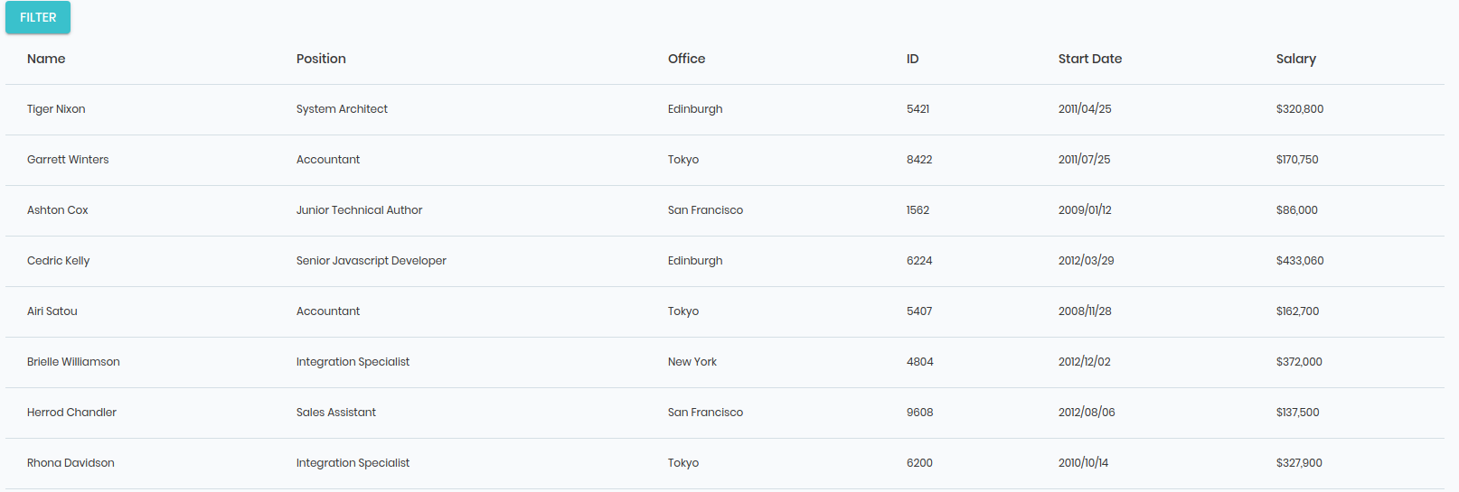

After filtering:

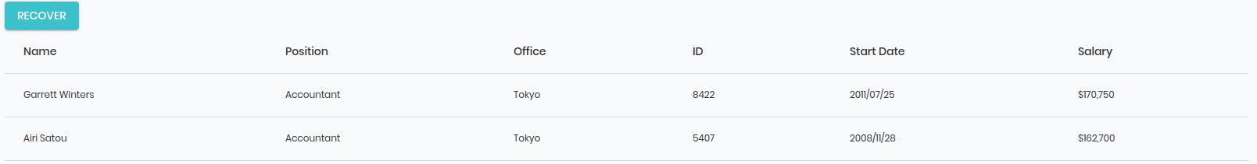

Resources:

<https://nodejs.org/en/>

<https://github.com/facebook/create-react-app>

<https://material-ui.com/>

<https://material-ui.com/components/tables/#table>