linked List

Linked List node: A node in a linked list is composed of two things, a int Data, that contains the information, and a pointer, called next, that points into the next node, if there is only one node (or is the last one of the list) the next node points to NULL.

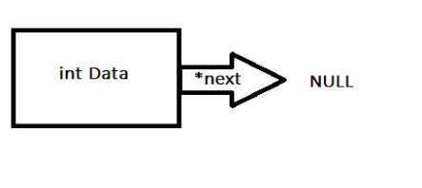
For example, a linked list that cointaints the numbers 4, 5, 6 and 8, will look like:

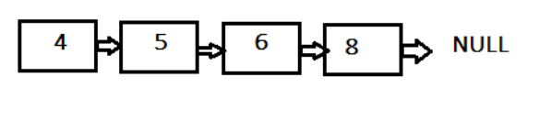

Linked List functions:

void push_front(struct Node **head, int data );

It inserts a node at the front of a linked list, it takes as parameters the current linked list that is head, and took it as a pointer (that is why it has two**) in order to pass the list as a reference into the function and made modifications to it. The other parameter is the data integer to insert.

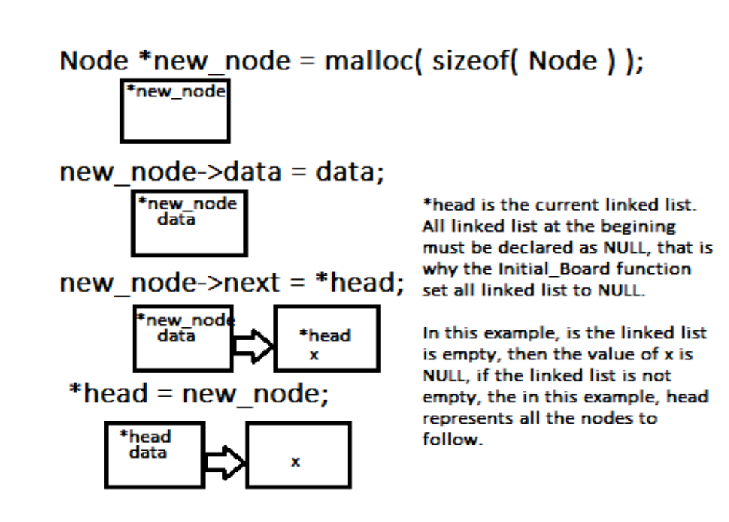
Node* removeTop(struct Node* head) AND Node* removeLast(struct Node* head)

removeTop, removes the first element on a linked list.
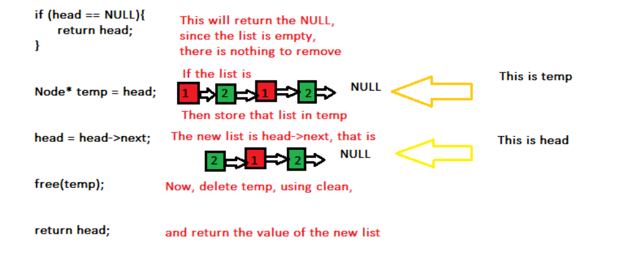
removeLast, iterates throug all list and delete the last element

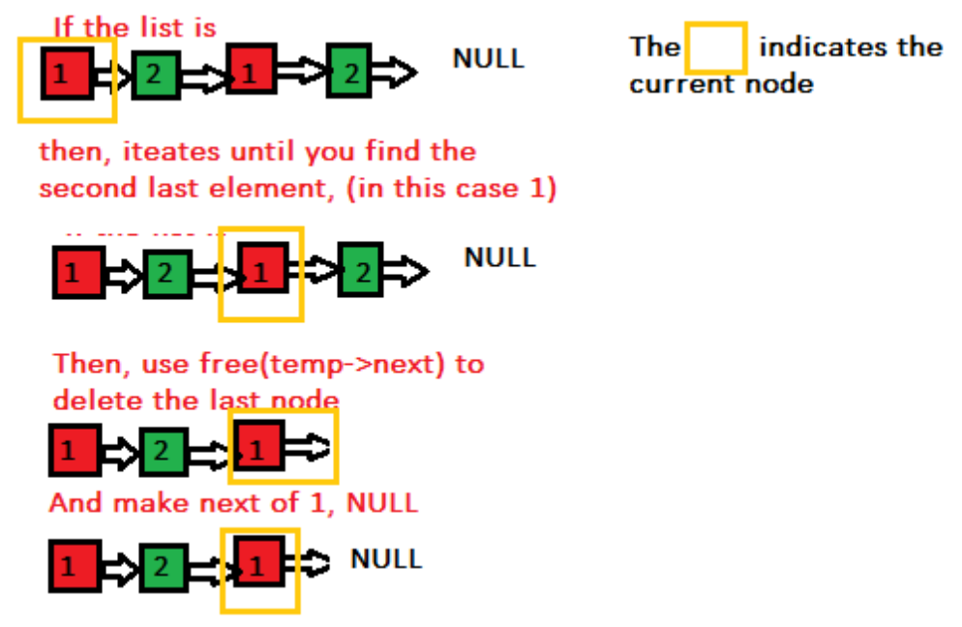

void printList(struct Node* n)

This function takes as parameter the current linked list, in this case, is the parameter named n, and iterates through it to print each element.

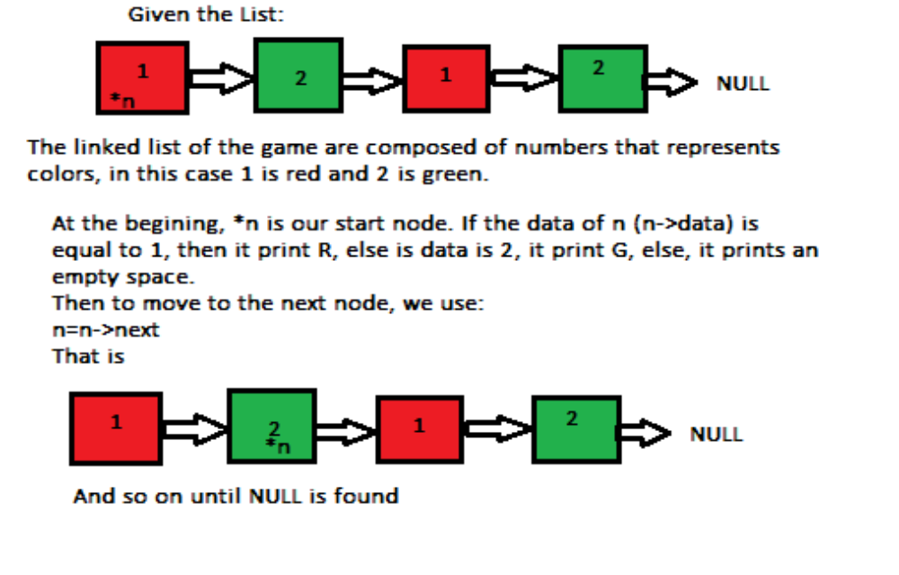
void printTop(struct Node* n); AND void printLast(struct Node* n);

They work just as printList, the difference is that these functions only print one node. printTop, simply prints the first node *n and it stops, while printLast looks until it read the second last node (remember that the last node is always null), and print its value.

int getTop(struct Node* n); AND int getLast(struct Node* head);

They work just as printTop and printLast, but instead of print the value, they return the value of the data n->data.

int sizeList(struct Node* n)
Works just like printList, just that instead of print the values, count the nodes, so for the last list example (1->2->2->2->NULL), it returns 4.

Copy_list and revser example

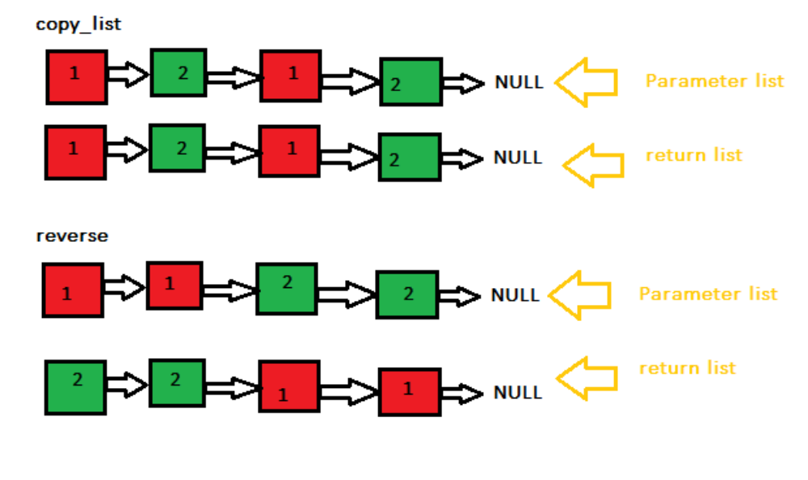
Turn function

The turn function takes as parameter the current player, and displays the following:

- Color of the player
- Number of the player (1 or 2)
- Information about the number of pieces to enter into the board
- Information about the captured pieces (pieces from the other player)
- Menu to take action, which includes the following:

- Information about a space: It prompts the user to a location, and displays information if space is a block or out of range, it displays the message that is blocked or out of range. Otherwise, it calls the function printList, to print the pieces on that spot, and the function sizeList, to return the number of pieces. It also calls the function printTop, to display which is the top piece on that position.

- Possible pieces to move: Takes as a parameter, the color of the player. It iterates in a double loop through all the board, and if space is not blocked, it calls the function getTop to check if the top color of the stack (of the linked list) is the same as the color of the player, if it is, then calls printList to display all the pieces and the space coordinates. It return the number of possible moves.

- Place a piece into the board: If there are possible moves on the board, then it is not possible to put a piece into the board. If there are no possible pieces, but the player does not have available pieces, then is not possible to use this option. Else, it prompts the user for a position to put the piece in. The position must be not blocked. It then calls the function push_front to insert the pieces and decrease the number of available pieces from the user. If the movement was successful, this would be the last action of the player for this turn.

- Move a piece: prompt the user to enter the coordinates of a piece. The program checks if the coordinate is valid (not blocked or out of range), and it checks that the piece at the top is the same color as the color of the player. Then, it checks the size of the stack (LinkedList), if there are more of one piece, then, the user if prompted to enter the number of pieces the player wants to move. Next, the program enters into a for loop from 0 to the number of pieces in the stack, this is to keep track of the number of moves that the player is allowed to move (it can be from 1 to 5). For each move, the user is asked to enter a direction, the destination coordinate is calculated, and the function move is called. After the move function, the program checks if the stack has more than 5 pieces, by calling the function CheckFor5Rule. This would be the last action of the player for this turn.

- Pass turn: it pass the turn, and it would be the turn of the next player.

CheckFor5Rule
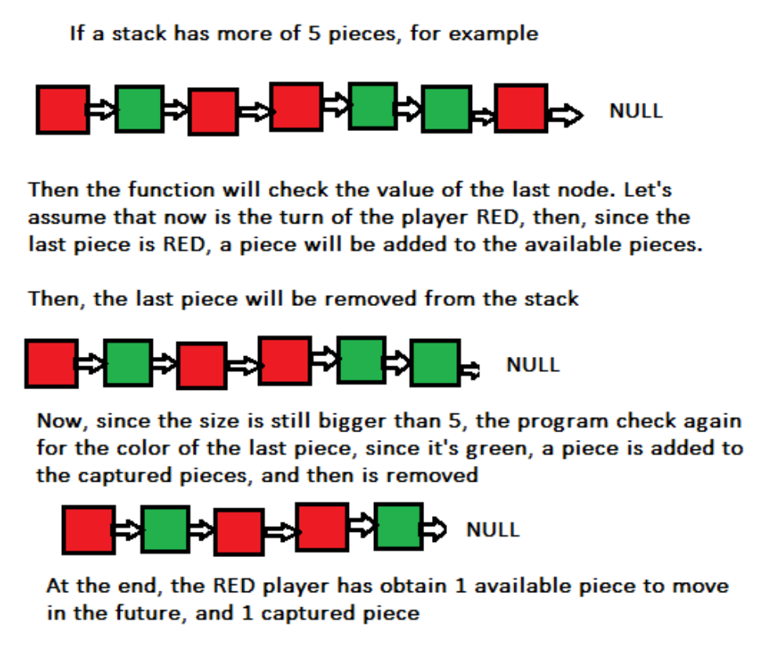
Move function

The following pictures describes the working of the move function.
