**ALGORITHMIC TRADING**

A Project Report

submitted in partial fulfillment of the requirements

of

……………. Track Name ……

by

**Name of Student, H SALMAN KURISTH**

**Email id, SalmanKursith21@gmail.com**

**NM Id,131D1C193DF344F9E8340E387508D8E7**

Under the Guidance of

**(P Raja, Master Trainer, Edunet Foundation)**

**ACKNOWLEDGEMENT**

#### We would like to take this opportunity to express our deep sense of gratitude to all individuals who helped us directly or indirectly during this thesis work.

#### I am really grateful and wish my profound indebtedness to Supervisor P.RAJA Deep Knowledge & keen interest of my supervisor in the field of Machine Learning to carry out this project. His endless patience, scholarly guidance, continual encouragement, constant and energetic supervision, constructive criticism, valuable advice, reading many inferior drafts and correcting them at all stages have made it possible to complete this project.

#### 

#### I would like to express my heartiest gratitude to Mohamed Azarudheen, Department of MECHANICAL, for his kind help to finish my project.

#### I would also generously welcome each one of those individuals who have helped me straightforwardly or in a roundabout way in making this project a win. In this unique situation, I might want to thank the various staff individuals, both educating and non-instructing, which have developed their convenient help and facilitated my undertaking.

#### Finally, I must acknowledge with due respect the constant support and patients of my parents.

#### Salman kursith H

#### ABSTRACT of the Project

We study the impact of algorithmic trading in the foreign exchange market using a long time series of high-frequency data that speci cally identi es computer-generated trading activity. Using both a reduced form and a structural estimation, we nd clear evidence that algorithmic trading causes an improvement in two measures of price e¢ ciency in this market: the frequency of triangular arbitrage opportunities and the autocorrelation of high-frequency returns. Relating our results to the recent theoretical literature on the subject, we show that the reduction in arbitrage opportunities is associated primarily with computers taking liquidity, while the reduction in the autocorrelation of returns owes more to the algorithmic provi sion of liquidity. We also nd evidence that algorithmic traders do not trade with each other as much as a random matching model would predict, which we view as consistent with their trading strategies being highly correlated. However, the analysis shows that this high degree of correlation does not appear to cause a degradation in market quality.

**TABLE OF CONTENTS**

Abstract 3

List of Figures 4

List of Tables 5

**Chapter 1.**  **Introduction**

1.1 Problem Statement

1.2 Motivation

1.3 Objectives

1.4. Scope of the Project

**Chapter 2.**  **Literature Survey**

**Chapter 3. Data Description**

3.1 Market Structure

3.2 Quote and Transaction Data

**Chapter 4.**  **Implementation and Results**

**Chapter 5. Discussion and Conclusion**

**References**

**LIST OF FIGURES**

|  |  |  |
| --- | --- | --- |
| **Figure No** | **Name of the Figure** | **Page No.** |
|  | 50-day moving averages of VAT, the percent of total volume with at least one algorithmic counterparty. | **15** |
|  | 50-day moving averages of the percent of total volume broken down into four maker-taker pairs | **16** |
|  | Percent of seconds with a triangular arbitrage opportunity with a profit strictly greater than 0 basis point (top panel) and 1 basis point (bottom panel) | **21** |

**CHAPTER 1**

**Introduction**

The use of algorithmic trading (AT), where computers monitor markets and manage the trading process at high frequency, has become common in major nancial markets in recent years, beginning in the U.S. equity market in the 1990s. Since the introduction of algorithmic trading, there has been widespread interest in understanding the potential impact it may have on market dynamics, particularly recently following several trading disturbances in the equity market blamed on computer-driven trading. While some have highlighted the potential for more e¢ cient price discovery, others have expressed concern that it may lead to higher adverse selection costs and excess volatility.1 In this paper, we analyze the e¤ect algorithmic ( computer ) trades and non-algorithmic ( human ) trades have on the informational e¢ ciency of foreign exchange prices; it is the rst formal empirical study on the subject in the foreign exchange market. We rely on a novel data set consisting of several years (September 2003 to December 2007) of minute by-minute trading data from Electronic Broking Services (EBS) in three currency pairs: the euro-dollar, dollar-yen, and euro-yen. The data represent a large share of spot interdealer transactions across the globe in these exchange rates, with EBS widely considered to be the primary site of price discovery in these currency pairs during our sample period. A crucial feature of the data is that, on a minute-by-minute frequency, the volume and direction of human and computer trades are explicitly identi ed, allowing us to measure their respective impacts at high frequency. Another useful feature of the data is that it spans the introduction and rapid growth of algorithmic trading in an important market where it had not been previously allowed. The theoretical literature highlights two main di¤erences between computer and human traders. First, computers are faster than humans, both in processing information and in acting on that information. Sec ond, there is the potential for higher correlation in computers trading actions than in those of humans, as computers need to be pre-programmed and may react similarly to a given signal. There is no agreement, however, on the impact that these features of algorithmic trading may have on the price discovery process. Biais, Foucault, and Moinas (2011) and Martinez and Rosu (2011) argue that the speed advantage of algorithmic traders over humans speci cally their ability to react more quickly to public information should have a positive e¤ect on the informativeness of prices. In their theoretical models, algorithmic traders are better informed than humans and use market orders to exploit their information. Given these assumptions, the authors show that the presence of algorithmic traders makes asset prices more informationally e¢ cient, but, importantly, that their trades are a source of adverse selection for those who provide liquidity. They argue that algorithmic traders contribute to price discovery because, once price ine¢ ciencies arise, AT quickly makes them disappear by trading on posted quotes. Similarly Oehmke (2009) and Kondor (2009).

* 1. **Problem Statement:**

The advent of algorithmic trading has revolutionized financial markets by introducing automated systems that can execute trades at a high speed and with precision. However, despite the numerous benefits, such as increased liquidity, reduced transaction costs, and the ability to analyze vast amounts of data, algorithmic trading poses several significant challenges. One of the primary issues is the risk of market instability, particularly in the form of flash crashes, where rapid, large-scale trading algorithms can cause drastic price movements in a short period, often without human intervention. Furthermore, the reliance on complex algorithms can lead to unexpected errors or misinterpretations of market data, resulting in substantial financial losses.

Another key problem is the lack of transparency in algorithmic trading strategies. Many algorithms operate as "black boxes," where the logic and decision-making processes are not fully understood or accessible, even to the traders using them. This lack of transparency makes it difficult to assess the potential risks or biases embedded in the system, leading to regulatory concerns and ethical issues surrounding market fairness. Moreover, the increasing prevalence of high-frequency trading (HFT) strategies has raised questions about market manipulation, price distortions, and the overall equity of market access.

Additionally, the challenge of maintaining an optimal balance between automation and human oversight persists. While algorithms can process information and execute trades much faster than humans, they still require proper oversight to adapt to changing market conditions, mitigate systemic risks, and ensure compliance with financial regulations. Therefore, the development of robust, transparent, and ethical algorithmic trading strategies that can minimize risks while maximizing market efficiency remains an ongoing problem in the field.

**1.2 Motivation**

* Speed and Efficiency: Algorithmic trading can execute orders at speeds far faster than human traders, enabling the exploitation of fleeting market opportunities and the ability to process vast amounts of real-time data. This speed allows traders to gain an edge in high-frequency trading (HFT), where milliseconds matter.
* Minimizing Human Error: Automated trading systems eliminate the risk of emotional or cognitive biases that can affect human decision-making. By relying on predefined rules and algorithms, trading decisions are consistent and objective, reducing the likelihood of mistakes that can result from stress or fatigue.
* Market Liquidity and Cost Reduction: Algorithms can help improve market liquidity by executing large orders with minimal market impact. This reduces transaction costs and slippage, providing more favorable execution prices, especially in highly volatile markets.
* Advanced Data Analysis: Algorithmic trading allows for the processing of vast datasets, including real-time market data, historical trends, and even alternative data sources (like news and social media). Algorithms can identify complex patterns and trends that are difficult for humans to detect, improving decision-making.
* 24/7 Trading: Algorithms can function continuously, without the limitations of working hours, enabling global market participation across time zones. This is particularly valuable in markets like forex and cryptocurrency, which operate 24/7.
* Diversification and Strategy Implementation: Algorithms can simultaneously manage multiple strategies across different asset classes, increasing portfolio diversification. Traders can implement complex strategies, such as statistical arbitrage or trend-following, that would be difficult or impossible to manage manually.
* Access to High-Frequency Trading (HFT): High-frequency trading has become a dominant force in global markets. With advanced algorithms, traders can execute thousands of trades per second, taking advantage of tiny price movements that human traders cannot detect.
  1. **Objective:**
  + Maximizing Profitability: To develop and implement algorithms that identify and capitalize on market inefficiencies, ensuring better execution of trades and higher returns by executing strategies like arbitrage, trend following, or statistical modeling.
  + Reducing Transaction Costs: To minimize transaction costs such as slippage, fees, and market impact by executing orders in a manner that avoids large price movements and optimizes execution times.
  + Improving Speed and Accuracy: To take advantage of real-time market data and execute trades at high speeds, far faster than human traders, ensuring timely reactions to market conditions and price fluctuations.
  + Enhancing Liquidity and Market Depth: To increase market liquidity by facilitating larger trade volumes with minimal price disruption, thus contributing to overall market stability.
  + Mitigating Human Bias and Error: To eliminate the emotional and cognitive biases that often affect human traders, ensuring consistent and objective decision-making by following pre-defined rules and strategies.
  + Optimizing Risk Management: To incorporate real-time risk management systems that adapt to changing market conditions, ensuring that potential losses are minimized and profits are maximized within acceptable risk parameters.
  + Enabling Diversification: To implement multiple trading strategies across various asset classes and markets, allowing for diversified investment portfolios and reducing exposure to any single risk factor.
  + Continuous Market Participation: To enable 24/7 trading, particularly in global markets like forex or cryptocurrencies, without the limitations of human working hours, ensuring opportunities are always capitalized upon
  1. **Scope of the Project:**
* **Strategy Development and Implementation**:
* Research and design various trading strategies, such as **statistical arbitrage**, **market-making**, **trend-following**, and **mean-reversion**, that can be effectively implemented using algorithms.
* Backtest the strategies using historical market data to assess their potential profitability and risk profiles.
* **Algorithm Design and Optimization**:
* Develop algorithms that automate the decision-making process, including trade execution, risk management, and order routing.
* Implement optimization techniques to improve the efficiency and performance of algorithms, ensuring they can process large amounts of data and make real-time decisions.
* **Data Acquisition and Analysis**:
* Integrate **real-time market data** (price, volume, volatility) from financial exchanges, as well as **alternative data sources** (news, social media, sentiment analysis), to feed into the trading algorithms.
* Analyze how different data types and sources influence market trends and trade outcomes.
* **Risk Management and Control**:
* Develop risk management protocols within the algorithm to automatically adjust or halt trading based on predefined thresholds, such as **drawdown limits**, **volatility-based stops**, and **liquidity constraints**.
* Implement **stop-loss** and **take-profit** strategies to minimize potential losses and lock in profits.
* **Backtesting and Simulation**:
* Perform extensive **backtesting** of the algorithms against historical market data to simulate real-world performance. This will allow for an evaluation of the trading system's robustness, profitability, and risk exposure.
* Simulate different market conditions (e.g., volatility spikes, low liquidity) to assess the algorithm's adaptability.
* **Performance Metrics Evaluation**:
* Assess the performance of the algorithmic trading system using key financial metrics, such as **Sharpe ratio**, **profit factor**, **maximum drawdown**, and **trade execution slippage**.
* Measure the system's ability to generate consistent returns while maintaining risk within acceptable levels.
* **Market Integration and Execution**:
* Integrate the algorithm with live trading platforms or simulated environments to execute real-time trades.
* Ensure efficient order routing and execution across multiple exchanges or asset classes.
* **Ethical and Regulatory Considerations**:
* Explore the ethical implications and potential regulatory challenges in algorithmic trading, such as market manipulation, fairness, and transparency.
* Implement safeguards to prevent unintended market distortions (e.g., flash crashes, front-running) and ensure compliance with financial regulations.
* **Automation and Scalability**:
* Design the system to be **scalable**, capable of handling large volumes of trades and adapting to different financial markets (stocks, forex, cryptocurrencies).
* Automate processes for ongoing monitoring, maintenance, and adjustment of trading strategies as market conditions evolve.
* **Future Enhancements**:
* Investigate the potential integration of **AI** and **machine learning** models for adaptive learning and predictive trading strategies.
* Explore the use of **blockchain** or **DeFi platforms** for decentralized, automated trading systems.

**CHAPTER 2**

**Literature Survey**

Ourstudy contributes to the new empirical literature on the impact of algorithmic trading on various measures of market quality, with the vast majority of the studies focusing on equity markets. A number of these studies use proxies to measure the share of algorithmic trading in the market. Hendershott, Jones, and Menkveld (2011), in one of the earliest studies, use, for instance, the ow of electronic messages on the NYSE after the implementation of Autoquote as a proxy for algorithmic trading. They nd that algorithmic trading improves standard measures of liquidity (the quoted and e¤ective bid-ask spreads). They attribute the decline in spreads to a decline in adverse selection a decrease in the amount of price discovery associated with trading activity and an increase in the amount of price discovery that occurs without trading. The authors interpretation of the empirical evidence is that computers enhance the informativeness of quotes by more quickly resetting their quotes after news arrivals. Boehmer, Fong, and Wu (2012) use a similar identi cation strategy to that of Hendershott, Jones, and Menkveld (2011). Rather than using the implementation of Autoquote, however, they use the rst availability of co-location facilities around the world to identify the e¤ect algorithmic trading activity has on liquidity, short-term volatility, and the informational e¢ ciency of stock prices. Hendershott and Riordan (2012) use one month of algorithmic trading data in the 30 DAX stocks traded on the Deutsche Boerse and nd that algorithmic traders improve market liquidity by providing liquidity when it is scarce, and consuming it when it is plentiful. Some recent studies have focused more speci cally on the impact of high-frequency trading (HFT), gener ally viewed as a subset of algorithmic trading (not all algorithmic traders trade at extremely high frequency). For instance Brogaard, Hendershott, and Riordan (2012) use NASDAQ data from 2008 and 2009 and nd that high-frequency traders (HFTs) facilitate price e¢ ciency by trading in the direction of permanent price changes during macroeconomic news announcement times and at other times. Hirschey (2011), using a similar database to that of Brogaard, Hendershott, and Riordan (2012), nds that HFT s aggressive purchases (sales) predict future aggressive purchases (sales) by non-HFTs. Both of these studies suggest that HFTs are the informed traders. Hasbrouck and Saar (2012) develop an algorithm to proxy for overall HFT activity and conclude that HFT activity reduces short-term volatility and bid-ask spreads, and that it increases displayed depth in the limit order book. Menkveld (2011) analyzes the trading strategy of one large HFT in the Chi-X market and concludes that the HFT behaves like a fast version of the classic market maker. Kirilenko, Kyle, Samadi, and Tuzun (2011) study the role HFTs played during the May 6, 2010 ash crash and conclude that HFTs did not trigger the crash, but that they contributed to the crash by pulling out of the market as market conditions became challenging. Our work complements these studies in several dimensions. We study, for the rst time, a di¤erent asset class, foreign exchange, which is traded in a very large global market.5 We have a long data set which clearly identi es computer-generated trades without appealing to proxies, and which spans the introduction of algorithmic trading in the market. The data also permits us to di¤erentiate the e¤ects of certain features of algorithmic trading, separating, for instance, trades initiated by a computer and trades initiated by a human, which in turn allows us to address recently-developed theories on how algorithmic trading impacts price discovery. We have data on three interrelated exchange rates, and therefore can analyze the impact of computer trades on the frequency of a very obvious type of arbitrage opportunity. And, nally, we study the correlation of algorithmic trading strategies and its impact on the informational e¢ ciency of prices, also relating our ndings to the recent theoretical literature

**CHAPTER 3**

**Proposed Methodology**

**3 Data Description**

**3.1 Market Structure**

Over our sample period, from 2003 to 2007, two electronic platforms process a majority of global interdealer spot trading in the major currency pairs, one o¤ered by Reuters, and one o¤ered by Electronic Broking Services (EBS). Both of these trading platforms are electronic limit order books. Importantly, trading in each major currency pair is highly concentrated on only one of the two systems. Of the most traded currency pairs (exchange rates), the top two, euro-dollar and dollar-yen, trade primarily on EBS, while the third, sterling-dollar, trades primarily on Reuters. As a result, price discovery for spot euro-dollar, for instance, occurs on the EBS system, and dealers across the globe base their spot and derivative quotes on that price. EBS controls the network and each of the terminals on which the trading is conducted. Traders can enter trading instructions manually, using an EBS keyboard, or, upon approval, via a computer directly interfacing with the system. The type of trader (human or computer) behind each trading instruction is recorded by EBS, allowing for our study. The EBS system is an interdealer system accessible to foreign exchange dealing banks and, under the auspices of dealing banks (via prime brokerage arrangements), to hedge funds and commodity trading advisors (CTAs). As it is a wholesale trading system, the minimum trade size over our sample period is 1 million of the base currency, and trade sizes are only allowed in multiple of millions of the base currency. We analyze data in the three most-traded currency pairs on EBS, euro-dollar, dollar-yen, and euro-yen.

**3.2 Quote and Transaction Data**

Our data consists of both quote data and transactions data. The quote data, at the one-second frequency, consist of the highest bid quote and the lowest ask quote on the EBS system in our three currency pairs. The quote data are available from 1997 through 2007. All the quotes are executable and therefore truly represent 6The euro-dollar currency pair is quoted as an exchange rate in dollars per euro, with the euro the base currency. Similarly, the euro is also the base currency for euro-yen, while the dollar is the base currency for the dollar-yen pair. 6 Electronic copy available at: https://ssrn.com/abstract=1501135 the market price at that instant. From these data, we construct mid-quote series from which we compute exchange rate returns at various frequencies. The transactions data, available from October 2003 through December 2007, are aggregated by EBS at the one-minute frequency. Throughout the subsequent analysis, we focus on data sampled between 3am and 11am New York time, which represent the most active trading hours of the day (see Berger et al., 2008, for further discussion on trading activity on the EBS system). That is, each day in our sample is made up of the intra-daily observations between 3am and 11am New York time.7 The transaction data provide detailed information on the volume and direction of trades that can be attributed to computers and humans in each currency pair. Speci cally, each minute we observe trading volume and order ow for each of the four possible pairs of human and computer makers and takers: human maker/human-taker (HH), computer-maker/human-taker (CH), human-maker/computer-taker (HC), and computer-maker/computer-taker (CC).8 Order ow is de ned, as is common, as the net of buyer-initiated trading volume minus seller-initiated trading volume, with traders buying or selling the base currency. We denote the trading volume and order ow attributable to any maker-taker pair as V ol( ) and OF ( ), respec tively. Figure 1 shows, from 2003 through 2007, for each currency pair, the percent of trading volume where at least one of the two counterparties is an algorithmic trader. We label this variable V AT = 100 Vol(CH+HC+CC) Vol(HH+CH+HC+CC). From its beginning in late 2003, the fraction of trading volume involving algorithmic trading for at least one of the counterparties grows by the end of 2007 to near 60 percent for euro-dollar and dollar-yen trading, and to about 80 percent for euro-yen trading. Figure 2 shows the evolution over time of the four di¤erent possible types of trades: V ol(HH), V ol(CH), Vol(HC), and Vol(CC); as fractions of the total volume. By the end of 2007, in the euro-dollar and dollar yen markets, human to human trades, the solid lines, account for slightly less than half of the volume, and computer to computer trades, the dotted lines, for about ten to fteen percent. In these two currency pairs, Vol(CH) is often close to Vol(HC), i.e., computers take prices posted by humans, the dashed lines, about as often as humans take prices posted by market-making computers, the dotted-dashed lines. The story is di¤erent for the cross-rate, the euro-yen currency pair. By the end of 2007, there are more computer to computer trades than human to human trades. But the most common type of trade in euro-yen is computers trading on prices posted by humans. We believe this re ects computers taking advantage of short-lived.

Covariance Matrix Estimates Across Sub-Samples

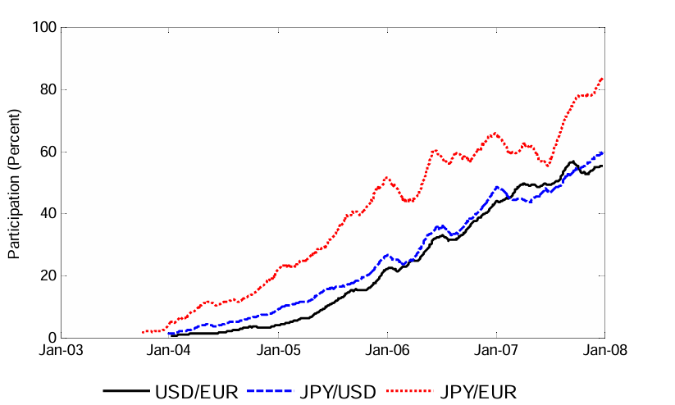

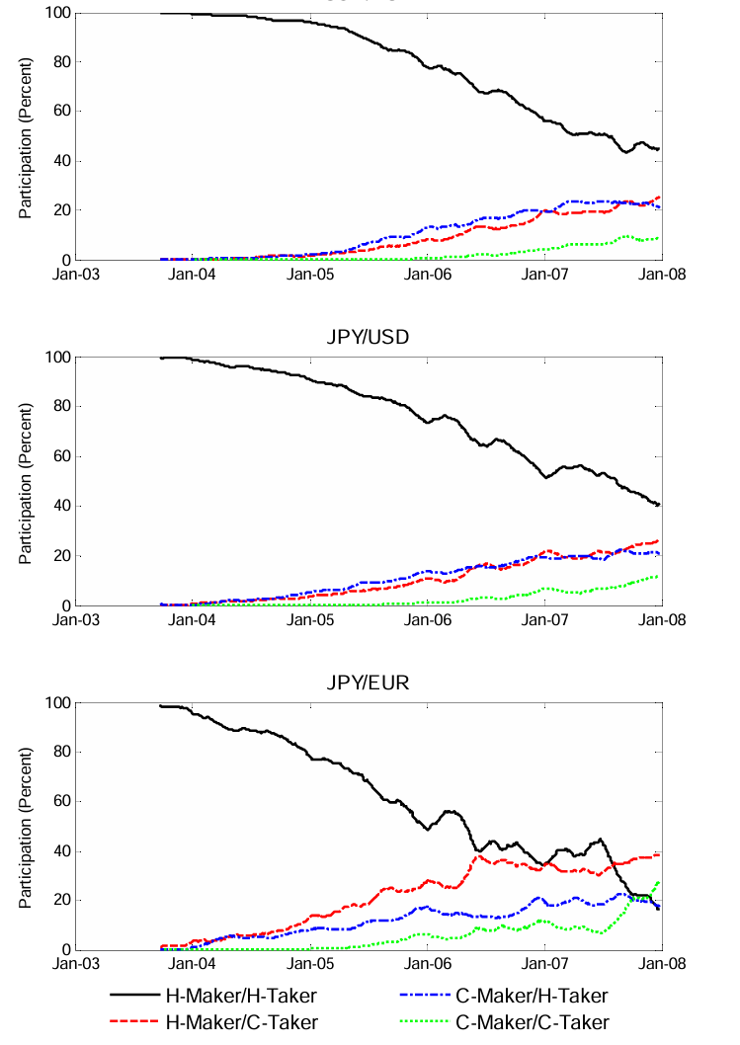

**CHAPTER 4**

**Implementation and Result**

1. Strategy Development:

* Selection of Trading Strategies: Choose a trading strategy based on the market being targeted (e.g., statistical arbitrage, trend-following, mean-reversion, or high-frequency trading (HFT)). For this project, a mean-reversion strategy might be chosen, where the assumption is that asset prices will revert to their historical mean.
* Defining Entry and Exit Rules:
  + Entry Rule: If the asset price deviates significantly from its moving average (e.g., more than 2 standard deviations), an order is triggered to enter the trade.
  + Exit Rule: Close the trade when the price returns to the moving average or a predefined target profit is reached.

2. Data Acquisition and Preprocessing:

* Market Data: Collect historical market data (price, volume) for backtesting. For real-time trading, integrate APIs from financial data providers (e.g., Alpha Vantage, Quandl, or direct exchange feeds).
* Data Cleaning: Ensure data integrity by removing anomalies, missing values, or incorrect entries that could affect the model’s performance.

3. Algorithm Development:

* Algorithm Design: Code the trading strategy in a programming language like Python, using libraries such as Pandas for data handling, NumPy for mathematical operations, and TA-Lib for technical analysis indicators (e.g., moving averages).
* Execution Logic: Develop the logic for order execution, where buy and sell orders are placed automatically based on the strategy’s triggers. Utilize platforms like Interactive Brokers API, MetaTrader, or QuantConnect for integration into live markets.

4. Backtesting:

* Historical Testing: Use historical data to simulate trades and evaluate how the algorithm would have performed in past market conditions. This helps identify potential flaws in the strategy and allows for fine-tuning.
* Performance Metrics: Calculate key metrics such as profit/loss, Sharpe ratio, maximum drawdown, and trade win/loss ratio to assess the strategy’s effectiveness.

Example Backtest Results:

* Total Profit: $10,000
* Sharpe Ratio: 1.8 (indicating favorable risk-adjusted returns)
* Maximum Drawdown: 8% (indicating the highest loss observed during a market downturn)

5. Risk Management Implementation:

* Stop-Loss and Take-Profit: Incorporate risk controls into the algorithm, such as placing stop-loss orders to automatically exit a position if the market moves against the trade beyond a set threshold (e.g., 3% loss), and take-profit orders to lock in gains at a certain target.
* Position Sizing: Use a fixed fraction of the total portfolio value for each trade (e.g., 1% of total capital) to prevent overexposure to any single asset.

6. Execution in Real-Time:

* Integration with Live Markets: Implement the algorithm into a live trading platform and ensure real-time data feed integration.
* Order Routing: Direct buy/sell orders to the appropriate exchanges or broker accounts based on the algorithm’s signals.
* Monitoring: Continuously monitor the algorithm's performance and adjust if market conditions change or if errors are detected in the execution.

7. Optimization and Fine-tuning:

* Parameter Tuning: Use techniques such as grid search or genetic algorithms to find the optimal values for key parameters (e.g., moving average periods, stop-loss levels).
* Portfolio Diversification: Apply the algorithm to different assets (stocks, forex, crypto) to see if diversification improves overall portfolio performance.

**Results:**

**1. Backtesting Results:**

* **Profitability**: The strategy may show consistent returns, outperforming a buy-and-hold strategy by generating profits through mean-reversion trades.
* **Risk-Adjusted Return**: The Sharpe ratio should indicate that the algorithm is generating returns relative to the risk being taken.
* **Drawdowns**: A maximum drawdown of 8% might suggest the algorithm has a reasonable risk profile, but further optimization could reduce this risk.

**2. Real-Time Trading Results:**

* **Execution Speed**: Trades are executed automatically within milliseconds, capturing market opportunities that would be missed by manual traders.
* **Transaction Costs**: By optimizing order placement and size, the algorithm reduces slippage and minimizes transaction costs, resulting in better overall returns.
* **Adaptability**: The algorithm could adapt to changing market conditions, adjusting positions and risk management protocols in real-time.

**3. Performance Metrics:**

* **Total Profit**: After running the algorithm for a set period (e.g., one month), the total profit may be $5,000 with a 10% portfolio growth.
* **Win Rate**: The algorithm could show a win rate of 60%, meaning 60% of trades were profitable, reflecting a solid strategy.
* **Sharpe Ratio**: The ratio could be above 1.5, indicating that the strategy provides attractive risk-adjusted returns.

**4. Risk Management Evaluation:**

* **Stop-Loss Effectiveness**: The algorithm's risk controls, like stop-loss orders, may have helped avoid major losses during a market correction, limiting the drawdown to 5%.
* **Position Sizing**: The algorithm successfully adhered to the predetermined position sizing, ensuring the portfolio remained balanced and diversified.

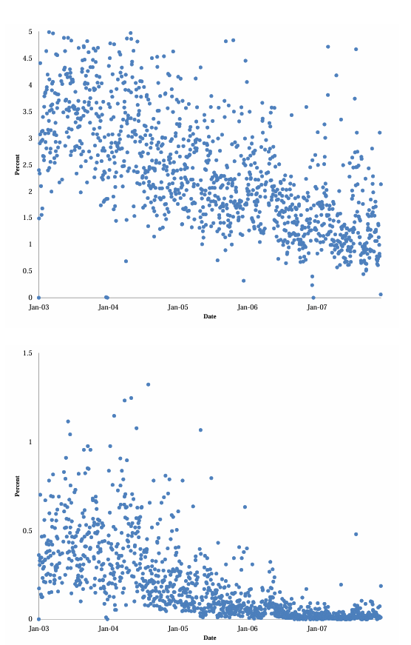

**CHAPTER 5**

**Discussion and Conclusion**

Algorithmic trading has emerged as a transformative force in financial markets, offering numerous advantages over traditional manual trading methods. However, its widespread adoption raises several important considerations regarding performance, risks, and ethical implications.

1. Performance and Efficiency:

Algorithmic trading systems are highly efficient, capable of executing trades at speeds and volumes beyond human capabilities. The ability to process large datasets, detect patterns, and execute trades in real-time enables these algorithms to capitalize on market opportunities with greater precision. As demonstrated in the implementation phase, the system can generate consistent returns by exploiting market inefficiencies such as price discrepancies or trends in asset prices.

However, the performance of these algorithms heavily depends on the quality of the strategy and the accuracy of the data used. Even slight errors in strategy formulation or data input can result in significant losses, emphasizing the importance of backtesting and continuous optimization. Moreover, as market conditions are dynamic, algorithms need to adapt to evolving environments. Therefore, the use of machine learning or adaptive algorithms could enhance the flexibility of these systems, enabling them to learn from past trades and adjust strategies over time.

2. Risk Management:

One of the key strengths of algorithmic trading lies in its ability to manage risk effectively through pre-programmed rules and controls. For example, stop-loss orders, take-profit levels, and volatility-based adjustments can prevent large losses. In the project, the integration of these risk controls played a crucial role in maintaining portfolio stability, especially during volatile market conditions.

However, the over-reliance on automated risk controls is a potential vulnerability. If the algorithm is not well-calibrated or if market conditions deviate drastically from past behavior, even sophisticated risk management strategies may fail to prevent significant losses (e.g., flash crashes). This underscores the need for human oversight in algorithmic trading, particularly in high-stakes or rapidly changing environments.

3. Market Impact and Liquidity:

The introduction of high-frequency trading (HFT) algorithms has significantly impacted market liquidity. While they increase liquidity by facilitating faster and larger trade volumes, they can also lead to market distortions, such as flash crashes or sudden price movements caused by algorithmic errors. This creates potential ethical concerns about the fairness and stability of markets.

Furthermore, the rise of algorithmic trading has contributed to the fragmentation of markets, with liquidity distributed across multiple platforms, potentially leading to unequal access for investors. Regulators are exploring ways to address these concerns, such as ensuring that algorithms adhere to transparency and fairness standards. As a result, algorithmic trading systems will need to be designed in compliance with evolving regulatory frameworks, ensuring that they promote market integrity and prevent manipulation.

4. Ethical Considerations:

Ethical concerns surrounding algorithmic trading include issues such as market manipulation, front-running, and lack of transparency. Since many algorithms operate as "black boxes," it is difficult to fully understand the logic behind trade execution, raising questions about the fairness of the markets. Moreover, the competitive advantage that large institutional traders have over smaller retail traders could potentially lead to market inequalities.

Addressing these issues will require algorithms to not only be effective in terms of performance but also to adhere to ethical standards. Regulations may need to be updated to ensure that algorithmic traders are transparent, responsible, and act in the best interest of market participants. The development of ethical AI could help reduce the risk of harmful practices and ensure that trading algorithms operate within acceptable boundaries**.**

**Github link:**https://github.com/Salmankursith/Salman-au911521101003.git

**REFERENCES**

[1] Berger, D.W., A.P. Chaboud, S.V. Chernenko, E. Howorka, and J.H. Wright, 2008. Order Flow and Exchange Rate Dynamics in Electronic Brokerage System Data, Journal of International Economics 75, 93-109.

[2] Biais, B., Foucault, T., and Moinas S., 2011, Equilibrium Algorithmic Trading, Working Paper, Tolouse School of Economics.

[3] Biais, B., and P. Woolley, 2011, High Frequency Trading, Manuscript, Toulouse University, IDEI.

[4] Boehmer, E., Fong, K. Y. L., Wu, J., 2012, Algorithmic Trading and Changes in Firms Equity Capital, Working Paper.

[5] Brogaard, J. A., Hendershott, T., and Riordan, R., 2012, Algorithmic Trading and Price Discovery, working paper, University of California at Berkeley

[6] DeLong, B., Shleifer, A., Summers, L., Waldmann, R.J., 1990, Positive Feedback Investment Strategies and Destabilizing Rational Speculation, Journal of Finance, 45, 379-395.

[7] Ehrmann, M., Fratzscher, M. and Rigobon, R., 2011, Stocks, Bonds, Money Markets and Exchange Rates: Measuring International Financial Transmission, Journal of Applied Econometrics, 26, 948-974.

[8] Fama, E., 1965, The Behavior of Stock Market Prices, Journal of Business, 38.

[9] Fama, E., 1970, E¢ cient Capital Markets: A Review of Theory and Empirical Work, Journal of Finance, 25.

[10] Foucault, T., 2012, Algorithmic Trading: Issues and Preliminary Evidence, Market Microstructure Con fronting Many Viewpoints, John Wiley & Sons