**Matlab:**

**Q1:**

**When sigma=0.8, kernel size constant** 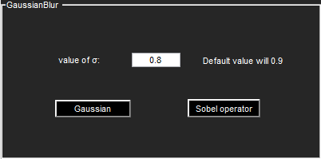

**3x3 gaussian blur:**

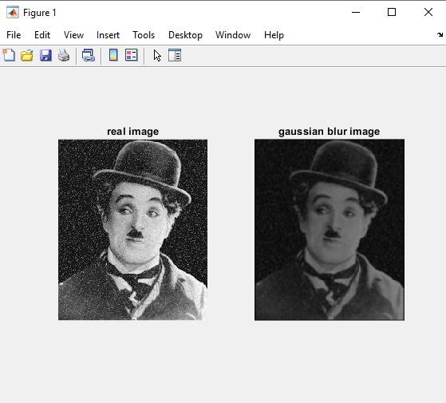

**5X5 gaussian blur:**

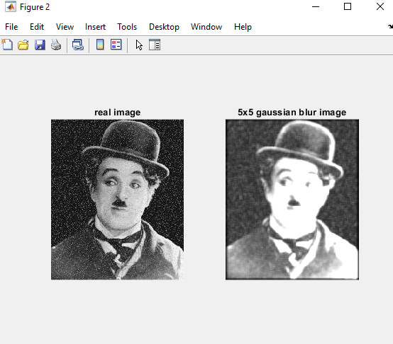

**When sigma =2.5**

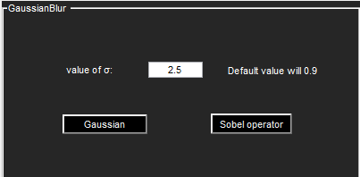

**3x3 gaussian blur**

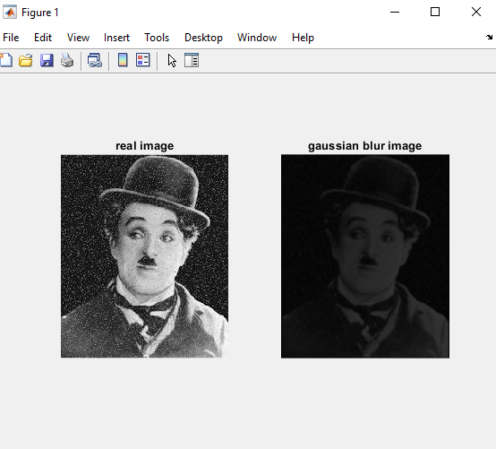

**5x5 gaussian blur**

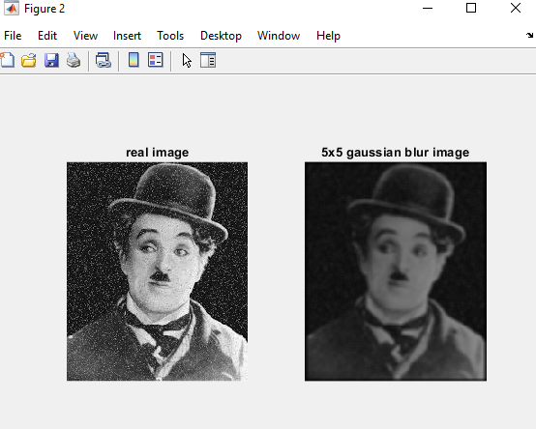

**Q2:**

**When sigma=0.8 with different kernel size**



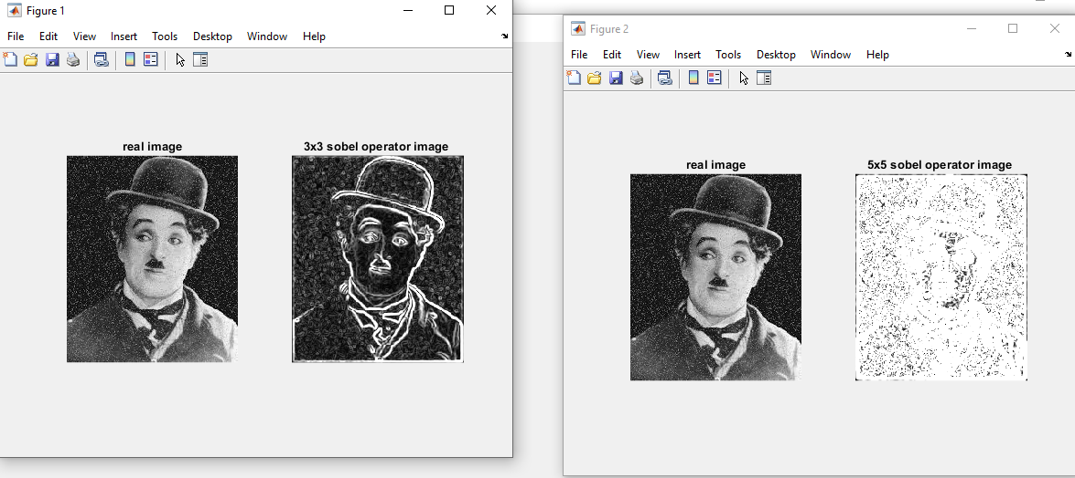

When sigma is 2.5 with different kernel



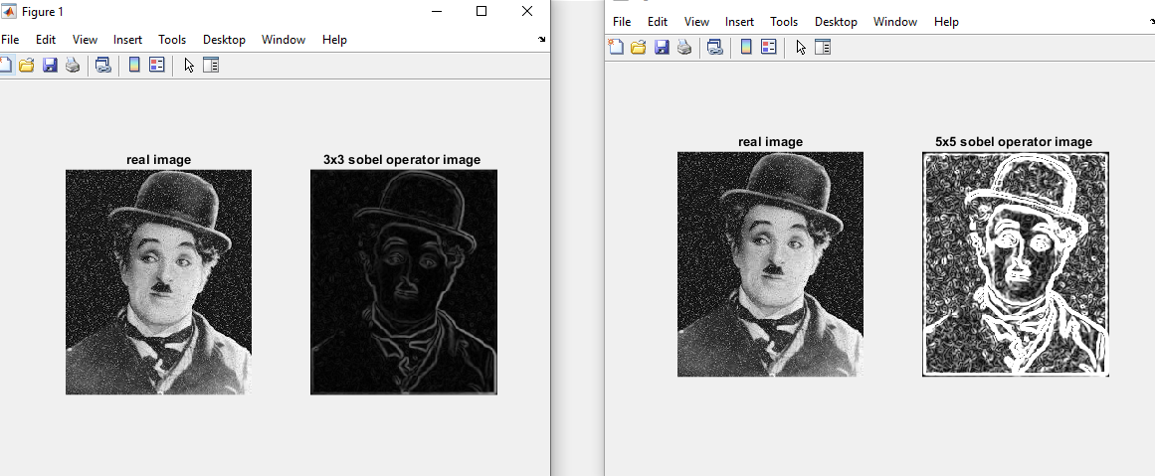

**Python**

**Q1: Gaussian blur**

**When sigma=2.5**

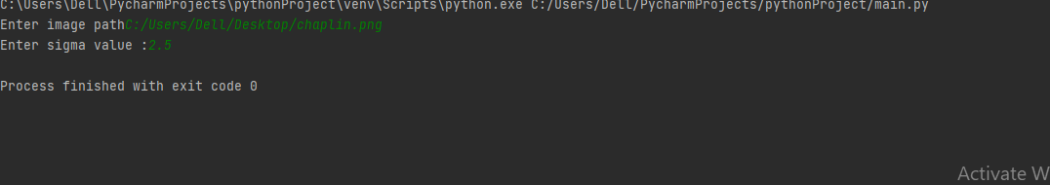

**Gaussian blur image is 3x3**

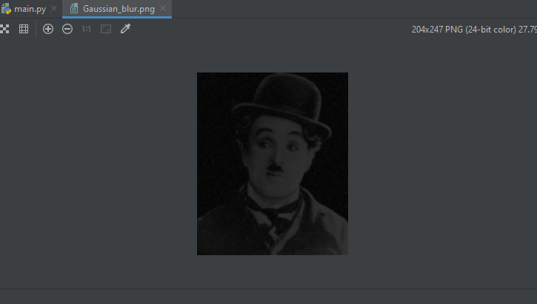

**Gaussian blur 5x5:**

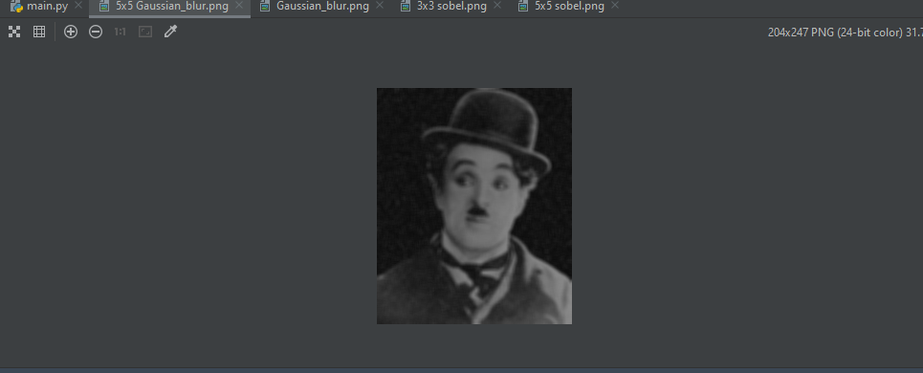

When sigma=0.9



**3x3 gaussian blur:**

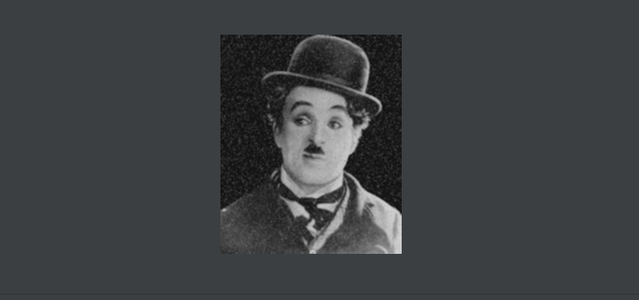

**5x5 gaussian blur:**

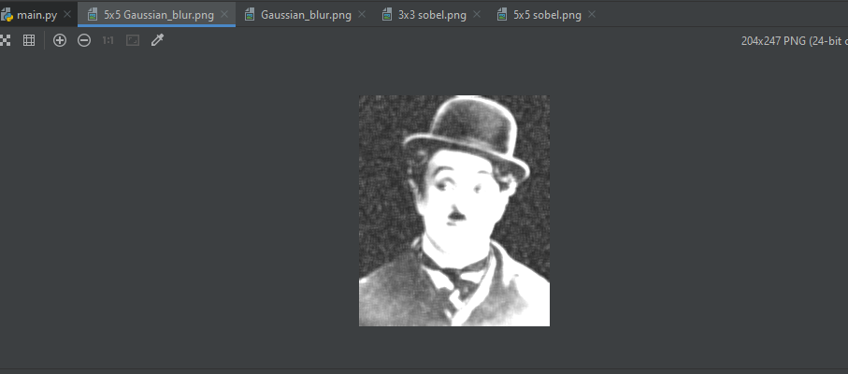

Q2: Sobel image with 3x3 and 5x5 kernel

When sigma=2.5

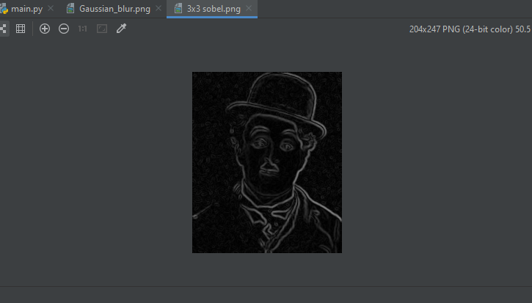

5x5 kernel:

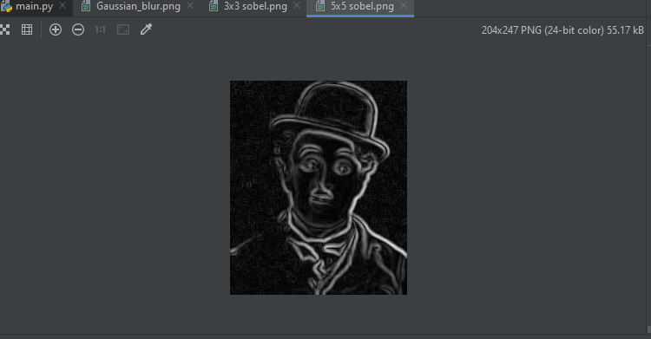

When sigma=0.9

3x3 kernel

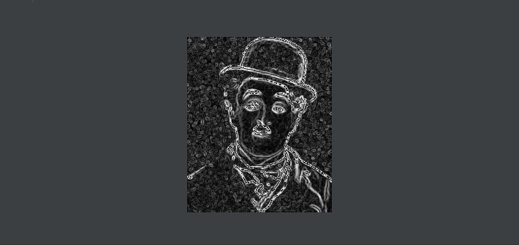

5x5 kernel

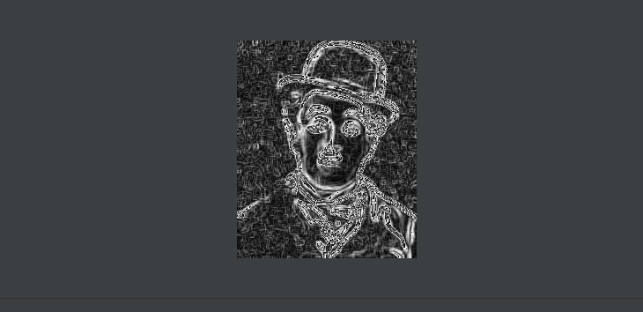

**Java:**

**Q1:**

**When sigma=0.2**

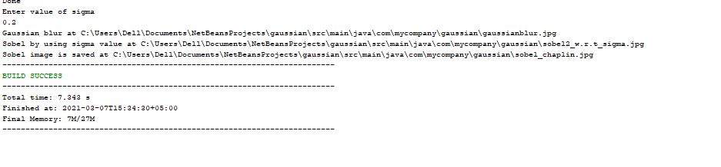

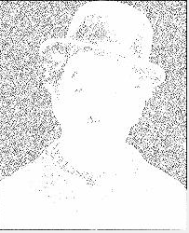

**Q2:3x3 kernel**

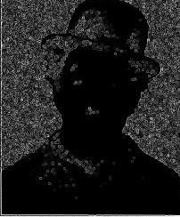

**Sobel direct applies on image**

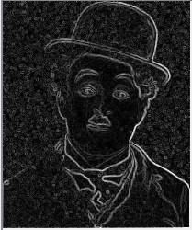

**C++:**

**Q1: REAL_image**

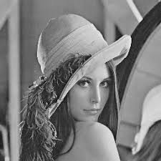

**When sigma=0.9 3x3 Gaussian blur**

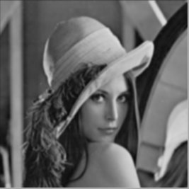

**When sigma 2.5**

**Q2: 3x3 Sobel operator**

