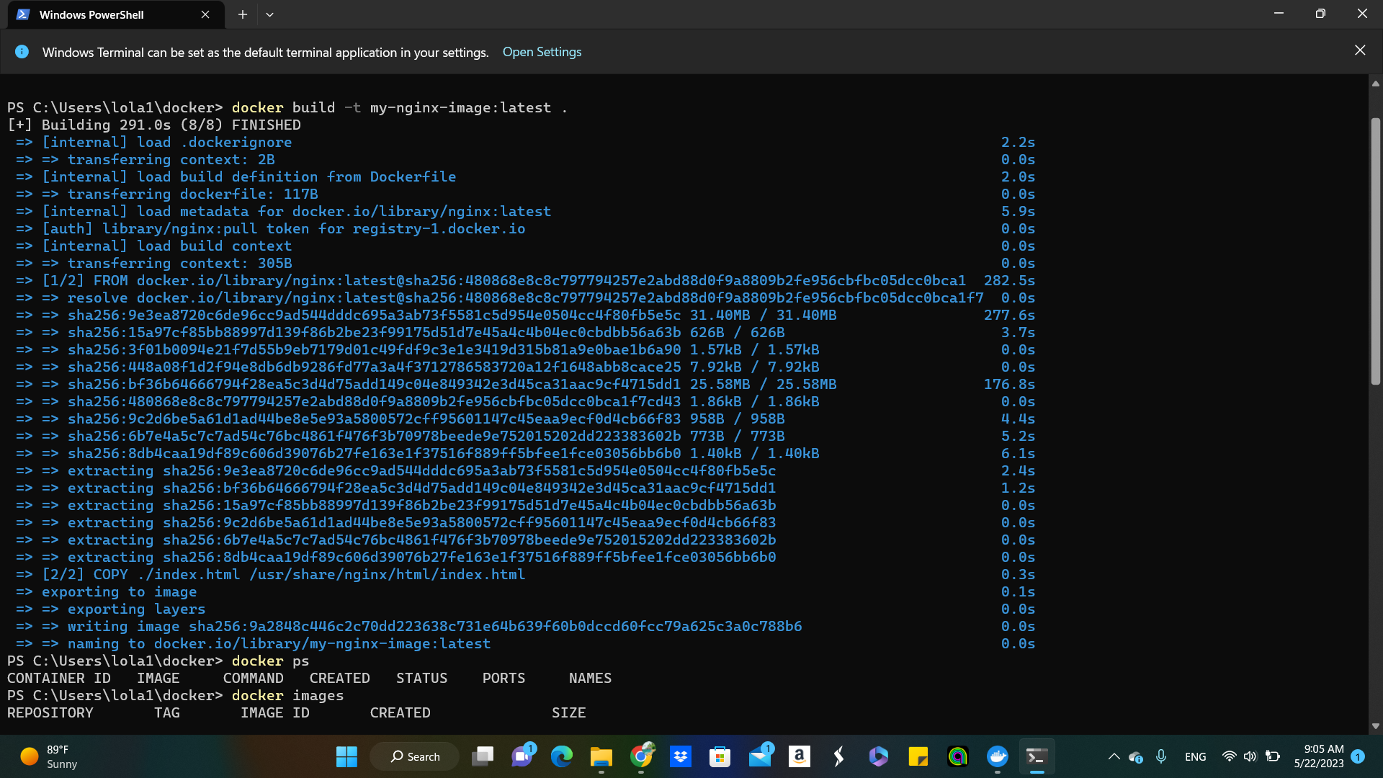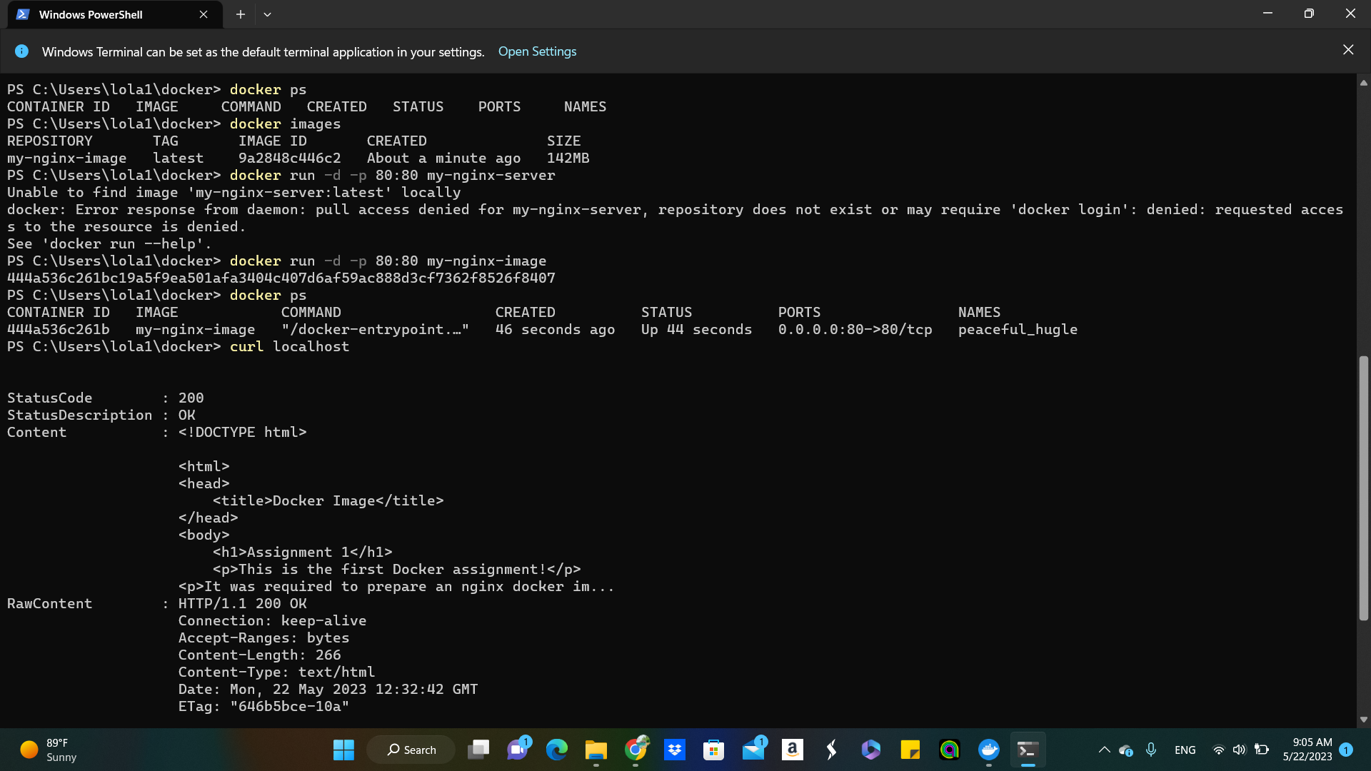

1-I built the image using the command written above , it will build the docker image using the docker file in the current directory and i tagged it with my-nginx-image

2- once it was built , you can run the docker container

3- the command starts the docker in detached mode , maps port 80 on your local machine to port 80 in the container , and uses my-nginx-image.

4- when i tested the web html and that was the final page

