2021
Happy Game Documentation
lauri salminen

Sisällys
Project setup 3
Component information 4
Waypoint 4
Properties 4
Debug Information 5
Debug UI 5

Project setup
- Show waypoints correctly
  - Scene view → Gizmos → untick 3D icons
- Hide minimap from the scene camera
  - Editor top right → Layers dropdown → Hide minimap
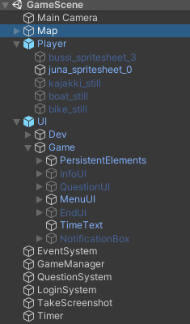
- Default Scene setup as of version 1.0 – Set this before build or testing

- In the development version the password for accessing the game is 1234.
- If required to edit the Questions.csv you must change your systems delimiter type.
  - When opened in Excel the delimiter used is picked from the Windows locale settings.
  - The delimiter used in the csv file is |, default Windows delimiter in locale Finland is ;.
  - If edited using the wrong delimiter the file might break.
  - Make sure Microsoft Excel is closed before trying to change the CSV delimiter. ...
  - Steps: Control Panel → Regional Settings → Additional Settings → Change List separator to pipe (“|”).

Component information

Waypoint
GameObjects with this script attached define the path that PathFollow script uses to move.
For the path editor of PathFollow to function, you need at least three of these points in the path container.
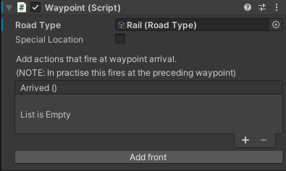
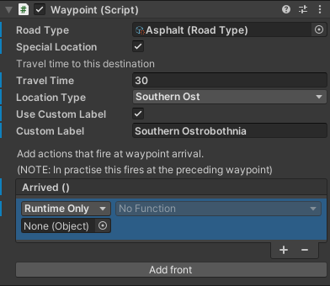Figure 1: All the options extended
Figure 2: Minimal information

Properties
Property: | Function:
Road Type | Road type used on this waypoint, takes a RoadType scriptable object. Gets read after leaving the point prior to this. Vehicle gets set according to this.
Special Location | Is this waypoint a destination?
-Travel Time | Travel time in seconds from the prior special location to this.
-Location Type | Set the type of the location, these are taken from the LocationType enum.
-Use Custom Label | If this is not set, script uses the LocationType as the label.
--Custom Label | Set a custom label for the WayPoint. Label used by announcements.
Arrived event | Run a function when the player arrives at the waypoint.
Use the arrived event for example to play an animation when passing through the point. By placing an object with an animator into the Object field, you can use its functions to create actions.
This can also take other scripts or components. (Audio Source, etc.)
Use the Add front button to add a waypoint between two previously placed points.

Debug Information

Debug UI (as of version 1.0)
UI elements:
Restart button: currently non-functional
Fast Forward button: speeds up the time scale to 10x.
Normal Speed button: sets the time scale to 1x.
Score +1 button: Currently adds 2 points to score. (This is a bug)
Score -1 button. Currently removes 2 points from the score.
Score text: Shows the current score, currently updates only when pressing the score buttons. To see current score, press +1 then -1.
Other info:
The debug UI is only visible when the game is running in the editor or in Debug mode. UIManager contains a check in the UIInit() function, where it only enables this UI if running in a Debug build or in the editor.

