CURALINA & CO.
Integrated AI Interior Design MVP
A 14-Week Project Proposal
Recommendation and room composition • Product colour variants • Catalogue-grounded room rendering
A demonstrable end-to-end MVP that converts customer preferences, room information and a curated product catalogue into a compatible room bundle, approved product colour variants and a grounded room visualization.
Prepared for: Curalina & Co. Prepared by: Four-Person Project Team
Version: 1.0 Date: 8 September 2026
Planning basis: four part-time student contributors; partial product catalogue; integrated MVP rather than production launch.

Executive Summary
Curalina & Co. is seeking an AI-assisted interior design experience that can recommend purchasable products, create approved colour variations from a product photograph, and visualize the selected products in a customer room. The proposed 14-week engagement delivers these capabilities as one integrated MVP while keeping each engine independently testable.

Recommendation
Proceed with a bounded living-room pilot using the three agreed design styles, a curated catalogue subset and existing generative foundation models. Do not train a diffusion model from scratch during the MVP.

The three delivery areas
Area | Business question | MVP outcome
1. Recommendation and room composition | Which purchasable products belong together and fit the brief? | Ranked, explainable room bundle that satisfies rules, budget and basic spatial constraints.
2. Product colour-variant generation | How would the same product look in approved colours? | Validated recoloured variants that preserve product identity, form, texture and lighting.
3. Catalogue-grounded room rendering | How will the chosen bundle look in the customer room? | Controlled room image based on the approved products, variant IDs and approximate placement plan.

Delivery posture
- Integrated MVP: one workflow and shared data contracts, not three disconnected demos.
- Part-time capacity: planned at approximately 10-12 hours per person per week, or 560-672 team hours across 14 weeks.
- Partial catalogue: catalogue audit and enrichment are scheduled as core engineering work.
- Human approval: designers remain responsible for approving inferred product tags, generated variants and final renders.
- Pilot-first: prove feasibility, quality and client value before production hardening or broader room coverage.
1. Project Objectives and Scope
Objectives
- Translate customer questionnaire responses into a structured design profile.
- Standardize and enrich enough catalogue products to support a credible living-room demonstration.
- Recommend a coordinated, explainable and constraint-compliant product bundle.
- Generate approved colour variations from a single product photograph without changing product identity.
- Render the selected products within an uploaded customer room image using controlled generation.
- Capture designer review and customer-refinement signals for future model improvement.

MVP scope
In scope for 14 weeks | Deferred beyond MVP
One pilot room type: living room | All room types and whole-residence harmonization
Three canonical styles: Organic Modern, Mid-Century Scandinavian and Contemporary Luxe | Open-ended style discovery
Curated catalogue subset with required metadata | Automated onboarding of every supplier catalogue
Colour changes on supported product regions | Unrestricted material, geometry or construction changes
Existing pretrained image-generation models with controls | Training a foundation diffusion model from scratch
User-supplied measurements and basic layout validation | Exact dimensions inferred from one photograph
Demonstration deployment and documented APIs | Production SLA, autoscaling, full security certification and commerce integration

Scope guardrail
If catalogue readiness, product-image quality or client review turnaround falls behind, the pilot catalogue size will be reduced before product fidelity or end-to-end integration is sacrificed.
2. Proposed Solution Architecture
The MVP separates decision-making from visualization. The recommendation engine determines what should be selected, the variant service determines which approved visual variant is used, and the room renderer visualizes the resolved selection. This prevents a generative model from inventing products or silently overriding business rules.
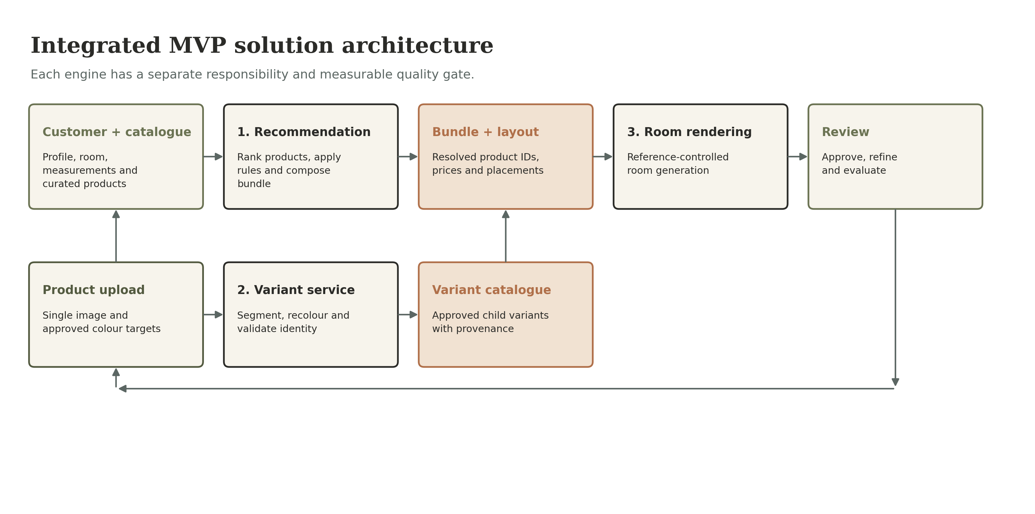
Core technical components
Component | Responsibility | MVP implementation
Experience/API layer | Accept questionnaire, room photo, measurements and product uploads. | Simple web/API workflow with traceable job IDs.
Catalogue service | Store parent products, variants, attributes, availability and image provenance. | Normalized relational or document schema plus object storage.
Recommendation service | Filter, classify, rank and assemble a valid room bundle. | Hybrid ML similarity/ranking plus deterministic rules and bundle checks.
Variant service | Create colour variants while preserving the original product. | Segmentation mask, controlled recolouring and human approval.
Rendering service | Generate a room visualization grounded in selected references. | Pretrained model with reference, mask, depth or layout conditioning.
Evaluation layer | Measure rule compliance, product fidelity and user acceptance. | Automated metrics plus designer-reviewed golden scenarios.
3. Workstream 1 — Recommendation and Room Composition
This workstream produces the structured product bundle consumed by the room renderer. It combines machine learning for ambiguous aesthetic matching with deterministic rules for facts that must not be guessed.
Functional sequence
- Create a customer design profile from room type, style, atmosphere, pattern preference, lifestyle needs and budget.
- Filter products that fail category, availability, price, durability or dimensional constraints.
- Predict or infer style and appearance attributes from product text and images where supplier metadata is incomplete.
- Rank eligible products using customer-product similarity and style compatibility.
- Assemble a complete room bundle and perform basic compatibility, budget and spatial validation.
- Return alternatives for the Refine Item experience while preserving compatibility with the rest of the room.

MVP deliverables
Deliverable | Acceptance evidence
Canonical product and design-profile schema | Versioned field definitions and sample records approved by the client.
Catalogue enrichment pipeline | Required fields populated for the curated pilot set with source and confidence tracking.
Baseline style classifier / semantic matcher | Repeatable notebook or service evaluation against designer-labelled examples.
Rules and scoring service | Every accepted or rejected product includes an explanation of key rules and scores.
Room-bundle API | Returns required categories, selected variant IDs, total price and validation status.
Substitution API | Returns compatible alternatives without violating hard constraints.

Success measures
- Precision@5 and NDCG@5 measured against a small designer-labelled test set.
- Zero hard-constraint violations in agreed golden test scenarios.
- 100% of recommendations trace to a catalogue product and variant ID.
4. Workstream 2 — Product Colour-Variant Generation
This service accepts one product image and an approved colour request. It creates a new visual asset while preserving the product silhouette, dimensions, construction details, camera angle, background relationship, shadows and non-editable materials.

MVP limit
The initial commitment is controlled colour variation on supported regions such as upholstery or painted finishes. Fabric-to-leather conversion, new geometry and unseen camera angles are separate research problems.

Processing pipeline
Stage | Action | Quality control
1. Ingest | Validate image format, resolution, product ID and requested colour. | Reject unsupported or ambiguous inputs.
2. Segment | Identify the editable product region and preserve protected regions. | Human-correctable mask preview.
3. Generate | Apply controlled recolouring and limited generative refinement. | Use recorded seed, source image and colour specification.
4. Validate | Compare identity, shape, structure, colour and artifacts. | Automated checks plus designer review.
5. Register | Store the result as a child variant of the parent SKU. | Variant status: supplier-confirmed, custom-order or conceptual preview.

MVP deliverables and measures
- Product-upload endpoint and supported-input validation.
- Editable-region mask generation with manual correction support.
- Approved colour palette or exact colour-code input.
- Variant generation service using an existing foundation model or image-editing pipeline.
- Side-by-side review screen showing original, mask and generated variant.
- Variant metadata, provenance and approval status stored in the catalogue.
- Designer acceptance target established during week 4 and evaluated on a fixed product test set.
5. Workstream 3 — Catalogue-Grounded Room Rendering
The room renderer consumes an uploaded room image, customer-confirmed measurements, the selected bundle, approved product references and a placement plan. Its purpose is visualization, not product selection.
Control strategy
Control | Why it is required
Product reference conditioning | Keeps the rendered furniture visually tied to the selected catalogue item.
Segmentation and inpainting masks | Limits changes to intended regions and protects doors, windows or retained items.
Depth or layout conditioning | Improves perspective, scale and approximate placement consistency.
Recorded generation seed | Allows outputs to be reproduced and compared.
Negative constraints | Reduces duplicate, invented or structurally altered furniture.
Post-generation validation | Detects missing products, identity drift, colour errors and obvious spatial failures.

MVP deliverables
- Room-photo upload and minimum image-quality validation.
- Basic room mask and reference-conditioned room-generation pipeline.
- Generation request containing selected product/variant IDs, approximate placements and design profile.
- Rendered output with provenance metadata and downloadable image.
- Designer review checklist covering product identity, count, colour, placement and hallucinations.

Quality measures
Measure | MVP interpretation
Catalogue traceability | Every intended visible product maps to an approved product/variant ID.
Product identity preservation | Designer rates whether silhouette and distinctive details remain recognizable.
Colour fidelity | Generated product colour remains within the agreed tolerance or passes designer review.
Object and spatial completeness | Expected products appear once; golden-room tests show no obvious collisions, blocked openings or implausible scale.
6. Team Structure and Delivery Model
The team is intentionally cross-functional. Each person has a primary workstream and a secondary responsibility so the project does not stall when school deadlines collide with project work.
Role | Primary accountability | Secondary accountability
Team Member 1 — Project Manager / Business Analyst / QA Lead | Client discovery, backlog, schedule, acceptance criteria, UAT and decision log. | Catalogue rules, documentation and integration testing.
Team Member 2 — ML / Recommendation Engineer | Catalogue enrichment, feature engineering, classifier, similarity ranking and evaluation. | Rules service and substitution logic.
Team Member 3 — Computer Vision / Generative AI Engineer | Product segmentation, colour variants, controlled room rendering and visual evaluation. | Image-data preparation and model experiments.
Team Member 4 — Full-Stack / Cloud / Integration Engineer | APIs, UI workflow, storage, orchestration, deployment and observability. | Data contracts, CI/CD and demo reliability.

Capacity assumptions
- Each contributor averages 10-12 project hours per week outside coursework.
- The team protects one two-hour collaboration block and one short stand-up each week.
- No more than two people are assigned to a critical task without a named owner.
- Weeks 7 and 13 contain scope and quality gates to absorb academic workload variance.
- Client feedback is returned within two business days for scheduled approvals.

Working cadence
Cadence | Purpose
Weekly planning | Confirm capacity, choose committed backlog and surface school conflicts.
Twice-weekly stand-up | Track blockers and integration dependencies; 15 minutes.
Weekly client checkpoint | Demonstrate progress and request bounded decisions.
End-of-week integration build | Merge only tested work against the shared contracts.
Milestone reviews | Formal go/no-go checks in weeks 2, 7, 10, 13 and 14.
7. Fourteen-Week Delivery Roadmap
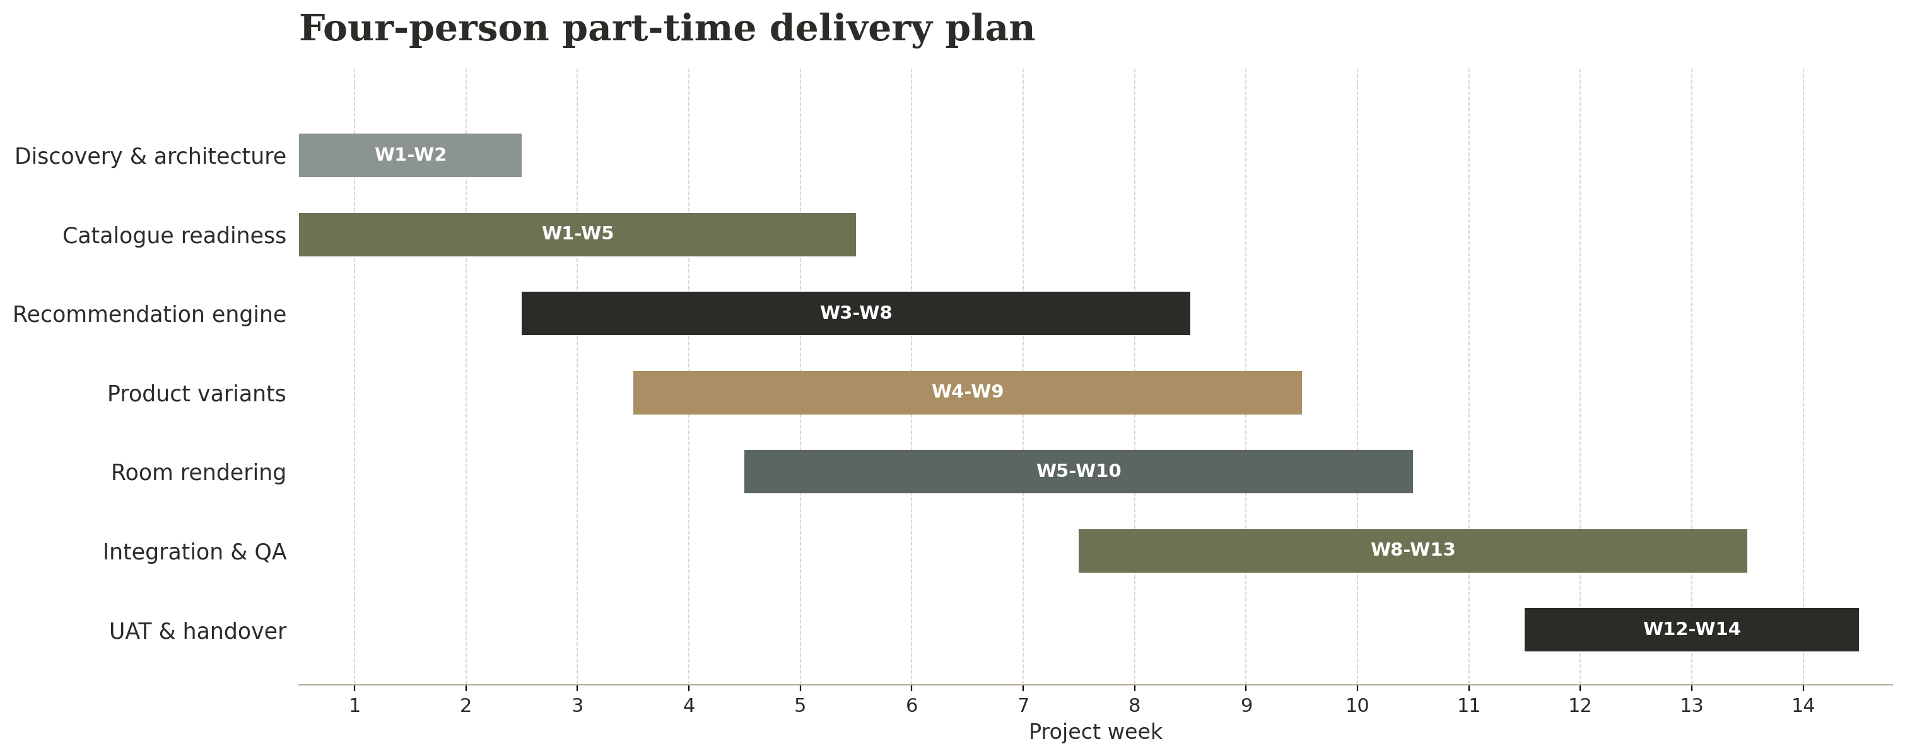
Critical path
Catalogue readiness and stable data contracts unlock all three engines. Variant and rendering experiments begin early, but integration is not committed until approved catalogue assets and IDs are available.

Wk. | Focus | Planned work | Exit artifact
1 | Mobilize and audit | Confirm use cases, MVP boundaries, roles, repo, environments and catalogue inventory. | Project charter; RAID log; data audit plan.
2 | Requirements and architecture | Canonical styles, rules, product schema, APIs, golden scenarios and target metrics. | Architecture and data-contract gate.
3 | Catalogue foundation | Normalize pilot products, images, IDs, dimensions, price and availability; label sample products. | Curated catalogue v0.1.
4 | Baselines | Recommendation baseline; segmentation/recolouring spike; rendering feasibility spike. | Three feasibility readouts and metric baselines.
5 | Recommendation alpha | Style/attribute enrichment, hard filters, preference matching and explanation output. | Ranked product API alpha.
6 | Composition alpha | Required categories, budget checks, pair compatibility and basic spatial checks. | Living-room bundle alpha.
7 | Midpoint scope gate | Evaluate quality, catalogue readiness and integration risk; freeze pilot catalogue and golden tests. | Approved MVP scope and recovery actions.

Fourteen-week delivery roadmap — continued
Wk. | Focus | Planned work | Exit artifact
8 | Variant service alpha | Product upload, masks, controlled colour variants, provenance and approval workflow. | Approved-variant workflow alpha.
9 | Rendering alpha | Room mask, bundle references, layout hints, controlled generation and visual checklist. | Grounded render alpha.
10 | Integration gate | Connect customer profile, recommendation, approved variants and renderer using shared IDs. | End-to-end happy-path demo.
11 | Quality improvement | Tune ranking, variant fidelity and rendering controls against fixed test sets. | Evaluation report v0.1.
12 | Workflow completion | Refinement loop, failure handling, audit metadata, deployment automation and documentation. | Feature-complete release candidate.
13 | Client UAT | Run golden scenarios, defect triage, performance checks and client acceptance review. | UAT report and prioritized fixes.
14 | Finalization and handover | Resolve critical defects, deliver demonstration, architecture, runbook and next-phase roadmap. | Integrated MVP and handover pack.

Formal milestone gates
Gate | Decision
Week 2 — Foundation | Are scope, data contracts, pilot catalogue fields and evaluation cases approved?
Week 7 — Midpoint | Do quality results justify the integrated scope, or should catalogue size/features be reduced?
Week 10 — Integration | Can one traceable request complete the full happy path?
Week 13 — UAT | Do agreed golden scenarios pass without critical defects?
Week 14 — Handover | Are the MVP, documentation, limitations and next-phase recommendations accepted?
8. Integrated MVP Definition of Done
The MVP is complete only when the three workstreams operate through one traceable workflow. A polished image alone is not acceptance evidence.
- A user submits a living-room profile, room image and verified measurements.
- The system returns a complete catalogue-backed room bundle with explanations and no hard-constraint violations in golden tests.
- A user or designer uploads a supported product and produces at least three approved colour variants while preserving product identity.
- The selected product and variant IDs are passed into the room renderer without manual ID substitution.
- The renderer produces a plausible room image containing the intended product set for agreed golden scenarios.
- Every generated variant and room render retains source references, model/version information, parameters, seed and approval status.
- The team demonstrates failure handling for missing metadata, poor images and rejected generations.
- Evaluation results, known limitations, setup instructions, architecture and operational runbook are delivered.

Priority model
Priority | Commitment
Must have | Canonical catalogue subset; customer profile; explainable bundle; colour variants; grounded render; shared IDs; golden tests; demo deployment.
Should have | Product substitutions, mask correction, multiple render candidates, designer feedback capture and basic monitoring.
Could have | Additional room type, material replacement experiment, automated room segmentation or richer spatial planning.
Will not have in MVP | Custom foundation-model training, exact single-photo measurement, photorealistic multi-angle product reconstruction, full commerce or production SLA.
9. Quality, Testing and Evaluation Plan
Each workstream requires its own evaluation because a visually attractive room can conceal poor recommendations, and a strong recommender cannot compensate for product identity drift in a render.
Test layer | Coverage | Evidence
Unit tests | Schema validation, rule calculations, filters, price totals, colour parsing and API contracts. | Automated test report in CI.
Model evaluation | Style classification, ranking relevance and coverage. | F1/confusion matrix plus Precision@5 and NDCG@5.
Visual variant tests | Identity, colour, protected regions, artifacts and reproducibility. | Fixed product set with designer ratings.
Golden-room tests | Bundle completeness, constraints, product count, visual grounding and spatial plausibility. | Founder-approved scenarios and pass/fail checklist.
Integration tests | Customer request through bundle, variant selection and room render. | Traceable end-to-end runs.
UAT | Business usefulness, explanation clarity and refinement flow. | Signed UAT summary with critical defects resolved.

Proposed acceptance thresholds
Final numeric thresholds should be approved in week 2 after the team measures a baseline. The proposal commits to the following non-negotiable conditions:
- No known hard-constraint violations in the approved golden scenarios.
- No untraceable product appearing in a final accepted bundle.
- No generated product variant presented as purchasable unless supplier or client status supports that claim.
- No final room render accepted when a required hero product is absent, duplicated or materially changed.
- Unsupported inputs and known limitations are documented in the UI and handover pack.
10. Risks, Dependencies and Mitigations
Risk | Chance | Impact | Mitigation
Catalogue lacks required attributes | High | High | Audit in week 1; curate a bounded pilot set; track source/confidence; obtain designer labels.
Part-time availability fluctuates | High | High | Weekly capacity planning; single accountable owner; scope gates; reserve weeks 11-13 for stabilization.
Product identity drifts during generation | High | High | Use masks/reference controls; fixed test set; human approval; reject rather than quietly accept.
One photo cannot provide reliable dimensions | High | Medium | Require customer-confirmed measurements; treat vision estimates as advisory.
Client feedback is delayed | Medium | High | Pre-book reviews; use written decision log; default to previously approved rules after deadline.
Supplier variants are not purchasable | Medium | High | Store commercial status and never merge conceptual previews with confirmed variants.
API/model cost or latency is excessive | Medium | Medium | Benchmark during spikes; cache assets; limit render attempts; document unit economics.
Three engines integrate late | Medium | High | Freeze API contracts in week 2; use mocks; run first happy path by week 10.

Client dependencies
- Provide the current product catalogue, representative images, prices and availability fields in week 1.
- Nominate one design authority who can resolve contradictory rules and approve labels, variants and golden rooms.
- Provide five to ten room images and approve the canonical styles, pilot catalogue and golden scenarios by week 2.
- Return scheduled feedback within two business days and classify generated variants as conceptual, custom-order or supplier-confirmed.
11. Governance, Security and Responsible AI
Although this is an MVP, the team will preserve the foundations required for later production work. Generated images must be identifiable, reproducible and connected to their source assets.
Control area | MVP commitment
Data provenance | Store source catalogue row/image, transformation type, model/version, parameters, seed and reviewer status.
Human oversight | Require designer approval for inferred attributes, product variants and client-facing golden renders.
Access and privacy | Restrict uploaded customer-room images and avoid using them for training without explicit approval.
Commercial truth | Keep supplier-confirmed, custom-order and conceptual variants clearly separated.
Reproducibility | Version schemas, prompts, rules, model references and test scenarios.
Failure transparency | Return structured reasons when no valid bundle or acceptable image can be produced.
Security baseline | Use secret management, authenticated endpoints, dependency scanning and least-privilege storage access.

Change control
Any request that adds room types, material transformations, 3D reconstruction, supplier commerce integration or production non-functional requirements will be estimated as a change request. The project manager will record impact on scope, schedule, quality and team capacity before the team commits.
12. Handover Package and Recommended Next Phase
Week 14 handover
- Integrated demonstration application and deployment instructions.
- Source code, configuration templates and versioned data contracts.
- Pilot catalogue and enrichment documentation.
- Recommendation, variant and rendering evaluation reports.
- Golden test scenarios, UAT summary and known-defect list.
- Architecture diagram, operating runbook and model/service inventory.
- Prioritized roadmap and cost/effort assumptions for the next phase.

Recommended phase after MVP
Priority | Next-phase capability
1 | Expand and automate catalogue onboarding, supplier validation and product-image quality checks.
2 | Add dining room and bedroom after the living-room rules and data contracts prove reusable.
3 | Improve spatial planning with structured floor plans, multi-view capture, depth data or LiDAR where available.
4 | Develop learning-to-rank from refinements, approvals and purchases once legitimate behavioural labels exist.
5 | Evaluate 3D product assets or multi-view reconstruction for products where exact identity is commercially critical.
6 | Complete production hardening: observability, cost controls, privacy review, security testing, scaling and SLAs.

Client approval
Approve the 14-week integrated MVP direction, nominate the design decision-maker, release the partial catalogue and representative images, and authorize week 1 discovery and data audit.

Planning assumptions requiring confirmation at kickoff
- Average contributor availability of 10-12 hours per week.
- Living room and a curated catalogue subset form the initial pilot.
- The committed variant workflow is colour-only and may use approved pretrained models; the result is an integrated feasibility MVP, not a production launch.

