Отчет по работе №2

Испытания:

1. mrm8488/bert-mini-finetuned-age_news-classification
2. textattack/bert-base-uncased-imdb
3. muhtasham/bert-small-mlm-finetuned-imdb
4. car13mesquita/bert-based-uncased-finetuned-imdb
5. muhtasham/bert-tiny-mlm-finetuned-imdb-finetuned-emotion

Изменения:

1. dataset = datasets.load_dataset('imdb')
2. tokenizer = AutoTokenizer.from_pretrained("muhtasham/bert-tiny-mlm-finetuned-imdb-finetuned-emotion")
3. model = AutoModelForSequenceClassification.from_pretrained("muhtasham/bert-tiny-mlm-finetuned-imdb-finetuned-emotion", num_labels=4, ignore_mismatched_sizes=True)

Результат:

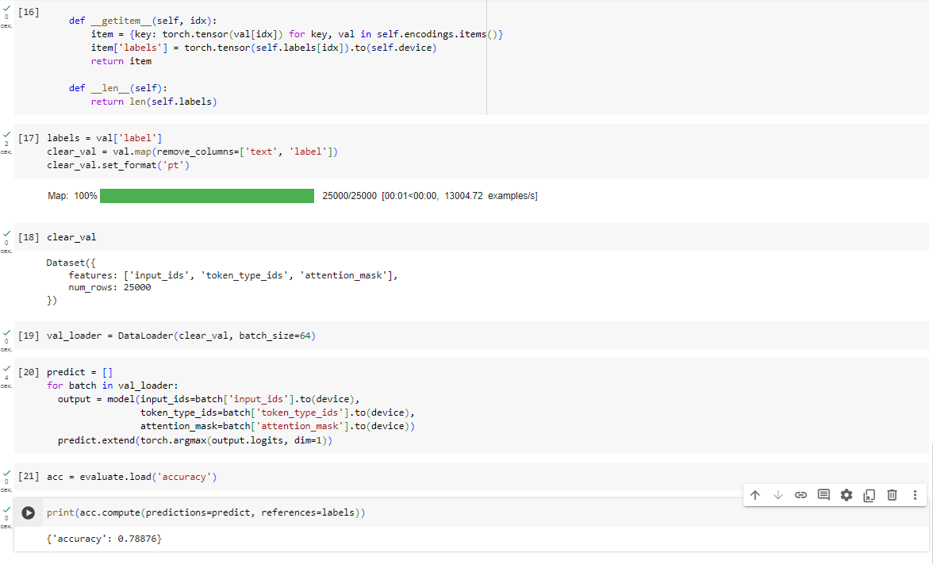

Ссылка:

https://colab.research.google.com/drive/1wNq08T_A9i3lMcohAAot0IeJJ043Sh78?usp=sharing