BBDS Data Science Challenge Project

Extended Program

A research on Seattle 9/11 calls

Final Report

Iqbal Ismail

December 4, 2019

Foreword
It has been a privilege to be assigned a high quality data science project challenge like this. There is no better way to understand the nuances of a complex domain like machine learning than resolving a challenging problem which stretches you to try out many types of algoirthms.

Contents

Section |  | Heading | Page Number
Executive Summary |  | Objective and scope of the project | 4
Project Deliverables |  | Data Exploration and analysis  Data quality and normalization  Categorization of data and mapping | 5
Evaluation |  | Data Exploration and analysis  Data quality and normalization  Categorization of data and mapping | 6
Networking, alignment, sustainability |  | Mode of communication and how project was made sustainable | 7
Recommendations / Next steps |  | List of observations, recommendations | 8
Appendices | A | Team members and roles | 9
Appendices | B | Meeting minutes
Appendices | C | Outputs and artifacts
Executive Summary
The objective of the project is to research the most common reason for 911 calls in Seattle area based on the data which shows four reasons ,Latte Spills, Beaver Attacks, Seal Attacks, and Celebrity Sightings of Marshawn Lynch . The project will explore data sufficiency, data accuracy, and research and employ suitable machine learning algorithms, and will produce and document and present the conclusion to all stake holders
Project Deliverables :

Data Exploration and Analysis

- Find out the most common reason for calling 9-1-1?

Data Quality and Normalization

- Research if there are there any mislabeled data points?
Using EDA, it is observed that except "Latte spills" all other types have some data points that look mislabeled.

Data Exploration and Analysis

- Categorize data points and map to different reasons for the calls.

Evaluation

Data Exploration and Analysis

Using the data analysis, it is found the most common reason is Beavers with a frequency of 508 occurrences

Data Quality and Normalization

Using EDA, it is observed that except "Latte spills" all other types have some data points that look mislabeled.

Data Exploration and Analysis

Using visualization techniques such as scatter plot, data points for calls can be grouped together based on latitude and longitude. We could develop an algorithm to predict a 911 call either based on unsupervised learning using k-means/hierarchal clustering to group similar calls together and then label each group by type, or after labeling we could train a classification model to predict the type of call (label) using just latitude and longitude as input features

The two algorithms we decided to evaluate for this project is k-means clustering and another common model known as DBSCAN (Density Based Spatial Clustering of Applications with Noise
Networking, alignment, sustainability

The project team met regularly twice in a week . Produced minutes and reviewed with the team lead. All roles were properly aligned and conclusions were shared with the executive board
Recommendations/Lessons Learned/Next Steps:

From our experimentation, we found DBScan technique is suitable for this .

K-means uses Euclidean distance which is not accurate for latitude & longitude points on earth as earth is sphere.
To prove our point, we build both models-- K-means & DBSCAN -- to compare which performs better.

What we learnd is k-means/hierarchical clustering algorithm and DBSCAN both use distance (Euclidean, Manhattan, etc.) to group similar data points together. Additionally, DBSCAN uses ‘minimum cluster size’ as an additional parameter.

We also learned that since latitude/longitude are on a sphere (Earth), the distance between 2 points using just the Euclidean would not be accurate.

The recommended way would be to use haversine formulae and calculate geodesic distances instead – this is where DBSCAN has a comparative advantage

Appendices

Appendix | Item | Page
A | Team members and roles | x
B | Meeting Minutes | x
C | Report outputs and Artifacts | x

Appendix A

Oad Salochina – Project lead
Fazal Wahab - Project Manager
Huma Asmi– Business Analyst
Iqbal Ismail – Data Engineer
Nadir Syed- Data scientist
Omer Rafi - Database Admin
Nawazuddin Khaja – Citizen data scientist

Appendix B

Meeting minutes is available on request

Appendix C

Graph of the 911 calls using the Latitude and Longitude

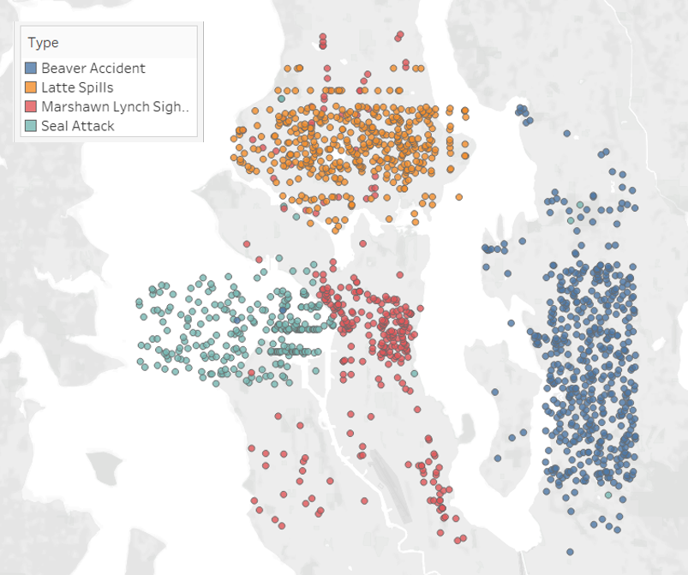

Plot for K-means

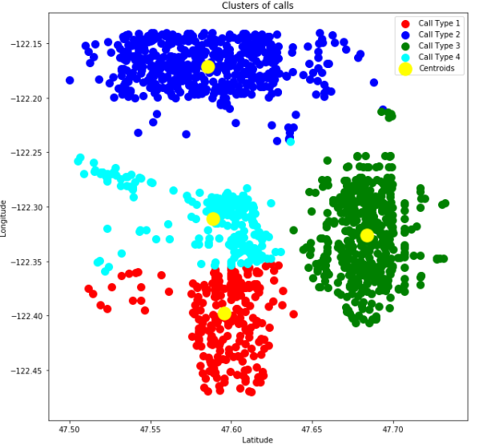

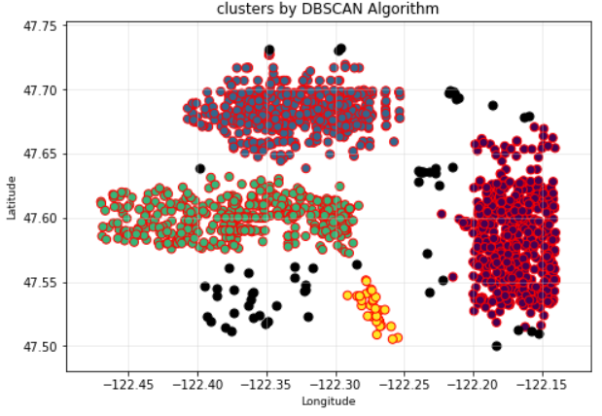

Cluster | # Correct | Total Data Points
Seal Attack | 240 | 266
Beaver Accident | 499 | 508
Latte Spills | 416 | 416
Marshawn Lynch Sighting | 258 | 324

Mislabeled data
