BIGGY
SECURITY INFORMATION & EVENT MANAGEMENT
Project Report & Technical Dossier

A from-scratch, single-node SIEM / XDR platform (intrusion detection, active response, an in-house malware engine, network telemetry, cross-platform agents, and court-ready forensic integrity) in one hackable application.

VERSION  1.0 | CLASSIFICATION  Internal / Portfolio | CONSOLE  localhost:8642 | STACK  Python, FastAPI, SQLite

EXECUTIVE SUMMARY
What Biggy is, in one screen
Biggy is a security operations console that watches a network and the machines on it, decides what matters, responds automatically, and keeps a tamper-evident record an investigator can trust.
Where enterprise platforms like Splunk or Wazuh spread the same job across an indexer, a manager, a message bus and a cluster of search nodes, Biggy folds it into a single Python service with a browser console and a lightweight agent. It ingests events, normalises and hash-chains them, runs a live rule engine (IDS), takes containment action (IPS), scans files with its own malware engine, enriches indicators against VirusTotal, maps the network, and gives an analyst a real investigation workflow: cases, an IOC watchlist, an entity timeline, and one-click evidence capture.
The three jobs
- Detect. A data-driven IDS with MITRE ATT&CK tags, brute-force and scan thresholds, and an in-house malware scanner.
- Respond. Rules auto-block a source IP or quarantine a file; analysts contain indicators in one click.
- Prove. Every event is cryptographically chained; backups and case bundles carry SHA-256 manifests.
01 INTRODUCTION
What a SIEM is, and what this one does differently
A SIEM (Security Information and Event Management) is the nerve centre of a security team. It collects logs and telemetry from across an environment, correlates them to surface real threats out of the noise, raises alerts, and stores everything for investigation and compliance. Modern platforms extend into XDR (Extended Detection and Response), adding endpoint agents and automated containment so the system does not just report an attack; it acts on it.
Biggy is a complete, self-contained implementation of that idea. It is not a log viewer with a dashboard bolted on; it is the full loop (collect, normalise, detect, respond, investigate, prove) with a deliberately small footprint. The entire platform is a Python web service plus a single agent script, backed by one SQLite database. There is no Elasticsearch, no message queue, no cluster to stand up. You clone it, run one command, and open a browser.
THE ONE-LINE DEFINITION
Biggy turns raw events from a network and its endpoints into ranked, actionable, provable security intelligence, and can contain threats on its own.

Who it is for
Security learners and home-lab operators who want a real SIEM they can read end to end; small teams that need visibility without an enterprise budget; and anyone building intuition for how detection, response and digital forensics actually fit together. Because the whole system is legible, it doubles as a teaching instrument.
02 BACKGROUND & HISTORY
How security monitoring got here
Security monitoring evolved in layers, and Biggy deliberately stands on all of them:
Era | What appeared | What Biggy inherits
1990s: Log management | Centralised collection of syslog and event logs; keep everything, search later. | Normalised event pipeline and full-text search.
2005: SIEM named | Gartner coins the term SIEM: correlation rules turn raw logs into ranked alerts. | The data-driven IDS rule engine and alert triage.
2010s: HIDS and agents | Host-based agents (OSSEC, then Wazuh) add file integrity, process and endpoint visibility. | The cross-platform host agent and endpoint event log.
2018+: XDR and SOAR | Detection extends to automated response and threat-intel enrichment. | Active response (IPS), VirusTotal intel, IOC auto-matching.
Now: DFIR-native | Investigators demand evidence integrity: logs that can be proven untampered. | The tamper-evident hash chain, cases and evidence bundles.

The reference points are well known. Wazuh pairs endpoint agents with a central manager and an OpenSearch or Elastic back end for storage and dashboards. Splunk centres on an indexer that ingests and stores machine data and a search head that runs queries against it. Both are powerful and both are heavy. Biggy asks a different question: how much of that value can one clean, readable application deliver?
03 WHY WE BUILT IT
The gap Biggy fills
The problem
Real SIEMs are the right answer for large enterprises and the wrong answer for everyone learning, prototyping, or running a lab: multi-service deployments, steep resource floors, and licensing that starts in the tens of thousands. The learning curve hides the very mechanics a newcomer needs to see.
The response
One application that still does the whole job (IDS, IPS, malware scanning, threat intel, network mapping, agents, and forensics) with every mechanism visible and hackable. It runs on a laptop, needs no external services, and reads like a textbook you can execute.
Design goals
- Complete, not a toy. Cover the real SIEM loop end to end, not just an event viewer.
- Single-node and dependency-light. Python and SQLite; five packages; nothing to orchestrate.
- Trustworthy by construction. The platform's own record is tamper-evident, because attackers clear logs.
- Cross-platform reach. One agent that runs on Windows, Linux and macOS.
- Distinctive, legible interface. A dense operations console, not a generic admin theme.
04 SYSTEM ARCHITECTURE
One service, many engines
Biggy is a single FastAPI application. A vanilla-JavaScript console talks to it over REST and a live WebSocket; a set of internal engines share one SQLite database in WAL mode; a lightweight agent and a background Windows Event Log collector feed the pipeline; and the VirusTotal cloud is the only optional external dependency.

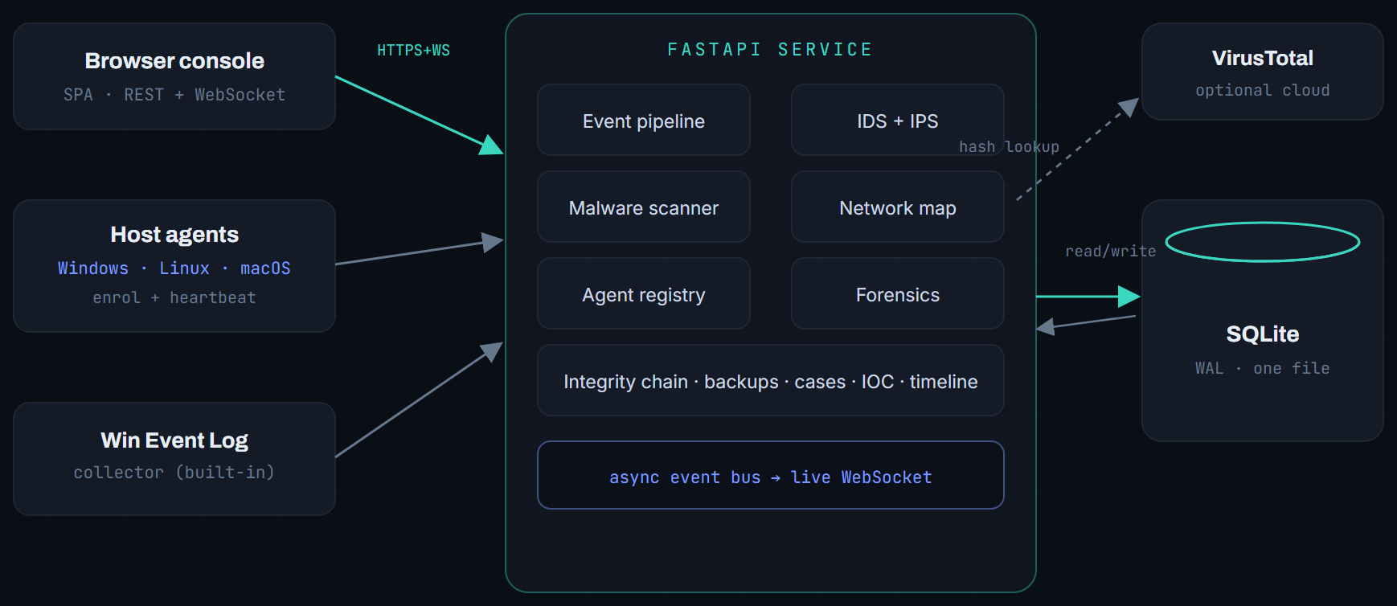
Fig. 4.1. The whole system is one service between a browser and a database. Agents and the log collector feed it; VirusTotal is the only outside call, and it is optional.
The consequence of this shape is operational simplicity. Reads run in a worker thread pool so a slow query never freezes the live feed; all database access is serialised through one connection so there is never lock contention; and background collectors run as daemon threads that publish into the same async bus the WebSocket drains. There is exactly one process to start and one file to back up.
05 DATA FLOW, BIT BY BIT
The life of an event
Every signal (a Windows logon, an agent heartbeat, a file verdict, a port-scan result, a console login) enters through one function, ingest_event(), and travels the same seven stages. This single pipeline is why detection, forensics and the live feed always agree.

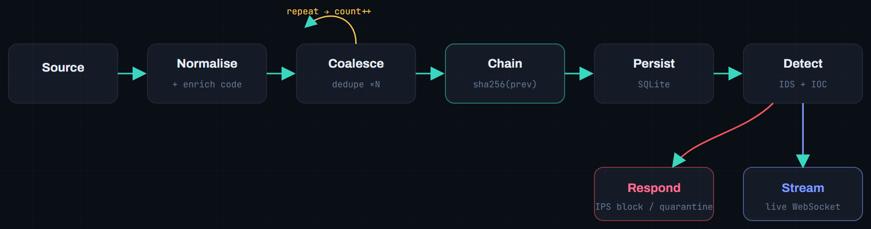
Fig. 5.1. One entry point, seven stages. A repeated event folds back into its existing row (x N); a new one is hash-chained, stored, scored, and streamed.
Stage by stage
1. Source and normalise. The raw signal becomes a common event shape: timestamp, source, host, category, severity, message, IPs, user. If it carries a Windows event code, the code is decoded from a knowledge base of about 70 entries that supplies a human name, a severity, a category and a MITRE technique.
2. Coalesce. If an identical event just fired, Biggy bumps a count on the existing row instead of writing a duplicate, so a service spamming the same code appears once as a single counted line, not thirty times. Combos are capped so long floods roll into fresh groups.
3. Chain. A new event is linked into a tamper-evident hash chain: chain_hash = sha256(prev_hash, event). The count and last-seen fields are deliberately excluded, so coalescing never invalidates the chain.
4. Persist. The event is written to SQLite through the single serialised connection.
5. Detect. The IDS rule set and the IOC watchlist evaluate the event. Threshold rules sum coalesced counts, so a burst of six identical failed logins still trips brute-force detection while raising exactly one, de-duplicated alert.
6. Respond. If a matched rule's action is block or quarantine, the source IP is added to the IPS blocklist or the file is flagged, automatically and in-line.
7. Stream. The event (or a lightweight count-updated message) is published to the async bus and pushed to every connected console over the WebSocket, so the operator sees it the instant it lands.

06 ACCESS & LOGIN
Authenticated, and logged
Every session starts at an authenticated gate. Passwords are stored as PBKDF2-HMAC-SHA256 hashes; sessions are signed, stateless tokens. Crucially, every sign-in attempt is itself an event: successful or failed logins flow through the same pipeline and appear in the feed, so the console's own access is monitored like anything else.

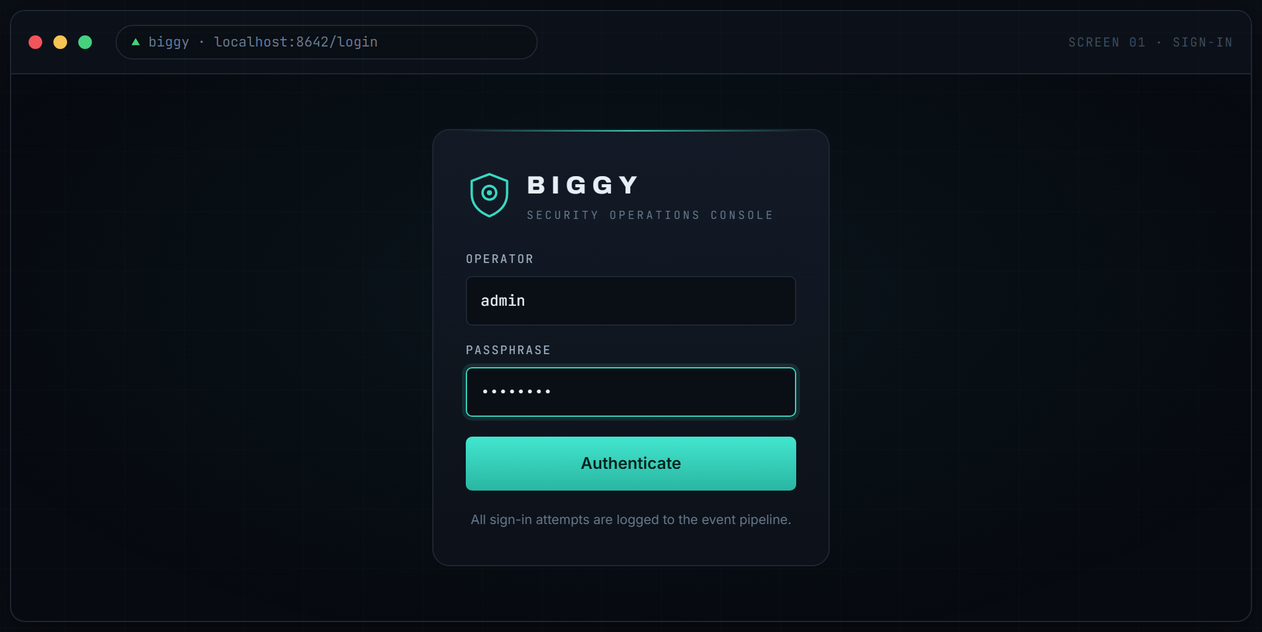
Screen 01. The sign-in gate. First-run credentials are created automatically; the account and role live in the same database as everything else.
07 OVERVIEW DASHBOARD
Posture at a glance
The Overview is the operator's home: the numbers that matter across the top, a real-time event feed down the left, and severity and category analytics on the right. Following information-design practice, the summary sits above the detail and state is encoded in form (colour-coded severity chips, a live connection light) so what needs attention reads in a glance, before a single word.

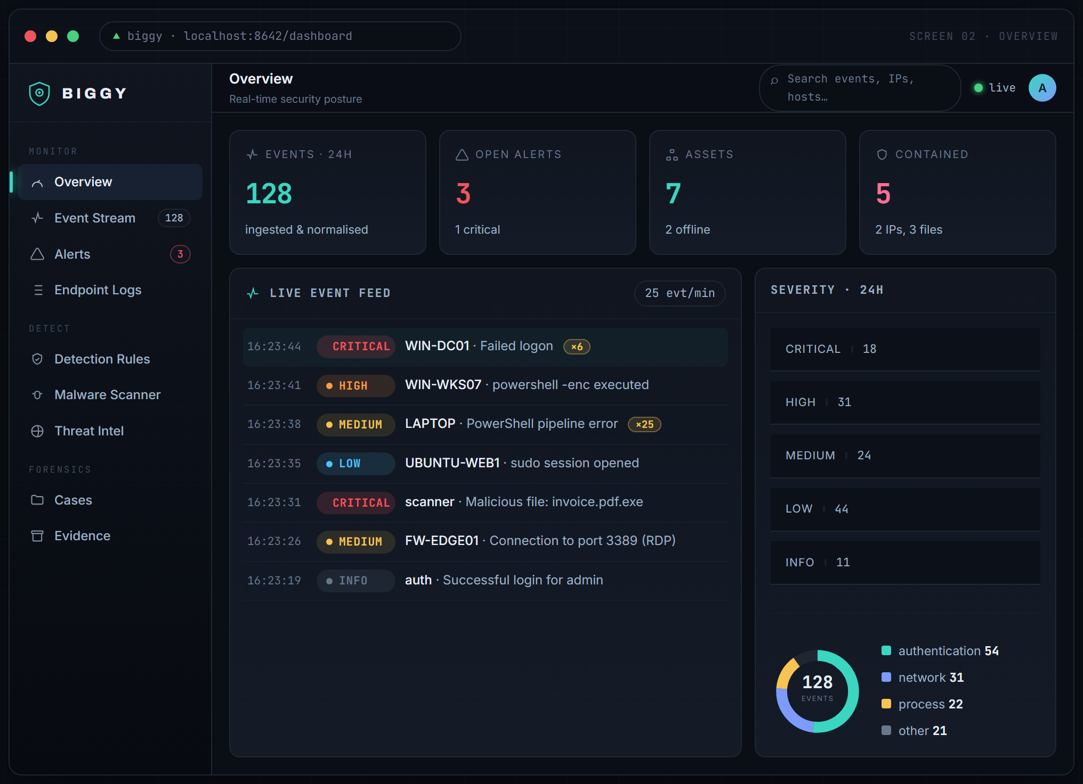
Screen 02. The full console: a fixed navigation rail grouped by job, a live-connection indicator, streaming events with coalesced count badges, and severity and category analytics.
08 EVENTS, COALESCING & DETAIL
From a wall of noise to one clear line
Real endpoints are noisy: a single service can emit the same error dozens of times a second. Biggy coalesces identical repeats into one row carrying a count, so twenty-five duplicate PowerShell errors read as a single counted line instead of burying the feed. Detection still counts every occurrence, and alerts are de-duplicated so a burst raises one alert, not twenty-five.
Any event (in the feed, the stream, or the endpoint log) is clickable. The detail panel decodes the event, lays out every field, shows the raw record, exposes its place in the audit chain, and offers the next investigative move.

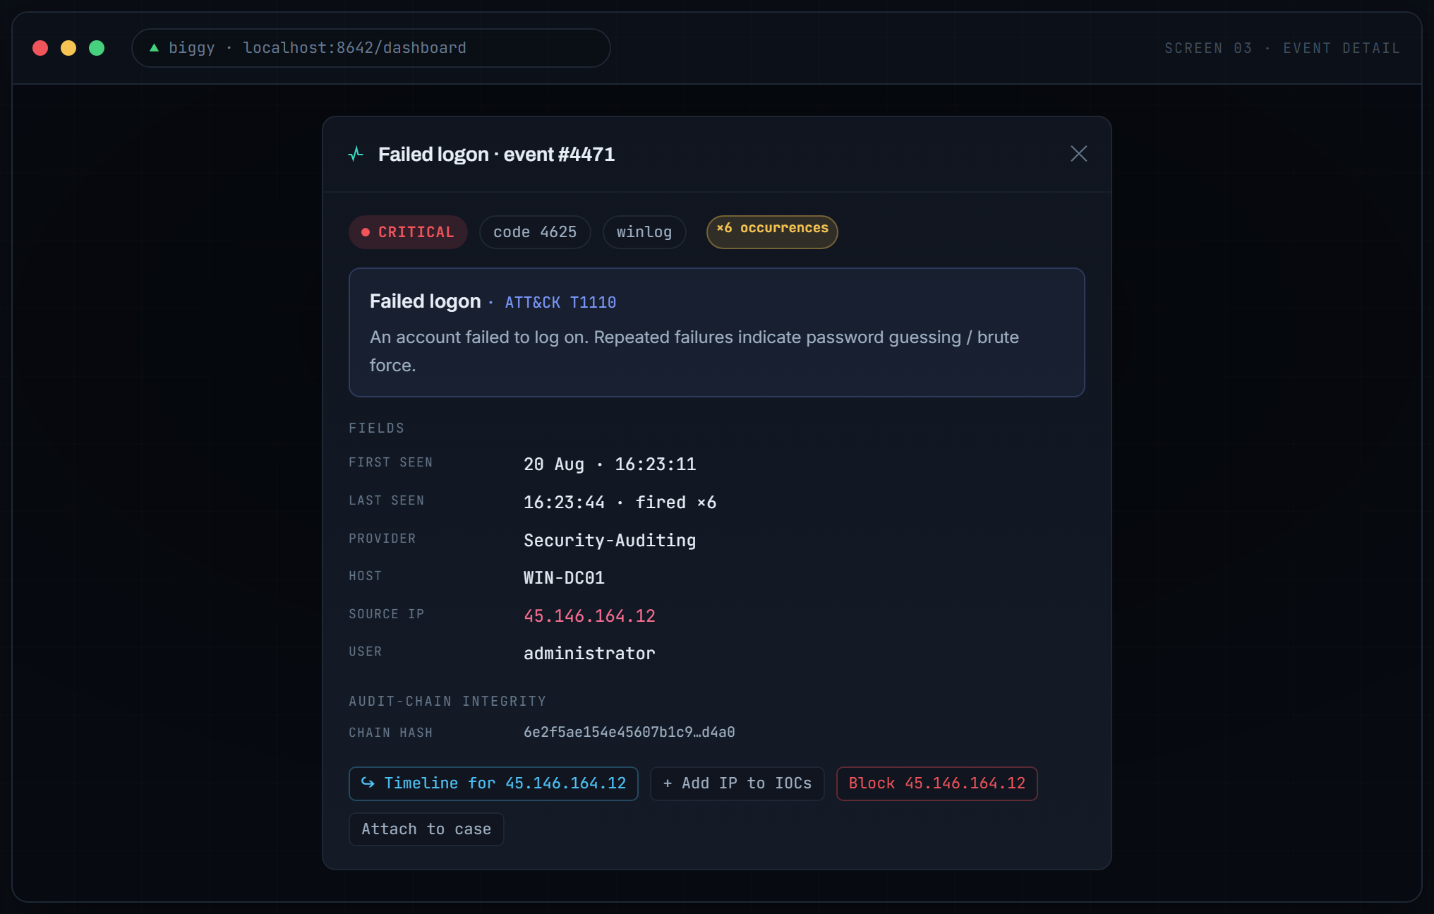
Screen 03. Click-through detail for a coalesced brute-force event: decoded meaning with its ATT&CK technique, every field, the audit-chain hash, and one-click pivots.
09 DETECTION & RESPONSE
Rules that watch, actions that bite
Detection is data, not code. Rules live in the database, so an operator adds a detection without touching the source. Four match types cover most needs: contains, equals, regex, and threshold (N events from one entity inside a window, which is how brute-force and port-scan bursts are caught). Every rule carries a MITRE ATT&CK technique and an action: alert, block (add the source IP to the IPS blocklist), or quarantine.

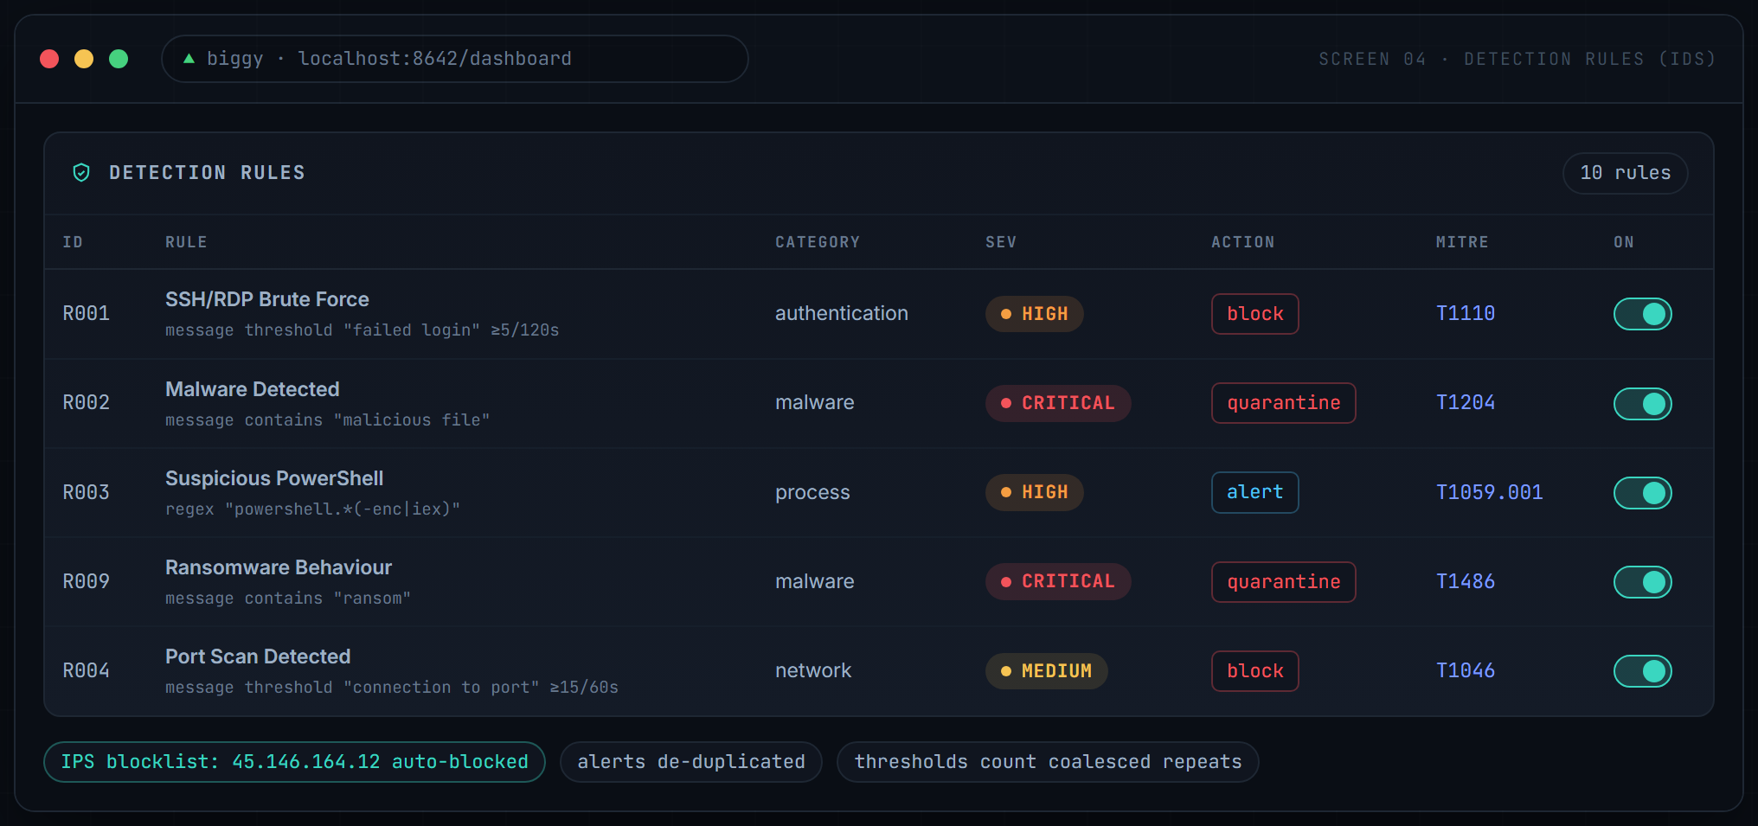
Screen 04. The IDS ruleset. Toggle a rule live, or deploy your own. When a block rule fires, the offending IP lands on the Active-Response blocklist automatically.
WORKED EXAMPLE: BRUTE FORCE TO AUTO-BLOCK
Six failed logons from 45.146.164.12 land within two minutes. Rule R001's threshold trips on the summed count, one alert is raised (the other five are de-duplicated), and the IP is written to the blocklist, all in-line, before an analyst has touched anything.

10 MALWARE SCANNER
A malware engine of its own
Biggy does not outsource its verdicts. The Biggy Engine reaches a decision locally by combining four techniques into a weighted risk score: MD5, SHA-1 and SHA-256 hash signatures (including the EICAR test file), dangerous-extension and double-extension naming heuristics, YARA-style content rules (encoded PowerShell, reverse shells, macro auto-exec, ransom notes, embedded executables), and Shannon entropy to flag packed or encrypted payloads. A background watcher scans a folder (your Downloads by default) and on-demand scans accept drag-and-drop. VirusTotal enrichment layers on top when a key is present.

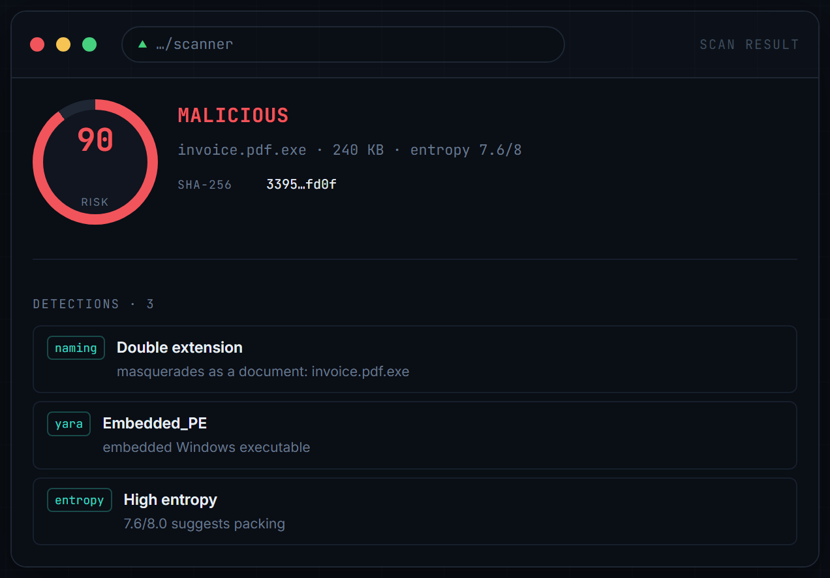
Screen 05. A local verdict on invoice.pdf.exe: risk 90 of 100, three detections (double extension, embedded PE, high entropy), reached without the cloud.
Why build the engine, not just call VirusTotal? Because a SIEM cannot depend on the cloud to reach a verdict: it must work offline, on files it cannot upload, and at a rate no public API allows. The local engine gives an instant first opinion; VirusTotal deepens it when available.
11 THREAT INTELLIGENCE
The world's opinion, on demand
Biggy integrates VirusTotal (API v3) to check any file hash, IP address, domain or URL against more than 90 engines. Results are cached to respect rate limits, and verdicts are tuned for real-world noise: a hard malicious verdict requires multiple detections, while one or two stray vendor flags surface as suspicious, so a popular domain with a single false positive does not cry wolf. Intel is wired throughout: tick a box to enrich a file scan, or hit the intel button on any remote IP in the connections table.

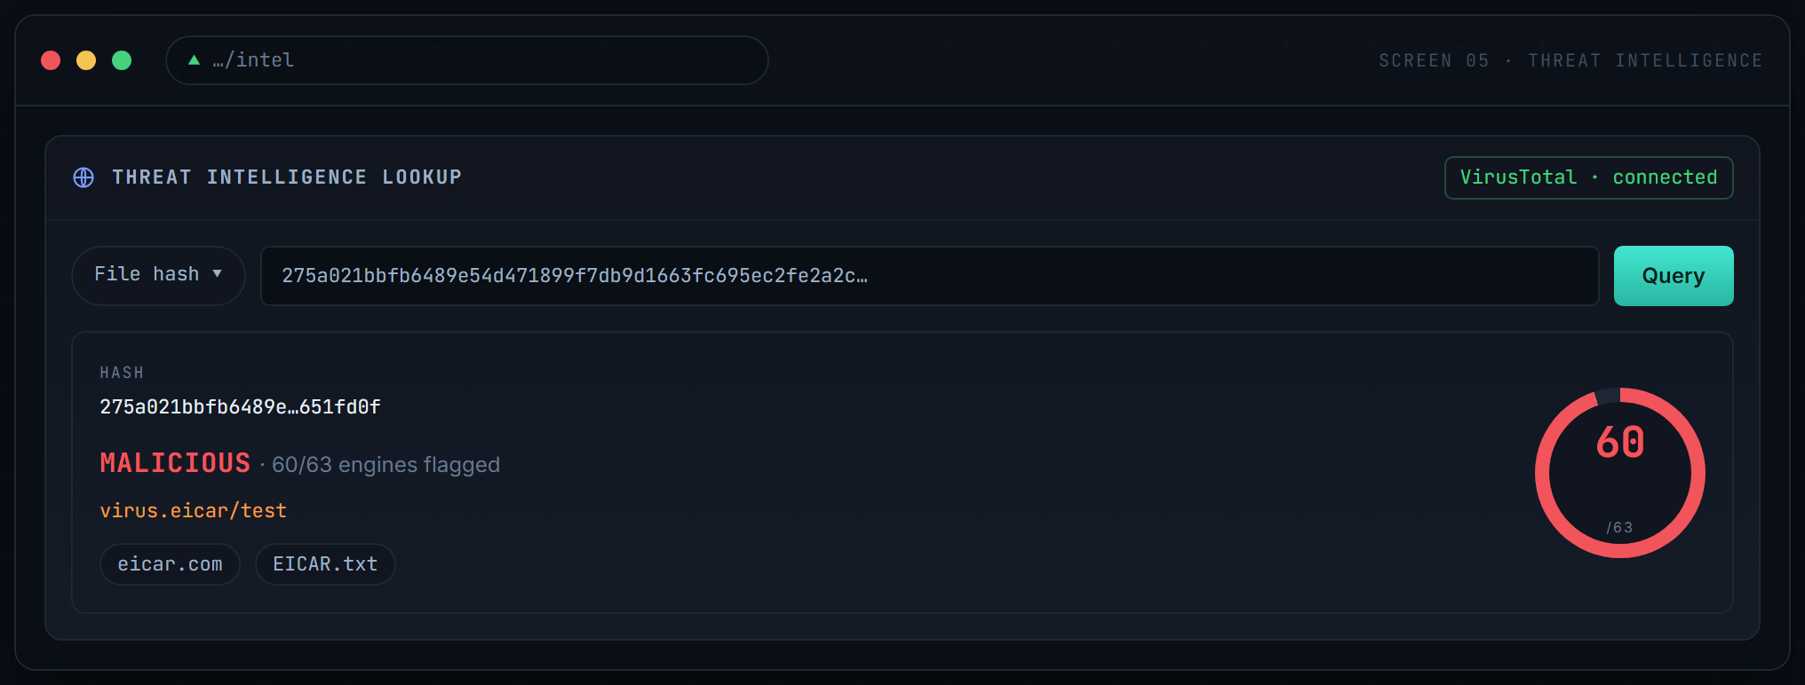
Screen 06. A live VirusTotal lookup on the EICAR test hash: 60 of 63 engines, threat label virus.eicar/test, and one click to add the indicator to the blocklist.
12 NETWORK TELEMETRY
See the wire, map the room
The Network view answers a simple question: what is on my network, and what is it doing? It discovers devices with an ARP and ping sweep, monitors them up and down, and port-scans any target with real nmap (falling back to a built-in threaded scanner when nmap is absent), flagging risky exposed services. Alongside the asset map, a live telemetry strip shows real-time throughput and packet counts, an interface inventory that names the actual hardware, link quality, and a live socket table.

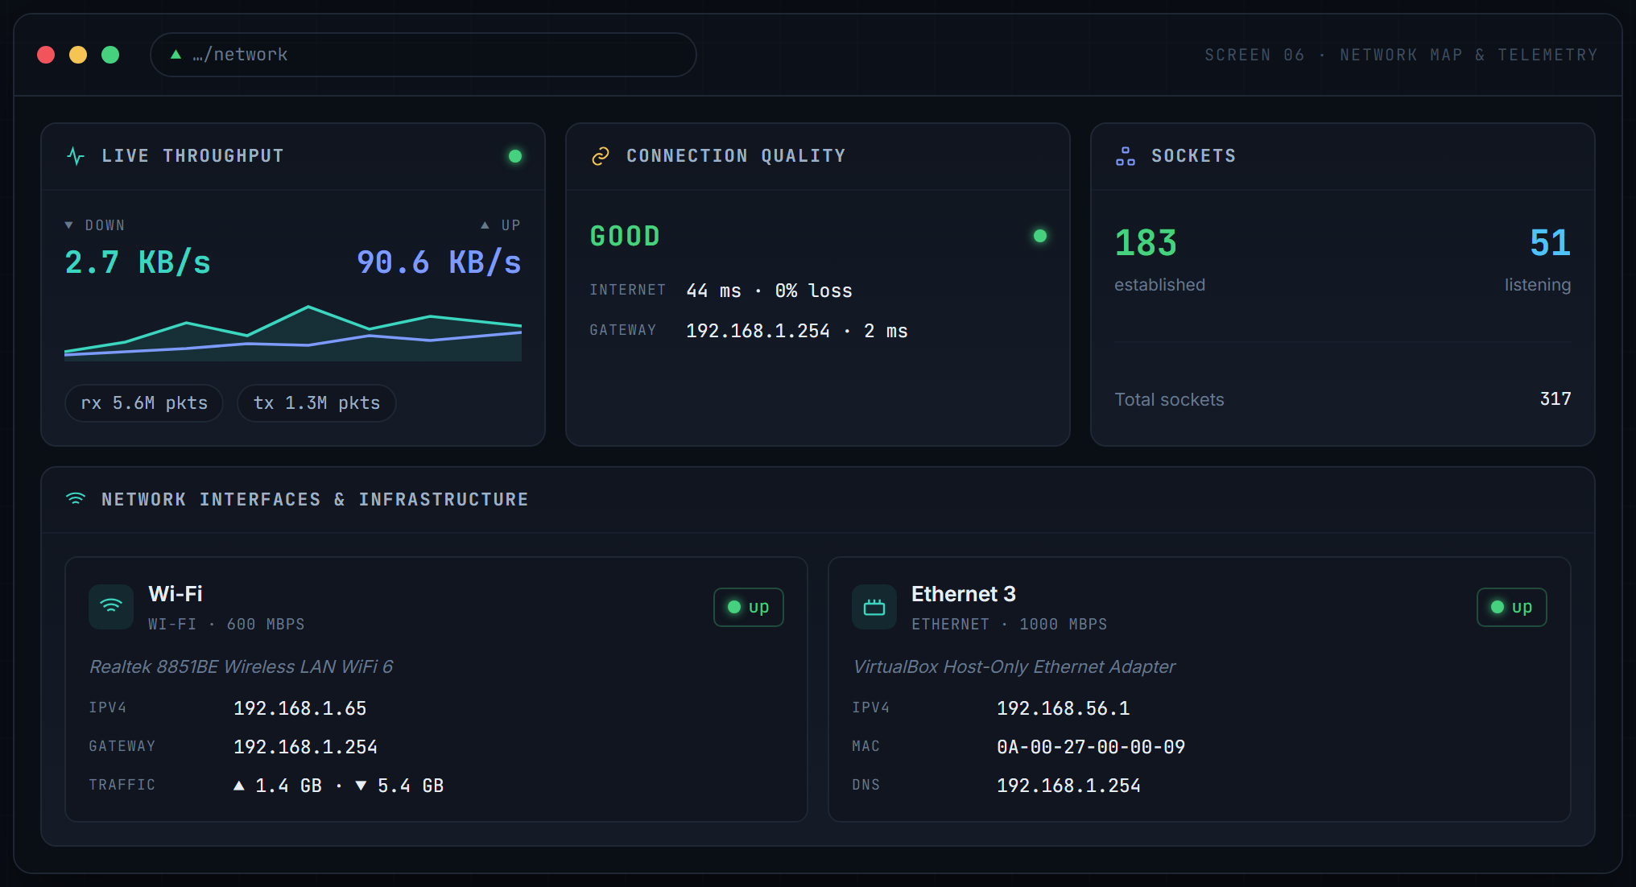
Screen 07. Live network telemetry: real throughput with a dual sparkline, packet counters, connection grade, socket census, and an interface inventory naming the actual adapters with their speeds, addresses and gateway.
13 ENDPOINT EVENT LOG
The OS log, decoded and de-spammed
Biggy pulls real entries from the Windows Event Viewer via Get-WinEvent and presents them as clean one-liners. Each coded event shows a decode icon: hover it and a tooltip explains what the code means, its likely cause, and its ATT&CK technique, drawn from a curated knowledge base of about 70 codes. Anything uncurated still shows its real message. And because coalescing runs here too, the classic flood of identical PowerShell errors collapses to a single counted line.

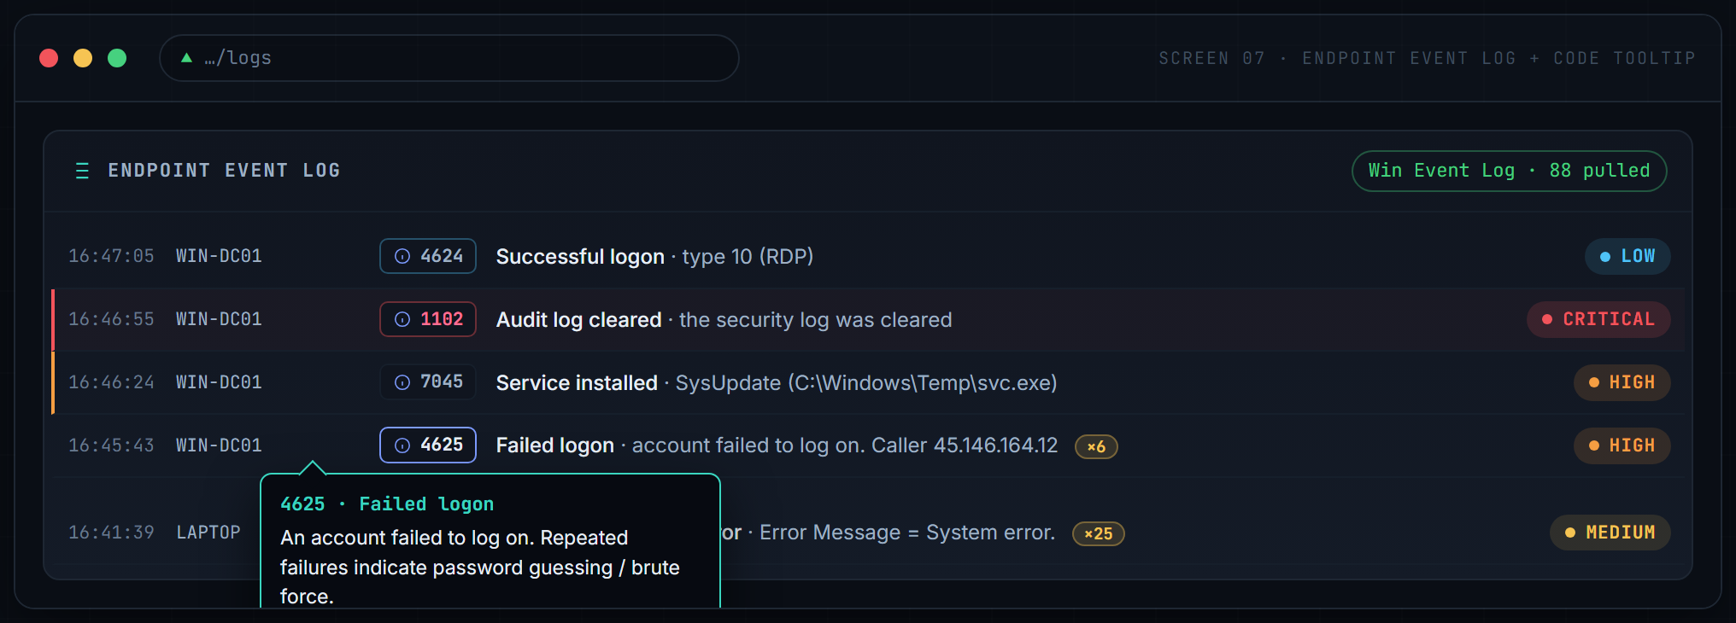
Screen 08. The endpoint log with a decode tooltip open on event 4625. Note the critical 1102 audit-log-cleared entry and the coalesced 4100 flood reduced to one counted line.

14 AGENTS & MULTI-OS REACH
One agent, every operating system
Visibility beyond the server comes from a single, dependency-light host agent: one Python script that needs only psutil. It enrols with the manager, then heartbeats every 30 seconds with CPU, memory, disk, uptime, process and connection counts, network I/O, and locally-observed detections (a suspicious process, an Office app spawning a shell, a new listening port). On Windows it also forwards Event Log entries. The exact same script runs on Windows, Linux and macOS; OS-specific collection is feature-detected and simply skipped where it does not apply.

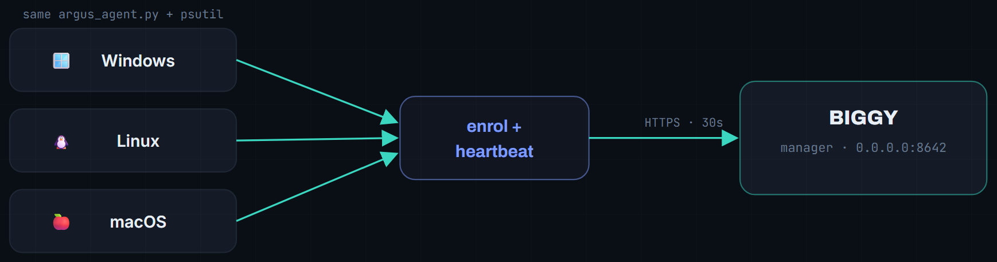
Fig. 14.1. The manager binds all interfaces; the identical agent enrols from any OS on the network. Windows adds Event Log forwarding; every platform reports metrics.

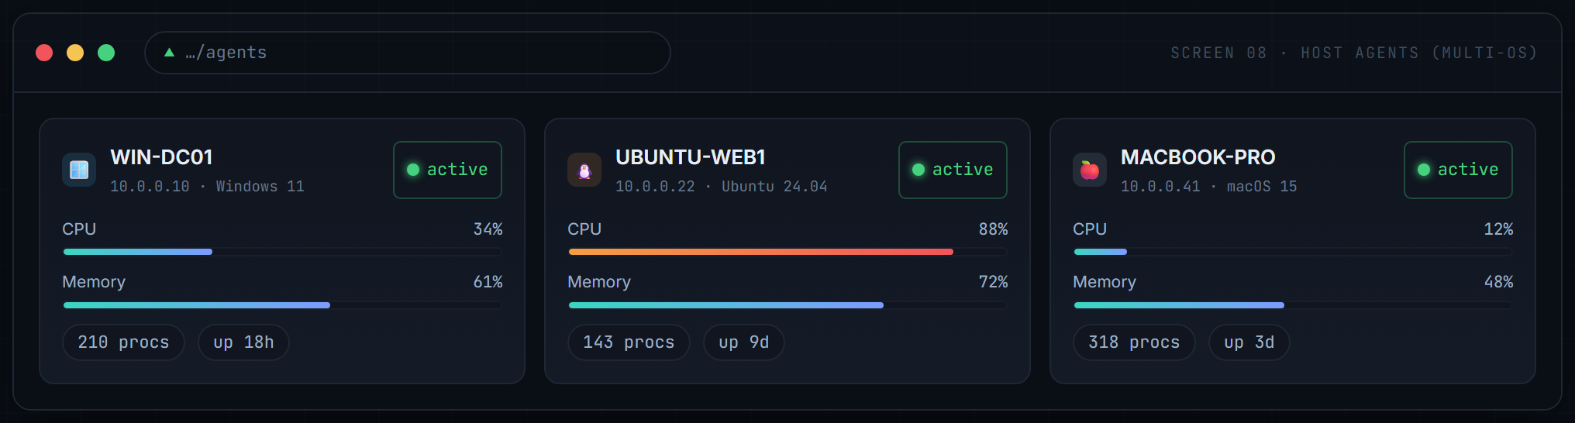
Screen 09. Three operating systems reporting to one console. The manager serves the agent script at /agent.py, so onboarding a device is three commands.
Onboarding any device on the network is three commands:
# on any device on the network (Windows, Linux or macOS)
pip install psutil
curl http://<manager-ip>:8642/agent.py -o argus_agent.py
python argus_agent.py --server http://<manager-ip>:8642 --key <agent-key>

15 FORENSICS & INTEGRITY
Evidence you can defend
This is where Biggy goes past most learning SIEMs. Attackers clear logs, and that is precisely why the platform's own record must be provable. Biggy links every event into a tamper-evident hash chain: each entry commits to the one before it, so a single altered or deleted event breaks every link after it, and the break points to exactly where.

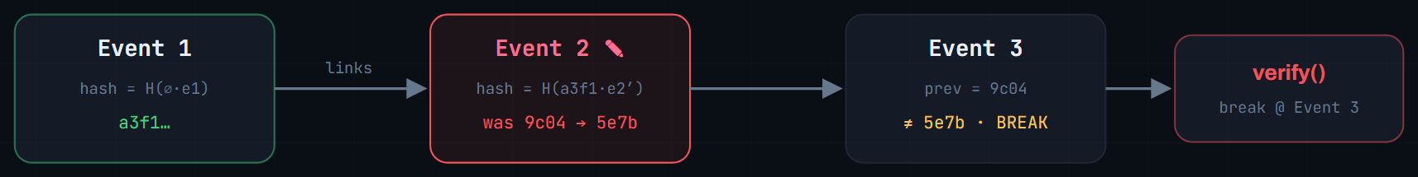
Fig. 15.1. Editing Event 2 changes its hash, so Event 3's stored previous link no longer matches; verification fails and names Event 3 as the break.
Around that spine sits a full investigation toolkit: evidence backups, case management, an IOC watchlist, host triage, an entity timeline, and one-click chain verification.
Capability | What it does
Evidence backups | Rotating, compressed .jsonl.gz log backups with a SHA-256 manifest and the chain head embedded; small files, verifiable any time.
Case management | Investigations with attached events, alerts, IOCs and notes, a time-stamped chain of custody, exportable as one hashed evidence bundle.
IOC watchlist | Indicators that auto-match every incoming event, raising an alert and auto-blocking hostile IPs.
Host triage | One-click volatile capture (processes, connections, autoruns, ARP and DNS) saved as a hashed artifact.
Entity timeline | Pivot on any IP, host or user to reconstruct everything that touched it, in order.
Chain verification | One click walks the entire chain and reports verified, or names the exact tampered event.

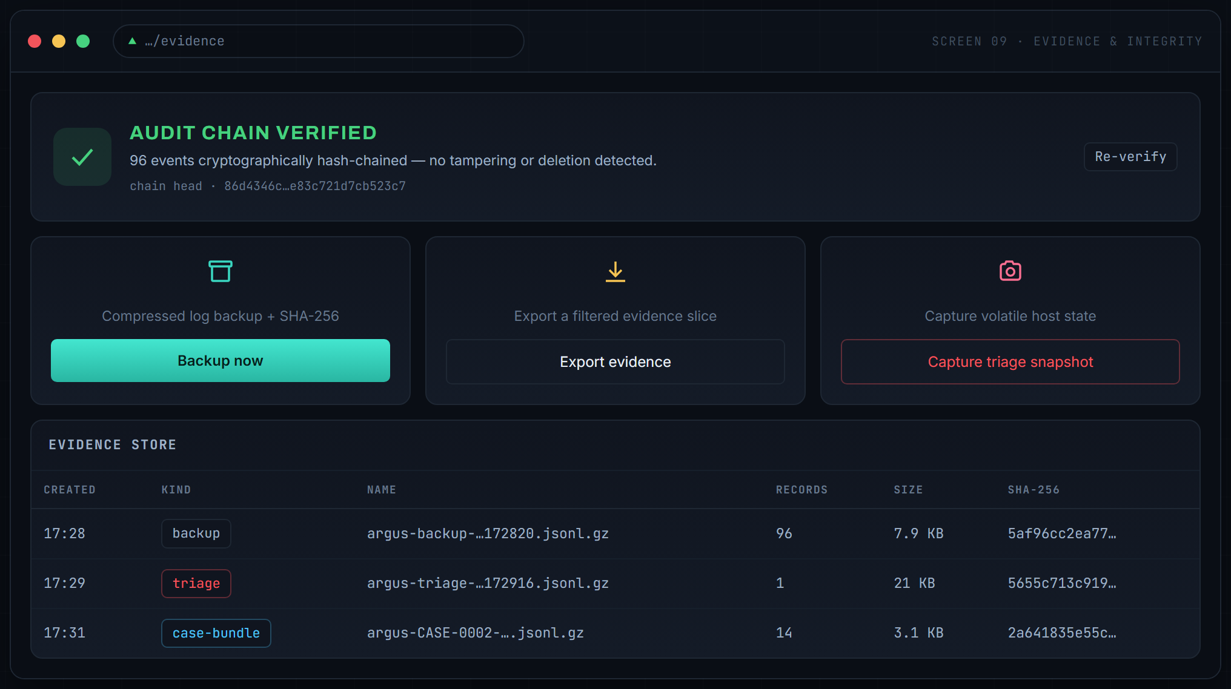
Screen 10. The Evidence view. The green banner is the platform vouching for its own record; below it, one-click backup, export and triage, and a re-verifiable evidence store.
An investigation, end to end
# | Step | Where in Biggy
1 | Brute-force alert fires; source IP auto-blocked. | Alerts, Active Response
2 | Open a case; attach the alert and the offending event. | Cases
3 | Add the IP to the watchlist so future hits self-flag. | IOC Watchlist
4 | Pivot the timeline on the IP to see every touch, in order. | Timeline
5 | Capture a triage snapshot of the affected host. | Evidence, Triage
6 | Export the case as a hashed evidence bundle for handover. | Cases, Export

16 TECHNOLOGY STACK
Small, sharp, boring on purpose
Every dependency earns its place; the stack is deliberately unexotic so the interesting parts are the security mechanics, not the plumbing.
Layer | Choice | Why
Web service | FastAPI and Uvicorn | Async, typed, WebSocket-native; sync reads run in the thread pool so the event loop never stalls.
Storage | SQLite (WAL) | One file, zero setup; a single serialised connection removes lock contention entirely.
Console | Vanilla JS and CSS | No framework, no build step; a hand-built design system keeps it fast and distinctive.
Agent and host | psutil | Cross-platform metrics and process or connection enumeration from one API.
Scanning | hashlib and nmap | Standard-library crypto for the engine; real nmap when present, threaded fallback when not.
Intel | httpx to VirusTotal v3 | Async cloud reputation, cached to respect the public rate limit.
Auth and integrity | hashlib (stdlib) | PBKDF2 passwords, signed session tokens, SHA-256 audit chain, no crypto dependencies.

Runtime footprint: Python 3.12, five pip packages, one database file. No Docker, no cluster, no external services required to run.
17 PERFORMANCE ENGINEERING
The case of the five-second stall
An honest report includes the hard bug. Early on, the console would freeze for 5 to 17 seconds at random. The instinct was to blame the database, but the culprit was the background malware watcher. Scanning a Downloads folder that held an 11 GB spread of files, it was reading each entire file into memory before inspecting it (a 3.4 GB read for one installer), then running a pure-Python entropy loop and eleven regexes over 25 MB per file, all while holding Python's Global Interpreter Lock, which starved every incoming web request.
Endpoint | Before | After
/api/devices | 17.8 s | 0.14 s
/api/logs | 8.3 s | 0.15 s
/api/net/quality | 6.7 s | 0.15 s

The fixes were structural: read only a file's first few megabytes, sample entropy from 64 KB, yield the lock between files; serve read endpoints from the thread pool so a slow query cannot freeze the loop; drive network telemetry from a background sampler so no request ever blocks on a sleep or a ping; and serialise all database access through one connection. The result: every endpoint under 0.42 s, worst case, even while scanning 11 GB.
THE LESSON
The database is the usual suspect and was innocent. In a threaded Python service, a CPU-bound background task holding the interpreter lock will masquerade as slow I/O everywhere else. Profile the whole process, not just the query.

18 DEPLOYMENT
Running in a minute
# step 1: set up
cd biggy && python -m venv .venv && .venv\Scripts\activate
pip install -r requirements.txt
# step 2: run
python run.py
# step 3: open
http://localhost:8642 (sign in: admin / first-run password)

Two optional switches unlock the cloud and the network:
- VirusTotal. Drop a free API key into .env and hash, IP, domain and URL reputation goes live across the console.
- Multi-device. The manager binds all interfaces, so any machine on the network can fetch /agent.py and enrol. Allow inbound TCP 8642 through the host firewall and you have a fleet.
SCOPE & SAFETY
Biggy is a lab and learning platform. Before exposing it beyond localhost: change the signing secret and agent key, set a strong password, serve behind TLS, and only scan networks and files you are authorised to test.

19 ROADMAP
Where it goes next
- File Integrity Monitoring. Baseline critical files and directories; alert on any change.
- Printable incident reports. Generate a PDF per case: timeline, IOCs, evidence hashes.
- ATT&CK coverage matrix. Map every detection to the ATT&CK grid and visualise gaps.
- GeoIP and enrichment. Locate remote IPs on the network map; enrich connections with ASN and geography.
In closing
Biggy set out to prove that the whole SIEM loop (detect, respond, investigate, and prove) fits in one legible application. It runs on a laptop, reads like a textbook, and does the real work: it catches the brute force, blocks the IP, scans the file, maps the network, watches every OS, and can stand behind its own evidence. That was the brief, and it is met.
20 REFERENCES & METHOD
How this report was built
Structure and framing were grounded in current guidance on technical documentation (introduction, architecture, data flow, deployment, diagram-supported) and on how the leading SIEM platforms present themselves (a central manager with endpoint agents, a real-time dashboard, and an indexed store). The visuals are faithful recreations of the actual Biggy console in its own design system; the multi-OS agent panel is a representative mock-up, as the reference deployment currently runs a single host.
- AltexSoft. Technical Documentation in Software Development: Types and Best Practices.
- Helpjuice. Software Documentation Guide.
- Wazuh. Open Source XDR and SIEM: Platform Overview (wazuh.com/platform/overview).
- ObjectFirst. Wazuh SIEM: Features, Architecture and Hands-On.
- PeerSpot. Splunk Enterprise Security vs Wazuh comparison.

BIGGY SIEM, Project Dossier v1.0. An open-source, single-node SIEM / XDR platform.

