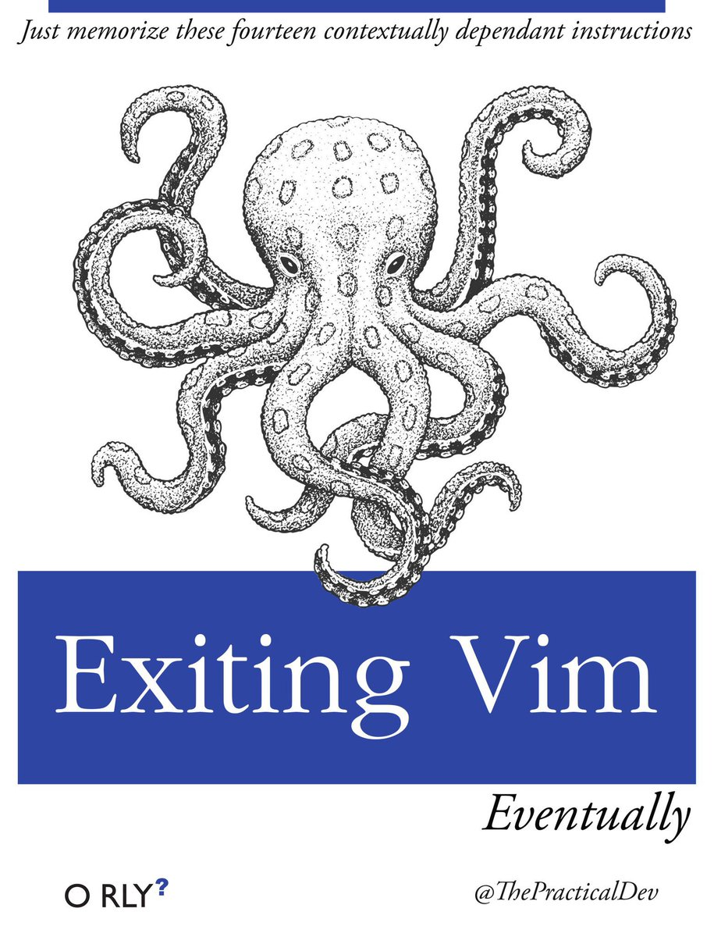
Vim
Table of Contents
Vim 1
split 1
open files 1
buffers vs tabs 1
tabs 1
Buffers 1
folding 1
:settings 2
insert 2
comment a block of code 3

split
:vsp ~/.vimrc | vertical
:sp | horizontal
this command also accepts a filename
:10sp ~/.vimrc | split height
:q | close split
ctrl + w = | equal split size
ctrl+W R | swap splits

open files
:e. | open explorer
:e[space][ctrl+d] | list files in Dir
:find **/worke<tab> | find file
:Sexplore :Vexplore | alternative explorer
:NERDTreeFind | NerdTree

buffers vs tabs
a buffer is the in-memory text of a file
a window is a viewport on a buffer
a tab is a collection of windows

tabs
tabs were only designed to have different layouts of windows, an open file is just loaded into a buffer
it’s wasteful to force a single tab to point to a single buffer
$ vim -p file1 file2 file 3
open vim with some tabs
set showtabline=2 | always show tabs
:tabs | see open tabs
:tabe <filepath> | open new tab
:tabnew <path> | open new tab
:tabn/:tabp gt/gT | next/previous tab
{i}gt | go to tab in position i
:tabm i | move tab to pos i

Buffers
:ls :files :buffers |  |  |  | list buffers
% | current | h | hidden
a | active | # | alternate
+ | changes`

%bd | delete all buffers
bd# | delete buffer #
e# | open last buffer

folding
:set foldmethod=indent |  |  |  | auto folding
zj zk | prev/next fold |  | zE | delete all folds
zo | open fold |  | zc | close fold
zO | open all folds |  | zM | close all folds
:mkview |  | save folds

:settings
:set number | lines number
:set wrap | :set nowrap
:syntax on | :colorscheme monokai
:set tabstop=2 | :set shiftwidth=2
:set breakindent | :set autoindent
:set expandtab

insert
Esc 10 i $ Esc | $$$$$$$$$$

ESC:q! |  | BLOODY QUIT
i | insert mode |  |  |  | ESC |  | normal mode
:w | write (save) |  |  |  | :wq |  | save and exit
:h | HALP
:w !sudo tee % |  |  |  |  | write with sudo
basic EDIT
d | delete |  |  |  | y |  | copy
dd | delete line |  |  |  | yy |  | copy line
 |  |  |  |  | Y |  | copy line
x | delete char |  |  |  | p |  | paste (also the last deletion)
dw | delete word
u | undo |  |  |  | U |  | undo line
 |  |  |  |  | CTRL+R |  |  |  | redo
Advanced EDIT
d$ | delete till EOL
daw | delete the word under the cursor |  |  |  |  | caw |  | and put you in insert mode
programming EDIT
>> | indent line |  |  |  | << |  | de-indent
3>> | indent 3 lines |  |  |  | 2<< |  | de-indent 2 lines
NAVIGATE
0 | begin of line |  |  |  | $ |  | end of line
I | insert in bol |  |  |  | A |  | insert in eol
w | →word |  |  |  | b |  | ←word
ctrl+ F |  |  | next page |  | xxG |  | go to line xx
ctrl+ B |  |  | prev page |  | gg |  | go to first line
 |  |  |  |  | G |  | go to last line
SELECT
v |  |  | star select |  | gv |  | reselect
 |  |  |  |  | v10j |  | select 10rows
ctrl+ v |  |  | column |  | V |  | entire line
vib |  |  | inside [] |  | viB |  | inside {}
vab |  |  | inclusive
FIND
/string |  |  |  | search | n |  | next match
:s/match /replace |  |  |  |  |  |  | :center
!sort

comment a block of code
1. go to first line of the block
2. CTRL+V and select lines with down arrow
3. SHIFT+I and #
4. ESC
1. put the cursor on the first #  2. CTRL+V and select lines  3. x | uncomment

