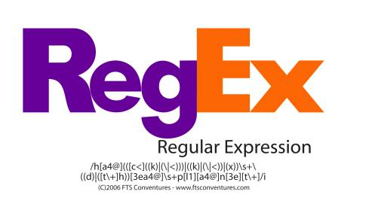

List

abc… | Letters
123… | Digits
\b | Word Boundaries
\d | Any Digit
\D | Any Non-digit character
\s | Any Whitespace
\S | Any Non-whitespace character
\w | Any Alphanumeric character
\W | Any Non-alphanumeric character
. | Any Character
\. | Period
[abc] | Only a, b, or c
[^abc] | Not a, b, nor c
[a-z] | Characters a to z
[a-zA-Z] | LETTERS
[0-9] | Numbers 0 to 9
{m} | m Repetitions
{m,n} | m to n Repetitions
* | Zero or more repetitions
+ | One or more repetitions
? | Optional character
(…) | Capture Group
(a(bc)) | Capture Sub-group
(.*) | Capture all
(abc|def) | Matches abc or def
\A \z | Start and end of the string
^…$ | Start and end of the line
(those last two don't work on online regex things because you past the whole thing instead of using single strings)

Classes
An expression of the form [[:name:]] matches the named character class "name",
[[:lower:]] matches any lower case character.
alnum | Any alpha-numeric character.
alpha | Any alphabetic character.
blank | Any whitespace character that is not a line separator.
cntrl | Any control character.
d | Any decimal digit
digit | Any decimal digit.
graph | Any graphical character.
l | Any lower case character.
lower | Any lower case character.
print | Any printable character.
punct | Any punctuation character.
s | Any whitespace character.
space | Any whitespace character.
unicode | Any extended character whose code point is above 255 in value.
u | Any upper case character.
upper | Any upper case character.
w | Any word character (alphanumeric characters plus the underscore).
word | Any word character (alphanumeric characters plus the underscore).
xdigit | Any hexadecimal digit character.

Each of these predefined character classes also has a negated form.
You can match any character that is not a digit by doing this: /\D/

/.ejected/
matches "dejected","rejected", "%ejected" and "8ejected"

/[^A-Fa-f0-9]/ matches any character except a valid hexadecimal digit
/[dr]ejected/ matches either d or r, followed by ejected" matches either "dejected" or "rejected" but not "&ejected"
you can also insert a range:
lowercase letters: /[a-z]/

/[A-Fa-f0-9]/ matches any character
a through f (upper- or lowercase) or any digit.
(space, tab, newline).
\i makes the regex match case insensitive.

Ruby

.gsub
string.gsub(/\s+/, "") removes whites

.scan
stringona = "The car costs $1000 and the cat costs $10"
stringona.scan(/\d+/) do |x|
puts x
end => 1000 => 10

(groups)
x = "This is an".match(/(\w+) (\w+)/)
puts “#{x[0]}, #{x[1]}, #{x[2]}”
=> This is an, This, is
match returns a MatchData object that can be accessed like an array.
The first element (x[0]) contains the data matched by the entire regex | each successive element contains what’s matched by each match group of the regex

