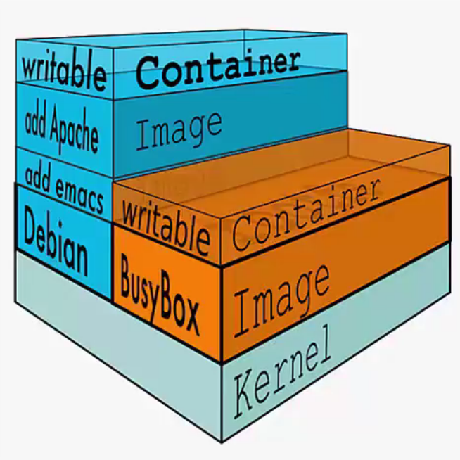

commands

run
$ docker run [options] [image] [commands] [args]
$ docker run ubuntu ps ax
$ docker run ubuntu:14.04 echo “Hello World”
$ docker run -i -t ubuntu:latest /bin/bash
-i | connect to STDIN | -t | get a pseudo terminal | /bin/bash | a terminal process

list images
$ docker images

list containers
$ docker ps | -a lists also the stopped ones

stop containers
$ docker stop CONTAINER_ID

detached mode
$ docker run -d cents:7 ping

logs
$ docker logs CONTAINER_ID

inspect
$ docker inspect CONTAINER_ID

host address
127.0.0.1

