 GLOSSARY v1.5
Table of Contents
The Three States 2
workflow 2
INIT 3
--bare 3
CLONE 3
ADD 3
interactive add 3
COMMIT 4
git commit -m (-m) 4
git commit -a 4
git commit --amend 4
committiquette 4
tag 5
status 5
diff 5
log 5
git reflog 6
push 6
remote 7
rename 7
delete (rm) 7
add 7
fetch 7
Github 7
BitBucket 7
pull 7
branching 8
git checkout 8
compare 8
branch 8
merge 8
delete 8
rename 8
merge -s ours 8
HEAD 8
restore 10
1. checkout 10
2. reset 10
3. Revert 10
clean 10
rebase 11
undo commit 11
reset 11
renaming files 11
Removing Files 12
.gitignore 12
Patches 12
applying patches 12
Export the Repository 13
Archive 13
Bundle 13
stashes 13
Plumbing 13
Garbage 13
Submodule 13
config 14
colors 14
alias 14
see existing aliases 14
editor 14
Heroku 14
Github Pages 14
SublimeGit 15
initialize the git repository, 15
The Status View 15
Adding Files 15

REMOTE | clone/pull→ | LOCAL | → | STAGING | → | WORKING COPY
REMOTE |  | LOCAL |  | STAGING | checkout → | WORKING COPY
REMOTE | ← push | LOCAL | ← commit | STAGING | ← add | WORKING COPY
 |  | local

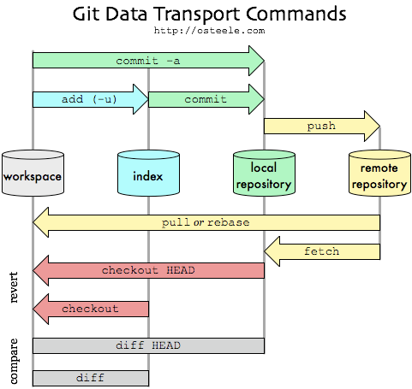

The Three States
Committed means that the data is safely stored in your local database.
Modified means that you have changed the file but have not committed it to your database yet.
Staged means that you have marked a modified file in its current version to go into your next commit snapshot.

workflow
Developing a project revolves around the basic edit/stage/commit pattern.
1. you edit your files in the working directory | 2. when you’re ready to save a copy of the current state of the project, you stage changes  with git add | 3. after you’re happy with the staged snapshot, you commit it to the project history with git commit

INIT
to create a new Git repository in that directory
$ git init
to create it in a specified directory
$ git init project_culo

--bare
$ git init --bare project_culo
The --bare flag creates a repository that doesn’t have a working directory, making it impossible to edit files and commit changes in that repository.
Shared repositories should always be created as bare repositories because pushing branches to a non-bare repository has the potential to overwrite changes.
Think of --bare as a way to mark a repository as a storage facility, opposed to a development environment. This means that for virtually all Git workflows, the central repository is bare, and developers local repositories are non-bare.

CLONE
copies an existing Git repository.
$ git clone <repo> <directory>

ADD
The Staging Area is a buffer between the working directory and the project history.
The staging area is important (versus just committing in one step) because you often want to only add specific files at a time to a given commit.
The git add command adds a change in the working directory →to the → staging area.
It tells Git that you want to include updates to a particular file in the next commit.
However, git add doesn't really affect the repository in any significant way. | Changes are not actually recorded until you commit.
git add file.blah | git add '*.txt'
git add project_culo (directory)
git add file-name-1 file-name-2
to add all the project files to the repository :
$ git add -A

interactive add
$ git add -i
Then you first select the command and after it, the files you want to add

COMMIT
if you have to use the word "and" in your commit message to describe multiple sets of changes, you probably waited too long

any files you have created or modified that you haven’t run git add on since you edited them – won’t go into this commit.
$ git commit
Doing so launches your editor of choice. (This is set by your shell’s $EDITOR )

git commit -m (-m)
to type your commit message inline with the commit command
$ git commit -m "Story 182: Fix benchmarks for speed"
$ git commit -m "title" -m "body"

git commit -a
-a flag is a shortcut for the (very common) case of committing all modifications to existing files (or files created using git mv, which don’t count as new files to Git)
Be careful about using the -a flag improperly; if you have added any new files to the project since the last commit, you still have to tell Git about them using git add -A first.

git commit --amend
to rename the commit

committiquette
1) Separate subject from body with a blank line |  | 2) Limit the subject line to 50 characters
3) Capitalize the subject line | 4) Do not end the subject line with a period
5) Use the imperative mood in the subject line |  | 6) Wrap the body at 72 characters
7) Use the body to explain what and why vs. how

tag
Tags are convenient references to official releases and other significant milestones
$ git tag -a v1.0 -m "Stable version"
$ git tag -a <tag-name> -m "<description>"
the -a flag tells Git to create an annotated tag
$ git tag -n | to see the list with messages

status
It simply shows you what's been going on with git add and git commit.
$ git status -s
?? New files that aren’t tracked
A new files that have been added to the staging area
M modified files

diff
to see what is different from our last commit, the details of the git status command - how files have been modified or staged on a line by line basis.
$ git diff
--staged | changes you just staged
--cached | changes between the staged snapshot and the most recent commit
--stat | short form
$ git diff HEAD~2..HEAD~1
will output the diff between the last two com
can also see diff between branches:
$ git diff branch-2 master file.rb

log
displays committed snapshots. It lets you list the project history, filter it, and search for specific changes.
If you get trapped with (END), quit with q

git status inspects  the working directory and the staging area | git log only  operates on the committed history
$ git log --oneline blue.html
$ git log master..mary/master --stat
git log -3  last 3 commits | git log --stat  includes which files were altered and the relative number of lines that were added or deleted from each of them.
git log -p
shows the full diff of each commit, which is the most detailed view you can have of your project history
git log --oneline single line, compact | git log <file>  Only display commits that include the specified file
git show --name-only
git log --author="<pattern>"
Search for commits by a particular author. <pattern> can be a plain string or a regular expression.
git log --grep="<pattern>"
Search for commits with a commit message that matches <pattern>, which can be a plain string or a regular expression.
git log <since>..<until>
Show only commits that occur between <since> and <until>. Both arguments can be either a commit ID, a branch name, HEAD, or any other kind of revision reference.
git log --graph --decorate
--graph will draw a text based graph of the commits on the left hand side of the commit messages.
--decorate adds the names of branches or tags of the commits that are shown.
$ git log --branches --remotes --tags --graph --oneline --decorate --all HEAD

git reflog
Displays the local, chronological history of a repository.

push
The name of the remote is origin and the default local branch name is master.
$ git push -u origin master

$ git push -u origin –-all

The -u tells Git to remember the parameters, so that next time we can simply run
$ git push

remote
Remote repositories are versions of your project that are hosted on the Internet or network somewhere. | You can have several of them, each of which generally is either read-only or read/write for you.
$ git remote -v
-v (verbose) shows you the URLs that Git has stored for the shortname to be used when reading and writing to that remote:

rename
$ git remote rename oldname newname

delete (rm)
$ git remote rm paul

add
the git remote add takes two arguments:
-A remote name, for example, origin
-A remote URL, for example,
https://github.com/user/repo.git

For example:
git remote add origin https://github.com/user/repo.git

git remote add classic git@github.com:Salomanuel/caliscoso.git

fetch
$ git fetch [remote-name]

Github
create a repository for the project and on the command line do:
$ remote add origin
git@github.com:Salomanuel/culo.git
$ git push -u origin master

BitBucket
is like GitHub but more focused on private rep
GitHub offers unlimited free repositories (with collaboration) for open-source repositories while charging for private reps | Bitbucket allows unlimited free private repos while charging for more than a certain number of collab.

$ git remote add origin git@bitbucket.org:Salomanuel/hello_app.git
$ git push -u origin --all
# pushes up the repo and its refs for the first time

pull
$ git pull origin master
If you're working with other people or doing work on multiple machines, you'll need to keep your local repo up to date with the remote one sitting on Github.

branching
Once you’ve built up a project history,

git checkout
is an easy way to “load” any of these saved snapshots. It serves three distinct functions,
checking out
files | commits | branches

Checking out a commit makes the entire working directory match that commit. This can be used to view an old state of your project without altering your current state in any way.
Checking out a file lets you see an old version of that particular file, leaving the rest of your working directory untouched.
$ git checkout <branch>
$ git checkout <commit>
$ git checkout a1e8fb5
$ git checkout <commit> <file>
$ git checkout a1e8fb5 hello.py

$ git checkout -b modify-README
does the following for you:
git branch BLBLBL | #create a new branch
git checkout BLBLBL | #then switches to the new BLBLBLbranch

compare
git diff mybranch master -- myfile.cs

branch
$ git branch
all branches | -a | remote branches |  | -r

merge
$ git checkout master
Switched to branch 'master'
$ git merge modify-README
$ git merge origin/master
To see which files have issues merging:
$ git diff --name-only --diff-filter=U

delete
$ git branch -d modify-README
the -D flag will delete the branch even though we haven’t merged in the changes.

rename
If it is your current branch just do
git branch -m new_name
If it is another branch you want to rename.
git branch -m old_name new_name
If your branch was pushed, then after renaming you need to delete it from the remote git and ask your new local to track a new remote branch.
git push origin :old_name

merge -s ours
git checkout updated-branch  git merge -s ours master  git checkout master  git merge updated-branch | to reset master and  replace it
with updated-branch

HEAD
two major purposes, tells Git:
which commit to take files from when you checkout | where to put new commits when you commit
and it tells Git where to put new commits when you commit. When you run git checkout <ref> it points HEAD to the ref you’ve designated and extracts files from it. When you run git commit it creates a new commit object, which becomes a child of current HEAD. Normally HEAD points to one of the heads, so everything works out just fine.

The HEAD reference, is recorded in .git/HEAD
Unlike the branch tips, HEAD is not a direct link to a commit. | HEAD refers to a branch,  which Git uses to figure out which commit is currently checked out.
a detached HEAD state occurrs when HEAD does not coincide with the tip of any branch. Internally, all this means to Git is that .git/HEAD doesn’t contain a local branch.

restore

1. checkout
to temporarily go back to it, fool around, then come back to where you are, it's better to switch to a new branch (This will detach your HEAD)
git checkout 2e17d67
if you want to make commits while you're there
git checkout -b old-state 2e17d67
$ git checkout master -f
to FORCE the checkout (and ignore changes)
git checkout is about
updating the working tree (to the index or the specified tree). It will update the HEAD only if you checkout a branch (if not, you end up with a detached HEAD).

2. Revert
if you've published the work, you probably don't want to reset the branch, since that's effectively rewriting history
that means creating a commit with the reverse patch to cancel it out


instead of removing the commit from the project history, git figures out how to undo the changes introduced by the commit and appends a new commit with the resulting content.
This prevents Git from losing history, which is important for the integrity of your revision history and for reliable collaboration.

clean
git clean -f | removes all untracked files
git clean -fd | also the folders
git clean -n | show which files will be deleted

3. reset
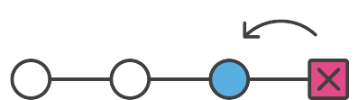
git reset HEAD -- uoo.a
unstage files and reset pointer to HEAD
Since git add checksums a file and adds it to the "index", git reset HEAD overwrites that with what it was before, thereby effectively unstaging it
When you run git reset without specifying a flag it defaults to --mixed. The other options are --soft and --hard
git reset --soft
moves HEAD to specified commit reference, index and staging are untouched
The first thing git reset does is undo the last commit and put the files back onto the stage. If you include the --soft flag this is where it stops.
If you run git reset --soft HEAD~ (the parent of the HEAD) the last commit will be undone and the files touched will be back on the stage again.
git reset --hard
unstage files AND undo any changes in the working directory since last commit
discards your staged changes and the changes in your working directory. | resets your staging area and working directory to the state they were in at the given commit.

Reverting vs. Resetting
git revert undoes a single commit—it does not "revert" all subsequent commits

Reverting has two important advantages over resetting.
1, it doesn’t change the project history, which makes it a “safe” operation for commits that have already been published to a shared repository.
2, git revert is able to target an individual commit at an arbitrary point in the history, whereas git reset can only work backwards from the current commit.
For example, if you wanted to undo an old commit with git reset, you would have to remove all of the commits that occurred after the target commit, remove it, then re-commit all of the subsequent commits.
If git revert is a “safe” way to undo changes, you can think of git reset as the dangerous method.
When you undo with git reset(and the commits are no longer referenced by any ref or the reflog), there is no way to retrieve the original copy—it is a permanent undo

rebase
git rebase <new-base>
Move the current branch’s commits to the tip of <new-base>, which can be either a branch name or a commit ID.
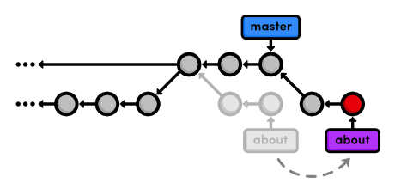
git checkout about  git rebase master  git log --oneline | it requires you to be on the branch that you want to move
After the rebase, about is a linear extension of the master branch, enabling us to do a fast-forward merge later on. Rebasing also allowed us to integrate the most up-to-date version of master without a merge commit.
git rebase -i master
interactive rebase: This should open up a text editor populated with all of the commits
pick 5cf316e Add empty page in about
squash 964e013 Add contents to about
pick 89db9ab Add HTML page for bio
edit 2bda8e5 Add empty HTML page
If you ever find yourself lost in the middle of a rebase and you’re afraid to continue, you can use --abort to abandon it and start over
git rebase --continue |  | to finish

undo commit
git rebase -i master
git reset --mixed HEAD~1

git reset moves the checked out snapshot to a new commit,
HEAD~1 tells it to reset to the commit that occurs immediately before the current HEAD

reset
git reset is specifically about updating the index, moving the HEAD.
git reset --hard
Moves the HEAD backwards, and changes the working directory to match.
changes the working directory to look exactly like the most recent commit, giving the effect of removing uncommitted changes
git reset --mixed
Moves the HEAD backwards, but doesn't change the working directory.
preserves the working directory, which contains the changes we want to separate.
The HEAD moved, but the working directory remained unchanged. This results in a repository with uncommitted modifications
git reset --hard HEAD~1

renaming files
mv oldfolder newfolder | actually does:
git add newfolder
git remove oldfolder

Removing Files

$ git rm PROJECTS.md
$ git rm -r --cached .
Remove ALL tracked files
To remove a file from Git, you have to remove it from your tracked files (more accurately, remove it from your staging area) and then commit. The git rm command does that, and also removes the file from your working directory so you don’t see it as an untracked file the next time around.
If you simply remove the file from your working directory, it shows up under the “Changed but not updated” (that is, unstaged) area of your git status output.

.gitignore
You have to create a file named .gitignore
*.[oa] | any files ending in “.o”/“.a”
*~ | all files ending with a tilde (~)
tmp/ | ignore folder temp
Setting up a .gitignore file before you get going is generally a good idea.
The rules for the patterns you can put in the .gitignore file are as follows:
-patterns starting with / avoid recursivity | -Standard glob patterns work
-patterns ending with / to specify a dir |  | -negate a pattern by starting it with an !
-blank lines or lines starting with # are ignored

$ git add . | All files will be added back in,
except those in .gitignore

Patches
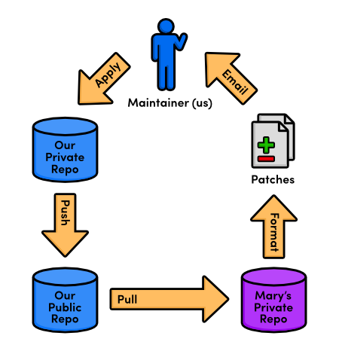
As a programmer, you’re most likely to use patches when you want to fix a bug in someone else’s project. After fixing it, you can send them a patch of the resulting commit. For this kind of one-time-fix, it’s much more convenient for you to generate a patch than to set up a public Git repository.
$ git format-patch <branch-name>
Creates a patch for each commit contained in the current branch but not in <branch-name>. You can also specify a commit ID instead of <branch-name>.
This creates a file called
0001-Change-pink.patch that contains enough information to re-create the commit from the last step.
The master parameter tells Git to generate patches for every commit in the current branch that’s missing from master.

applying patches
$ git am < 0001-Change-pink.patch
The git am command is configured to read from something called “standard input,” and the < character is how we can turn a file’s contents into standard input. As it’s really more of an operating system topic, you can just think of this syntax as a quirk of git am

Export the Repository

Archive
$ git archive master --format=zip --output=../website-12-10-2012.zip
This takes the current master branch and places all of its files into a ZIP archive (or a tarball), omitting the .git directory. Removing the .git directory removes all version control information, and you’re left with a single snapshot of your project.

Bundle
$ git bundle create ../repo.bundle master
in this case, the file retains the .git dir
It’s like we just pushed our master branch to a remote, except it’s contained in a file instead of a remote repository.
We can even clone it using git clone
$ git clone repo.bundle repo-copy -b master

stashes
$ git stash | $ git stash apply
to temporarily remove changes to retrieve them later
patches represent a committed snapshot,
stashes represent a set of uncommitted changes

It takes the uncommitted modifications, stores them internally, then does a
git reset --hard to give us a clean working directory. This also means that stashes can be applied to any branch, not just the one from which it was created.
In addition to temporarily storing uncommitted changes, this makes stashing a simple way to transfer modifications between branches.
So, for example, if you ever found yourself developing on the wrong branch, you could stash all your changes, checkout the correct branch, then run a git stash apply.

Plumbing
$ git cat-file commit HEAD
to see a commit object, with the complete representation: |  | tree | parent
 |  | user data
 |  | commit message
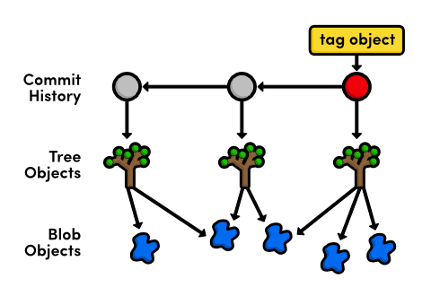
to see a tree | $ git cat-file tree 552acd
(formatted) | $ git ls-tree 552acd
to see a file | $ git cat-file blob c6a1e6
to see a tag | $ git cat-file tag v2.0

Garbage
This compresses individual object files into a faster, smaller pack file and removes dangling commits (from a deleted, unmerged branch).
$ git gc
the garbage collection command, is undo-able. If you want to continue exploring the contents of the .git/objects folder, you should do so before running the following command. Normal Git functionality will not be affected.

Submodule
proprio BOH, guarda

config
~/.gitconfig
$ git config --list
to see the settings
$ git config --global user.name
$ git config user.name <name>
$ git config user.email <email>
$ git config --global core.editor
$ git config --global --edit

colors
$ git config --global color.ui auto

alias
$ git config --global alias.lg
“log --branches --remotes --tags --graph --oneline --decorate --all HEAD”

see existing aliases
$ git config --get-regexp alias

editor
$ git config --global core.editor "
subl -n -w" | vim"
Now running $ git commit in Terminal will launch Sublime Text 3 app (subl) in a new window (-n), and the command line will wait (-w) until the commit message is saved.

Heroku
for deploying rails apps
$ heroku version
$ heroku create
$ git push heroku master
$ heroku run rake db:migrate
$ heroku open
$ heroku rename rails-t-hello-manuel
$ heroku logs
if the remote is not created automatically:
$ git remote add heroku git@heroku.com:application-name.git

Github Pages
(you have first to verify your email address)
and you need to make and push a branch called gh-pages
$ git checkout -b gh-pages
$ git push -u origin gh-pages
https://<user>.github.io/<repo>/

SublimeGit

initialize the git repository,
-open the command palette with Ctrl+Shift+P
-find the Git: Init command.
Try just typing ginit.
Another way to initialize a repository is to just start using the Git: Status command. If you aren’t on a repository, SublimeGit will ask you to initialize one.

The Status View
Most of the adding/staging/unstaging and so on happens from the Git: Status command.
Local
Information on our current branch (master), and the location of our repository (~/Desktop/djangotut)
Head
Info about the current HEAD commit. Since we haven’t committed anything yet, there is nothing to show. After our first commit, we will be able to see the abbreviated SHA1, and the first line of the commit message.
Untracked files
This section shows files inside our project which have yet to be added to git. When we get a little further, some more sections will show up, such as unstaged changes, staged changes and stashes.

Adding Files
We can press s on each file individually, and allow the status window to update between each press. If we don’t want to wait for the status window to update, we can also select all of the files we’d like to add, and then press s. Or we could use Sublime Text’s awesome multiple caret feature with CTRL + ALT + UP and place a caret on every line before pressing s. This will add all of the files, since SublimeGit supports multiple selection.
Another way to go would be placing the caret on the section header and pressing s.
Finally, we could press ctrl+shift+s which will add everything. This command can result in a lot of changes, which is why it’s purposefully been made a little hard to type.

