 | CSS Glossary  v1.3

Table of Contents
Comments 1
Insert CSS 2
External Style Sheet 2
Internal Style Sheet 2
Inline Styles 2
Cascading Order 2
Selectors 3
#ID selectors 3
.Class selectors 3
Type selectors 3
Attribute [selectors] 3
> Child selectors 3
* Universal selector 3
Pseudo:class selectors 4
selector priority 4
cascading 4
specificity 4
Combining 4
Layering 4
CSS properties 5
Box Model 5
Padding 5
Margin 5
Borders 5
Border-radius 5
Size 5
Box-sizing 5
Display 6
inline-block 6
removing spaces 6
Position 7
Float 7
clear 7
floats vs containers 7
float first 7
Collapsing 7
overflow 7
clearfix 7
Formatting text 8
text-align 8
font-size 8
font-family 8
colour 8
font-style 8
text-transform 8
font-variant 8
text-decoration 8
font-weight 8
Line height 8
Letter-spacing 8
shorthand font properties 8
embed fonts 8
Elements 9
Lists 9
tables 9
width and height 9
alignment 9
vertical alignment 9
padding 9
Links 9
Images 9
background-image 9
Grids 9
Frameworks 10
reset CSS 10
Bootstrap 10
Link 10
globals 11
grids 11
SASS 11
mixin 11
Cursor 11
Red glow: 11
Design 12
Visual Hierarchy 12
CRAP 13
Contrast 13
Alignment 13
Repetition 13
Proximity 13

Comments
/* single line */ | /* This is a multi-line comment */

Insert CSS
There are 3 ways of inserting a style sheet:
1. External style sheet | 2. Internal style sheet
3. Inline style

External Style Sheet
Each page must include a reference to the external style sheet file inside the <link> element inside the <head> section:
<head>
<link rel="stylesheet" type="text/css" href="mystyle.css">
</head>
The external file should not contain any html tags and must be saved with a .css extension.

Internal Style Sheet
used if one single page has a unique style.

<head>  <style>  h1 {color: red}  </style>  </head> | defined in the <style> element, inside the <head> section of an HTML page

Inline Styles
used to apply a unique style for a single element.
<h1 style="color:blue;margin-left:30px;">This is a heading.</h1>

Cascading Order
1. Inline style (inside an HTML element) | 2. External and internal style sheets (in the head)
3. Browser default
So, an inline style (inside a specific HTML element) has the highest priority, which means that it will override a style defined inside the <head> tag, or in an external style sheet, or a browser default value.

Selectors
Selectors are used in CSS to select the parts of the HTML that are being styled. You can use several different methods for selecting an element
selector {rules;rules;rules;}

#ID selectors
select only a single item on a page. Like the term ("identification") indicates, ID selectors will ONLY select the 1st element with a matching ID
#thatThingINeededToStyle {
color: blue;
font-size: 24px;}
/* HTML Selected: <span id="thatThingINeededToStyle"> */
a#codecademy {color: purple;}
/* HTML Selected: <a href="http://codecademy.com" id="codecademy"> */

.Class selectors
select HTML elements by their Class name. Unlike ID selectors, Class selectors select all elements with a matching class.
a.link {font-size: 12px;}
/* HTML Selected: <a href="http://google.com" class="link">,
<a href="http://codecademy.com" class="link jumbo"> */
.jumbo {text-size: 1000px;}
/* HTML Selected: <a href="http://codecademy.com" class="link jumbo">,
<span class="jumbo"> */

Type selectors
You are able to select HTML elements first by simply using the name of the element.
body { background-color: #333; }
h1 { color: blue; }
a { text-underline: none; }

Attribute [selectors]
to select HTML by their attributes.
a[href="http://codecademy.com"] {
color: purple;}
/* HTML Selected:
<a href="http://codecademy.com"> */
input[type="text"] {width: 100px;}
/* HTML Selected: <input type="text"> */
input[required]{border: 1px red ;}
/* HTML Selected:
<input type="text" required> */

> Child selectors
multiple selectors to get the exact elements you want, by using parental nesting.
By using >, you can select only the direct children of an element, going down only one lvl
ul > li {display: inline-block}
Selects only the first-level list items
in all ul lists
ul a {text-underline: none;}
Selects all anchors which have
an ul list as their ancestry
ul + span {display: inline;}
Selects only spans that directly follow an ul list
a ~ h1 {color: blue;}
Selects all h1 elements that are in the general vicinity of an anchor

* Universal selector
to select all the elements in a particular range.
the universal selector is the most performance taxing selector, and should be used sparingly.
* {background-color: blue;}
//Selects ALL HTML elements in the page
body * {color: red;}
/* Selects ALL children of the body */
div > * {color: red;}
/* Selects ALL first-level children of all divs on the page */

Pseudo:class selectors
Pseudo Selectors can be used to narrow down a selection with certain rules.
li:first-child {color: red;}
/* selects only <li> elements that
have no elements before them
<ul>
<li>Selected; will be red</li>
<li>Not selected</li>
<li>Not selected</li>
</ul> */

li:last-child {color: red;}
/* does the opposite;
only the last <li> will be red. */
ol li:nth-child(4)
/* selects the 4th child of the
ordered list inside the unordered list
<ul><li><ol>
<li>Start</li>
<li>Inputs go between ()</li>
<li>Actions go between {}</li>
<li>jQuery is for chumps!</li>
</ol></li>
<li>Inputs separated by commas</li>
<li>Inputs blabla</li></ul>
a:hover {text-decoration: underline;}
/* underlines all links when the user puts their mouse over them */
a:active {font-weight: bold;}
/* makes all links bold while the user is clicking on them. */

selector priority

cascading
p { background: orange; }
p { background: green; }
p will be green

specificity
the priority is:
1. id | 2. class | 1. type
HTML | <p id="food">...</p>
CSS | #food { color: red; }  p { color: blue; }
 | the food will be red (because id > type)

Combining
HTML | <div class="hotdog">  <p class="mustard">...</p>
CSS | .hotdog p { color: brown; }  .hotdog p.mustard { color: yellow;
the hotdog will be yellow
(because brown has 1 class s and 1 type s 0-1-1
and yellow has 2 class s and 1 type s 0-2-1)

Layering
HTML | <a class="btn btn-danger">...</a>  <a class="btn btn-success">...</a>
CSS | .btn { font-size: 16px; }  .btn-danger { color: red; }  .btn-success { color: green; }
 | two classes separated by a space

CSS properties
Each CSS rule can have as many properties as you like. Each of them applies to the elements that the selector applies to.
h1 {
font-size: 24px;
font-weight: bold;
border: 1px solid black;
color: pink;
}

Box Model

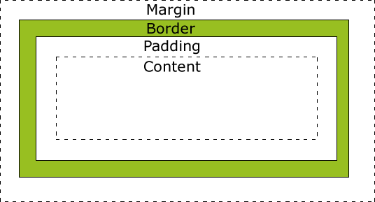
Padding
#box { padding: 10px 20px; }
top and bottom are 10px; left and right are 20px
works with both block and inline elements

Margin
#box {margin: 10px 5px 10px 5px;}
the centering magic:
width:50%; margin: 0 auto;
top and bottom margin are not accepted by inline-level elements
(but inline-block do accept them)

Borders
requires 3 values: |  |  | width |  | style |  | color
the style can be
solid | double | dashed |  | dotted |  | none
div { border: 6px solid black }

Border-radius
div { border-top-right-radius: 5px }

Size
margin-right + border-right +  padding-right +  width +  padding-left +  border-left + margin-left | total width
margin-top + border-top +  padding-top +  height +  padding-bottom +  border-bottom + margin-bottom | total height
keep in mind that inline-level elements will not accept the width and height properties or any values tied to them

browsers may apply default margins and padding to an element to help with legibility and clarity; The default margins and padding for these elements may differ from browser to browser, but a CSS reset will deal with that

Box-sizing
Introduced by CSS3, can change the box model to support different calculations.
div { box-sizing: border-box; }
content-box is the default value, leaving the box model as an additive design, as it was
border-box alters the box model so that any border or padding property values are included within the width and height
width: 400px, padding: 20px  border: 10px, | the actual width will remain 400 pixels.
It makes the math much, much easier.
If we want an element to be 400px wide, it is, and it will remain 400px wide no matter what padding or border values we add to it.

Display
body { display: inline; }
inline  size: | Default value.
inline  size: | Displays an element like <span>  makes the element sit on the same line as another element, but without formatting it like a block.  The inline display value is better suited for HTML elements that are blocks by default, such as headers and paragraphs.
inline  size: | expands and contracts horizontally to only take as much width as it needs  and it cannot have a fixed size  will NOT accept the width and height properties or any values tied to them
block  size: | Displays an element as a block element (like <p>) It won't let anything sit next
block  size: | default width is 100%  will accept the width and height prop
inline-block  touching:  size: | makes the element a block box, but will allow other elements to sit next to it on the same line.
inline-block  touching:  size: | they are not always touching, or displayed directly against one another. Usually a small space will exist between two inline-block elements
inline-block  touching:  size: | expands and contracts horizontally to only take as much width as it needs  accepts width,height,  padding,border,margin
flex | Displays an element as an block-level flex container. New in CSS3
initial | Sets this property to its default value.
inherit | from its parent element.
none | do not display (can use it for images)

inline-block
allows us to take full advantage of the box model without having to worry about clearing any floats
section { display: inline-block;
width: 30%;}
with 3 sections, it creates 3 columns

removing spaces
</section><section> | removing spaces
</section><!--  --><section> | using comments between tags

Position
position: static; the default one;
not affected by top, bottom, left, and right
always positioned according to the normal flow of the page. { position: static; }
position: relative;
positioned relative to its normal position.
leaving space for an element as intended while not allowing other elements to flow around it
{ position: relative; left: 30px; }

position: fixed;
always in the same place even if the page is scrolled | top, bottom, left, right properties are used to position the element.

{position: fixed; bottom: 0; right: 0;}
position: absolute;
removes the object from the flow and makes it positioned relative to the nearest positioned ancestor (instead of positioned relative to the viewport, like fixed)
accepts top, bottom, left, right
{position: absolute;bottom: 0;right: 0}
they also create a new coordinate system for child elements

Float
A box that is shifted to the left or
right on the current line.
The most interesting characteristic of a float is that content may flow along its side (or be prohibited from doing so by clear).
img { float: left; }
Allows to remove an element from the normal flow of the page | Elements will float all the way to the edge of its parent element all the way to the edge of the page
When it's used on multiple elements at the same time, it allows to put them next or opposite, like in multiple columns
The width of the floating element will default to the width of the content within it
That can be neutralized by adding a fixed width
The display value of the element will also be changed to block
section { float: left; width: 30%; }
three equal columns (with 3 sections)
Often margin and padding property values aren’t interpreted correctly, causing them to blend into the floated element; other properties can be affected, too.

clear
div { clear: left; } | Used to clear the floats
accepts left, right, and both | Used to clear the floats

floats vs containers

float first
a rule that works nicely is to place the floats first in the HTML, before any non-floated elements

Collapsing
floated elements are originally calculated in the normal flow and then removed, the #container element doesn’t consider it within its bounds and therefore acts as if it isn’t even there | One of the most common ways to fix a collapsed parent element is to place an element with the clear property after our floated element by having it recalculate its height now that there’s an element sitting below it

overflow
#container { overflow: hidden; }
it's complicated, it was not intented for this, so it also has some weird consequences

clearfix
the floated elements must reside within a parent element. The parent element will act as a container, leaving the flow of the document completely normal outside of it
<header>...</header>
<div class="clearfix">
<section>...</section>
<aside> ... </aside>
</div>
<footer>...</footer>
.clearfix:before, .clearfix:after
{ content: ""; display:table; }
.clearfix:after { clear: both; }
.clearfix { clear: both; *zoom: 1; }
section { float: left; width: 60%; }
aside { float: right; width: 30%; }
The technique shown here for containing elements is know as a “clearfix”
it can often be found with the class name of clearfix or cf

Formatting text

text-align
h1 { text-align: center; }
values: left, center, right, justify

font-size
body { font-size: 14px; }
12px, 2em, 50%, small

font-family
names of >2 words "need to be wrapped" |  |  | the last font should be a keyword value
body { font-family: "Helvetica Neue",
Helvetica, Arial, sans-serif; }
Serif | Sans-Serif |  |  | Fantasy
Cursive |  | Monospace

colour
h2 { color: white }
h3 { color: #3b5998}

font-style
.special { font-style: italic; }
normal, italic, oblique, and inherit

text-transform
h1 { text-transform: uppercase; }

font-variant
.firm { font-variant: small-caps; }
normal, small-caps, and inherit

text-decoration
a { text-decoration: none }
mostly used to remove underlines from links

font-weight
.daring { font-weight: bold; }
normal, bold, bolder, lighter, inherit
100, 400 (normal), 700(bold), 900
not all type faces have all the values

Line height
the distance between two lines of text
the best practice for legibility is to set it around 150% (or just 1.5)
body { line-height: 22px; }
it can also be used to vertically center text
.btn
{ height: 22px; line-height: 22px: }

Letter-spacing
.h1 { letter-spacing: .5px; }

shorthand font properties
all of the properties together! in this order:
font-style, font-variant, font-weight, font-size, line-height, font-family
html {
font: italic small-caps bold
14px/22px "Helvetica Neue",
Helvetica, Arial, sans-serif;
}

embed fonts
<head>
...
<link rel="stylesheet"
href="http://fonts.googleapis
.com/css?family=Lato:100,300,400">
</head>
body { font 300 16px "Lato"; }
Although Lato is a single word, because it is an embedded web font we’ll want to surround it with quotation marks within any CSS reference
I don't understand this:
@font-face { font-family: "Lobster";
src: local("Lobster"),
url("lobster.woff") format("woff");}
body { font-family: "Lobster"; }

Elements

Lists
li { float: left; }
ul.a {list-style-type: circle;}
ul.b {list-style-type: square;}
ol.c {list-style-type: upper-roman;}
ol.d {list-style-type: lower-alpha;}
○ Coffee ■ Tea III. Coca Cola d. Water

tables
The border-collapse property sets whether the table borders should be collapsed into a single border
table { border-collapse: collapse; }
table,th,td {border: 1px solid black;}
width and height | alignment
table {width: 100%;}  th { height: 50px; } | th {  text-align:left;}
vertical alignment | padding
td {vertical-align: bottom; } | th, td {  padding: 15px; }

Links
to style links in various state
a { color: blue; } |  | default
a:link | unvisited | a:visited | visited
a:hover | a.focus | a:active
they should be written in this precise order
the main ones are | :link and :visited
they can be combined | a:link:hover

Images
More often than not, images are displayed as block-level elements or are floated flush to one side, while all of the other content wraps around the image as necessary
img {
width: 200px
float: right;
margin: 8px 0 0 20px;
padding: 4px; }

background-image
The background or background-image property is the preferred option when the image being used is part of the design or user interface
As such, it’s not directly relevant to the content
body {
background-image: url("paper.gif"); }

Grids
HTML | CSS
<div class="grid">  <div class="col-2-3">  Main Content  </div>  <div class="col-1-3">  Sidebar  </div>  </div | .col-2-3 {  width: 66%;}  .col-1-3 {  width: 33%;}  .grid:after{  content: "";  display: table;  clear: both; }
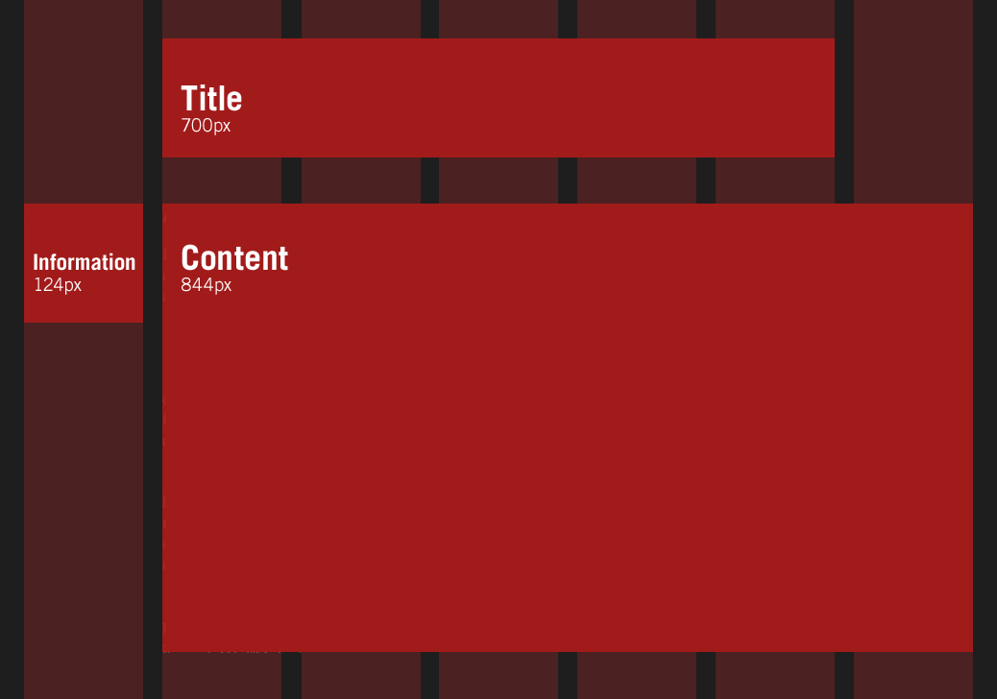

Frameworks

reset CSS
the goal of a reset stylesheet is to reduce browser inconsistencies in things like default line heights, margins and font sizes of headings and so on.
They often appear in CSS frameworks, one is the "meyerweb reset". The following one is very generic and should be tweaked, edited and extended.
/* http://meyerweb.com/eric/tools/css/reset/ v2.0 | 0110126 License: none (public domain) */
/* basic reset */

html, body, div, span, applet, object, iframe, h1, h2, h3, h4, h5, h6, p, blockquote, pre, a, abbr, acronym, address, big, cite, code, del, dfn, em, img, ins, kbd, q, s, samp, small, strike, strong, sub, sup, tt, var, b, u, i, center, dl, dt, dd, ol, ul, li, fieldset, form, label, legend, table, caption, tbody, tfoot, thead, tr, th, td, article, aside, canvas, details, embed, figure, figcaption, footer, header, hgroup, menu, nav, output, ruby, section, summary, time, mark, audio, video {
margin: 0;
padding: 0;
border: 0;
font-size: 100%;
font: inherit;
vertical-align: baseline;
}
/* HTML5 display-role reset for older browsers */
article, aside, details, figcaption, figure, footer, header, hgroup, menu, nav, section {
display: block;
}
body {
line-height: 1;
}
ol, ul {
list-style: none;
}
blockquote, q {
quotes: none;
}
blockquote:before, blockquote:after,q:before, q:after {
content: '';
content: none;
}
table {
border-collapse: collapse;
border-spacing: 0;
}

Bootstrap
an open-source web design framework from Twitter that makes it easy to add nice web design and user interface elements to an HTML5 application that also makes the application’s design responsive, ensuring that it looks sensible across a wide range of devices.
# Gemfile
gem 'bootstrap-sass'
The Bootstrap framework natively uses the Less CSS language for making dynamic stylesheets, but the Rails asset pipeline supports the (very similar) Sass language by default, so bootstrap-sass converts Less to Sass and makes all the necessary Bootstrap files available to the current application
@gray will become $gray
# app/assets/stylesheets/custom.scss
any stylesheets in this directory will automatically be included as part of application.css
@import "bootstrap-sprockets";
@import "bootstrap";
RESTART THE DAMN SERVER NOW

Link
place it into <head> before all other stylesheets
<meta name="viewport" content="width=device-width, initial-scale=1, shrink-to-fit=no">

<link rel="stylesheet" href="https://maxcdn.bootstrapcdn.com/bootstrap/4.0.0-beta/css/bootstrap.min.css" integrity="sha384-/Y6pD6FV/Vv2HJnA6t+vslU6fwYXjCFtcEpHbNJ0lyAFsXTsjBbfaDjzALeQsN6M" crossorigin="anonymous">
optional JavaScript plugins,jQuery, and Popper.js go near the end of the page, right before the closing </body> tag.
Be sure to place jQuery and Popper.js first, as the JavaScript plugins depend on them
<script src="https://code.jquery.com/jquery-3.2.1.slim.min.js" integrity="sha384-KJ3o2DKtIkvYIK3UENzmM7KCkRr/rE9/Qpg6aAZGJwFDMVNA/GpGFF93hXpG5KkN" crossorigin="anonymous"></script>
<script src="https://cdnjs.cloudflare.com/ajax/libs/popper.js/1.11.0/umd/popper.min.js" integrity="sha384-b/U6ypiBEHpOf/4+1nzFpr53nxSS+GLCkfwBdFNTxtclqqenISfwAzpKaMNFNmj4" crossorigin="anonymous"></script>
<script src="https://maxcdn.bootstrapcdn.com/bootstrap/4.0.0-beta/js/bootstrap.min.js" integrity="sha384-h0AbiXch4ZDo7tp9hKZ4TsHbi047NrKGLO3SEJAg45jXxnGIfYzk4Si90RDIqNm1" crossorigin="anonymous"></script>

globals
requires HTML5 doctype
box-sizing: border-box;
responsive meta viewport tag (for mobile)

grids
all divs are divided into 12 columns |  | col-md-6 is half-width  col-md-12 is full width
the last number is how many columns
xs | extra small (phones) |  | sm | small(tablets)
md | medium (desktops) |  | lg | large (big desk)
3 equal columns
.col-md-4 | .col-md-4 | .col-md-4
3 unequal columns
.col-md-3 | .col-md-6 | .col-md-3

SASS

mixin
to allow a group of CSS rules to be packaged up and used for multiple elements
@mixin box_sizing {
-moz-box-sizing: border-box; }
.debug_dump { @include box_sizing; }

Cursor
specifies the type of cursor to be displayed when pointing on an element
sw-resize | div { cursor:alias; }
all-scroll | default | alias | zoom-in
context-menu | e-resize | cell | zoom-out
col-resize | ew-resize | help | initial
vertical-text | grabbing | grab | no-drop
nesw-resize | n-resize | none | pointer
ns-resize | ne-resize | text | progress
nwse-resize | nw-resize | wait | w-resize
not-allowed | s-resize | auto | crosshair
row-resize | se-resize | copy | move
url(smiley.gif),url(myBall.cur),auto

Red glow:
box-shadow: 0 0 128px red;
syntax:
/* offset-x | offset-y | color */
box-shadow: 60px -16px teal;

/* offset-x | offset-y | blur-radius | spread-radius | color */
box-shadow: 2px 2px 2px 1px rgba(0, 0, 0, 0.2);

/* Any number of shadows, separated by ,*/
box-shadow: 3px 3px red, -1em 0 0.4em olive;

Design

Visual Hierarchy
Some content should be viewed first, some second, some third
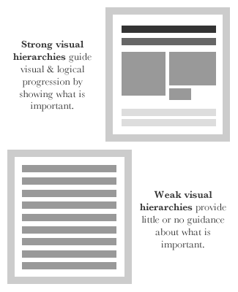
The most important content is at the top of the hierarchy. | It’s the visual element you look at first, which then directs you to what to look at next.
Use it to tell a story
f you’re creating a sign-up screen, for example, the hierarchy might be made up of a catchy headline, some supporting motivational copy (perhaps features & benefits of using the service), a signup form, and a submit button.

CRAP
Contrast | Repetition | Alignment | Proximity
whatch the examples in the CRAP pdf

Contrast
Contrast is what we notice, and it’s what gives a design its energy.
contrast in many ways:
manipulation of space (near and far, empty and filled) | color choices (dark and light, cool and warm)
manipulation of space (near and far, empty and filled) | positioning of elements (top and bottom, isolated and grouped)
text selection (serif and sans serif, bold and narrow)
Contrast can help you create a design in which one item is clearly dominant.This helps the viewer “get” the point of your design quickly.
If all items in a design are of equal or similar weight with weak contrast and with nothing being clearly dominant, it is difficult for the viewer to know where to begin.
Strong contrast attracts interest. | Weak contrast is not only boring, but it can be confusing.
Every single element of a design such as line, shape, color, texture, size, space, type, and so on can be manipulated to create contrast.

Alignment
nothing in your slide design should look as if it were placed there randomly | obtaining unity among elements of a single slide
Even elements that are quite far apart on a slide should have a visual connection, something that is easier to achieve with the use of grids.

Repetition
Reusing of the same or similar elements throughout your design. | It will bring a clear sense of unity, consistency, and cohesiveness.
Where contrast is about showing differences, repetition is about subtly using elements to make sure the design is viewed as being part of a larger whole.
For example a consistent background and consistent use of type adds unity across a deck of slides.
you must be careful not to have
too much repetition
background elements may soon become tiring, rather than generating interest | the tenth time a different slide is shown but with the same repetitive element
a starfish in the lower right is an element that would be a stronger repetitive element if its size and location occasionally shifted in harmony with the content of different slides and in a way that was subtle and did not interfere with the primary message.

Proximity
is about moving things closer or farther apart to achieve a more organized look | related items should be grouped together so that they will be viewed as a group, rather than as several unrelated elements
Audiences will assume that items that
are not near each other |  |  | are near to each other
are not closely related |  | are grouped into a single unit of similar items
People should never have to “work” at trying to figure out which caption goes with which graphic |  | or whether or not a line of text is a subtitle or a line of text unrelated to the title
Do not make audiences think
like trying to decipher your slide’s organization and design priority

